

# DECLARATION OF THESIS CONFIDENTIALITY



# LIBRARY FORM



# ACKNOWLEDGEMENT

I would like to express my heartfelt gratitude to my academic home, Asia Pacific University of Technology and Innovation. The nurturing environment, excellent facilities, and abundant resources have been crucial to the development and completion of this research project. The supportive community here has greatly enriched my academic journey.

Special thanks go to Mr. Justin Gilbert Alexius Silvester, my dedicated supervisor. His guidance, encouragement, and expertise have been instrumental in shaping the direction and quality of this research. His unwavering support and insightful feedback have been invaluable throughout this endeavour.

I also extend my sincere appreciation to the second marker, Ms. Tan Li June, for her prompt responses and valuable contributions to the refinement and improvement of this research project.

My family has been my rock, providing unwavering support and encouragement throughout this journey. Their belief in my abilities and constant encouragement have been the driving force behind my success.

Lastly, I am grateful to my friends. Each one of you has played a unique role in my journey, offering insights, advice, and encouragement that have been invaluable. Your collective efforts have enriched my learning experience and fostered a spirit of collaboration and mutual growth. Your support has been instrumental in overcoming challenges and achieving my goals, and for this, I am deeply appreciative.

Collectively, the contributions of my university, supervisor, second marker, family, and friends have shaped the success of this research project. I am truly grateful for the collaborative spirit that has defined this journey.

# ABSTRACT

Identifying and supporting at-risk students is essential for their academic success and well-being. This research project focuses on using machine learning techniques to develop predictive models for identifying these students. By analysing data related to student performance, engagement, and socio-economic factors, we aim to uncover patterns that indicate which students are at risk. Using the CRISP-DM methodology, various machine learning algorithms are applied and found that the tuned XGBoost model, with an accuracy of around 0.92, provided the best results. The findings suggest that this model can offer valuable insights for early identification and intervention, potentially transforming educational support systems. Aiming to guarantee inclusive, equitable, and high-quality education for everyone, Sustainable Development Goal 4 of the United Nations is in line with the findings of this project.

***Keywords –*** At-Risk Students, Education, Machine Learning, Predictive Modelling, Student Performance, XGBoost

**SDG Goal 4: Ensure inclusive and equitable quality education and promote lifelong learning opportunities for all**

# Table of Contents

DECLARATION OF THESIS CONFIDENTIALITY 2

LIBRARY FORM 3

ACKNOWLEDGEMENT 4

ABSTRACT 5

Table of Contents 6

List of Figures 9

LIST OF TABLES 24

CHAPTER 1: INTRODUCTION 26

1.1 Introduction 26

1.2 Problem Background 27

1.2.1 Growing Dropout Rates 27

1.2.2 Lack of Comprehensive Data Integration and Analysis 28

1.2.3 Challenges in Identifying the Determinant Factors that Contribute to Student Dropout or Failing 28

1.3 Project Aim 28

1.4 Objectives 29

1.5 Scope 29

1.5.1 Deliverables 29

1.5.2 Constraint and Project Boundaries 31

1.6 Potential Benefit 32

1.6.1 Tangible Benefits 32

1.6.2 Intangible Benefits 32

1.6.3 Target User 34

1.7 Overview of the Project 34

1.8 Project Plan 36

CHAPTER 2: LITERATURE REVIEW 37

2.1 Introduction 37

2.2 Domain Research 37

2.2.1 Educational Data Mining and Learning Analytics 37

2.2.2 Machine Learning Algorithms on Student Performance Prediction 42

2.2.3 Machine Learning Model Evaluation 48

2.3 Similar Systems / Works 51

2.4 Technical Research 55

2.4.1 Operating System Chosen 55

2.4.2 Python – Selected Programming Language 55

2.4.3 Jupyter Notebook in Visual Studio Code – IDE Chosen 56

2.4.4 Libraries / Tools Chosen 56

2.5 Summary 57

CHAPTER 3: METHODOLOGY 59

3.1 Introduction 59

3.2 Methodology 59

3.2.1 Introduction of Methodology (CRISP-DM) 59

3.2.2 Methodology Choice and Justification 60

3.2.3 Phases of CRISP-DM 61

3.3 Summary 62

CHAPTER 4: DESIGN AND IMPLEMENTATION 63

4.1 Introduction 63

4.2 Data Collection 64

4.3 Data Pre-Processing 64

4.3.1 Exploratory Data Analysis (EDA) 64

4.3.2 Data Pre-Processing 67

4.3.3 Data Cleaning after Data Integration 89

4.3.4 Data Manipulation 110

4.4 Data Understanding 111

4.4.1 Variables 111

4.4.2 Observations 115

4.4.3 Data Visualization (After Pre-Processing) 132

4.4.4 Additional Analysis 143

4.5 Model Building 155

4.5.1 Binary Classification 155

4.5.2 Multi-Class Classification 172

4.6 Summary 187

CHAPTER 5: result and discussion 189

5.1 Introduction 189

5.2 Model Evaluation and Discussions 190

5.2.1 Evaluation Method 190

5.2.2 Binary Classification 197

5.2.3 Multi-Class Classification 256

5.2.4 Feature Importance for Selected Models 315

5.3 Model Comparison 339

5.3.1 Comparison Across Models 339

5.4 Model Deployment 340

5.4.1 Code Implementation 340

5.4.2 User Input 346

5.4.3 CSV File Upload 352

5.5 Summary 355

chapter 6: CRITICAL EVALUATION 356

6.1 Critical Evaluation 356

6.2 Limitation 356

6.3 Recommendation 356

References 358

appendices 362

Appendix A: PPF – Title Registration Proposal 362

Appendix B: Ethics Forms (Fast Track) 369

Appendix C: Log Sheets 373

Appendix D: Poster 379

Appendix E: Gantt Chart 380

Appendix F: Sample Code Implementation 381

# List of Figures

Figure 1: Project Plan 35

Figure 2: Confusion Matrix 47

Figure 3: Formula for Accuracy Calculation 49

Figure 4: Formula for Precision Calculation 49

Figure 5: Formula for Recall Calculation 49

Figure 6: Formula for F1 Score Calculation 49

Figure 7: CRISP–DM Diagram (IBM Documentation, 2021) 59

Figure 8: Libraries to be Installed 64

Figure 9: Libraries to be Imported 64

Figure 10: Source Code of Loading Datasets 64

Figure 11: Source Code of Setting the Display Setting 65

Figure 12: Formatting Before and After Standardization 68

Figure 13: Relationships between Datasets 69

Figure 14: Common Key for Data Integration 71

Figure 15: Source Code of Merging studentInfo and studentReg 71

Figure 16: Output of Merging studentInfo and studentReg 71

Figure 17: Source Code of Merging studentAss and assessments 71

Figure 18: Output of Merge studentAss and assessments 72

Figure 19: Source Code of Creating Unique Identifier 72

Figure 20: Output of Creating Unique Identifier 72

Figure 21: Source Code of Showing Missing Values in 'score' 72

Figure 22: Output of Missing Values in ‘score’ 73

Figure 23: Source Code of Filtering Rows (Missing Score & Late Submissions) 73

Figure 24: Output of Filtering Rows 73

Figure 25: Source Code of Handling Missing Values in ‘score’ 73

Figure 26: Source Code of Showing the Rows that Contain Missing Values in 'score' 74

Figure 27: Output of Rows Containing Missing Values in ‘score’ 74

Figure 28: Source Code of Handling Missing Values in Remaining Records and Check 74

Figure 29: Output of Checking Missing Values in ‘score’ 74

Figure 30: Source Code of Separating Regular Assessment and Exams 75

Figure 31: Source Code and Output of Calculating Score of Regular Assessment for Each Student 75

Figure 32: Source Code and Output of Extracting Exam Assessment 76

Figure 33: Source Code and Output of Merging ‘regular_scores’ and ‘exam_scores’ 76

Figure 34: Source Code and Output of Replacing Missing Value 77

Figure 35: Source Code and Output of Calculating the Final Score 77

Figure 36: Source Code and Output of Descriptive Description of ‘final_scores’ 78

Figure 37: Source Code of Merging ‘studentAss_merge_assessments’ and ‘final_scores’ 78

Figure 38: Output of Data Merging 78

Figure 39: Source Code and Output of Grouping by Common Columns and Mean Calculation for ‘final_score’ 79

Figure 40: Source Code of Merging ‘merged_df’ and ‘studAssessment’ DataFrame 79

Figure 41: Output of Data Merging 79

Figure 42: Source Code of Merging ‘updated_df’ and ‘courses’ DataFrame 80

Figure 43: Output of Data Merging 80

Figure 44: Source Code and Output of Merging studentVle and vle 80

Figure 45: Source Code and Output of Checking Unique Values 81

Figure 46: Source Code and Output of Creating New Column ‘click_type’ 82

Figure 47: Source Code and Output of Calculating Sum of ‘sum_click’ 82

Figure 48: Source Code and Output of Deriving Columns 83

Figure 49: Source Code and Output of Grouping and Aggregating Sum of Clicks 83

Figure 50: Source Code of Merging ‘updated_df’ and ‘studentVle_merge_vle_group’ 84

Figure 51: Output of Data Merging 84

Figure 52: Source Code and Output of Informative Summary of ‘updated_df’ DataFrame 85

Figure 53: Source Code and Output of Converting Data Type of ‘id_student’ 85

Figure 54: Source Code of Plotting Correlation Matrix 86

Figure 55: Output of Plotting Correlation Matrix 87

Figure 56: Source Code and Output of Checking for Duplicates 88

Figure 57: Source Code of Creating Function to Check Outliers 88

Figure 58: Source Code of Appling Function to ‘updated_df’ DataFrame 89

Figure 59: Output of Showing Outliers for num_of_previous_attempts, studied_credits and date_registration 90

Figure 60: Output of Showing Outliers for date_unregistration, final_score and module_presentation_length 91

Figure 61: Output of Showing Outliers for sum_click, before_course_click and after_course_click 92

Figure 62: Source Code of Function to Check Missing Values 93

Figure 63: Source Code and Output of Checking Missing Values in ‘updated_df’ DataFrame 94

Figure 64: Source Code of Dropping Columns 95

Figure 65: Output of DataFrame after Dropping Column 95

Figure 66: Source Code of Checking Rows with Missing Values in ‘final_score’ 95

Figure 67: Output of Rows with Missing Values in ‘final_score’ 95

Figure 68: Source Code and Output of Checking Missing Values in ‘final_score’ 96

Figure 69: Source Code of Calculating Mean Score for Each Unique Combination 96

Figure 70: Source Code of Merging ‘updated_df’ and ‘mean_scores’ 97

Figure 71: Output of Data Merging 97

Figure 72: Source Code of Function Filling Missing Values using Mean 97

Figure 73: Source Code of Filling Missing Values using Mean 97

Figure 74: Output of ‘updated_df’ DataFrame after Mean Imputation for ‘final_score’ 97

Figure 75: Source Code of Checking Missing Value in ‘after_course_click’ 98

Figure 76: Output of Checking Missing Value in ‘after_course_click’ 98

Figure 77: Source Code and Output of Checking Missing Values by Category in ‘final_result’ 98

Figure 78: Source Code and Output of Mean Calculation 99

Figure 79: Merge ‘updated_df’ and ‘mean_clicks’ 100

Figure 80: Source Code and Output of Filling Missing Values with Mean 100

Figure 81: Source Code and Output of Filling Missing Values in ‘sum_click’ 101

Figure 82: Source Code of Checking Missing Values in ‘date_registration’ 102

Figure 83: Output of First 10 Rows with Missing Values in ‘date_registration’ 102

Figure 84: Source Code and Output of Imputing Mode to Missing Values in ‘date_registration’ 102

Figure 85: Source Code and Output of Checking Missing Values 103

Figure 86: Source Code of Dropping Unnecessary Columns 103

Figure 87: Output of DataFrame after Dropping Columns 103

Figure 88: Source Code of Creating New Feature 104

Figure 89: Output of Creating New Feature 104

Figure 90: Source Code of Making a Copy from ‘final_df’ 104

Figure 91: Source Code to Encode the Categorical Columns and Print the Label Mappings for Each Encoded Columns 105

Figure 92: Output of Label Mappings for Categorical Columns using LabelEncoder 105

Figure 93: Source Code to Encode the Categorical Columns in Ordinal Way and Print the Label Mappings for Each Encoded Columns 106

Figure 94: Output of Label Mappings for Categorical Columns using OrdinalEncoder 106

Figure 95: Source Code of Filtering DataFrame 107

Figure 96: Output of Filtered DataFrame 107

Figure 97: Source Code and Output of Informative Summary 107

Figure 98: Source Code of Merging final_df and encoded_df 108

Figure 99: Output of Data Merging 108

Figure 100: Source Code and Output of Dropping ‘index’ Column 109

Figure 101: Source Code and Output of Rearranging Columns 109

Figure 102: Source Code and Output of Showing Number of Rows and Columns in Each Dataset 114

Figure 103: Source Code of Informative Summary 130

Figure 104: Output of Informative Summary 130

Figure 105: Source Code of Plotting Gender Distribution by Bar Chart 131

Figure 106: Bar Chart of Gender Distribution 131

Figure 107: Source Code of Plotting Region Distribution by Bar Chart 132

Figure 108: Bar Chart of Region Distribution 132

Figure 109: Source Code of Plotting Highest Education Distribution by Bar Chart 133

Figure 110: Bar Chart of Highest Education Distribution 133

Figure 111: Source Code of Plotting Disability Distribution by Bar Chart 134

Figure 112: Bar Chart of Disability Distribution 134

Figure 113: Source Code of Plotting IMD Band Distribution by Bar Chart 135

Figure 114: Bar Chart of IMD Band Distribution 135

Figure 115: Source Code of Plotting At Risk Distribution by Bar Chart 136

Figure 116: Bar Chart of At Risk Distribution for Both Binary and Multi Class 136

Figure 117: Source Code of Plotting Final Score Distribution by Histogram 137

Figure 118: Histogram of Final Score Distribution 137

Figure 119: Source Code of Plotting Sum Click Distribution by Histogram 138

Figure 120: Histogram of Sum Click Distribution 138

Figure 121: Source Code of Plotting Before Course Click Distribution by Histogram 139

Figure 122: Histogram of Before Course Click Distribution 139

Figure 123: Source Code of Plotting After Course Click Distribution by Histogram 140

Figure 124: Histogram of After Course Click Distribution 140

Figure 125: Source Code of Plotting Correlation Matrix of At Risk with Other Variables 141

Figure 126: Correlation Matrix of At Risk with Other Variables 141

Figure 127: Source Code of Plotting Gender vs At Risk Indicators by Bar Chart 142

Figure 128: Bar Chart of Gender vs At Risk Indicators 142

Figure 129: Source Code of Plotting Region vs At Risk Indicators by Bar Chart 143

Figure 130: Bar Chart of Region vs At Risk Indicators 143

Figure 131: Source Code of Plotting Highest Education vs At Risk Indicators by Bar Chart 144

Figure 132: Bar Chart of Highest Education vs At Risk Indicators 144

Figure 133: Source Code of Plotting Disability vs At Risk Indicators by Bar Chart 146

Figure 134: Bar Chart of Disability vs At Risk Indicators 146

Figure 135: Source Code of Plotting IMD Band vs At Risk Indicators by Bar Chart 147

Figure 136: Bar Chart of IMD Band vs At Risk Indicators 147

Figure 137: Source Code of Final Score vs At Risk Indicators by Histogram 148

Figure 138: Histogram of Final Score vs At Risk Indicators 149

Figure 139: Source Code of Annotating Boxplot 150

Figure 140:Source Code of Plotting Before Course Click vs At Risk Indicators by Boxplot 150

Figure 141: Boxplot of before Course Click vs At Risk Indicators 150

Figure 142: Source Code of Plotting After Course Click vs At Risk Indicators by Boxplot 151

Figure 143: Boxplot of After Course Click vs At Risk Indicators 152

Figure 144: Source Code of Plotting Sum Click vs At Risk Indicators by Boxplot 153

Figure 145: Boxplot of Sum Click vs At Risk Indicators 153

Figure 146: Source Code of Importing Library and Reading Dataset 154

Figure 147: Output of Showing First 5 Rows of the Dataset 154

Figure 148: Source Code of Excluding Object Data Types 154

Figure 149: Output of ‘stud_numeric_data’ DataFrame 155

Figure 150: Source Code of Separating into X (features) and y (target) 155

Figure 151: Source Code of Splitting and Scaling Training and Testing Set 156

Figure 152: Source Code of Building Logistic Regression Model 157

Figure 153: Source Code of Defining the Parameter Grid for Logistic Regression Model 157

Figure 154: Source Code of Performing Hyperparameter Tuning using GridSearchCV for Logistic Regression 158

Figure 155: Source Code of Retrieving the Best Parameters and Score from GridSearchCV for Logistic Regression 158

Figure 156: Source Code of Training and Making Predictions with a Decision Tree Model 159

Figure 157: Source Code of Defining the Parameter Grid for Decision Tree Tuning 159

Figure 158: Source Code of Performing Hyperparameter Tuning using GridSearchCV for Decision Tree 160

Figure 159: Source Code of Retrieving the Best Parameters and Score from GridSearchCV for Decision Tree 160

Figure 160: Source Code of Training and Making Predictions with a Random Forest Model 161

Figure 161: Source Code of Defining the Parameter Grid for Random Forest Tuning 161

Figure 162: Source Code of Performing Hyperparameter Tuning Using GridSearchCV for Random Forest 162

Figure 163: Source Code of Retrieving the Best Parameters and Score from GridSearchCV for Random Forest 163

Figure 164: Source Code of Training and Making Predictions with a Gradient Boosting Model 163

Figure 165: Source Code of Defining the Parameter Grid for Gradient Boosting Tuning 164

Figure 166: Source Code of Performing Hyperparameter Tuning Using GridSearchCV for Gradient Boosting 164

Figure 167: Source Code of Retrieving the Best Parameters and Score from GridSearchCV for Gradient Boosting 165

Figure 168:Source Code of Training and Making Predictions with XGBoost Model 165

Figure 169: Source Code of Defining the Parameter Grid for XGBoost Tuning 166

Figure 170: Source Code of Hyperparameter Tuning Using GridSearchCV for XGBoost 166

Figure 171: Source Code of Retrieving the Best Parameters and Score from GridSearchCV for XGBoost 167

Figure 172: Source Code of Building, Compiling, and Training an ANN Model 168

Figure 173: Source Code of Defining and Wrapping an ANN Model Function for Binary Classification 169

Figure 174: Source Code of Defining the Parameter Grid for ANN Model Tuning 169

Figure 175: Source Code of Hyperparameter Tuning Using GridSearchCV for ANN Model 169

Figure 176: Source Code of Retrieving the Best Parameters and Score from GridSearchCV for ANN Model 170

Figure 177: Source Code of Retraining the Best ANN Model and Making Predictions 170

Figure 178: Source Code of Importing Pandas and Reading the MultiSelectedFeatures.csv Dataset into a DataFrame 171

Figure 179: Output of Displaying the First and Last Five Rows of the multiStudData DataFrame 171

Figure 180: Output of Showing Information About the MultiSelectedFeatures.csv Dataset 172

Figure 181: Source Code of Selecting Numeric Columns from the DataFrame and Creating a Copy 172

Figure 182: Output of Displaying the Numeric Columns from the MultiSelectedFeatures.csv Dataset 173

Figure 183: Source Code of Separating Features and Target Variable from the DataFrame 173

Figure 184: Source Code of Splitting the Dataset and Scaling the Features 173

Figure 185: Source Code of Training and Making Predictions with Logistic Regression Model for Multi Classification 174

Figure 186: Source Code of Defining the Parameter Grid for Logistic Regression Tuning 174

Figure 187: Source Code of Hyperparameter Tuning Using GridSearchCV for Multi-Class Logistic Regression 175

Figure 188: Source Code of Retrieving the Best Parameters and Score from GridSearchCV for Multi-Class Logistic Regression 175

Figure 189: Source Code of Training and Making Predictions with Decision Tree Model 176

Figure 190: Source Code of Defining the Parameter Grid for Decision Tree Tuning 176

Figure 191: Source Code of Hyperparameter Tuning Using GridSearchCV for Decision Tree Model 177

Figure 192: Source Code of Retrieving the Best Parameters and Score from GridSearchCV for Decision Tree Model 177

Figure 193: Source Code of Training and Making Predictions with Random Forest Model 178

Figure 194: Source Code of Defining the Parameter Grid for Random Forest Tuning 178

Figure 195: Source Code of Hyperparameter Tuning Using GridSearchCV for Random Forest Model 179

Figure 196: Output of Showing the Best Parameters and Cross-Validation Accuracy for Random Forest Model 179

Figure 197: Source Code of Training and Making Predictions with Gradient Boosting Model 180

Figure 198: Source Code of Parameter Grid for Gradient Boosting Hyperparameter Tuning 180

Figure 199: Source Code of Hyperparameter Tuning Using GridSearchCV for Gradient Boosting Model 181

Figure 200: Output Showing the Best Parameters and Cross-Validation Accuracy for Gradient Boosting Model 181

Figure 201: Source Code of Training and Making Predictions with XGBoost Model 182

Figure 202: Source Code of Parameter Grid for XGBoost Hyperparameter Tuning 182

Figure 203: Source Code of Hyperparameter Tuning Using GridSearchCV for XGBoost Model 183

Figure 204: Output of Showing the Best Parameters and Cross-Validation Accuracy for XGBoost Model 183

Figure 205: Source Code of Building, Compiling, and Training an ANN Model for Multiclass Classification 184

Figure 206: Source Code of Defining and Wrapping an ANN Model Function Using KerasClassifier 185

Figure 207: Source Code of Parameter Grid for Hyperparameter Tuning of ANN Model 185

Figure 208: Source Code of GridSearchCV for Hyperparameter Tuning of ANN Model 186

Figure 209: Source Code and Output of Best Parameters and Cross-Validation Accuracy for ANN Model 186

Figure 210: Source Code of Evaluating Base Models except ANN (Both Binary and Multi Classification) 189

Figure 211: Source Code of Evaluating Base ANN Model (Binary Classification) 189

Figure 212: Source Code of Evaluating Base ANN Model (Multi Classification) 190

Figure 213: Source Code of Plotting the ROC Curve and Displaying ROC AUC Value for Models except ANN (Both Binary and Multi Classification) 191

Figure 214: Source Code of Plotting the ROC Curve and Displaying ROC AUC Value for ANN Model (Binary Classification) 192

Figure 215: Source Code of Plotting the ROC Curve and Displaying ROC AUC Value for ANN Model (Multi Classification) 193

Figure 216: Source Code of Plotting the Learning Curve to Check for Underfitting or Overfitting for Models except ANN (Both Binary and Multi Classification) 194

Figure 217: Source Code of Plotting the Learning Curve to Check for Underfitting or Overfitting for ANN Model (Both Binary and Multi Classification) 195

Figure 218: Source Code of Plotting the Learning Curve to Check for Underfitting or Overfitting for ANN Model (Both Binary and Multi Classification) 196

Figure 219: Base Logistic Regression Model Performance on Binary Classification 196

Figure 220: plot_roc_curve Function Call for Base Logistic Regression on Binary Classification 197

Figure 221: ROC Curve for Base Logistic Regression on Binary Classification 198

Figure 222: Train and Test Accuracy Evaluation Code for Base Logistic Regression on Binary Classification 199

Figure 223: Base Logistic Regression Performance on Binary Prediction 199

Figure 224: plot_learning_curve Function Call for Base Logistic Regression on Binary Classification 200

Figure 225: Learning Curve for Base Logistic Regression on Binary Classification 200

Figure 226: Tuned Logistic Regression Model Performance on Binary Classification 201

Figure 227: plot_roc_curve Function Call for Tuned Logistic Regression on Binary Classification 202

Figure 228: ROC Curve for Tuned Logistic Regression on Binary Classification 203

Figure 229: Train and Test Accuracy Evaluation Code for Tuned Logistic Regression on Binary Classification 204

Figure 230: Tuned Logistic Regression Performance on Binary Prediction 204

Figure 231: plot_learning_curve Function Call for Tuned Logistic Regression on Binary Classification 205

Figure 232: Learning Curve for Tuned Logistic Regression on Binary Classification 206

Figure 233: Base Decision Tree Model Performance on Binary Classification 207

Figure 234: plot_roc_curve Function Call for Base Decision Tree on Binary Classification 207

Figure 235: ROC Curve for Base Decision Tree on Binary Classification 208

Figure 236: Train and Test Accuracy Evaluation Code for Base Decision Tree on Binary Classification 209

Figure 237: Base Decision Tree Performance on Binary Prediction 209

Figure 238: plot_learning_curve Function Call for Base Decision Tree on Binary Classification 210

Figure 239: Learning Curve for Base Decision Tree on Binary Classification 210

Figure 240: Tuned Decision Tree Model Performance on Binary Classification 211

Figure 241: plot_roc_curve Function Call for Tuned Decision Tree on Binary Classification 212

Figure 242: ROC Curve for Tuned Decision Tree on Binary Classification 212

Figure 243: Train and Test Accuracy Evaluation Code for Tuned Decision Tree on Binary Classification 213

Figure 244: Tuned Decision Tree Performance on Binary Prediction 214

Figure 245: plot_learning_curve Function Call for Tuned Decision Tree on Binary Classification 214

Figure 246: Learning Curve for Tuned Decision Tree on Binary Classification 215

Figure 247: Base Random Forest Model Performance on Binary Classification 216

Figure 248: plot_roc_curve Function Call for Base Random Forest on Binary Classification 216

Figure 249: ROC Curve for Base Random Forest on Binary Classification 217

Figure 250: Train and Test Accuracy Evaluation Code for Base Random Forest on Binary Classification 218

Figure 251: Base Random Forest Performance on Binary Prediction 218

Figure 252: plot_learning_curve Function Call for Base Random Forest on Binary Classification 219

Figure 253: Learning Curve for Base Random Forest on Binary Classification 219

Figure 254: Tuned Random Forest Model Performance on Binary Classification 220

Figure 255: plot_roc_curve Function Call for Tuned Random Forest on Binary Classification 221

Figure 256: ROC Curve for Tuned Random Forest on Binary Classification 221

Figure 257: Train and Test Accuracy Evaluation Code for Tuned Random Forest on Binary Classification 222

Figure 258: Tuned Random Forest Performance on Binary Prediction 223

Figure 259: plot_learning_curve Function Call for Tuned Random Forest on Binary Classification 224

Figure 260: Learning Curve for Tuned Random Forest on Binary Classification 224

Figure 261: Base Gradient Boosting Model Performance on Binary Classification 225

Figure 262: plot_roc_curve Function Call for Base Gradient Boosting on Binary Classification 226

Figure 263: ROC Curve for Base Gradient Boosting on Binary Classification 226

Figure 264: Train and Test Accuracy Evaluation Code for Base Gradient Boosting on Binary Classification 227

Figure 265: Base Gradient Boosting Performance on Binary Prediction 227

Figure 266: plot_learning_curve Function Call for Base Gradient Boosting on Binary Classification 228

Figure 267: Learning Curve for Base Gradient Boosting on Binary Classification 228

Figure 268: Tuned Gradient Boosting Model Performance on Binary Classification 229

Figure 269: plot_roc_curve Function Call for Tuned Gradient Boosting on Binary Classification 230

Figure 270: ROC Curve for Tuned Gradient Boosting on Binary Classification 231

Figure 271: Train and Test Accuracy Evaluation Code for Tuned Gradient Boosting on Binary Classification 232

Figure 272: Tuned Gradient Boosting Performance on Binary Prediction 233

Figure 273: plot_learning_curve Function Call for Tuned Gradient Boosting on Binary Classification 233

Figure 274: Learning Curve for Tuned Gradient Boosting on Binary Classification 234

Figure 275: Base XGBoost Model Performance on Binary Classification 235

Figure 276: plot_roc_curve Function Call for Base XGBoost on Binary Classification 235

Figure 277: ROC Curve for Base XGBoost on Binary Classification 236

Figure 278: Train and Test Accuracy Evaluation Code for Base XGBoost on Binary Classification 237

Figure 279: Base XGBoost Performance on Binary Prediction 237

Figure 280: plot_learning_curve Function Call for Base XGBoost on Binary Classification 238

Figure 281: Learning Curve for Base XGBoost on Binary Classification 238

Figure 282: Tuned XGBoost Model Performance on Binary Classification 239

Figure 283: plot_roc_curve Function Call for Tuned XGBoost on Binary Classification 240

Figure 284: ROC Curve for Tuned XGBoost on Binary Classification 240

Figure 285: Train and Test Accuracy Evaluation Code for Tuned XGBoost on Binary Classification 241

Figure 286: Tuned XGBoost Performance on Binary Prediction 242

Figure 287: plot_learning_curve Function Call for Tuned XGBoost on Binary Classification 242

Figure 288: Learning Curve for Tuned XGBoost on Binary Classification 243

Figure 289: Base ANN Model Performance on Binary Classification 244

Figure 290: plot_roc_curve Function Call for Base ANN on Binary Classification 244

Figure 291: ROC Curve for Base ANN on Binary Classification 245

Figure 292: Train and Test Accuracy Evaluation Code for Base ANN on Binary Classification 246

Figure 293: Base ANN Performance on Binary Prediction 246

Figure 294: plot_learning_curve Function Call for Base ANN on Binary Classification 247

Figure 295: Learning Curve for Base ANN on Binary Classification 247

Figure 296: Tuned ANN Model Performance on Binary Classification 248

Figure 297: plot_roc_curve Function Call for Tuned ANN on Binary Classification 249

Figure 298: ROC Curve for Tuned ANN on Binary Classification 250

Figure 299: Train and Test Accuracy Evaluation Code for Tuned ANN on Binary Classification 252

Figure 300: Tuned ANN Performance on Binary Prediction 253

Figure 301: plot_learning_curve Function Call for Tuned ANN on Binary Classification 253

Figure 302: Learning Curve for Tuned ANN on Binary Classification 254

Figure 303: Base Logistic Regression Model Performance on Multi-Class Classification 255

Figure 304: plot_roc_curve Function Call for Base Logistic Regression on Multi-Class Classification 255

Figure 305: ROC Curve for Base Logistic Regression on Multi-Class Classification 256

Figure 306: Train and Test Accuracy Evaluation Code for Base Logistic Regression on Multi-Class Classification 257

Figure 307: Base Logistic Regression Performance on Multi-Class Prediction 257

Figure 308: plot_learning_curve Function Call for Base Logistic Regression 258

Figure 309: Learning Curve for Base Logistic Regression on Multi-Class Classification 258

Figure 310: Tuned Logistic Regression Model Performance on Multi-Class Classification 259

Figure 311: plot_roc_curve Function Call for Tuned Logistic Regression on Multi-Class Classification 260

Figure 312: ROC Curve for Tuned Logistic Regression on Multi-Class Classification 261

Figure 313: Train and Test Accuracy Evaluation Code for Tuned Logistic Regression on Multi-Class Classification 262

Figure 314: Tuned Logistic Regression Performance on Multi-Class Prediction 263

Figure 315: plot_learning_curve Function Call for Tuned Logistic Regression 264

Figure 316: Learning Curve for Tuned Logistic Regression on Multi-Class Classification 264

Figure 317: Base Decision Tree Model Performance on Multi-Class Classification 265

Figure 318: plot_roc_curve Function Call for Base Decision Tree on Multi-Class Classification 266

Figure 319: ROC Curve for Base Decision Tree on Multi-Class Classification 266

Figure 320: Train and Test Accuracy Evaluation Code for Base Decision Tree on Multi-Class Classification 267

Figure 321: Base Decision Tree Performance on Multi-Class Prediction 267

Figure 322: plot_learning_curve Function Call for Base Decision Tree 268

Figure 323: Learning Curve for Base Decision Tree on Multi-Class Classification 268

Figure 324: Tuned Decision Tree Model Performance on Multi-Class Classification 269

Figure 325: plot_roc_curve Function Call for Tuned Decision Tree on Multi-Class Classification 270

Figure 326: ROC Curve for Tuned Decision Tree on Multi-Class Classification 271

Figure 327: Train and Test Accuracy Evaluation Code for Tuned Decision Tree on Multi-Class Classification 272

Figure 328: Tuned Decision Tree Performance on Multi-Class Prediction 273

Figure 329: plot_learning_curve Function Call for Tuned Decision Tree 273

Figure 330: Learning Curve for Tuned Decision Tree on Multi-Class Classification 274

Figure 331: Base Random Forest Model Performance on Multi-Class Classification 275

Figure 332: plot_roc_curve Function Call for Base Random Forest on Multi-Class Classification 275

Figure 333: ROC Curve for Base Random Forest on Multi-Class Classification 276

Figure 334: Train and Test Accuracy Evaluation Code for Base Random Forest on Multi-Class Classification 277

Figure 335: Base Random Forest Performance on Multi-Class Prediction 277

Figure 336: plot_learning_curve Function Call for Base Random Forest on Multi-Class Classification 278

Figure 337: Learning Curve for Base Random Forest on Multi-Class Classification 278

Figure 338: Tuned Random Forest Model Performance on Multi-Class Classification 279

Figure 339: plot_roc_curve Function Call for Tuned Random Forest on Multi-Class Classification 280

Figure 340: ROC Curve for Tuned Random Forest on Multi-Class Classification 281

Figure 341: Train and Test Accuracy Evaluation Code for Tuned Random Forest on Multi-Class Classification 282

Figure 342: Tuned Random Forest Performance on Multi-Class Prediction 283

Figure 343: plot_learning_curve Function Call for Tuned Random Forest on Multi-Class Classification 283

Figure 344: Learning Curve for Tuned Random Forest on Multi-Class Classification 284

Figure 345: Base Gradient Boosting Model Performance on Multi-Class Classification 285

Figure 346: plot_roc_curve Function Call for Base Gradient Boosting on Multi-Class Classification 286

Figure 347: ROC Curve for Base Gradient Boosting on Multi-Class Classification 286

Figure 348: Train and Test Accuracy Evaluation Code for Base Gradient Boosting on Multi-Class Classification 287

Figure 349: Base Gradient Boosting Performance on Multi-Class Prediction 287

Figure 350: plot_learning_curve Function Call for Base Gradient Boosting on Multi-Class Classification 288

Figure 351: Learning Curve for Base Gradient Boosting on Multi-Class Classification 288

Figure 352: Tuned Gradient Boosting Model Performance on Multi-Class Classification 289

Figure 353: plot_roc_curve Function Call for Tuned Gradient Boosting on Multi-Class Classification 290

Figure 354: ROC Curve for Tuned Gradient Boosting on Multi-Class Classification 291

Figure 355: Train and Test Accuracy Evaluation Code for Tuned Gradient Boosting on Multi-Class Classification 292

Figure 356: Tuned Gradient Boosting Performance on Multi-Class Prediction 293

Figure 357: plot_learning_curve Function Call for Tuned Gradient Boosting on Multi-Class Classification 293

Figure 358: Learning Curve for Tuned Gradient Boosting on Multi-Class Classification 294

Figure 359: Base XGBoost Model Performance on Multi-Class Classification 295

Figure 360: plot_roc_curve Function Call for Base XGBoost on Multi-Class Classification 296

Figure 361: ROC Curve for Base XGBoost on Multi-Class Classification 296

Figure 362: Train and Test Accuracy Evaluation Code for Base XGBoost on Multi-Class Classification 297

Figure 363: Base XGBoost Performance on Multi-Class Prediction 297

Figure 364: plot_learning_curve Function Call for Base XGBoost on Multi-Class Classification 298

Figure 365: Learning Curve for Base XGBoost on Multi-Class Classification 298

Figure 366: Tuned XGBoost Model Performance on Multi-Class Classification 299

Figure 367: plot_roc_curve Function Call for Tuned XGBoost on Multi-Class Classification 300

Figure 368: ROC Curve for Tuned XGBoost on Multi-Class Classification 301

Figure 369: Train and Test Accuracy Evaluation Code for Tuned XGBoost on Multi-Class Classification 302

Figure 370: Tuned XGBoost Performance on Multi-Class Prediction 303

Figure 371: plot_learning_curve Function Call for Tuned XGBoost on Multi-Class Classification 303

Figure 372: Learning Curve for Tuned XGBoost on Multi-Class Classification 304

Figure 373: Base ANN Model Performance on Multi-Class Classification 305

Figure 374: plot_roc_curve Function Call for Base ANN on Multi-Class Classification 305

Figure 375: ROC Curve for Base ANN on Multi-Class Classification 306

Figure 376: Train and Test Accuracy Evaluation Code for Base ANN on Multi-Class Classification 307

Figure 377: Base ANN Performance on Multi-Class Prediction 307

Figure 378: plot_learning_curve Function Call for Base ANN on Multi-Class Classification 307

Figure 379: Learning Curve for Base ANN on Multi-Class Classification 308

Figure 380: Tuned ANN Model Performance on Multi-Class Classification 308

Figure 381: plot_roc_curve Function Call for Tuned ANN on Multi-Class Classification 310

Figure 382: ROC Curve for Tuned ANN on Multi-Class Classification 310

Figure 383: Train and Test Accuracy Evaluation Code for Tuned ANN on Multi-Class Classification 312

Figure 384: Tuned ANN Performance on Multi-Class Prediction 312

Figure 385: plot_learning_curve Function Call for Tuned ANN on Multi-Class Classification 313

Figure 386: Learning Curve for Tuned ANN on Multi-Class Classification 313

Figure 387: Source Code of Plotting Feature Importance for Logistic Regression 315

Figure 388: plot_feature_importance Function Call for Base Logistic Regression on Binary Classification 316

Figure 389: Feature Importance for Base Logistic Regression on Binary Classification 316

Figure 390: Source Code of Plotting Feature Importance for Tuned Decision Tree on Binary Classification 317

Figure 391: Feature Importance for Tuned Decision Tree on Binary Classification 318

Figure 392: Source Code of Plotting Feature Importance for Tuned Random Forest on Binary Classification 319

Figure 393: Feature Importance for Tuned Random Forest on Binary Classification 320

Figure 394: Source Code of Plotting Feature Importance for Base Gradient Boosting on Binary Classification 321

Figure 395: Feature Importance for Base Gradient Boosting on Binary Classification 322

Figure 396: Source Code of Plotting Feature Importance for Base Gradient Boosting on Binary Classification 323

Figure 397: Feature Importance for Tuned XGBoost on Binary Classification 324

Figure 398: Source Code of putting ann_model_binary as Function ‘build_ann_model’ 325

Figure 399: Source Code of Plotting Feature Importance for Base ANN using Permutation Importance on Binary Classification 325

Figure 400: Feature Importance for Base ANN using Permutation Importance on Binary Classification 326

Figure 401: Source Code of Plotting Feature Importance for Tuned Logistic Regression on Multi-Class Classification 327

Figure 402: plot_feature_importance Function Call for Tuned Logistic Regression on Multi-Class Classification 328

Figure 403: Feature Importance for Tuned Logistic Regression on Multi-Class Classification 329

Figure 404: Source Code of Plotting Feature Importance for Tuned Decision Tree, Tuned Random Forest, Tuned Gradient Boosting and Tuned XGBoost on Multi-Class Classification 330

Figure 405: plot_feature_importance Function Call for Tuned Decision Tree on Multi-Class Classification 330

Figure 406: Feature Importance for Tuned Decision Tree on Multi-Class Classification 331

Figure 407: plot_feature_importance Function Call for Tuned Random Forest on Multi-Class Classification 332

Figure 408: Feature Importance for Tuned Random Forest on Multi-Class Classification 332

Figure 409: plot_feature_importance Function Call for Tuned Gradient Boosting on Multi-Class Classification 333

Figure 410: Feature Importance for Tuned Gradient Boosting on Multi-Class Classification 333

Figure 411: plot_feature_importance Function Call for Tuned XGBoost on Multi-Class Classification 334

Figure 412: Feature Importance for Tuned XGBoost on Multi-Class Classification 335

Figure 413: Source Code of Plotting Feature Importance for Tuned ANN on Multi-Class Classification 336

Figure 414: Feature Importance for Tuned ANN on Multi-Class Classification 337

Figure 415: Performance Metrics for Various Binary and Multi-Class Models 338

Figure 416: Imports and Model Loading 339

Figure 417: Define Numeric Features and Thresholds 340

Figure 418: Preprocessing Function 340

Figure 419: Prediction and Advice Function 341

Figure 420:Utility Functions for CSV Handling 341

Figure 421:Streamlit App Interface 342

Figure 422:User Input Handling 343

Figure 423: CSV Upload Handling 344

Figure 424: User Interface of At-Risk Students Prediction Website using User Input 345

Figure 425: Example 1 347

Figure 426: Example 2 348

Figure 427: Example 3 350

Figure 428: User Interface of At-Risk Students Prediction Website using CSV Upload 351

Figure 429: Example of CSV Upload as Input 352

Figure 430: Filtered Data for CSV File Uploaded 353

Figure 431: Filtered Data for CSV File Uploaded 353

Figure 432: Gantt Chart 379

# LIST OF TABLES

Table 1: Similar Works of Predicting Student Performance 51

Table 2: Data Source from Kaggle 64

Table 3: Source Code and Output of Missing Values being Handled 67

Table 4: Source Code and Output for Renaming Columns 68

Table 5: Source Code and Output for Creating Unique Identifiers 70

Table 6: Information about Each Dataset 116

Table 7: First and Last 5 Rows Data in Each Dataset 119

Table 8: Unique Values in Each Dataset 122

Table 9: Duplication in Each Dataset 124

Table 10: Missing Values and Percentages of Missing Values in Each Dataset 125

Table 11: Descriptive Statistics for Numerical and Categorical Columns in Each Dataset 127

Table 12: Base vs. Tuned Logistic Regression Model on Binary Classification 202

Table 13: ROC AUC Comparison for Logistic Regression on Binary Classification 204

Table 14: Training and Testing Accuracy Comparison for Logistic Regression on Binary Classification 206

Table 15: Base vs. Tuned Decision Tree Model on Binary Classification 212

Table 16: ROC AUC Comparison for Decision Tree on Binary Classification 214

Table 17: Training and Testing Accuracy Comparison for Decision Tree on Binary Classification 215

Table 18: Base vs. Tuned Random Forest Model on Binary Classification 221

Table 19: ROC AUC Comparison for Random Forest on Binary Classification 223

Table 20: Training and Testing Accuracy Comparison for Random Forest on Binary Classification 224

Table 21: Base vs. Tuned Gradient Boosting Model on Binary Classification 230

Table 22: ROC AUC Comparison for Gradient Boosting on Binary Classification 232

Table 23: Training and Testing Accuracy Comparison for Gradient Boosting on Binary Classification 234

Table 24: Base vs. Tuned XGBoost Model on Binary Classification 240

Table 25: ROC AUC Comparison for XGBoost on Binary Classification 242

Table 26: Training and Testing Accuracy Comparison for XGBoost on Binary Classification 243

Table 27: Base vs. Tuned ANN Model on Binary Classification 250

Table 28: ROC AUC Comparison for ANN on Binary Classification 252

Table 29: Training and Testing Accuracy Comparison for ANN on Binary Classification 254

Table 30: Base vs. Tuned Logistic Regression Model on Multi-Class Classification 261

Table 31: ROC AUC Comparison for Logistic Regression on Multi-Class Classification 263

Table 32: Training and Testing Accuracy Comparison for Logistic Regression on Multi-Class Classification 264

Table 33: Base vs. Tuned Decision Tree Model on Multi-Class Classification 271

Table 34: ROC AUC Comparison for Decision Tree on Multi-Class Classification 273

Table 35: Training and Testing Accuracy Comparison for Decision Tree on Multi-Class Classification 274

Table 36: Base vs. Tuned Random Forest Model on Multi-Class Classification 281

Table 37: ROC AUC Comparison for Random Forest on Multi-Class Classification 283

Table 38: Training and Testing Accuracy Comparison for Random Forest on Multi-Class Classification 284

Table 39: Base vs. Tuned Gradient Boosting Model on Multi-Class Classification 291

Table 40: ROC AUC Comparison for Gradient Boosting on Multi-Class Classification 293

Table 41: Training and Testing Accuracy Comparison for Gradient Boosting on Multi-Class Classification 294

Table 42: Base vs. Tuned XGBoost Model on Multi-Class Classification 300

Table 43: ROC AUC Comparison for XGBoost on Multi-Class Classification 303

Table 44: Training and Testing Accuracy Comparison for XGBoost on Multi-Class Classification 304

Table 45: Base vs. Tuned ANN Model on Multi-Class Classification 310

Table 46: ROC AUC Comparison for ANN on Multi-Class Classification 312

Table 47: Training and Testing Accuracy Comparison for ANN on Multi-Class Classification 313

# CHAPTER 1: INTRODUCTION

## Introduction

In this era of globalization, education has emerged as a pivotal driver of individual and societal development, aligning closely with Sustainable Development Goal 4 (SDG 4), which seeks to ensure inclusive and equitable quality education for all. However, as the demand for skilled professionals continues to rise, educational institutions are confronted with the pressing challenge of nurturing at-risk students to ensure their success and retention.

One critical issue that looms over the educational landscape is the phenomenon of at-risk students, a concern that transcends various educational sectors, from secondary schools to tertiary universities. Students who are seen to be at risk are those who are perceived to have a higher likelihood of disengaging from their academic programs or dropping out of school before their time, which puts their educational and professional opportunities at risk.

In order to address this difficulty, it is necessary to use predictive analytics, which makes use of machine learning techniques to foresee and prevent pupils who are at danger of failing through the educational gaps. Despite the ongoing challenge of high at-risk student rates, educational institutions worldwide are acknowledging the crucial use of advanced technology, including machine learning, in effectively detecting students in danger and providing focused interventions.

This research explores the field of predictive analytics in relation to students who are at risk, using machine learning techniques to create a model that may detect possible elements that contribute to student disengagement. Various factors, including academic performance and level of engagement, are closely linked to at-risk students dropping out in this field of study. Hence, this study aims to use machine learning techniques to discover significant patterns from extensive amounts of educational data.

In essence, the effort to tackle the problem of students at risk requires an in-depth investigation of educational data to identify predictive patterns. The intersection of education and machine learning offers new opportunities for innovation, providing educational institutions with the necessary resources to effectively address and reduce the rates of students at risk of failure. As this investigation begins, the possible consequences go beyond statistical analysis. They might have the ability to completely change the educational field, making sure that students from different backgrounds can reach their maximum potential and have a meaningful impact on the global knowledge economy. This will advance the vision of inclusive and fair education for all, as outlined in SDG 4.

## Problem Background

The issue of student dropouts, often synonymous with at-risk students, has grown increasingly prevalent in the field of education, demanding immediate attention and innovative solutions. This topic has attracted substantial study attention because of its extensive implications for the educational field and its connection to Sustainable Development Goal 4 (SDG 4), which aims to guarantee inclusive and equitable quality education for everyone. Taking this into consideration, it is of the utmost need to do more research into the fundamental issues that are contributing to the rising dropout rates, the limits of the predictive models that are now in use, and the difficult of identifying the elements that are at play. To promote an inclusive educational environment, it is crucial to tackle these concerns in a comprehensive manner. This will ensure that all students, regardless of their background, have equal opportunities to access and successfully finish an excellent education.

### Growing Dropout Rates

The escalating dropout rates in educational institutions have become a matter of grave concern. Niyogisubizo et al. (2022) and Bravo et al. (2023) present alarming statistics, highlighting an increasing trend in student dropout rates. The study conducted by Niyogisubizo et al. (2022) revealed that 75% of dropouts occur within the initial weeks. Conversely, Bravo et al. (2023) found that among applicants, the first five years of monitoring student dropout rates showed a 51% rate, with only 29% successfully completing their courses. Following a ten-year follow-up, 40% of the original cohort completed their courses, while 59% dropped out (Bravo et al., 2023). This trend not only reflects a loss of potential but also indicates systemic weaknesses within the educational framework. Understanding and addressing the causes behind these high dropout rates is essential for improving student retention and success. This is particularly important in attaining Sustainable Development Goal 4 (SDG 4), which seeks to ensure inclusive and equitable access to high-quality education. The dropout phenomena negatively impact this objective by limiting the opportunity for an important segment of the student population to get ongoing, high-quality education.

### Lack of Comprehensive Data Integration and Analysis

The research by Mduma et al. (2019) and Bravo et al. (2023) points to a crucial gap in the current predictive models used for identifying potential dropouts. These models often overlook critical personal variables such as socio-economic background, family circumstances, and personal challenges. The failure to integrate these comprehensive data sets results in an incomplete understanding of the student profile, thereby limiting the effectiveness of early warning systems. For a robust solution aligning with SDG 4, it is imperative to develop more comprehensive and complex models. These models should not only predict dropout likelihood but also offer insights into the diverse and complex factors influencing student retention. Only then can educational institutions modify their support structures to meet the diverse requirements of their students and create a welcoming atmosphere where every student has an equal opportunity to achieve.

### Challenges in Identifying the Determinant Factors that Contribute to Student Dropout or Failing

Identifying and understanding the determinant factors that contribute to student dropout remains a complex challenge, as highlighted by Nabil et al. (2021). The multifaceted nature of this issue involves a blend of academic, demographic, economic and behavioural factors. The complexity is in the interplay and consequences of these diverse factors on a student's decision to give up their study. Accurately pinpointing and addressing these factors is crucial for developing effective interventions. This challenge is directly linked to SDG 4, as understanding these factors is vital for creating inclusive and equitable educational environments. Educational systems cannot be made to satisfy the requirements of all students, especially those who are at risk of dropping out, unless this complexity is resolved.

## Project Aim

The aim of the project is to create a predictive analytics model that use machine learning techniques to identify and prevent student dropouts in a proactive manner, ultimately increasing the rate at which students remain enrolled in educational institutions.

## Objectives

The objectives of this project are:

1. To conduct comprehensive existing studies on student dropout, predictive analytics and machine learning in the context of education
2. To study relevant dataset and identify the key indicators
3. To utilize machine learning algorithms to create predictive models for identifying the patterns related to student dropout or failing from education
4. To assess the effectiveness of various machine learning algorithms in forecasting student dropout by using appropriate measures such as accuracy, precision, recall, F1-score and area under the curve (ROC AUC)

## Scope

### Deliverables

Developing a machine learning model to predict at-risk students is a multi-step process that starts with research and understanding and ends with assessment of model effectiveness.

#### Literature Review and Research Understanding

Conducting a comprehensive literature analysis is crucial for gaining a deep understanding of the current research on student dropout, predictive analytics, and the application of machine learning in the field of education. This review will involve identifying and analysing relevant research papers, studies and articles in the domain of education and student dropout.

#### Data Analysis and Quality Assessment

Before building predictive models, it’s crucial to analyse the obtained data rigorously. This deliverable entails using visualization and statistical methods to understand the distribution of the data, detect any missing values, and evaluate its overall quality. Data quality assessment involves identifying and addressing issues such as outliers, data imbalances, and potential biases that could affect the accuracy of predictive models.

#### Data Cleaning and Preparation

Data cleaning and pre-processing are crucial in order to adequately prepare the data for modelling. The process includes addressing missing values, encoding categorical variables, and normalizing numeric features. Data cleaning makes ensuring the dataset is consistent and prepared for using in machine learning model training.

#### Model Development and Evaluation

This deliverable involves the core machine learning tasks of model development and evaluation. The machine learning algorithms which will be carried out in this study are XGBoost, Artificial Neural Network, Gradient Boosting, Random Forest, Decision Tree and Logistic Regression. The training dataset will be used to train these machine learning models. Once the models have been trained, their performance will be evaluated using appropriate assessment measures such as area under the curve (ROC AUC), recall, accuracy, and precision.

#### Assessment of Model Effectiveness

The efficacy of the proposed models will be thoroughly evaluated in this phase. A comparative analysis will be conducted to evaluate the efficacy of several machine learning models in predicting outcomes for students who are at risk. This assessment will examine several evaluation criteria and the model's capacity to generalize to unfamiliar data.

#### Model Deployment

The ultimate outcome is implementing the most effective model in a real operational setting. This phase encompasses the establishment of the essential infrastructure for making predictions in real-time, the integration of the model with current educational systems, and the verification that educators and administrators can use the model to accurately identify and provide assistance to pupils who are at danger.

### Constraint and Project Boundaries

#### Constraint

1. The project will rely on the availability and quality of existing educational data sources such as Kaggle.com. Limited or low-quality data can constrain the effectiveness of predictive models.
2. The project must be completed within a specified timeframe. This constraint may limit the depth and breadth of research and model development.
3. Computational resources, including hardware and software, will be constrained. This may impact the selection of machine learning algorithms and model complexity.
4. The project will work with the features available in the selected dataset. Limited or irrelevant features can constrain model performance.

#### What Will Be Done as Part of the Project

1. Dataset will be collected from available public sources which is Kaggle.com
2. Feature engineering methods will be used to extract meaningful features from the existing data, hence improving the predictive capability of the models.
3. Data pre-processing will be performed to clean, transform, and prepare the dataset for modelling.
4. Multiple machine learning models will be developed using the prepared dataset and will be tested to identify the best-performing model.
5. Model performance will be evaluated using appropriate metrics, including accuracy, precision, recall, F1-score, and area under the curve (ROC AUC).
6. Techniques for handling imbalanced datasets will be applied.

#### What Will Not Be Done as Part of the Project

1. Additional data collection beyond the existing dataset’s scope may not be feasible due to time and resource constraints.
2. Deploying highly complex models that require extensive computational resources may not be practical in the project.
3. Imputing missing data beyond reasonable feasibility may not be undertaken, and records with extensive missing values may be excluded.
4. The project will not engage in any activities that violate ethical guidelines or privacy regulations, including the unauthorized use of sensitive student data.

## Potential Benefit

### Tangible Benefits

Tangible benefits refer to favourable outcomes that can be precisely quantified and measured using established metrics (iSixSigma Staff, 2022). These benefits can be directly observed, and their impact can be assessed in terms of academic performance, resource optimization, dropout rates, learning environments and reporting as well as analytics.

#### **Improved Academic** Performance

By using predictive modelling, educators can intervene early and provide targeted support to improve these students’ academic outcomes.

#### Resource Optimization

This involves the efficient allocation and use of educational resources such as tutoring, counselling, and learning materials. Predictive modelling can help schools to identify which students need these resources the most, ensuring that they are used where they can have the greatest impact.

#### Reduced Dropout Rates

Predictive modelling can identify students at risk of dropping out, allowing for timely interventions to keep them engaged and enrolled.

#### Enhanced Learning Environments

By understanding the needs of at-risk students, schools can adapt their environments to better support these individuals, leading to a more inclusive and productive learning atmosphere.

#### Enhanced Reporting and Analytics

The data gathered can be used for comprehensive reporting, helping to track progress over time and make data-driven decision for future cohorts.

### Intangible Benefits

Intangible benefits are the benefits that are not easily measured or quantified but have a significant impact on the system’s users and stakeholders (iSixSigma Staff, 2022). They often relate to improvements in quality, satisfaction, or perception.

#### Increased Student Confidence and Engagement

The use of predictive modelling allows educators to tailor their teaching and support to individual needs, making learning more relevant and engaging. By identifying areas where students might struggle and intervening early, students can experience success in their learning, which boosts their confidence. With improved confidence, students are more likely to participate actively in class, engage in discussions, and be more open to learning and exploring new ideas.

#### Improved Tacher Satisfaction

Teachers can use insights from predictive models to refine their teaching strategies, making their instruction more effective and fulfilling. By seeing students succeed, especially those who were at risk, can be highly rewarding and increase job satisfaction. Moreover, working with predictive models and data-driven approaches can contribute to teachers’ professional growth and development.

#### Enhanced School Reputation

School recognized for their innovative and effective use of predictive modelling to support at-risk students can attract highly qualified and passionate teachers and staff. Educators often seek to work in environments where they can make a real difference and have access to cutting-edge resources and methodologies. Success in using predictive models to enhance student outcomes can attract positive media attention. This publicity can further boost the school’s profile, highlighting its commitment to leveraging technology for educational advancement.

#### Stress Reduction for Students and Educators

For educators, understanding which students need more attention helps in balancing workload and reduces the stress of trying to identify struggling students through less efficient means.

#### Long-term Societal Benefits

Addressing educational disparities early can lead to reductions in various social issues like poverty, crime, and unemployment in the long term. In addition, educated individuals are more likely to contribute positively to the economy, enhancing overall economic growth.

### Target User

#### Students (Especially Those At-Risk)

At-risk students are the primary beneficiaries of this project, as it aims to identify and support them through customized learning paths and targeted support services. By addressing their unique challenges and leveraging their strengths, the project helps in creating a more engaging and supportive educational experience. This personalised approach not only improves academic outcomes buy also increases students’ engagement and motivation, providing them with a stronger foundation for success both within and beyond the classroom.

#### School Administrators

For school administrators, the project serves as a strategic asset in planning and resource allocation. It enables them to make informed decisions based on predictive insights, ensuring that interventions for at-risk students are timely and effective. By leveraging data-driven strategies, administrators can optimize educational outcomes through the development of targeted programs and continuous performance monitoring. This ensures the efficient use of resources, aligning them with the areas of greatest need to maximize the impact on student success.

#### Teachers and Educators

Teachers and educations stand to benefit significantly from the predictive modelling project. It equips them with valuable insights into the needs and risks of their students, allowing for personalized instruction and early intervention. This target approach helps in modifying teaching strategies to better support at-risk students, fostering a more inclusive and effective learning environment. Furthermore, the project contributes to professional development by highlighting areas for improvement and innovation in teaching practices, ultimately enhancing the educational experience for both teachers and students.

## Overview of the Project

Chapter 1 provides a brief overview to the study and the topic at hand. The content presents relevant background information regarding the subject under investigation, while clearly stating the project's objective and specific goals. The scope of the project is defined, including details such as the specific dataset being utilised, the planned deliverables, and any constraints or limitations that need to be considered. The discussion focuses on the potential advantages, including both tangible and intangible benefits, as well as the specific user group that will derive benefits from the findings. The conclusion of Chapter 1 includes a project plan that provides a clear outline of the schedule and important milestones.

Chapter 2 provides an extensive review of previous research pertaining to the subject matter "Predictive Modelling on At-Risk Students using Machine Learning Techniques." The relevant research in the topic will be summarised, and an analysis will be conducted on similar systems or earlier work done on the matter. This project will explore the technical features and relevant technology utilised and provide a concise summary of the main discoveries from the literature review.

Chapter 3 describes the methodology selected for the project, focusing on the CRISP-DM framework. It includes a justification for the chosen method, outlines, the phases involved, and describes the procedures for data collection, initial interpretation, preprocessing, and understanding. The chapter concludes with a concise overview of the methodology.

Chapter 4 covers the design and implementation of the machine learning models. It discusses data collection, preprocessing, understanding, and model building. It ensures a comprehensive approach to developing the predictive model.

Chapter 5 presents the results of model evaluations and discusses their implication. It also provides details on the model deployment process, allows for a comprehensive view of the model’s effectiveness and practical application.

Chapter 6 provides a critical evaluation of the project, discusses its contributions to the community and industry, and highlights its strengths. Limitations will also be addressed and recommendations for future improvements will be provided. This structure approach ensures a thorough and organized development and evaluation of the predictive model for at-risk students.

## Project Plan



Figure 1: Project Plan

# CHAPTER 2: LITERATURE REVIEW



## Introduction

This chapter explores the existing body of information that is relevant to the project. The work begins by providing a thorough introduction to the project’s field, moving from broad ideas to precise details. This domain exploration involves an analysis of relevant theories, technologies, and algorithms that able to address the stated problems and associated challenges. In addition, an in-depth study of each sub-topic within the domain is conducted, guaranteeing a deep comprehension of the chosen area and its compatibility with the selected Sustainable Development Goal (SDG).

Moreover, the chapter also explores current systems and works that share similarities with this project. An in-depth analysis of their characteristics, strengths, and weaknesses is provided, followed by a critical assessment of their success in achieving the chosen SDG.

The chapter then delves into the technical research required for the project, detailing the analysis of hardware and software requirements. Justification for the selection of specific technologies is provided, including the choice of Jupyter Notebook and Python for data pre-processing and model development. The models to be developed – Logistic Regression, Decision Tree, Random Forest, Gradient Boosting, and Neural Network – are introduced, highlighting the project’s comprehensive approach to tackling the problem.

The chapter concludes with a summary that encapsulates the discussions held within the chapter, emphasising the crucial importance of the literature review in providing a strong basis for the project’s issue formulation and planning stages. The significance of the selected technologies and approaches in accomplishing the project's objectives is emphasised in this summary, which lays the foundation for the following chapters.

## Domain Research

### Educational Data Mining and Learning Analytics

Research on artificial intelligence (AI) in the subject of education is still in its early stages. However, Educational Data mining (EDM) and Learning Analytics (LA) are two major data-centric domains that have evolved in recent decades that use machine learning for educational research (\AHİN & YURDUGÜL, 2020; Lemay et al., 2021). EDM, or Educational Data Mining, is a method used to examine different types of data obtained from an educational setting. On the other hand, LA, or Learning Analytics, is a tool used to assess, collect, and analyse data related to students and their learning environment (Feldman-Maggor et al., 2020).

#### Educational Data Mining Applications

As mentioned by Romero & Ventura (2020), Educational Data Mining (EDM) is the use of data mining methods on datasets from educational settings to tackle significant educational questions. Online datasets and learning systems have been widely popular in recent years because due to their availability (Feng et al., 2022). EDM focuses on creating and implementing data mining techniques to analyse large amounts of data from different educational fields (Feng et al., 2022). Data mining techniques have been used in several areas of educational data management, including academic data analysis, dropout forecasting, student retention and student behaviour analysis. Educational Data Mining (EDM) to assess and make predictions are studied by several scholars in the education sector. Up-to-date overview of the tools and methods used in EDM are mentioned as follows.

Hung et al. (2020) analyse students’ learning behaviours in a flipped learning situation for coding instruction using EDM. In their study, they analysed data from two Python programming classes at a university in northern Taiwan, which included synchronous and asynchronous online activities. The analysis revealed that a Random Forest (RF) model, with an F1-score of 0.83, surpassed decision tree and Logistic Regression models in forecasting at-risk learners. It categorized learners into four unique categories based on their engagement with the course contents. One restriction noted was the dependence on self-reported surveys, which may lead to bias, and the particular of the learning management system used, possibly impacting the applicability to other blended learning settings.

Feng et al. (2022) examine and forecast the academic performance of students, suggesting that the selection of the optimal number of clusters may be first accomplished by using a statistic that has not been previously used in the K-means approach. Next, the clustering effect of the K-means algorithm is assessed by discriminant analysis. Additionally, a convolutional neural network (CNN) is used to train and assess classified data. The effectiveness of the model is assessed using two cross-validation methods, using two metrics. The experimental results demonstrate that the proposed strategy effectively addresses the challenge of objectively determining clustering numbers and enhances the reliability of prediction outcomes. One of the limitations of this investigation is that the clustering outcomes are optimised using an objective statis, but the initial selection of clustering centres in the K-means method is still random. The unpredictability might influence the precision of the clustering outcomes and subsequently impair the dependability of the prediction model. Another limitation in this study is that the researchers did not assess how the suggested technique performs in comparison to existing classification algorithms. Without doing comparative analysis, it is difficult to determine whether the suggested method surpasses current techniques or if superior alternatives exist.

Alshareef et al. (2020) identified common uses of Educational Data Mining (EDM) such as forecasting student performance, identifying negative behaviours, categorising students, and creating student models. They assessed the efficiency of various methods based on prediction accuracy as the assessment measure. Random Forest and Bayesian network are useful for forecasting student performance, whereas Social Network analysis is superior for identifying unwanted behaviours, as shown by the results. Clustering is useful for grouping students, whereas Social Network Analysis is good for student modelling. However, the limitation is that the evaluation process should include a broader range of criteria for assessment and comparison, instead of relying just on one metric.

Maheshwari et al. (2020) discussed the role of Educational Data Mining (EDM) in developing computerized approaches to analyse large volumes of educational data and identify patterns. The dataset for the study includes information on students from elementary to high school, instructors, and other pertinent data related to student progress from all districts in India for the academic year 2015 to 2016. The collection comprises three primary datasets obtained from the open government site of the Government of India. The datasets are used to create formulae for evaluating significant variables associated with student dropout rates. The most accurate prediction of dropout rates was obtained by applying the naive Bayes classifier to a dataset that includes variables such as female dropout rates, number of female instructors, and the proportion of schools with girls' toilets. The highest accuracy achieved was 82.35%, while the lowest accuracy was 57.35%. These characteristics are very influential in predicting dropout rates among female students. Conversely, using Random Forest resulted in decreased accuracy rates. The research revealed that the presence of female instructors had a greater impact on predicting dropout rates among female students than the availability of girls' toilets in schools.

The study conducted by Mengash (2020) aims to create an admissions system for higher education institutions. This is achieved by using data mining techniques to forecast the academic performance of candidates. Specifically, it aims to support universities in making admissions decisions by analysing pre-admission criteria. The dataset used in the research comprises 2,039 students who were enrolled at a Saudi public university's Computer Science and Information College between 2016 and 2019. Different data mining techniques are employed to build predictive models. The techniques considered include Artificial Neural Network (ANN), Naïve Bayes, Decision Trees and Support Vector Machines (SVMs). Accuracy, Recall and Precision are the metrics used to evaluate the models. The ANN technique achieves an accuracy rate above 79%, outperforming other classification techniques evaluated. The study’s limitations may include potential bias in the dataset and limited generalizability as the study is based on data collected from a single university in Saudi Arabia.

Overall, the discussed studies underscore the growing significance of Educational Data Mining (EDM) in addressing critical educational questions and enhancing decision-making processes in academic settings. By leveraging data mining techniques, researchers have been able to analyse large datasets from various educational fields to predict academic performance, predict academic performance, forecast student behaviours and identify patterns influencing student outcomes.

#### Learning Analytics Application

Educational organizations are beginning to use learning analytics due to the rise in educational data, enhanced data storage and management, and advancements in computers and associated analytical tools and algorithms (OECD, 2021). Learning analytics involves evaluating and analysing both fixed and changing data related to learners and learning settings to create real-time models, predictions, and improvements in learning processes and environments. It also aids in making educational decisions inside an organization (OECD, 2021). Various applications of learning analytics will be discussed, highlighting its potential to transform educational environments.

##### Personalised Learning

Learning analytics has a major role in personalized learning, which is directly related to Sustainable Development Goal 4 (SDG 4). SDG 4 aims to provide inclusive and fair quality education and encourage lifelong learning for everyone. By analysing data on individual learners’ behaviour, preferences and performance, educators can tailor the learning experience to meet each student’s unique needs, directly supporting the SDG 4 aim to provide personalised and inclusive education. This approach can help identify areas where learners struggle, enabling targeted interventions that can improve their understanding and retention of material (Lutfiani & Meria, 2022). Personalised learning pathways created through learning analytics enhance student engagement and learning effectiveness, leading to improved academic results and promoting an inclusive learning environment conducive to the success of all learners, regardless of their background or learning preferences (Lutfiani & Meria, 2022).

Ifenthaler & Yau (2020) performed a study that examined the use of learning analytics (LA) in higher education to improve personalized learning pathways and interventions, with the aim of boosting academic accomplishment. The research emphasizes the use of learning analytics (LA) using various approaches such as descriptive, predictive, and prescriptive analytics to get a deeper understanding of learning and teaching procedures. These methodologies are utilised to analyse data from many sources such as course assessments, learning management system activities and student information systems. This method of personalised learning is important for developing individualised support services that address the unique requirements of different learners, recognising that the factors contributing to academic performance might differ greatly among individuals. Higher education institutions may use LA to identify at-risk students early and customise interventions to help them succeed academically by addressing various obstacles to learning (Ifenthaler & Yau, 2020).

##### Early Warning System

Within educational technology, learning analytics is used to create early warning systems (EWS) that try to proactively detect kids who may be at danger of academic underperformance or leaving school (Sedrakyan et al., 2020). By analysing data from students’ activities in digital learning platforms, such as access patterns to learning materials, assignment submission times, engagement metrics and online forum participation, learning analytics allows institutions and educators to create predictive models.

Flanagan et al. (2022) carried out research on using learning analytics in early warning systems to detect students with poor interest and performance in open-book assessments. This study introduced a technique that uses historical data up to a certain period to forecast whether a student would have high or low levels of interest and performance. The study’s predictive algorithms indicated that learner involvement may be forecasted more accurately than learner performance, enabling the early identification of at-risk individuals as soon as a week after the introductory lecture.

Another study conducted by Sedrakyan et al. (2020) applied learning analytics to early warning systems in a multifaceted approach that focuses on enhancing student performance and retention by analysing and interpreting vast quantities of data captured through Learning Management Systems (LMS). This approach leverages algorithms, correlational models and learning behaviours. Early identification of students who may require support is crucial, as it significantly increases their chances of academic success.

### Machine Learning Algorithms on Student Performance Prediction

Using machine learning algorithms to forecast student performance is an innovative method in educational technology. Through the analysis of various datasets such as grades, attendance records, and online engagement, these algorithms provide valuable information about students’ academic progress, allowing educators to customise interventions for students who are at danger of doing poorly (Albreiki et al., 2021). This predictive capacity is crucial for creating an educational setting that is more adaptable, tailored, and effective, with the goal of improving student results and learning experiences.

#### Logistic Regression

Yağcı (2022) conducted a study where Logistic Regression was used to predict the final exam scores of undergraduate students. The algorithm used factors such as midterm test marks, department, and faculty data. The research showcased the efficacy of several machine learning algorithms, including Logistic Regression, K-Nearest Neighbour, Naïve Bayes, Random Forest, and Support Vector Machines, in accurately predicting students' academic outcomes. Specifically, the Logistic Regression algorithm showed a classification accuracy of 71.7%, which, although slightly lower than Random Forests and Neural Networks (both at 74.6% accuracy), remains competitive.

Waheed et al. (2020) carried out research comparing logistic regression with deep learning models to predict students' academic achievement using Virtual Learning Environment (VLE) data. Logistic Regression, a traditional machine learning model, demonstrated a solid performance with accuracies ranging from 79.82% to 85.60% depending on the specific application context. Deep learning models, particularly those utilising Artificial Neural Networks (ANNs), achieved classification accuracy between 86% to 93%, which is higher than Logistic Regression model.

Another study conducted by Hasan et al. (2020), logistic regression was evaluated alongside other models for predicting student academic performance, showing an accuracy of 87.0%, which are higher than previous study. Logistic regression performs competitively with Random Forest, the best-performing model, achieving an accuracy of 87% utilizing the equal width data transformation method and information gain ratio selection methodology. The difference in accuracy between the two models is just 1.3%. Logistic regression is a great choice for predictive modelling in educational data, demonstrating performance even if it was marginally surpassed by the Random Forest model in this case.

Logistic regression has demonstrated effectiveness in predicting student success across various studies. Logistic regression is a comparatively straightforward and interpretable model, in contrast to more complex ones such as deep learning or neural networks (Ellis, 2022). The model employs a linear combination of input characteristics to estimate the likelihood of a binary result, therefore enabling researchers with less knowledge in machine learning to use it.

#### Random Forest

Random Forest is a kind of ensemble learning technique that aggregates the predictions of numerous decision trees (Balabied & Eid, 2023). The approach is recognized for its durability, precision, and capability to manage high-dimensional data with complex connections (Balabied & Eid, 2023). The study found that this algorithm achieved 90% accuracy in identifying at-risk students, suggesting its effectiveness in academic settings. When compared to other models like decision trees and neural networks, Random Forest's ensemble method offers improved accuracy and generalization by mitigating the danger of overfitting, a prevalent issue with single decision trees.

The performance of the Random Forest algorithm in predicting college students’ performance based on their academic performance, as presented in the study by Kumar et al. (2023), was notably high during the training phase, achieving a 96.00% accuracy. However, its performance on the test data indicated a lower accuracy of 64.62%, suggesting overfitting to the training data. Compared to other models like Logistic Regression, Gaussian Naïve Bayes, Support Vector Machine, and K-Nearest Neighbour, Random Forest showed superior training accuracy but did not perform as well on unseen data, illustrating the importance of balancing model complexity with generalizability.

In the study presented by Nachouki and Naaj (2022), the performance of the Random Forest algorithm in predicting student performance to improve academic advising achieved high accuracy levels. Specifically, it demonstrated 91.32% accuracy when predicting based on second-year course grades and improved to 92.87% accuracy with the inclusion of third-year course grades. These results highlight the effectiveness of the Random Forest algorithm in accurately predicting student performance, showcasing its potential as a valuable tool for academic advisors and educators in making informed decisions to support student success.

The investigation of the Random Forest algorithm's use in predicting student performance is motivated by numerous crucial characteristics, such as its resilience, precision, and capacity to handle intricate interactions within high-dimensional data. The Random Forest algorithm is an ensemble learning technique that use several decision trees to produce predictions. This approach is very successful in detecting patterns and links between different elements that influence student achievement.

#### Decision Tree

Decision tree is structured with nodes stacked vertically from top to bottom. Each node symbolises a characteristic of an instance, with its branches indicating potential values (Mengash, 2020). Decision tree model, as presented by Mengash (2020), achieved accuracy of approximately 75% in predicting student performance, which is lower compared to the best-performing model, the Artificial Neural Network (ANN), with an accuracy of 79%. This indicates a difference of about 3.09% in accuracy between the decision tree and the ANN model.

In the study presented by Hasan et al. (2020), the tree-based classification algorithm, specifically the Classification Tree, showed a notable improvement in accuracy after applying data transformation and feature selection techniques. Before feature selection and transformation, the accuracy of the Classification Tree is 84.3%. After implementing an information gain feature selection and equal width data transformation, the accuracy of the Classification Tree improved to 87.2%. The Random Forest approach emerged as the top-performing model in the investigation, with an accuracy of 88.3% after the implementation of equal width data transformation and information gain ratio feature selection procedures. This represents a difference of 1.1% in accuracy between the Classification Tree and the Random Forest algorithm.

The Decision Tree model alone in the study conducted by Hussain and Khan (2021) achieved an impressive classification accuracy of 94.39% for marks prediction, showcasing its robustness in handling educational data for both classification and regression tasks. When compared with the kNN model alone, which secured an accuracy of 85.74% for grade prediction, the Decision Tree model demonstrated superior performance, reflecting its effectiveness in capturing the underlying patterns and relationships within the educational data more accurately than the kNN model. The best model, however, was the GA enhanced Decision Tree model, which achieved the highest classification accuracy of 96.64%. This indicates a notable improvement over the standalone Decision Tree model, with an accuracy increase of 2.25% for grade prediction.

Research on decision trees related to student performance predictions is driven by their interpretability, ease of understanding and their ability to handle both numerical and categorical data. The flexibility of handling both numerical and categorical data allows decision trees to used in a wide range of educational prediction tasks, from predicting final exam grades based on midterm grades to identifying at-risk students based on a variety of factors (Yağcı, 2022).

#### Gradient Boosting

Gradient boosting is a machine learning technique that combines the predictions of numerous weak learners, usually decision trees, in a sequential manner (Saini, 2024). In the study presented by Ahmed et al. (2021), gradient booting decision tree (GBDT) is highlighted for its robustness in predicting students’ performance, achieving the highest accuracy (89.1%) among evaluated models, including Logistic Regression, Naïve Bayes, and Support Vector Machine (SVM). When compared directly, GBDT outperformed the best-performing alternative model, SVM, which had an accuracy of 88.8%, by a small margin of 0.3%. this marginal difference underscores GBDT’s effectiveness, particularly in the context of predicting university students’ performance based on the provided dataset and methodology.

On the other hand, Extreme Gradient Boosting (XGBoost) is also considered as one form of Gradient Boosting. XGBoost is a machine learning technique that relies on the gradient-boosted decision tree (GBDT) approach (Cheng et al., 2024). It utilises Gradient Boosting for developing machine learning algorithms. XGBoost, as presented by Cheng et al. (2024), demonstrated solid performance in predicting students’ performance based on the balanced dataset, with an accuracy of 80.428% on the main data. When compared to the Random Forest Classifier, which showed the best performance among the standalone models with an accuracy of 82.122%, XG-Boost’s performance was slightly lower.

In another study presented by Sandhya et al. (2022), XGBoost achieved an accuracy of 96.28% after applying SMOTE, significantly improving from its initial 78.98% accuracy. The hybrid model, combining XGBoost and Random Forest, slightly outperformed standalone XGBoost with an accuracy of 97.83% after SMOTE, indicating a marginal difference of 1.55% between the hybrid model’s and XGBoost post-SMOTE accuracies. This illustrates XGBoost’s strong standalone performance and its potential for further improvement in combination with other algorithms.

However, gradient boosting and XGBoost are not often used in student performance prediction because of the complexity of these models, the high computing resources needed, and the degree of skill necessary for effective fine-tuning (Ashtari, 2024). These algorithms need meticulous parameter adjustment to avoid overfitting and enhance performance, which may a demanding and time-intensive task (GeeksforGeeks, 2023). In educational data mining, the performance of complex models may be impacted by variations in the availability and quality of data compared to simpler options (Ashtari, 2024).

Research on gradient boosting related to student performance prediction is driven by its effectiveness in handling complex, non-linear relationships, its ability to manage imbalanced datasets, and its versatility in handling both numeric and categorical data (Rajendran et al., 2022). These characteristics make gradient boosting a powerful tool for educational institutions aiming to predict student success and make data-driven decisions.

#### Neural Network

Neural Networks are computer models that imitate the complicated mechanisms of the huma brain (Ghorakavi, 2024). As stated by Ghorakavi (2024), neural networks are composed of linked nodes, or neurons, that analyse and learn from input, allowing for activities like decision-making and pattern recognition in machine learning. There are many types of neural networks, but only Artificial Neural Networks (ANN) will be discussed in this study. Artificial Neural Network (ANN) is a widely used method in Educational Data Mining (EDM) that emulates the human brain’s structure to address complicated issues (Mengash, 2020). The system has units that receive a weighted set of inputs and produce an output in response (Mengash, 2020).

In the study presented by Zeineddine et al. (2021), ANNs demonstrated an accuracy rate of 71.0%, which, while significant, was surpassed by the Ensemble Model’s overall accuracy of 75.9%. This highlights the ANN's effectiveness in educational data mining, although the Ensemble Model, incorporating multiple methods including ANN, achieved higher accuracy in predicting student success.

Based on another study presented by Hernández et al. (2021), Artificial Neural Networks (ANNs) were systematically implemented to predict academic performance, showing the capability to classify students’ performance with a high degree of accuracy: 82% for high performance and 71% for low performance classification. ANNs demonstrated superior performance in several evaluation metrics, such as recall and F1 score, compared to other machine-learning algorithms. This effectiveness underscores ANNs' utility in educational settings for accurately predicting student success, highlighting their potential over other predictive methodologies in handling complex, non-linear relationships within educational data.

Research based on neural networks related to student performance prediction is driven by their ability to model complex, non-linear relationships, their capacity to handle high-dimensional data, and their potential for achieving high accuracy in predictive tasks. By adjusting the architecture and tuning the parameters of the network, the model can be optimized to achieve the best possible performance on the prediction task at hand. This high accuracy makes neural networks a valuable tool for educational institutions aiming to make accurate predictions about student performance.

#### Short Conclusion

The explored machine learning algorithms, including Logistic Regression, Random Forest, Decision Tree, Gradient Boosting, XGBoost and Artificial Neural Networks (ANN), demonstrate varied effectiveness in predicting student performance. Logistic Regression and ANN show competitive accuracies, highlighting their utility in educational data mining. Random Forest excels with high accuracy rates in certain contexts but faces challenges like overfitting. Gradient Boosting and XGBoost offer robust performance enhancements yet require careful tuning to prevent overfitting. Overall, these algorithms present a promising avenue for enhancing educational outcomes through targeted interventions based on predictive analysis.

### Machine Learning Model Evaluation

Machine learning model evaluation is a crucial process that assess the performance of a machine learning model using various metrics (GeeksforGeeks, 2023). This evaluation helps in understanding how well the model can generalise its predictions to unseen data, identify its strengths and weaknesses, and ultimately improve its performance (GeeksforGeeks, 2023). Machine learning model evaluation plays a crucial role in assessing the accuracy, precision, recall and F1 score of the models. These metrics are essential for understanding the performance of the model in terms of its ability to correctly classify students into different performance categories.

#### Confusion Matrix

Confusion matrix is a fundamental tool for evaluating the performance of machine learning models. It provides a comprehensive summary of the model’s predictions, breaking down the outcomes into true position, true negatives, false positives, and false negatives. This allows for a detailed analysis of the model’s performance in terms of accuracy, precision, recall, and F1 score (Bhandari, 2024).

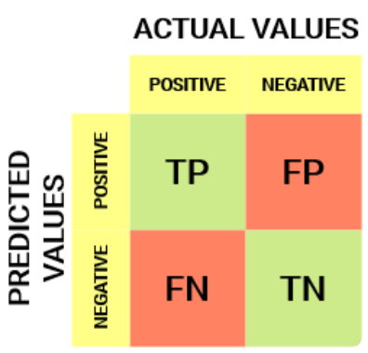

Figure 2: Confusion Matrix

##### Terms in a Confusion Matrix

* True Positive (TP)

These are the instances where the model correctly predicts the positive class. This is most desirable outcome, indicating that the model correctly identified the instances that truly belong to the positive class (Agrawal, 2024). For example, if the model predicts that a student with low interaction with VLE and poor grades in previous courses will likely fail in their current course. If the student indeed fails, this is a true positive. The model correctly identified a student who was at risk, and the prediction matched the actual outcome.

* True Negative (TN)

A true negative refers to the number of instances where the model correctly predicted the negative class. This also indicates that the model correctly identified the instances that do not belong to the positive class (Markham, 2020). For instance, a model predicts that a student with high level of interaction with VLE and high grades in previous courses is likely to pass their current course. If the student indeed passes, this is a true negative. The model correctly identified a student who was not at risk, and the prediction matched the actual outcome.

* False Positive (FP) – Type I Error

False positive is the number of instances where the model incorrectly predicted the positive class, meaning it incorrectly identified instances that belong to negative class as belonging to the positive (Datatron Technologies, 2022). False positive occurs when the model incorrectly identifies a student as being at risk of poor performance when they are not. This can lead to unnecessary interventions or concerns for students who are actually doing well, potentially impacting their motivation and performance. False positive is also known as “Type I Error” and can have significant implications depending on the context.

* False Negative (FN) – Type II Error

False negative refers to the number of instances where the model incorrectly predicted the negative class, meaning it incorrectly identified instances that belong to the positive class as belonging to the negative class (Datatron Technologies, 2022). For example, if a model predicts that a student with low interaction with VLE and poor grades in previous courses is likely to pass their current course but the student fails, this is a false negative. The model incorrectly identified a student who was at risk of failing.

#### Accuracy

Accuracy is a fundamental metric that measures the proportion of true positive predictions (correctly identified students) and true negative predictions (incorrectly identified students) out of all predictions made (GeeksforGeeks, 2023). It is a straightforward measure of how often the model is correct. However, accuracy can be misleading if the dataset is imbalanced, as it might be high but not very informative. The formula is as follows:

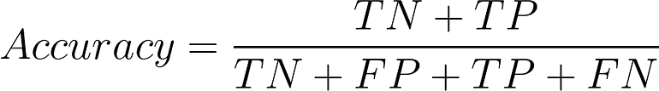

Figure 3: Formula for Accuracy Calculation

#### Precision

Precision is the ratio of true positives to the sum of true positives and false positives. It measures the model’s ability to avoid false positives (Datatron Technologies, 2022), which is particularly important in educational settings where false positives (predicting a student will fail when they actually won’t) can have significant consequences. The formula is as follows:

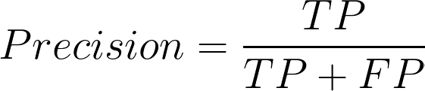

Figure 4: Formula for Precision Calculation

#### Recall

Recall is also known as sensitivity or the true positive rate. It measures the proportion of actual positives (student who will fail) that are correctly identified by the model (Datatron Technologies, 2022). It is crucial in scenarios where it is important not to miss any positive instances. The formula is as follows:

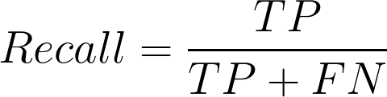

Figure 5: Formula for Recall Calculation

#### F1 Score

F1 score is the harmonic mean of precision and recall. It provides a balance between these two metrics and is particularly useful in situations where both false positives and false negatives are important. The F1 score can give a more nuanced view of the model’s performance than accuracy alone, especially in imbalanced datasets. The formula is as follows:

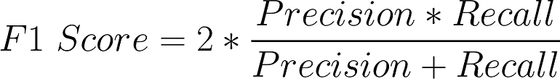

Figure 6: Formula for F1 Score Calculation

## Similar Systems / Works

Table 1: Similar Works of Predicting Student Performanc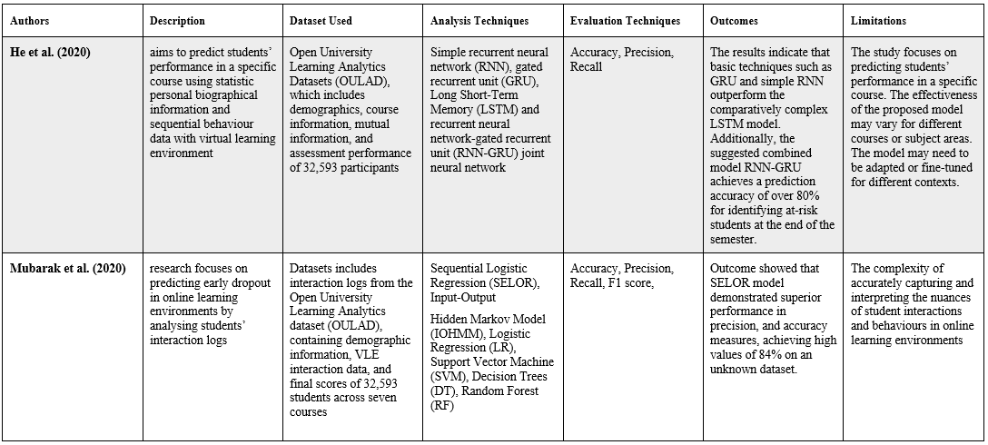e

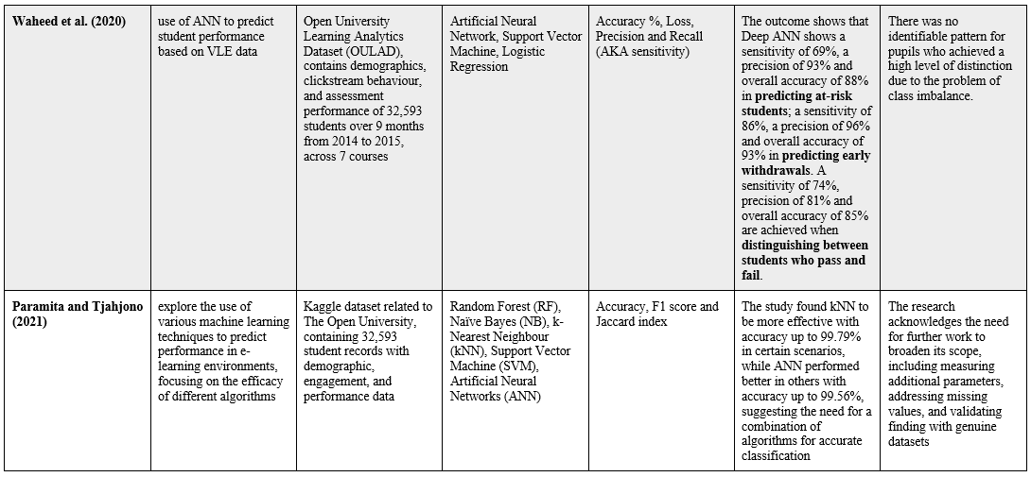

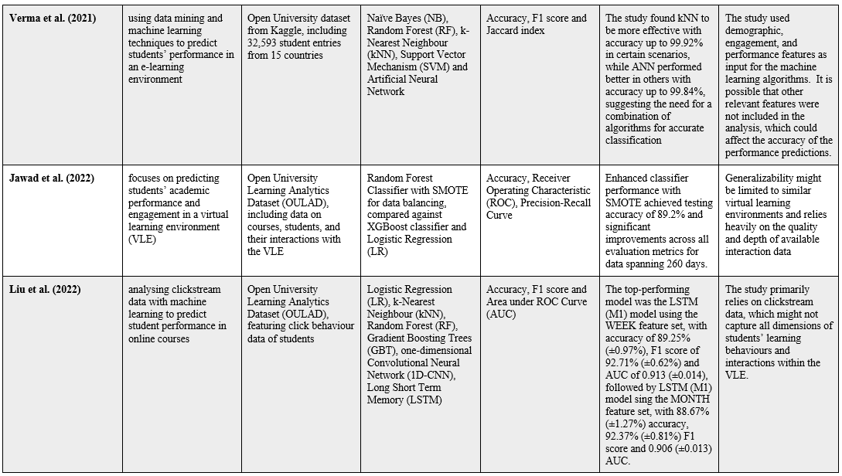

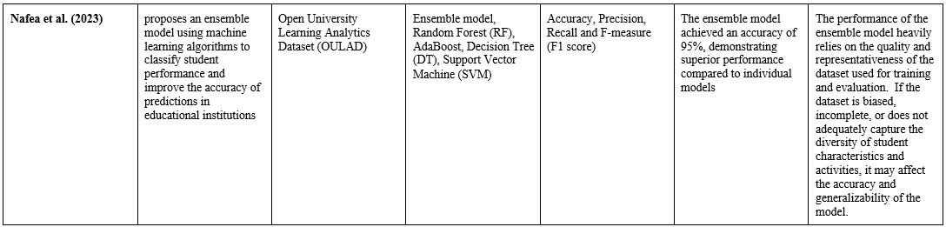Considering the research synthesized, it can be concluded that ensemble models, particularly those incorporating Random Forest, consistently emerge a superior in predicting student performance due to their high accuracy and F1 scores, indicating robust predictive capabilities and balanced consideration of precision and recall. Models utilizing advanced neural networks such as LSTM, also show promise due to their ability to capture sequential data patterns, although they may not always outperform simpler methods in every scenario.

In the project on predicting student performance, based on the existing literature, basic machine learning models may not be focused on, as studies have demonstrated the superior performance of more advanced or combined models. Evaluation metrics will not be restricted to accuracy alone. Instead, precision, recall and F1 score will also be used to provide more comprehensive assessment of model performance.

## Technical Research

### Operating System Chosen

Choosing Windows 11 for a project related to student performance prediction offers several advantages , especially when considering the development and execution of machine learning models . Windows 11 supports a wide range of machine learning libraries and tools, such as PyTorch and Scikit-learn, which are essential for developing predictive models for student performance. These libraries are crucial for data preprocessing, model training and evaluation. Moreover, many student performance prediction projects utilize Jupyter Notebooks for their development and documentation. Windows 11 provides a seamless experience for running Jupyter Notebooks, allowing for interactive coding, visualisation and documentation of the model development process.

### Python – Selected Programming Language

Python’s widespread use in developing machine learning models is attributed to several key factors. Firstly, its syntax is easy to read and understand, which not only makes it accessible to beginners but also speeds up development and debugging for more experienced developers (Talab, 2021; Corbo, 2023; Gupta, 2023; Ryabtsev, 2024). This contributes significantly to its adoption in the machine learning community. Python’s extensive library ecosystem, including libraries such as NumPy for numerical computations, Scikit-learn for handling basic machine learning algorithms like classification, regression and others, provides developers with powerful tools for efficiently implement machine learning algorithms (Karl, 2024).

Moreover, Python offers cross-platform compatibility, allowing code to be utilized across different operating systems, such as Window, Mac and Linux. The flexibility, as presented by Ryabtsev (2024) saves developers time and effort by enabling the use of the same codebase for applications on various platforms. The language’s scalability and exceptional performance in handling big data complex operations make it an ideal choice for machine learning applications (Ryabtsev, 2024).

Overall, the choice of Python for machine learning projects is underpinned by its ease of use, comprehensive libraries and frameworks, cross-platform compatibility, and scalability, making it the top option for developers implementing machine learning technologies.

### Jupyter Notebook in Visual Studio Code – IDE Chosen

Jupyter Notebook within the Visual Studio Code (VS Code) IDE offers several advantages that make it a better choice for coding, especially for tasks involving data analysis, machine learning and scientific computing. The Jupyter extension for VS Code integrates seamlessly with the editor, providing a unified environment for coding, running notebooks, and managing files (Poulopoulos, 2021).

Moreover, the Jupyter extension in VS Code offers features that are superior to the traditional Jupyter Notebook interface. These include execution time indicators, an outline mode for easy navigation, a Jupyter variable explorer, a data viewer, and cell debugging (Moffitt, 2021). On top of that, Moffitt (2021) also mentioned that, with VS Code, plots can be view in separate tabs for side-by-side analysis, which is more convenient than the standard Jupyter Notebook interface. Furthermore, VS Code is highly customizable and supports a wide range of extensions, which can further enhance the development environment (Minhas, 2022). This customization allows developer to tailor the IDE to his specific needs, improving productivity and efficiency.

In summary, the combination of the interactive and exploratory nature of Jupyter Notebooks with the powerful features and customization options of VS Code makes it n excellent tool for coding especially for tasks that require a mix of coding, data analysis and visualisation.

### Libraries / Tools Chosen

Several libraries and tools are crucial for different stages such as Exploratory Data Analysis (EDA), data pre-processing and predictive model development. The breakdown of suitable libraries and tools for each phase are as follows.

#### Exploratory Data Analysis (EDA) and Data Pre-processing

##### Pandas

Pandas is a fundamental library for data manipulation and analysis in Python. It provides high-performance, easy-to-use data structures, allowing for efficient data cleaning, manipulation and aggregation (Mahadevan, 2024).

##### NumPy

NumPy is essential for numerical computing in Python. It provides support for arrays, matrices, and high-level mathematical functions, making it ideal for pre-processing data and performing mathematical operations (GeeksforGeeks, 2024).

##### Matplotlib and Seaborn

The libraries are used for data visualisation, which is crucial for EDA. They provide functions and tools for creating static, animated, and interactive visualisation in Python. These visualisations can help in understanding the data distribution, identifying outliers, and exploring the relationship between variables (Mahadevan, 2024).

#### Predictive Model Development

##### Scikit-learn

Scikit-learn offers a wide range of algorithms of algorithms for classification, regression, clustering, dimensionality reduction and model selection (M, 2024). Its user-friendly interface and extensive documentation make it accessible for various data analysis tasks, including pre-processing and EDA (Purdy, 2024).

##### TensorFlow

TensorFlow is a powerful open-source library used for deep learning and machine learning applications, providing extensive support for neural networks and large-scale machine learning tasks (Ramchandani, et al., 2022). Compared to PyTorch, TensorFlow offers better deployment capabilities, extensive community support, and seamless integration with Google’s ecosystem, making it ideal for production environments (Hoijtink & Hardeveld, 2022).

## Summary

The first sub-chapter is focuses on the changing environment of Artificial Intelligence (AI) research in education, namely in Educational Data Mining (EDM) and Learning Analytics (LA). EDM uses data mining methods to evaluate various datasets from educational settings, focusing on academic data analysis and student behaviour analysis. LA is the process of analysing both fixed and dynamic data in educational environments to provide individualised learning experiences and early warning systems. The chapter highlights the increasing importance of EDM and LA in tackling important educational issues, improving decision-making, and changing learning environments by using data-driven analysis and forecasts.

Next sub-chapter focuses on the application of machine learning algorithms for predicting student performance in educational settings. Logistic Regression, demonstrated through various studies, showcasing competitive accuracy. Random Forest, known for its ensemble approach, exhibits high accuracy in identifying at-risk students but daces challenges such as overfitting. Decision tree models, which achieving impressive accuracy, may vary in performance based on data transformation and feature selection techniques. Gradient Boosting, including Extreme Gradient Boosting (XGBoost), displays robust predictive capabilities but demands careful parameter tuning. Last but not least, Artificial Neural Networks (ANN) show significant accuracy in predicting student success, outperforming other algorithms in certain contexts, despite the varied effectiveness of these algorithms, they collectively present a promising avenue for improving educational outcomes through tailored interventions informed by predictive analysis.

Followed by the previous sub-chapter, the next sub-chapter presents a comparative analysis of similar works in student performance predictions. Authors employ varios analysis techniques, evaluating algorithmic efficacy, strengths and limitations. The results provide a detailed comprehension of the capabilities and difficulties of predictive models in educational settings.

Finally, this section delves into the technical research aspects, highlighting Python’s dominance in machine learning due to its readability, extensive libraries (NumPy, Scikit-learn), cross-platform compatibility and scalability. The choice of Jupyter Notebook within Visual Studio Code is justified for its seamless integration, superior features, and customisation options, enhancing coding efficiency. Additionally, essential libraries such as Pandas, NumPy, Matplotlib, Seaborn, Scikit-learn and PyTorch are discussed for their pivotal roles in exploratory data analysis, data pre-processing and predictive model development. This technical foundation underscores the robustness and efficiency of the chosen tools and libraries in advancing machine learning applications.

# CHAPTER 3: METHODOLOGY



## Introduction

In this chapter, a detailed exploration of the methodology, data collection, initial data pre-processing, and understanding, leading towards the CRISP–DM framework. This begins with an introduction to the methodology (Section 3.2), where the chosen approach is outlines and justifications for this choice will be provided. The specifics of the methodology will be delved into, detailing the phases, activities, techniques, and processes that will be employed to navigate through the data analysis project.

Following the methodology, Section 3.3 is dedicated to Data Collection, highlighting how the dataset is identified and sourced, and providing dataset source link for accessibility and reproducibility.

Section 3.4 splits into two critical undertakings which are Initial Data Pre-processing and Data Understanding. In the first part, all necessary steps will be tackled using Jupyter Notebook in Visual Studio Code. This includes, data cleaning, standardization, integration, balancing and feature engineering to prepare the dataset for understanding and future model development. The second part focuses on understanding the dataset. Variables and observations are explained, and histograms among other visualizations are utilized to gain deeper insights into the data.

The chapter concludes with a summary (Section 3.5), summarising the discussions, methodologies, and insights obtained from the data-focused exploration, preparing for the application and implications of the discoveries in the future.

## Methodology

### Introduction of Methodology (CRISP-DM)

CRISP–DM, standing for Cross-Industry Standard Process for Data Mining, is a robust, widely recognized methodology that provides a structured approach to planning and executing data mining projects (Hotz, 2023). It is designed to guide users through the complexities of deriving valuable insights from data, regardless of the industry or the nature of the data challenges faced. The methodology is utilized across various sectors for predictive analytics, data mining, and machine learning projects, ensuring a systematic approach to data analytics that enhances the quality and efficiency of decision-making (Wehrstein, 2021). CRISP–DM encompasses six main phases which are Business Understanding, Data Understanding, Data Preparation, Modelling, Evaluation, and Deployment (Talaviya, 2023). Each phase is critical to the methodology’s iterative process, allowing for continuous improvement and adaptation to new findings as the project progresses.

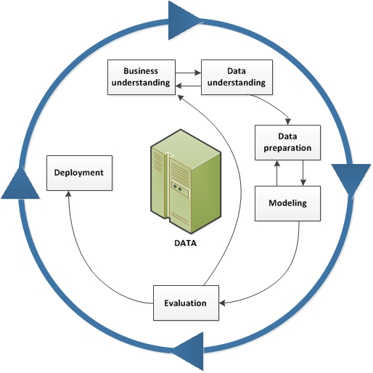

Figure 7: CRISP–DM Diagram (IBM Documentation, 2021)

### Methodology Choice and Justification

Choosing CRISP–DM over other methodologies such as SEMMA (Sample, Explore, Modify, Model, Assess) or KDD (Knowledge Discovery in Databases) for predicting student performance can be influenced by several factors. Each methodology has its strength, but CRISP–DM often stands out for its comprehensiveness, and adaptability, making it a preferred choice in various scenarios, including education.

CRISP–DM is a comprehensive and structured framework that is widely used recognized across industries. It is designed to be iterative and flexible, allowing for a systematic approach to data mining projects (IBM Documentation, 2021). CRISP–DM emphasizes the importance of understanding business objective and ensuring data quality (Wehrstein, 2021), which are crucial for predicting student performance accurately. The structured nature of CRISP–DM, with its six phases, sures that all necessary steps are considered, from understanding its business context to evaluating and deploying the models, making it suitable for complex projects like student performance prediction.

SEMMA, on the other hand, stands for Sample, Explore, Modify, Model and Assess, it provides a more linear, methodological approach focused primarily on the modelling aspects of data mining. While SEMMA offers a string structure for statistical analysis and model building, it places less emphasis on initial business or project understanding and the final deployment phase. This limitation can be significant in educational contexts where understanding the broader objectives and ensuring the practical application of results are crucial.

KDD, or Knowledge Discovery in Databases, provides a broader framework for discovering useful knowledge from large datasets, with data mining being one component of this process. However, when comparing CRISP–DM to KDD, the more focused and interactive approach of CRISP–DM is better suited to educational contexts. CRISP–DM’s flexibility and emphasis on understanding both the project objectives and the data itself make it an ideal choice for projects aimed at predicting student performance. This methodology allows the continuous refining of the approach based on evolving understanding and emerging data insights, ensuring that the predictive models developed are both accurate and aligned with the specific needs of educational institutions.

### Phases of CRISP-DM

#### Business Understanding

The initial phase involves identifying the project objectives and requirements from a business perspective, then converting this knowledge into a data mining problem definition (Shah, 2023). For student performance prediction, this phase would involve defining what aspects of student performance need to be predicted, such as previous academic performance and interaction with Virtual Learning Environment (VLE). The goal is to identify the problem the data mining project aims to solve, such as predicting which students are at-risk of failing.

#### Data Understanding

The second phase focuses on collecting the initial data and then proceeding with activities to get familiar with the data, identify data quality problems and discover first insights into the data (Shah, 2023). In the context of student performance prediction, this could involve collecting data on student demographics, assessment records, students’ interaction logs in VLE and any other relevant information that could influence performance.

#### Data Preparation

The data preparation phase covers all activities needed to construct the final dataset from the initial raw data (Shah, 2023). For student performance prediction, data preparation include cleaning the data (renaming columns and handling missing values), standardizing inconsistent format of the data, handling imbalanced data and selecting the most relevant features that will be used for the prediction model.

#### Modelling

In this phase, various modelling techniques are selected and applied, and their parameters are calibrated to optimize performance (Hotz, 2023). Typically, several techniques will be applied, and their performance compared before selecting the best approach. For predicting student performance, this involves using Logistic Regression, Random Forest, Decision Tree, Gradient Boosting, XGBoost and Artificial Neural Networks (ANN) to build models that can predict student outcomes based on the prepared data. The goal is to build models that accurately predicts student performance.

#### Evaluation

Before deployment, the model’s results are evaluated in the context of the business objectives defined in the first phase (Hotz, 2023). This critical phase ensures that the model adequately addresses the problem it was intended to solve. In student performance prediction, this involves assessing how well the models predict performance outcomes using evaluation metrics like accuracy, precision, recall, F1 score and ROC AUC.

#### Deployment

In the final phase, the model is deployed into a production environment, where it can be used to make predictions on new data (Shah, 2023). For predicting student performance, this could mean integrating the model into a school’s information system, where it can be used to predict student outcomes in real-time. The goal is to ensure that the model is ready to use and can be trusted to make accurate predictions.

## Summary

In this chapter, the methodology for predicting at-risk students using the CRISP-DM framework is detailed. The CRISP-DM framework was chosen for its structured and iterative approach, making it suitable for educational data mining projects. this methodology encompasses six phases: Business Understanding, Data Understanding, Data Preparation, Modelling, Evaluation, and Deployment.

The chapter outlines the data collection process and initial pre-processing steps, including cleaning, standardization, and feature engineering. Various modelling techniques, such as Logistic Regression and Random Forest, were applied. The models were evaluated using metrics like accuracy, recall, F1 score, and ROC AUD. The best-performing model will then be deployed for real-time predictions, ensuring its practical application in educational settings.

# CHAPTER 4: DESIGN AND IMPLEMENTATION



## Introduction

The development of a predictive model to identify at-risk students necessitates a structured and comprehensive approach. This chapter delves into the design and implementation phases of constructing such a model, emphasizing the critical steps involved from data collection to model building. The primary objective is to harness machine learning techniques to proactively identify students who may be at risk of academic failure, thereby enabling timely interventions and support.

Initially the chapter outlines the data collection process, ensuring that the dataset encompasses all relevant variables necessary for accurate predictions. Data pre-processing is a crucial step that involves cleaning, integrating, and transforming the data to ensure its suitability for analysis. Techniques for handling missing values, outliers, and data normalization are discussed in detail, as these steps are essential for preparing the dataset for machine learning algorithms.

Exploratory Data Analysis (EDA) is highlighted as a vital phase to uncover underlying patterns and relationships within the data. Through visualization and correlation analysis, EDA provides insights into data distribution and feature importance, guiding the subsequent model-building phase.

The chapter proceeds to the model-building process, exploring various machine learning algorithms, including Logistic Regression, Decision Tree, Random Forest, Gradient Boosting, XGBoost, and Neural Networks. The implementation details of each algorithm are discussed, with a focus on parameter tuning using GridSearchCV and cross-validation techniques to ensure optimal performance.

The ultimate goal of this chapter is to develop a robust predictive model that can be integrated into educational systems. By doing so, educational institutions can leverage the model to provide real-time predictions of at-risk students and implement targeted interventions to support their academic success. This chapter sets the stage for the model evaluation phase, which will be thoroughly discussed in the subsequent chapter.

## Data Collection

Table 2: Data Source from Kaggle

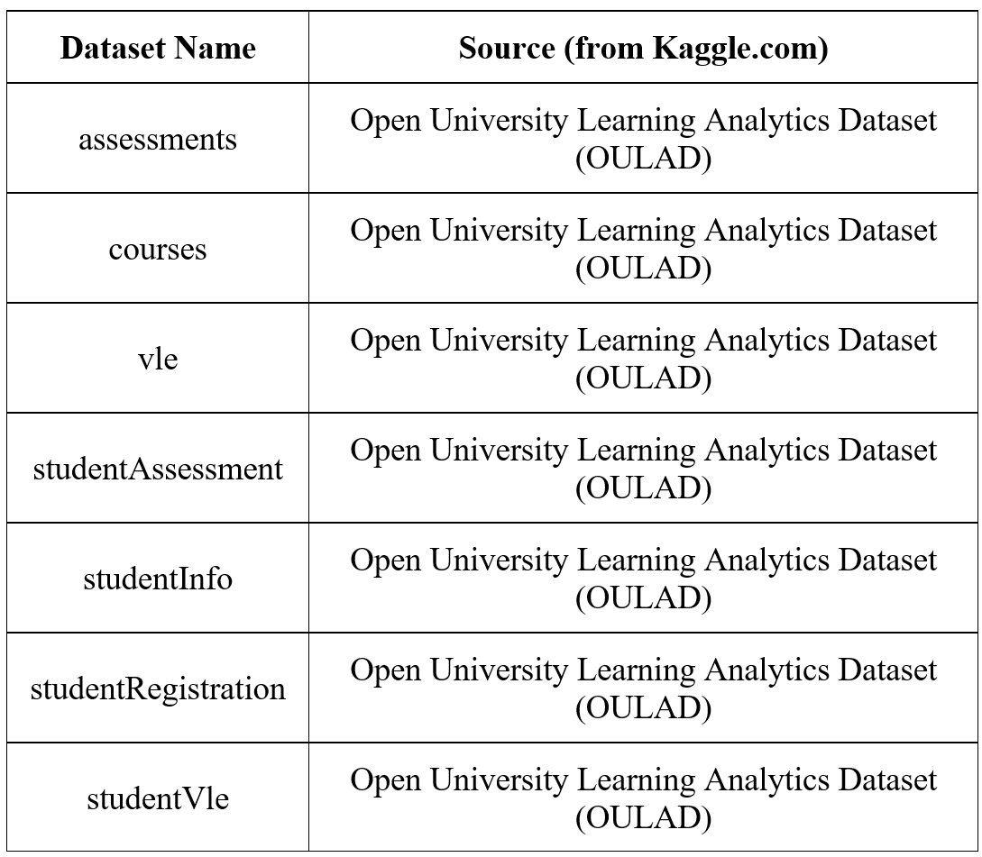

The Open University Learning Analytics Dataset (OULAD) is a dataset available on Kaggle. It contains information related to students’ demographics, academic performance, online learning activities. The dataset is derived from an online platform used by the Open University for delivering various courses. The data include details such as student registration information, assessment scores, interactions with online materials, and other relevant educational metrics. These details are included in 7 csv files as shown in Table 2.

This dataset is accessible through this link: [Open University Learning Analytics Dataset (OULAD) (kaggle.com)](https://www.kaggle.com/datasets/anlgrbz/student-demographics-online-education-dataoulad/data). The definition of columns for these datasets are available through this link: [Open Learning Analytics | OU Analyse | Knowledge Media Institute | The Open University](https://analyse.kmi.open.ac.uk/open_dataset).

## Data Pre-Processing

### Exploratory Data Analysis (EDA)

This section involves conducting an initial exploratory data analysis (EDA) to understanding the structure and characteristics of the data, examining data types, distributions, and summary statistics to identify patterns and potential outliers, and visualize key features to gain insights into the relationships between different variables.

#### Install and Import Libraries

Before going into data exploration, the 7 csv files shown in Table 2 will be loaded into data frame. Some libraries are needed to install and import into file to continue data pre-processing and data understanding.

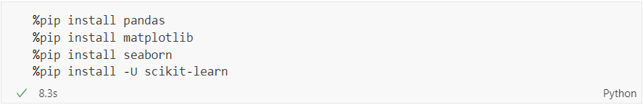

Figure 8: Libraries to be Installed

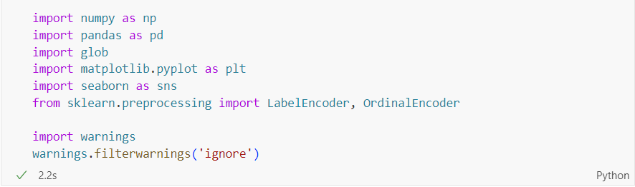

Figure 9: Libraries to be Imported

Figure 8 and Figure 9 showed the libraries that have been installed and imported for this project.

#### Load Datasets into Data Frame

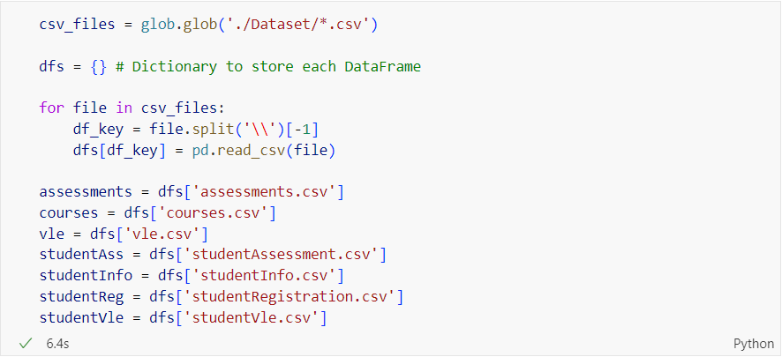

Figure 10: Source Code of Loading Datasets

glob module in Python is used for finding all the pathnames matching a specified pattern according to the rules used by the Unix shell (GeeksforGeeks, 2021). glob.glob(‘/*.csv’) function call returns a list of file paths that match the pattern and assigned them to the variable csv_files. An empty dictionary is initialised to store each DataFrame that are going to be loaded. After that, it loops through each csv file, extracts the filename from the file path, read the csv files into a data frame and stores it in the dictionary with the filename as the key. This allows for easy access to each DataFrame later. After all CSV files have been read into the dictionary, specific DataFrames can be accessed by their keys as shown in Figure 10.

#### Display Setting

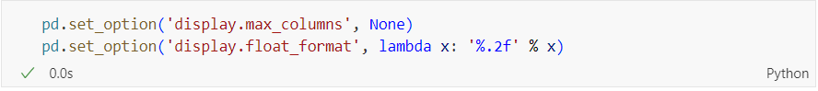

Figure 11: Source Code of Setting the Display Setting

The display of the output is set to display all the columns and suppress scientific notation.

### Data Pre-Processing

#### Data Cleaning

##### Handling Missing Values

Table 3: Source Code and Output of Missing Values being Handled

|  |  |
| --- | --- |
| **Dataset** | **Source Code and Output** |
| studentInfo |  |
| vle |  |

Table 3 showed how the missing values of the columns in ‘studentInfo’ and ‘vle’ being handled. The percentage of missing values in imd_band column is relatively low (3.41%). Therefore, the missing values are handled by imputing the mode of values in the column. Imputation with mode is used to handle the missing values of this column because the mode can provide a reasonable estimate of the missing values based on the data’s distributions (Zach, 2022). However, for week_from and week_to columns in ‘vle’ dataset, imputation with mode cannot be used to handle the missing values as the percentage of missing values are above 80% of the dataset, so these columns will be removed to handle the missing values.

Based on Table 3, there are missing values in the columns date in ‘assessments’, score in ‘studentAss’, date_registration and date_unregistration in ‘studentReg’. However, the missing values for these columns will be handled after performing data integration so that more information about the missing values can be seen.

##### Rename Columns

Table 4: Source Code and Output for Renaming Columns

|  |  |
| --- | --- |
| **Dataset** | **Source Code and Output** |
| assessments |  |
| studentVle |  |
| studentAss |  |

Table 4 shows the columns that are being renamed in three datasets – ‘assessments’, ‘studentVle’ and ‘studentAss’. Renaming columns to more descriptive and intuitive names enhance the overall readability and understanding of the dataset (TechClaw, 2023).

##### Format Standardization

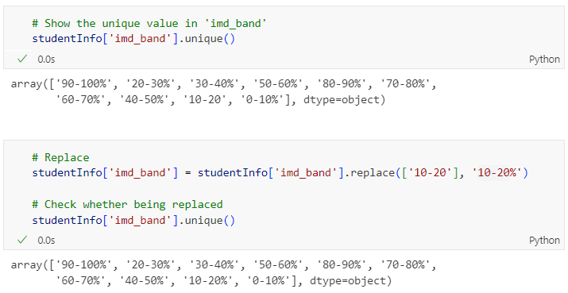

Figure 12: Formatting Before and After Standardization

Before performing the format standardization, ’10-20’ value does not have the consistent format compared to other unique values in imd_band column. Therefore, format standardization is performed by replacing ’10-20’ to ’10-20%’ so that the format is consistent. Consistency in data format ensures that the data is accurate and reliable (Atlan, 2023).

#### Data Integration

Since there are 7 csv files that are going to be used, data integration is used to merge the files together. Data integration is the process of combing and harmonizing data from multiple sources into a single, coherent dataset. Combining csv files allows for a more comprehensive analysis of the data. It enables the examination of data from multiple sources in one place, facilitating the identification of patterns, trends, and insights that might not be apparent when data is viewed in isolation (Choudhury, 2023).

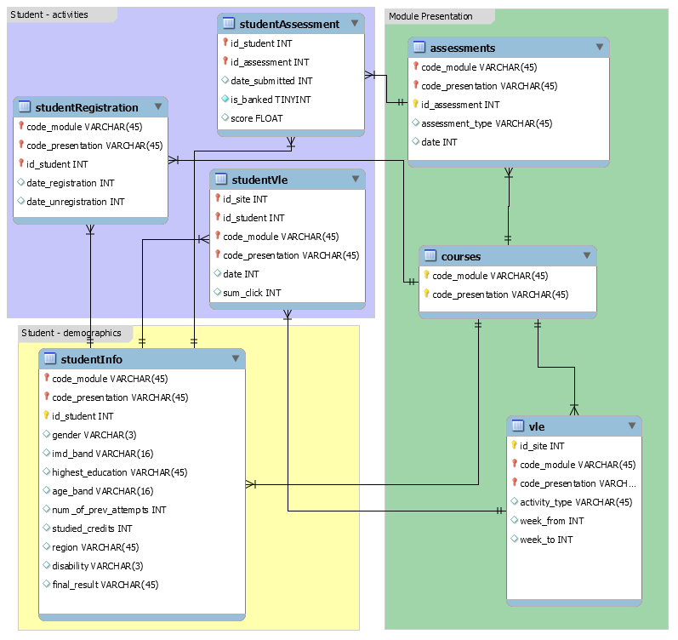

Figure 13: Relationships between Datasets

Figure 13 shows the database schema for all the files. Data integration will be performed based on the database schema. In order to merge the files successfully, unique identifiers are being created.

##### Create Unique Identifiers

Table 5: Source Code and Output for Creating Unique Identifiers

|  |  |
| --- | --- |
| **Dataset** | **Source Code and Output** |
| assessments |  |
| courses |  |
| vle |  |
| studentInfo |  |
| studentReg |  |
| studentVle |  |

Table 5 shows the unique identifiers that are being created in each dataset for merging purpose.

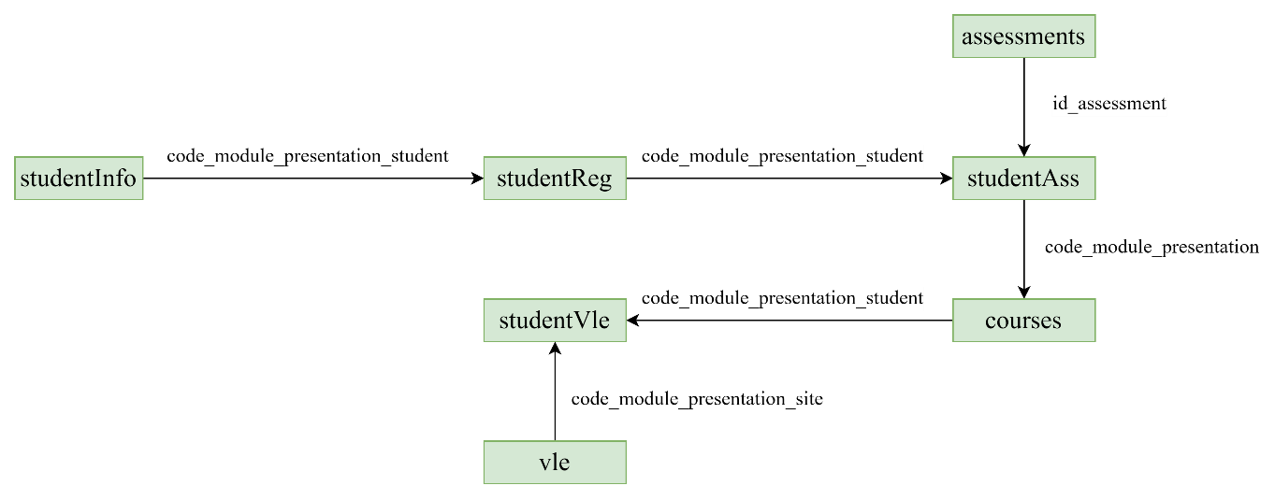

Figure 14: Common Key for Data Integration

Figure 14 shows how the datasets will be integrated and based on which key to integrate.

##### Merge studentInfo and studentReg on ‘code_module_presentation_student’

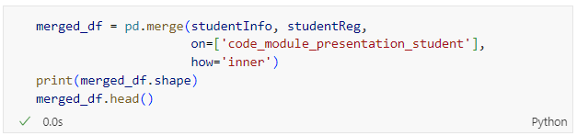

Figure 15: Source Code of Merging studentInfo and studentReg

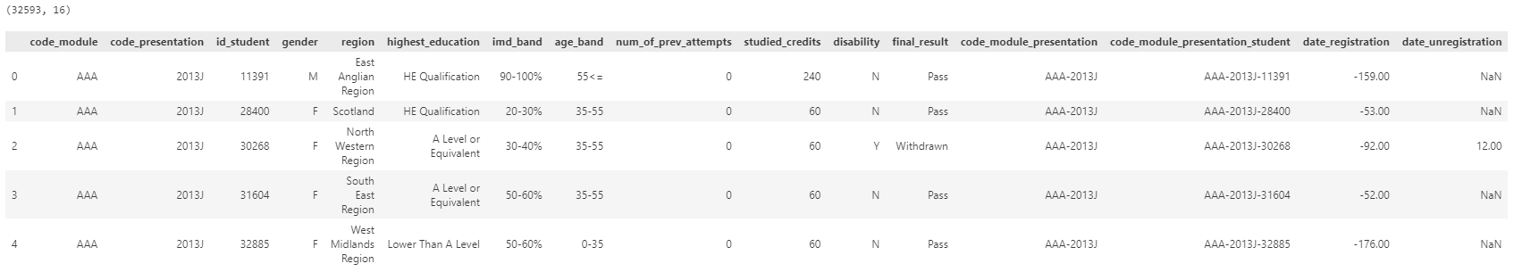

Figure 16: Output of Merging studentInfo and studentReg

‘studentInfo’ and ‘studentReg’ are merged using inner join based on code_module_presentation_student. The number of rows and columns after merging is 32,593 and 16 respectively. The output is as shown in Figure 16.

##### Merge studentAss and assessments on ‘id_assessment’

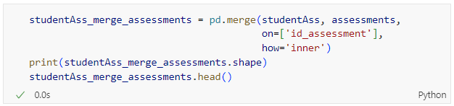

Figure 17: Source Code of Merging studentAss and assessments

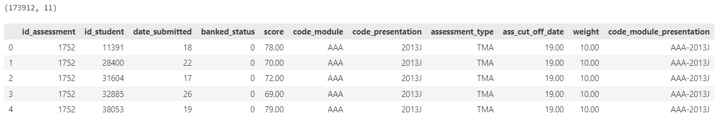

Figure 18: Output of Merge studentAss and assessments

Before merging ‘merged_df’ and ‘studentAss’, ‘studentAss’ is merged with assessment first. studentAss and assessments are merged using inner join based on id_assessment to retrieve the data from ‘assessments’. The number of rows and columns after merging is 173,912 and 11 respectively. The output is as shown in Figure 18.

##### Create Unique Identifiers for studentAss_merge_assessments



Figure 19: Source Code of Creating Unique Identifier

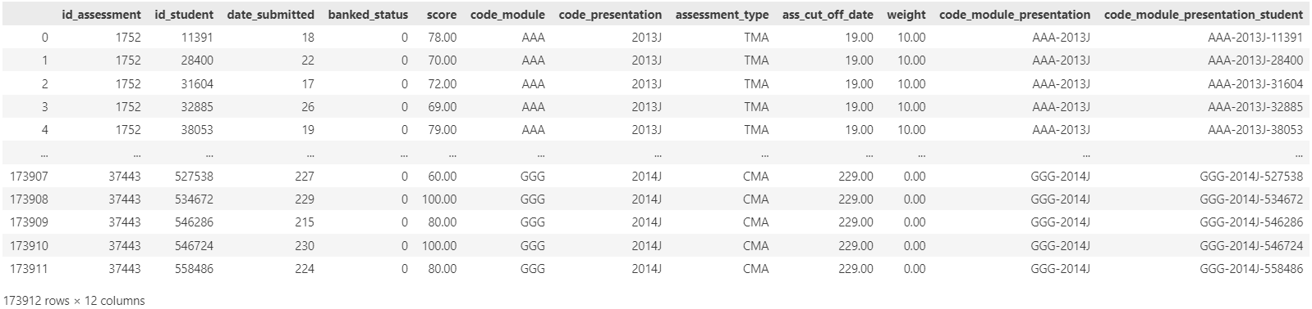

Figure 20: Output of Creating Unique Identifier

The code shown in Figure 19 creates a unique identifier for each student in each module presentation by concatenating the module presentation code and the student’s ID. This unique identifier facilitates merging and identifying records across different tables in the schema shown in Figure 13 and Figure 14. This operation is crucial in managing and analysing student performance, assessment data and interactions with the virtual learning environment. The number of rows and columns after merging is 173,912 and 12 respectively.

##### Handling Missing Values in ‘score’



Figure 21: Source Code of Showing Missing Values in 'score'

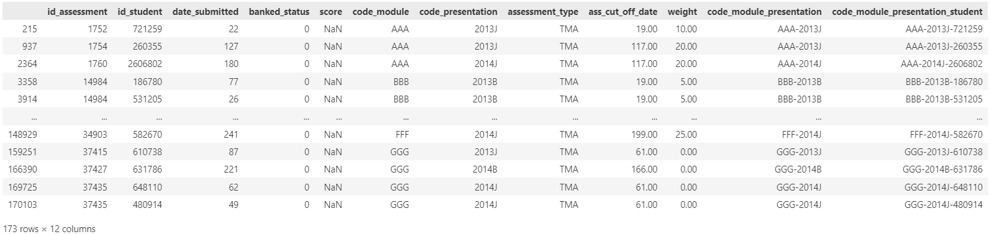

Figure 22: Output of Missing Values in ‘score’

Figure 21 shows the code that filters the DataFrame ‘studentAss_merge_assessments’ to show only the rows where the ‘score’ column has missing (NaN) values. The output shown in Figure 22 consist of 12 columns and 173 rows. Each row represents an assessment submission with a missing score. Filtering rows with missing scores are used to identify incomplete records, which will then be handled later. This helps in performing quality checks on the dataset to ensure completeness before conducting further analysis.

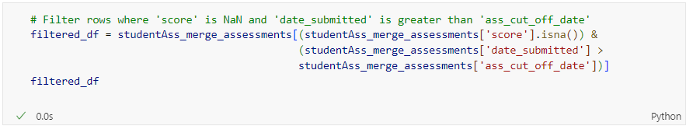

Figure 23: Source Code of Filtering Rows (Missing Score & Late Submissions)

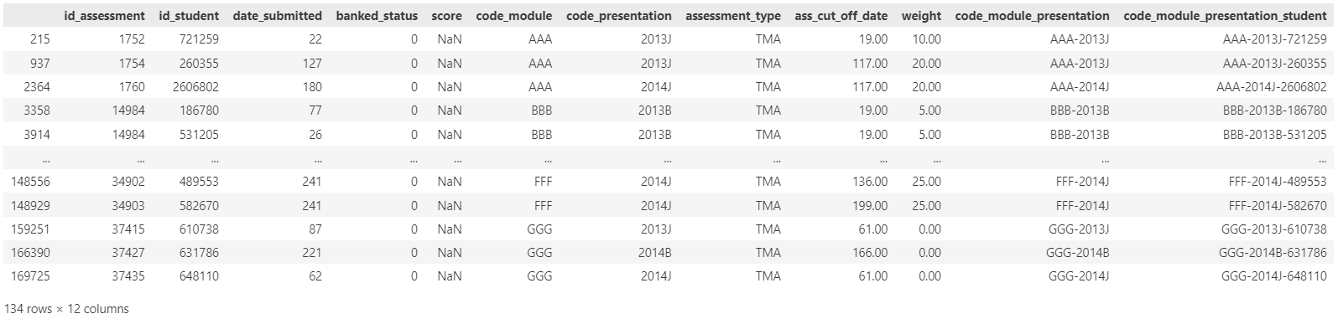

Figure 24: Output of Filtering Rows

Code shown in Figure 23 filters the assessments that were submitted late (after the cut-off date) and have not been graded yet (indicated by the missing score). There are 134 records that was late submitted and This filtering is useful for identifying late submissions. It helps in focusing on specific records that may require attention, such as reviewing why the scores are missing and taking appropriate actions.



Figure 25: Source Code of Handling Missing Values in ‘score’

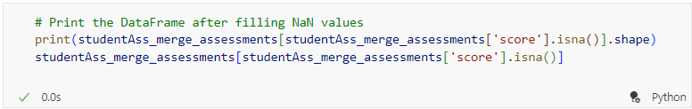

Figure 26: Source Code of Showing the Rows that Contain Missing Values in 'score'

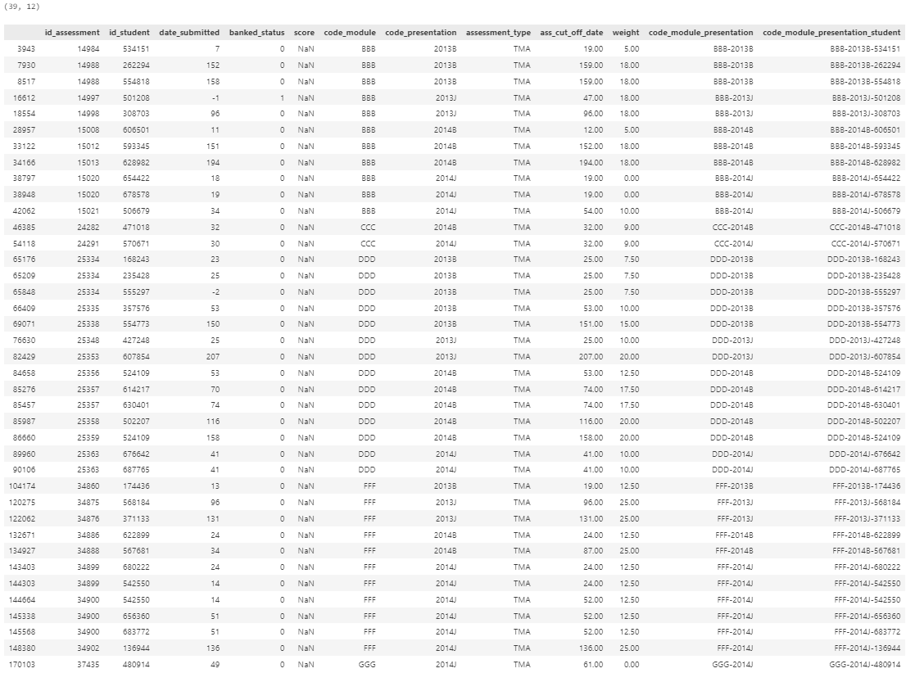

Figure 27: Output of Rows Containing Missing Values in ‘score’

Based on metadata provided by The Open University, it is assumed that if the assessment is late submitted, that assessment is directly scored 0. Therefore, in this case, all the missing values in ‘score’ where the submission is late are replaced with 0. After replacing, there are remaining 39 rows with missing values in ‘score’.

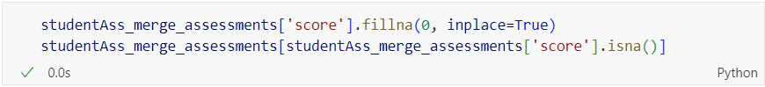

Figure 28: Source Code of Handling Missing Values in Remaining Records and Check



Figure 29: Output of Checking Missing Values in ‘score’

The code shown in Figure 28 fill the remaining data as 0. The remaining missing values in ‘score’ is due to the incomplete data entry after going through dataset, so all the remaining missing values will be filled with ‘0’. There are no remaining records with missing values in ‘score’, as shown in Figure 29.

##### Calculate Final Score for Each Student for Each Module

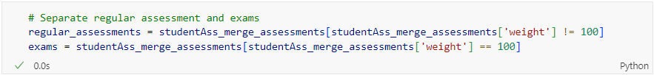

Figure 30: Source Code of Separating Regular Assessment and Exams

Based on the metadata provided by The Open University, the weight of the exams is treated separately and have the weight of 100% whereas the weight of the other assessments is sum to 100%. The code shown in Figure 30 indicates the method to separate these two types of assessments into different DataFrames for further pre-processing.

###### Regular Assessment

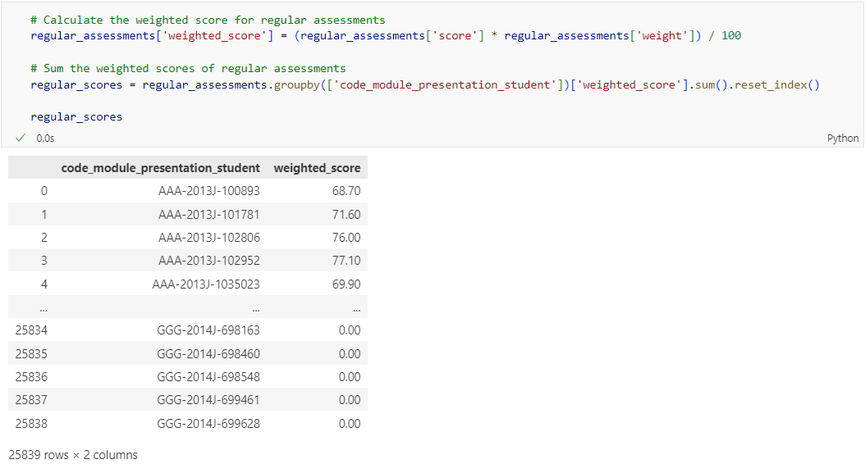

Figure 31: Source Code and Output of Calculating Score of Regular Assessment for Each Student

The code shown in Figure 31 calculates the weighted scores for regular assessments and then summing these weighted scores for each student within each module presentation. This provides an aggregated measure of each student’s performance in their regular assessments for each module presentation.

###### Exam

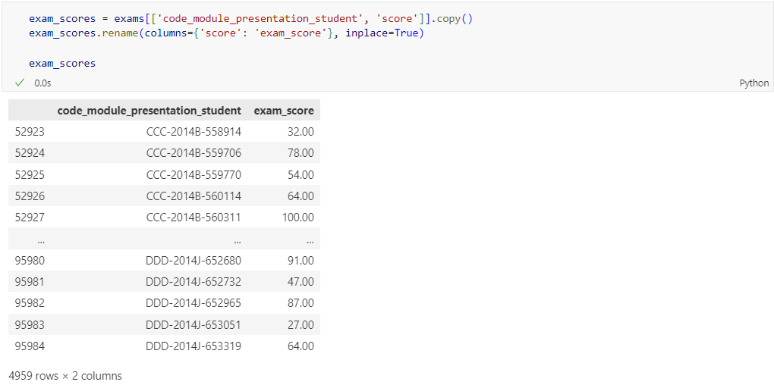

Figure 32: Source Code and Output of Extracting Exam Assessment

The code shown in Figure 32 extracts the exam scores from the ‘exams’ DataFrame created previously and preparing them for further analysis by renaming the column. This prepares the data for subsequent step where the exam scores will be merged with other types of assessment scores. By renaming the score column to exam_score, it clearly distinguishes exam scores from other scores, making the DataFrame easier to work with in the following steps.

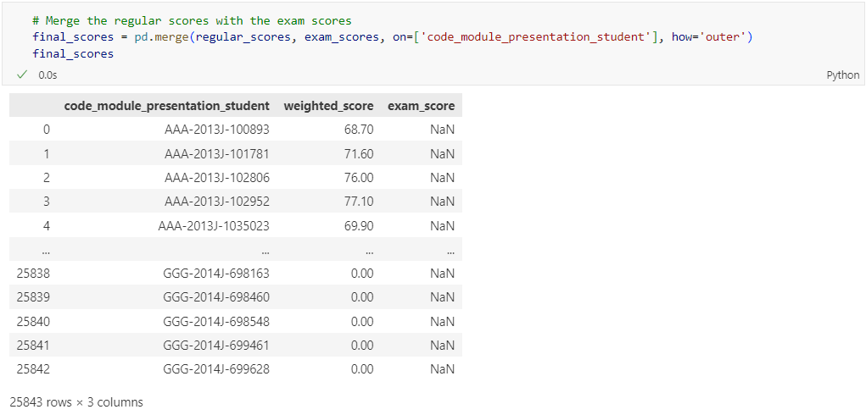

Figure 33: Source Code and Output of Merging ‘regular_scores’ and ‘exam_scores’

The code in Figure 33 merge the two DataFrames based on the code_module_presentation_student column, ensuring that all rows from both DataFrames are included in the final score using outer join. If any code_module_presentation_student exists in one DataFrame but not the other, the resulting merged DataFrame will contain NaN values for the missing data, as shown in Figure 33.

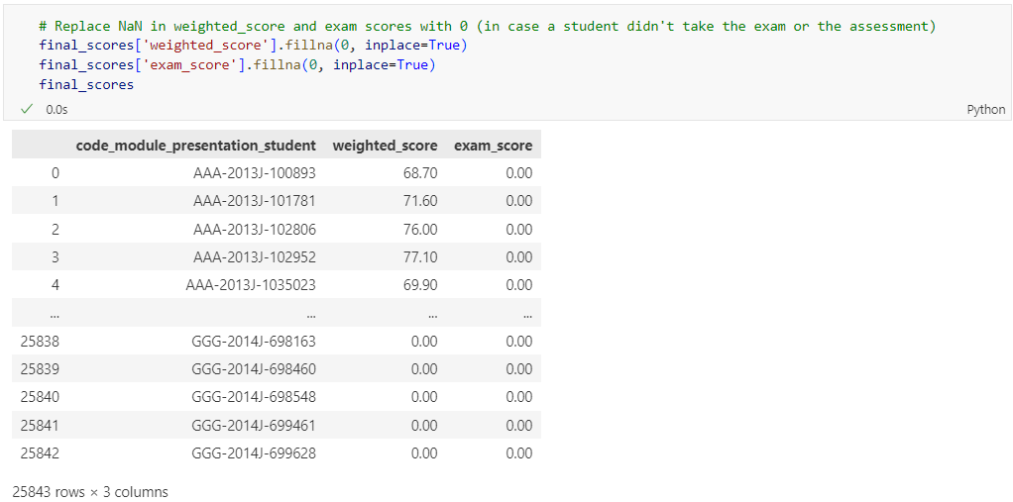

Figure 34: Source Code and Output of Replacing Missing Value

The code shown in Figure 34 replace the missing values to ensure that any missing score either weighted_score or exam_score are treated as 0. This is useful for further calculations, as it avoids potential issues caused by NaN values.

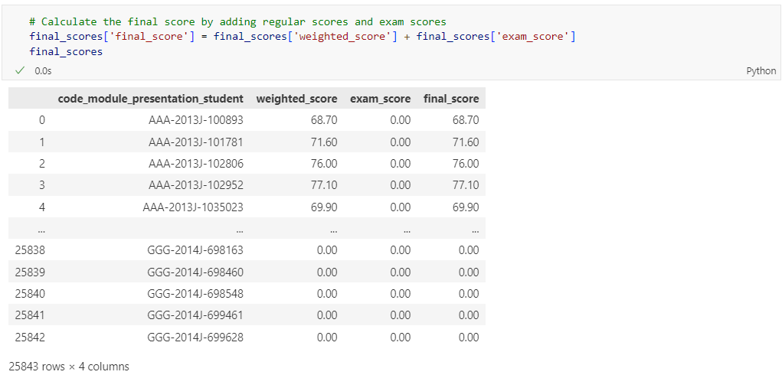

Figure 35: Source Code and Output of Calculating the Final Score

The code shown in Figure 35 calculates the total score for each student by adding their regular scores (weighted_score) and their exam scores (exam_score). Then, the updated DataFrame, including the final_score column, is displayed.

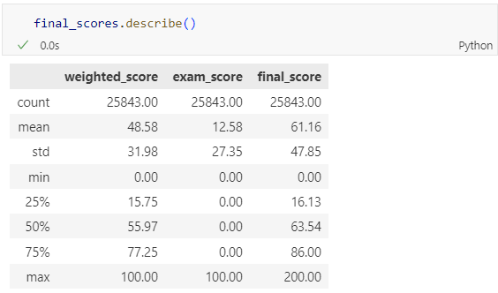

Figure 36: Source Code and Output of Descriptive Description of ‘final_scores’

The code in Figure 36 generates descriptive statistics of ‘final_scores’ DataFrame. The min and max values show the full range of scores, from 0 to 100 for individual assessments and up to 200 for the combined score. This indicates that at least one student achieved the perfect score in both the regular assessments and the exam, resulting in a combined final_score of 200.

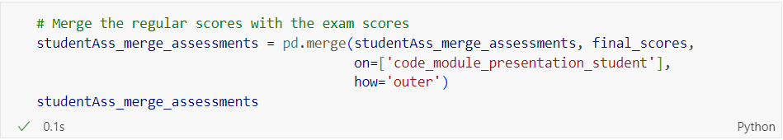

Figure 37: Source Code of Merging ‘studentAss_merge_assessments’ and ‘final_scores’

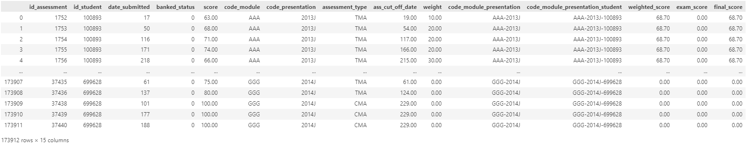

Figure 38: Output of Data Merging

The code shown in Figure 38 combine the data from ‘studentAss_merge_assessments’ with the ‘final_scores’ DataFrame, creating a more comprehensive dataset that includes information from both sources.

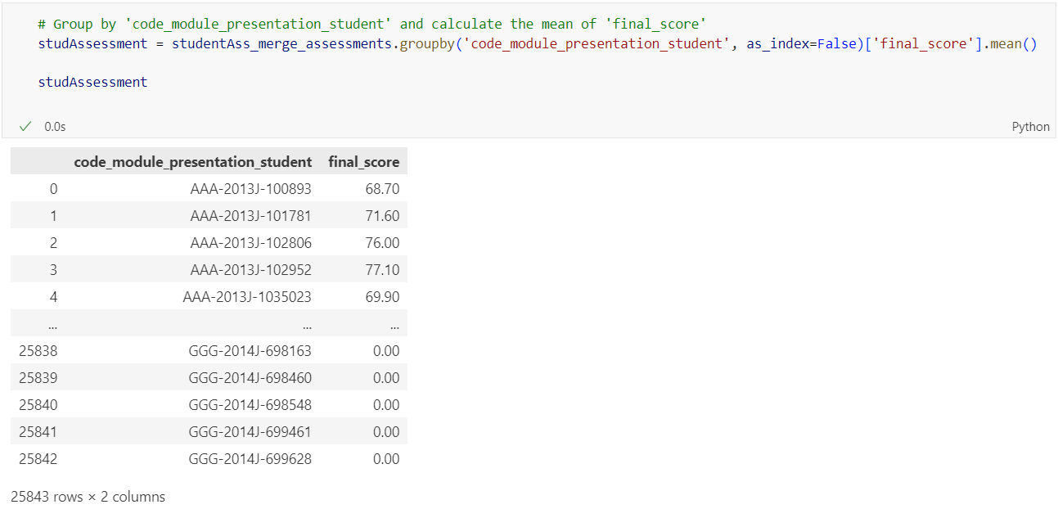

Figure 39: Source Code and Output of Grouping by Common Columns and Mean Calculation for ‘final_score’

The code shown in Figure 39 merges the ‘studentAss_merge_assessments’ DataFrame with ‘final_scores’ on the code_module_presentation_student column using an outer join. It then groups the merged DataFrame by code_module_presentation_student and calculates the mean of the final_score for each group. The output is a summary DataFrame showing the average final_score for each unique code_module_presentation_student.

##### Merge merged_df and studAssessment on ‘code_module_presentation_student’

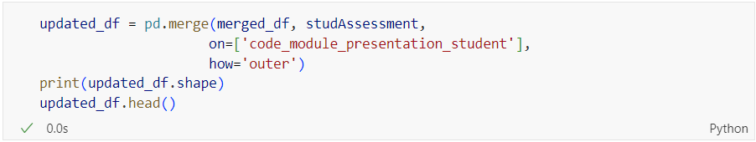

Figure 40: Source Code of Merging ‘merged_df’ and ‘studAssessment’ DataFrame



Figure 41: Output of Data Merging

The code shown in Figure 40 merges two DataFrame on a common column which is code_module_presentation_student, includes all records from both DataFrame, prints the shape of the resulting DataFrame and displays the first 5 rows to inspect the merged data.

##### Merge updated_df and courses on ‘code_module_presentation

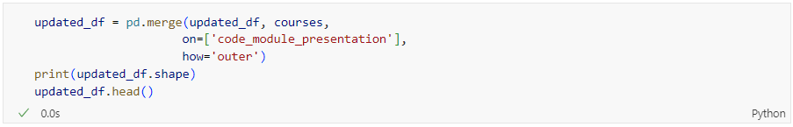

Figure 42: Source Code of Merging ‘updated_df’ and ‘courses’ DataFrame



Figure 43: Output of Data Merging

Figure 42 shows the code that merges the ‘updated_df’ DataFrame, which already contains combined data from ‘merged_df’ and ‘studAssessment’, with the ‘course’ DataFrame on code_module_presentation as the common column. The outer join ensures that all records from both DataFrames are included, even if there are missing matches. The shape of the resulting DataFrame is printed to show the number of rows and columns, which are 32,593 rows and 18 columns. Then, the first few rows are displayed for inspection of merged data.

##### Merge studentVle and vle on ‘code_module_presentation_site’

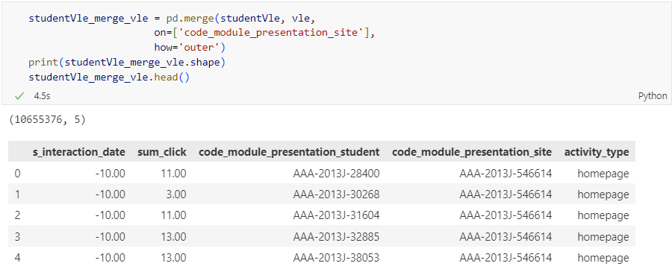

Figure 44: Source Code and Output of Merging studentVle and vle

Figure 44 shows the code merging two DataFrame, ‘studentVle’ and ‘vle’, on a common column code_module_presentation_site created previously, using outer join. The shape of the resulting DataFrame is printed to show the number of rows and columns, and the first few rows are displayed for inspection of the merged data, as shown in the output in Figure 44

##### Calculate Number of Clicks Before and After Course Starts

Number of clicks before course starts are calculated to indicate how proactive and prepared a student is, whereas the number of clicks after the course starts can indicate ongoing engagement and participation in the course. This helps in understanding how the student’s engagement evolves over time.

###### Check Unique Values for ‘s_interaction_date’

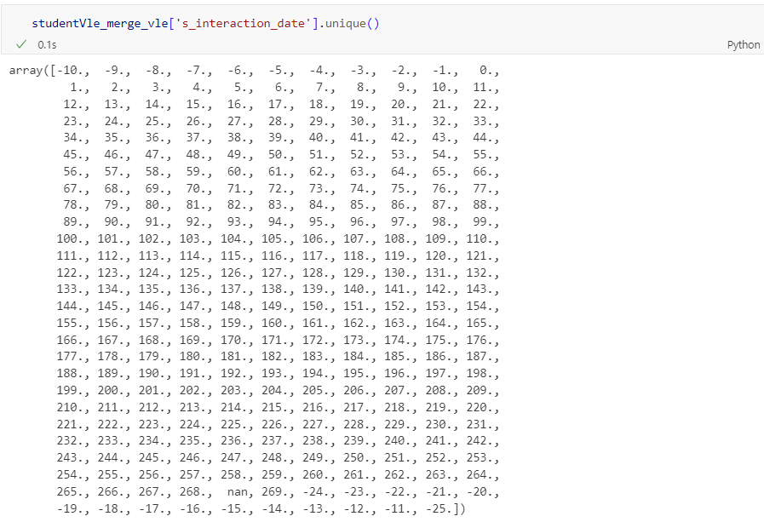

Figure 45: Source Code and Output of Checking Unique Values

From Figure 45, as there is negative and positive date in the column s_interaction_date, negative values mean that the student is accessing the material before the course starts and positive values refer to students accessing to the material after the course starts. Through this way, number of clicks before the module starts may be one of the factors which can help to determine whether the student is interested or not and will perform well or bad in the course. Therefore, whether a student has an interest on the course will be known by calculating the number of clicks before and after the course.

###### Create New Column ‘click_type’

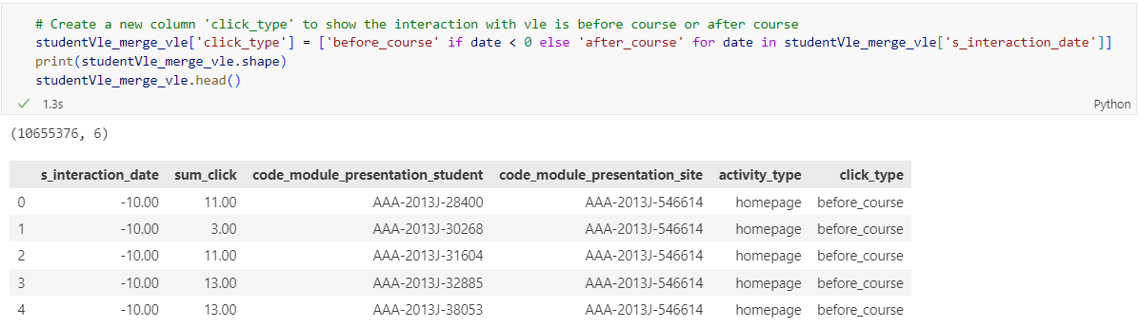

Figure 46: Source Code and Output of Creating New Column ‘click_type’

Figure 46 shows the code creating new column called click_type to the ‘studentVle_merge_vle’ DataFrame to categorize each VLE interaction as either occurring before or after the course starts, based on the values in the s_interaction_date column. It then prints the shape of the updated DataFrame to confirm the addition of the column and display the first few rows for inspection, as shown in Figure 46.

###### Calculate the sum of ‘sum_click’ grouped by ‘code_module_presentation_student’ and ‘click_type’

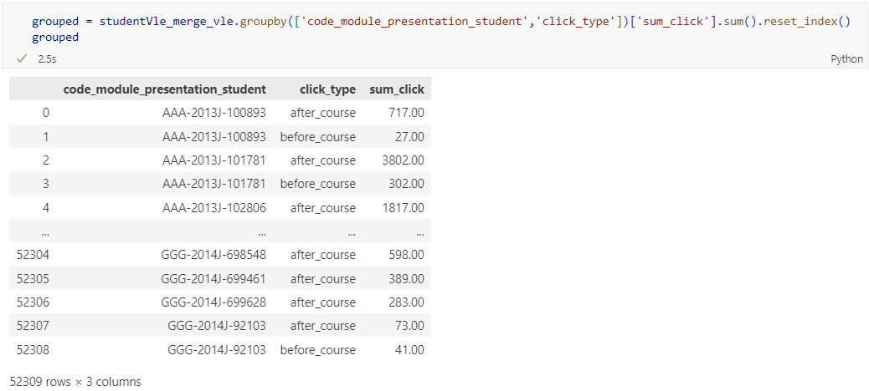

Figure 47: Source Code and Output of Calculating Sum of ‘sum_click’

The code in Figure 47 groups the interactions by student and interaction type (before or after the course), sums the number of clicks for each group, and creates a new DataFrame called ‘grouped’ with these aggregated results. This new DataFrame provides a clearer view of student engagement in terms of clicks before and after the course starts.

###### Derive ‘before_course_click’ and ‘after_course_click’ from ‘click_type’

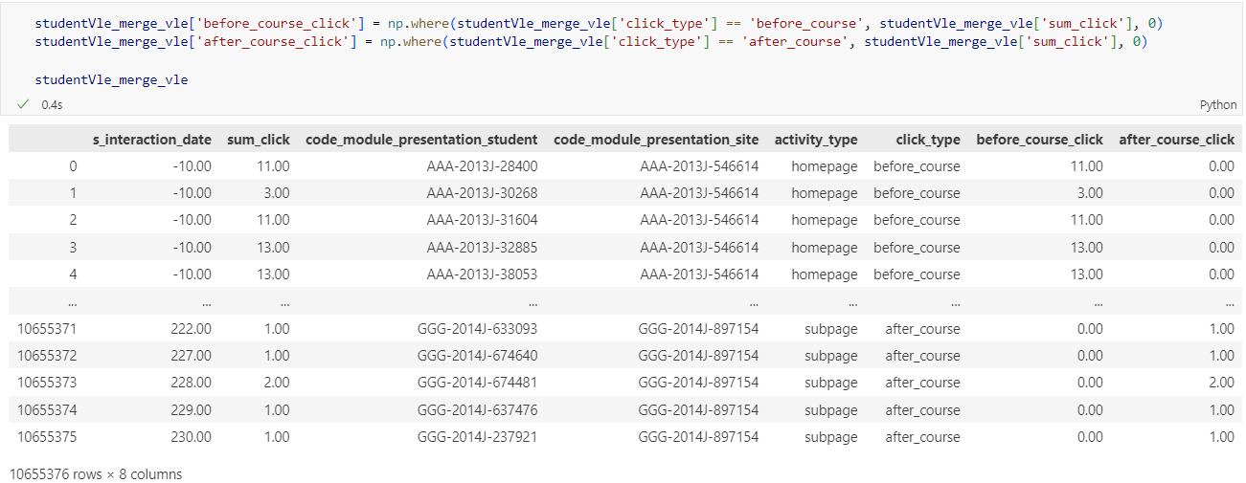

Figure 48: Source Code and Output of Deriving Columns

The code shown in Figure 48 creates two columns to distinctly categorize the number of clicks before and after the course starts. This helps in further analysis by clearly separating the interaction based on the timing relative to the course start date.

###### Group and Aggregate the Sum of Clicks for Each Student-Course Combination

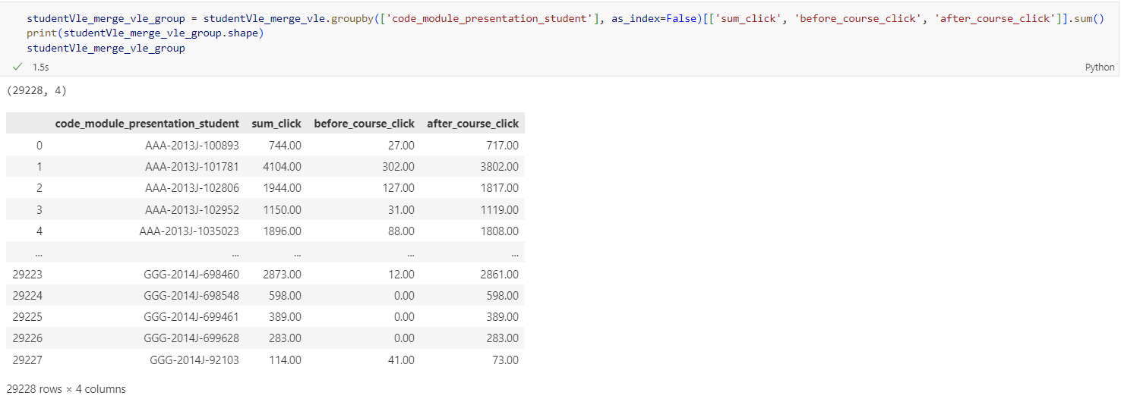

Figure 49: Source Code and Output of Grouping and Aggregating Sum of Clicks

Figure 49 shows the code grouping the ‘studentVle_merge_vle’ DataFrame by code_module_presentation_student, aggregating the sum of clicks for each student-course combination. It calculates the total number of clicks, as well as the clicks before and after the course starts, for each unique student-course combination. This results in a new DataFrame ‘studentVle_merge_vle_group’ that provides a summarized view of student interactions with the VLE, categorized by timing relative to the course start date. The shape of the new DataFrame is printed to show the number of unique student-course combinations and the structure of the aggregated data, as shown in Figure 49.

##### Merge ‘updated_df’ and ‘studentVle_merge_vle_group’

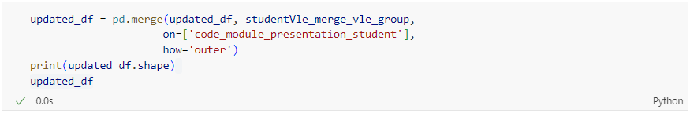

Figure 50: Source Code of Merging ‘updated_df’ and ‘studentVle_merge_vle_group’

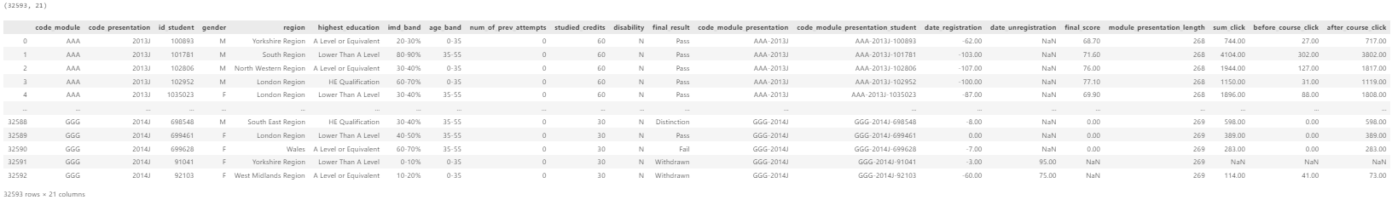

Figure 51: Output of Data Merging

The code shown in Figure 50 merges the ‘updated_df’ and ‘studentVle_merge_vle_group’ DataFrame on the code_module_presentation_student column using an outer join. The shape of the resulting DataFrame is printed to show the new dimensions, which contains 32,593 rows and 21 columns, and the merged data is displayed to inspect the combined data, as shown in Figure 51.

#### Correlation Matrix before Feature Engineering

##### Informative Summary

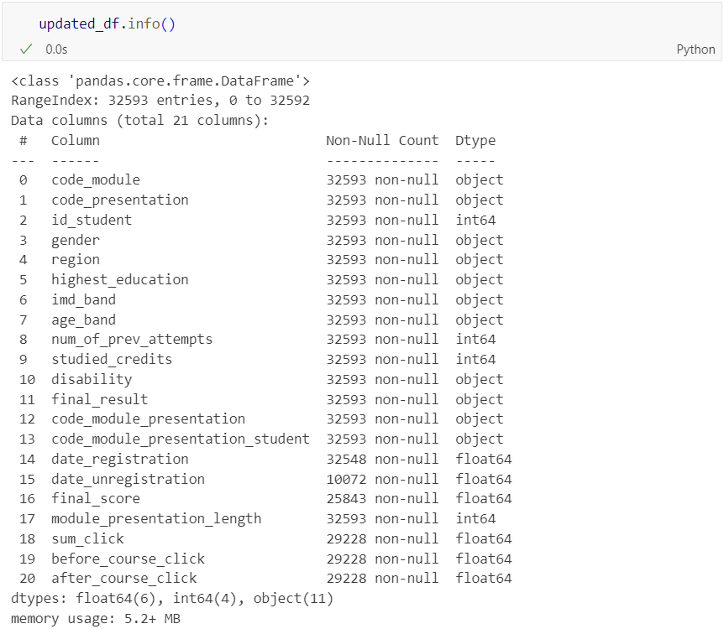

Figure 52: Source Code and Output of Informative Summary of ‘updated_df’ DataFrame

The code shown in Figure 52 provides a quick and informative summary of the DataFrame, including the number of entries, the number of non-null values for each column, the data types of the columns, and the total memory usage. This summary is useful for getting an overview of the DataFrame’s structure and for identifying potential issues with missing data or incorrect data types.

##### Convert Data Type of ‘id_student’

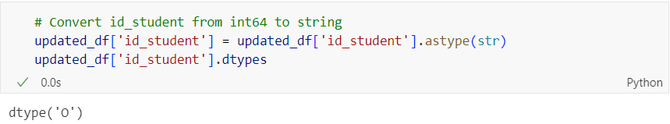

Figure 53: Source Code and Output of Converting Data Type of ‘id_student’

Figure 53 shows the code converting the id_student column in the ‘updated_df’ DataFrame from ‘int64’ to ‘string’ to ensure consistency, facilitate operations that require the column to be a string, and confirm the change by checking the data type. Student IDs are better handled as strings rather than numeric values.

##### Correlation Matrix

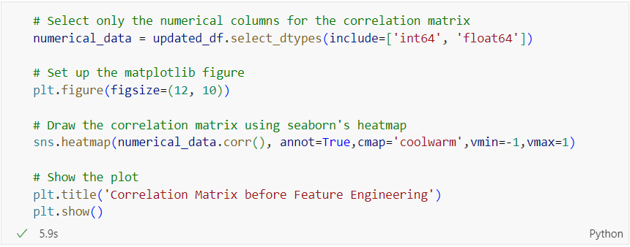

Figure 54: Source Code of Plotting Correlation Matrix

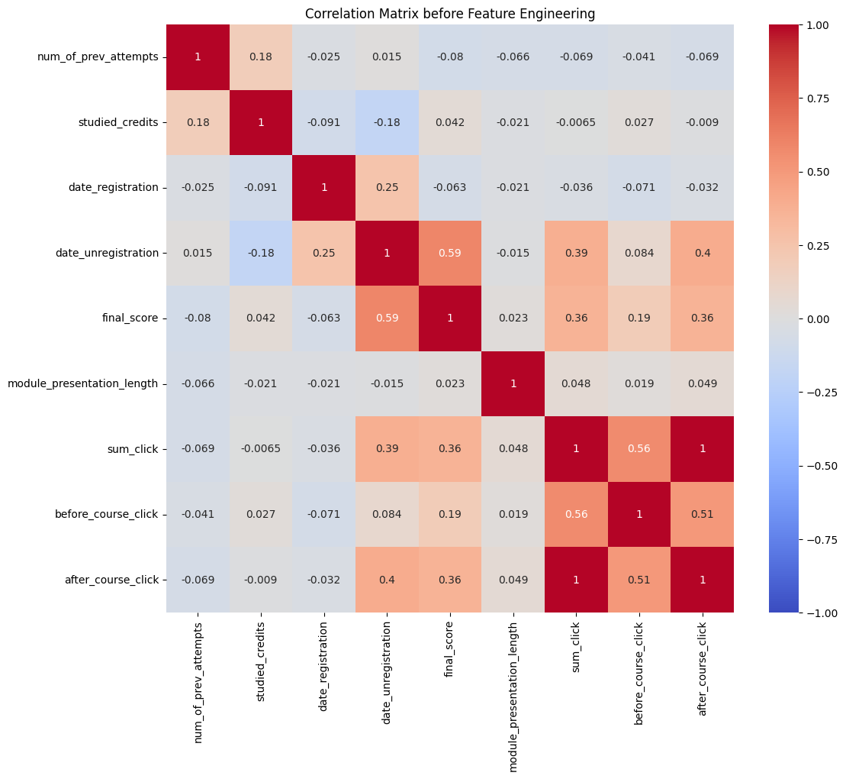

Figure 55: Output of Plotting Correlation Matrix

The code shown in Figure 54 selects the numerical columns from the ‘updated_df’ DataFrame and calculates the correlation matrix, which measures the linear relationship between each pair of numerical features. It then visualizes this correlation matrix using a heatmap. The heatmap uses a colour gradient to represent correlation values, with annotations showing the exact correlation coefficients. This visualisation helps in identifying the strength and direction of linear relationships between different numerical features in the dataset.

From the heatmap, several key correlations are observed. For instance, there is a moderately strong positive correlation between the date of unregistration and the final score, suggesting that students who unregistered later tended to have higher final scores. Similarly, there is a positive correlation between the total number of clicks and the final score, indicating that higher interaction with the VLE is associated with better performance. Conversely, some features show very low or negligible correlations, indicating little to no linear relationship. This analysis provides valuable insights for feature selection and engineering in predictive model, helping to identify which features might be more influential in predicting student outcomes.

### Data Cleaning after Data Integration

#### Check for Duplicates

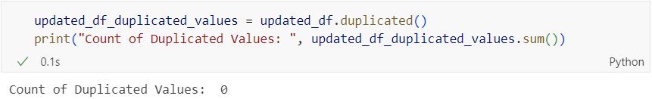

Figure 56: Source Code and Output of Checking for Duplicates

Figure 56 shows the code to check the duplicates in ‘updated_df’ and as shown in the figure, there is no duplicated values in the DataFrame.

#### Check for Outlier

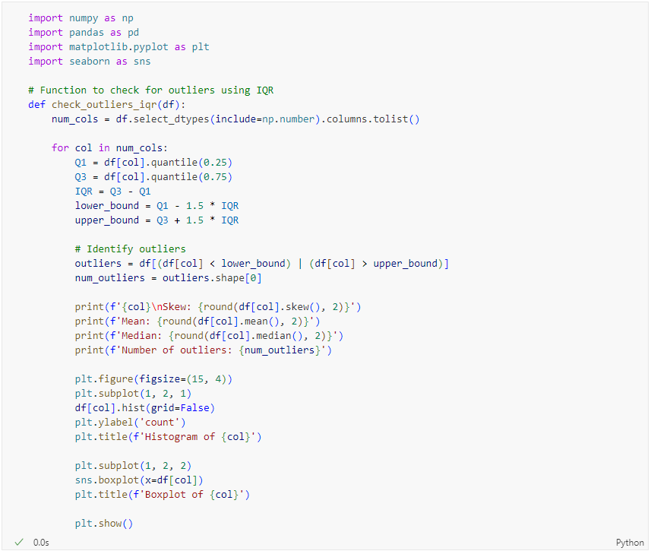

Figure 57: Source Code of Creating Function to Check Outliers



Figure 58: Source Code of Appling Function to ‘updated_df’ DataFrame



Figure 59: Output of Showing Outliers for num_of_previous_attempts, studied_credits and date_registration



Figure 60: Output of Showing Outliers for date_unregistration, final_score and module_presentation_length



Figure 61: Output of Showing Outliers for sum_click, before_course_click and after_course_click

Figure 57 and Figure 58 showed the code that create a function to check for the outliers by showing the values of skew, mean, median and number of outliers for all columns as well as plotting the distribution of the columns and box plot, and then applied the function on ‘updated_df’ DataFrame. The outputs are as shown in Figure 59, Figure 60 and Figure 61. However, the outliers are decided not to be handled due to several reasons. Firstly, the outliers represent the true variations in student performance, which are critical for understanding the full range of academic behaviours. Secondly, in educational data, outliers often signify the important events such as exceptionally high or low performance due to various factors. Therefore, removing these could lead to an incomplete understanding of student performance (Benkő, Bábel, & Somogyvári, 2022).

#### Check for Missing Values

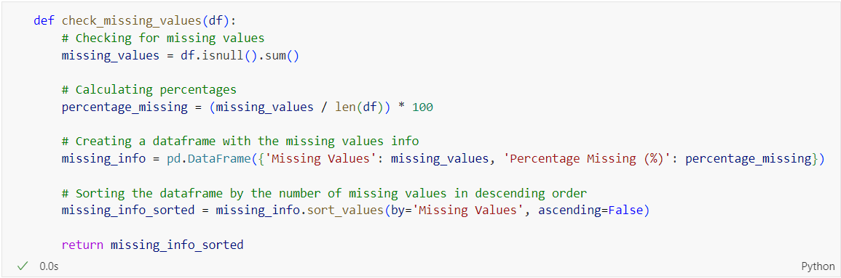

Figure 62: Source Code of Function to Check Missing Values

The function shown in Figure 62 checks for missing values in DataFrame and returns a new DataFrame summarizing the results. The summary includes the total number of missing values and the percentage of missing values for each column. The summary is sorted in descending order based on the number of missing values, making it easy to identify columns with the most missing data. This function is useful for quickly assessing the extent of missing data in a DataFrame.

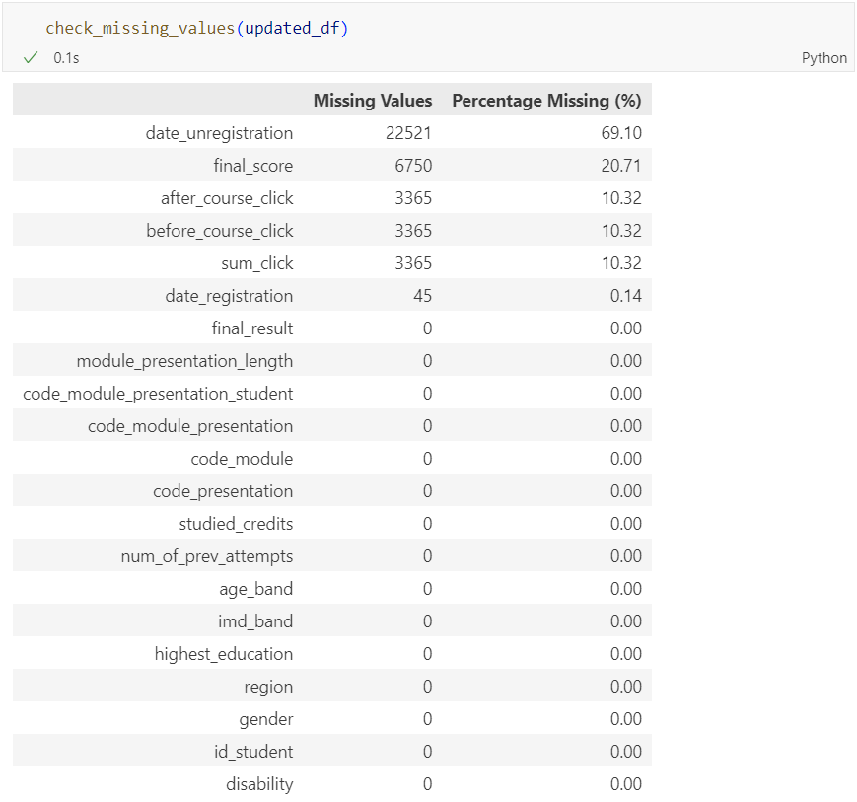

Figure 63: Source Code and Output of Checking Missing Values in ‘updated_df’ DataFrame

As shown in the output in Figure 63, date_unregistration column contributes to the largest missing data in the DataFrame. Based on the metadata provided by The Open University, students who completed the course have the field date_ unregistration empty.

#### Handle Missing Values

##### Missing Values in ‘date_unregistration’

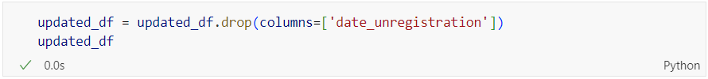

Figure 64: Source Code of Dropping Columns

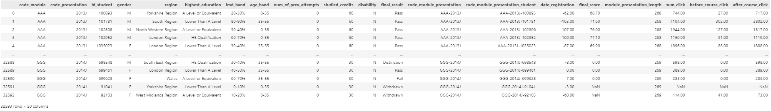

Figure 65: Output of DataFrame after Dropping Column

As shown in Figure 63, there are 69.10% of the missing values in date_unregistration. These missing values cannot use imputation because the column contains most of the missing values. Therefore, this column will be dropped as shown in Figure 65.

##### Missing Values in ‘final_score’

###### Check for Missing Values in ‘final_score’

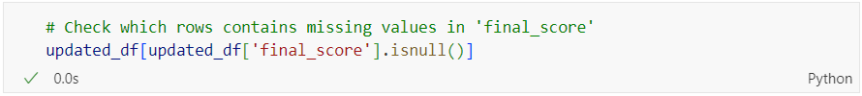

Figure 66: Source Code of Checking Rows with Missing Values in ‘final_score’

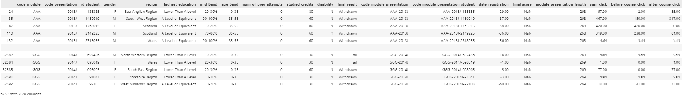

Figure 67: Output of Rows with Missing Values in ‘final_score’

Figure 66 shows the code to check which rows contains missing values in final_score and the output is shown in Figure 67. There are 6750 rows containing missing values in final_score.

###### Check the Categories in ‘final_result’ with Missing Values in ‘final_score’

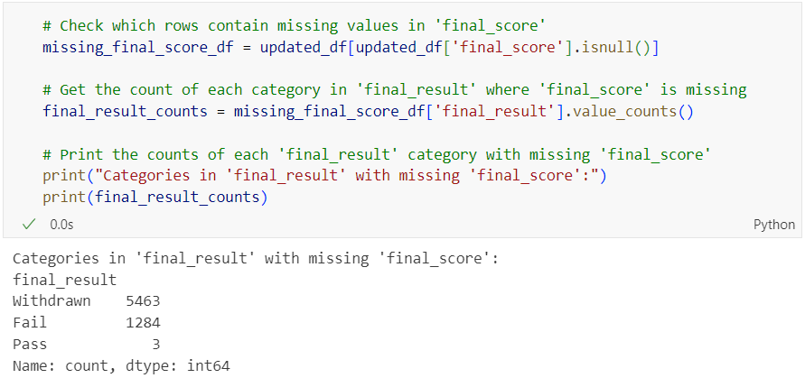

Figure 68: Source Code and Output of Checking Missing Values in ‘final_score’

The code shown in Figure 68 identifies and filters rows with missing final_score values in the ‘updated_df’ DataFrame. It then counts how many times each category in the final_result column appears within these filtered rows and prints these counts. This analysis helps to understand the distribution of final_score categories among the rows with missing final_score, which will be used later for mean imputation.

###### Calculate the Mean Score for Each Unique Combination

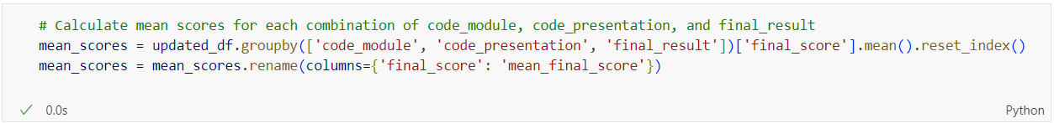

Figure 69: Source Code of Calculating Mean Score for Each Unique Combination

The code shown in Figure 69 calculates the mean of final_score for each combination of code_module, code_presentation and final_result, and stores these means in a new DataFrame called ‘mean_scores’. This new DataFrame provides a summarized view of the average performance for each combination of course module, presentation and final result, which will be used for imputation of missing values.

###### Merge updated_df and mean_scores



Figure 70: Source Code of Merging ‘updated_df’ and ‘mean_scores’

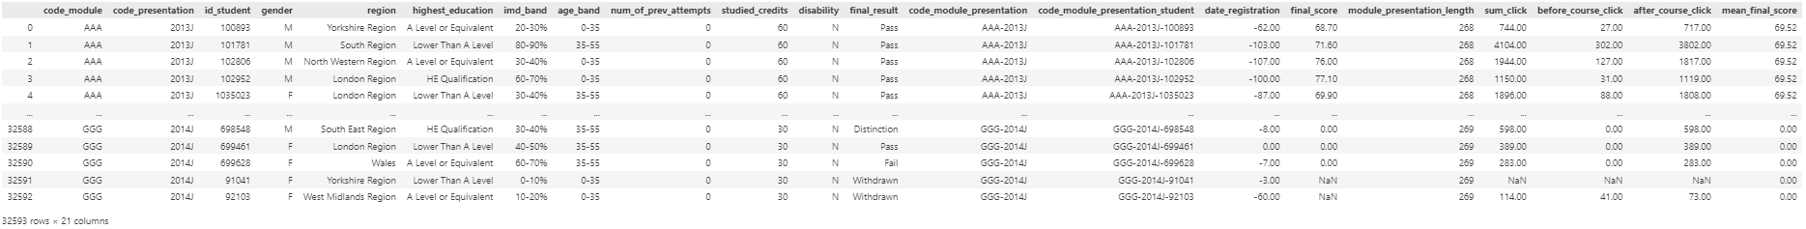

Figure 71: Output of Data Merging

The code shown in Figure 70 merges the ‘mean_scores’ DataFrame, which contains the mean of final score for each combination of code_module, code_presentation and final_result, back into the ‘updated_df’ DataFrame. This adds a new column mean_final_scores to ‘updated_df’, enriching the dataset with aggregated information.

###### Impute Missing Values in ‘final_score’

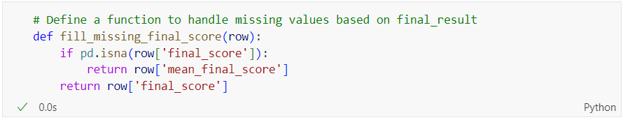

Figure 72: Source Code of Function Filling Missing Values using Mean

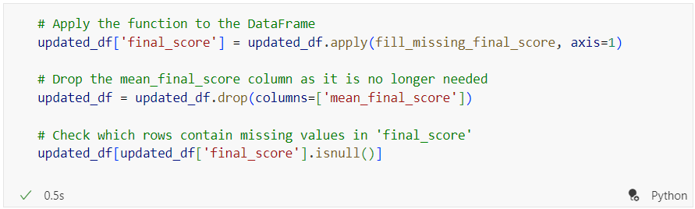

Figure 73: Source Code of Filling Missing Values using Mean



Figure 74: Output of ‘updated_df’ DataFrame after Mean Imputation for ‘final_score’

The function shown in Figure 72 checks if the final_score in a given row is missing. If it is, the function returns the value of mean_final_score for that row, effectively filling in the missing value with the average score for the relevant combination of code_module, code_presentation, and final_result. If the final_score is not missing, the function returns the original final_score. This function is useful for handling missing data in a meaningful and context-aware manner, ensuring the dataset remains complete and consistent for further modelling.

Figure 73 shows the code applies the ‘fill_missing_final_score’ function to each tow in the ‘updated_df’ DataFrame to fill in missing final_score values using the corresponding mean_final_score. It then drops the mean_final_score column since it is no longer needed. Finally, it checks for any remaining missing values in the final_score column to ensure that the imputation process was successful and that the DataFrame is now complete without missing values in the final_score column, as shown in Figure 74. This sequence of steps ensures that the dataset is clean and ready for further modelling.

##### Missing Values in ‘after_course_click’, ‘before_course_click’ and ‘sum_click’

###### Check Missing Value in ‘after_course_click’



Figure 75: Source Code of Checking Missing Value in ‘after_course_click’

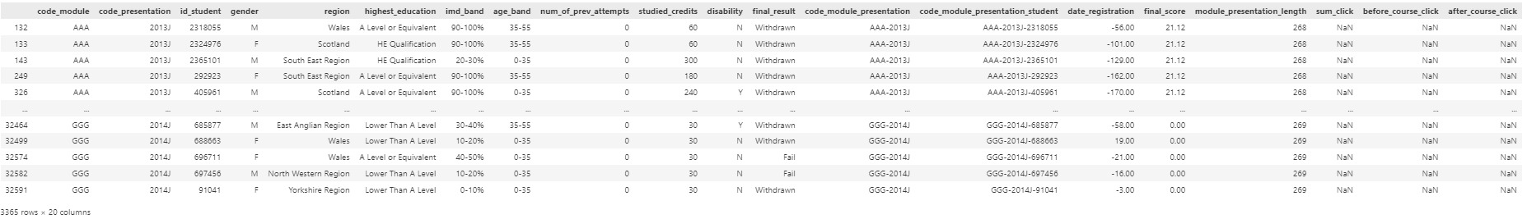

Figure 76: Output of Checking Missing Value in ‘after_course_click’

The code in Figure 75 checks which rows contain missing value in after_course_click and the output is as shown in Figure 76.

###### Check the Categories in ‘final_result’ with Missing Values in ‘after_course_click’

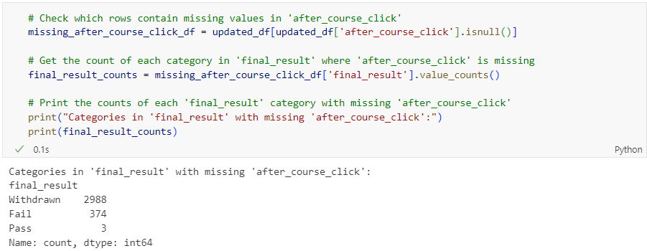

Figure 77: Source Code and Output of Checking Missing Values by Category in ‘final_result’

The code shown in Figure 77 identifies rows in the ‘updated_df’ DataFrame where the after_course_click column is missing. It then counts the occurrences of each unique value in the final_result column within these filtered rows and prints these counts. This analysis helps to understand the distribution of final_result categories among these rows with missing after_course_click values.

###### Calculate Mean for ‘after_course_click’ and ‘before_course_click’

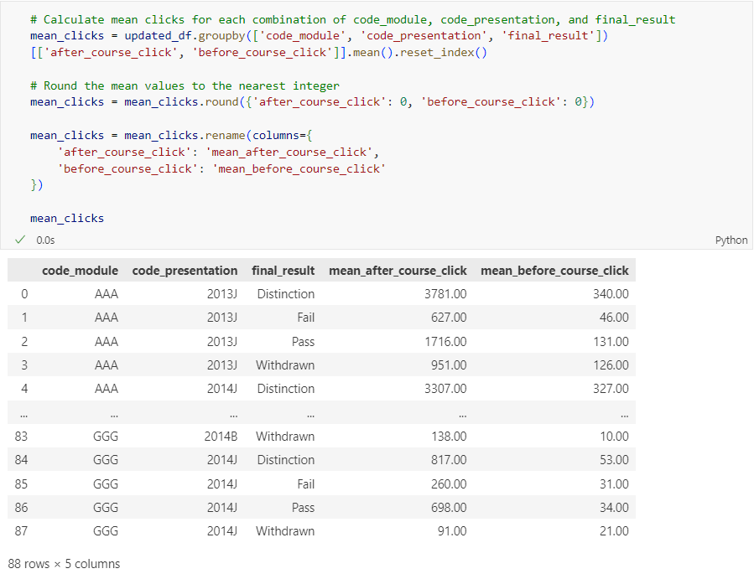

Figure 78: Source Code and Output of Mean Calculation

The code shown in Figure 78 calculates the mean number of clicks for both after_course_click and before_course_click for each unique combination of code_module, code_presentation, and final_result. The mean values are then rounded to nearest integer and the columns are renamed to mean_after_course_click and mean_before_course_click. Rounding the means helps in presenting the data in a more user-friendly format, especially when dealing with counts of interactions which are typical whole numbers. The resulting DataFrame ‘mean_clicks’ contains these aggregated and rounded means, as shown in Figure 78.

###### Merge updated_df and mean_clicks

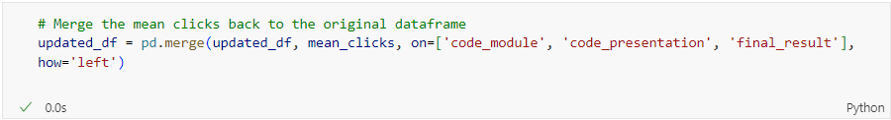

Figure 79: Merge ‘updated_df’ and ‘mean_clicks’

###### Impute Missing Values with Mean

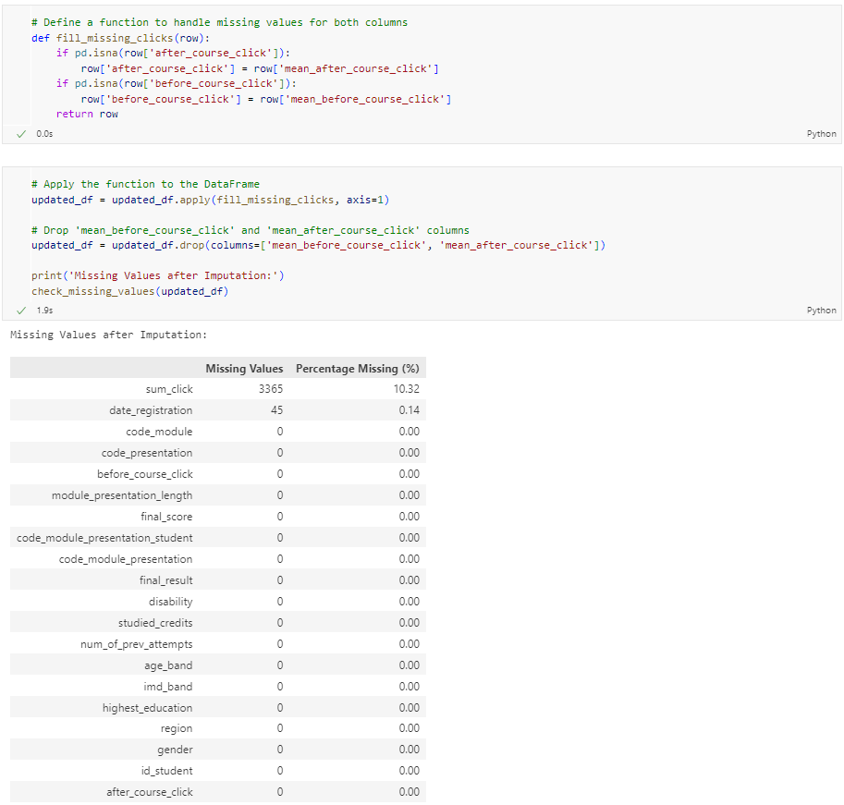

Figure 80: Source Code and Output of Filling Missing Values with Mean

The first code shown in Figure 80 defines a function ‘fill_missing_clicks’ to handle missing values in the after_course_click and before_course_click columns by filling them with the respective mean values. The function checks each row and replaces any missing values in these columns with the corresponding mean values. The function is then applied to the ‘updated_df’ DataFrame, ensuring that missing values in the click columns are appropriately imputed with the calculated means. This process helps to maintain data completeness and consistency for further analysis.

After applying the function to the DataFrame, the temporary mean columns, mean_before_course_click and mean_after_course_click are dropped. Finally, it checks and prints the remaining missing values in the DataFrames to verify the imputation results. The output in Figure 80 shows that all missing values in the after_course_click and before_course_click columns have been filled, but some missing values remain in the sum_click and date_registration columns.

##### Missing Values in ‘sum_click’

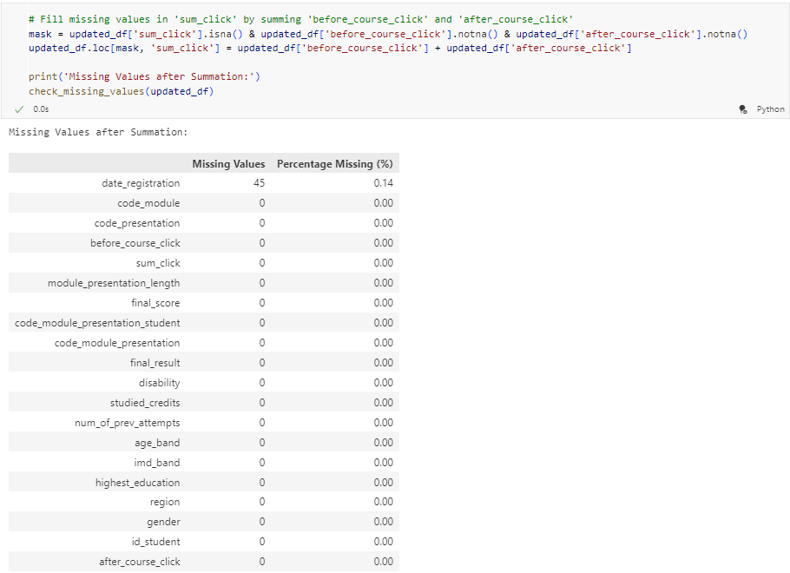

Figure 81: Source Code and Output of Filling Missing Values in ‘sum_click’

The code shown in Figure 81 fill missing values in the sum_click column by summing the values of before_course_click and after_course_click columns. It first creates a mask to identify rows where sum_click is missing but both before_course_click and after_course_click is not missing. Then, for these rows, it updates the sum_click value to be the sum of before_course_click and after_course_click. This ensures that the sum_click column is populated where possible, using available data from the other columns.

##### Missing Values in ‘date_registration’

###### Check Rows with Missing Values in ‘date_registration’



Figure 82: Source Code of Checking Missing Values in ‘date_registration’

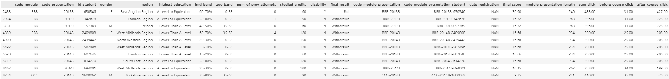

Figure 83: Output of First 10 Rows with Missing Values in ‘date_registration’

The code shown in Figure 82 filters the ‘updated_df’ DataFrame to display the first 10 rows where the date_registration column contains missing values. This allows for a closer inspection of the rows with missing date_registration data, as shown in Figure 83, to understand any patterns or anomalies that may exist within these specific entries.

###### Mode Imputation for Missing Values in ‘date_registration’

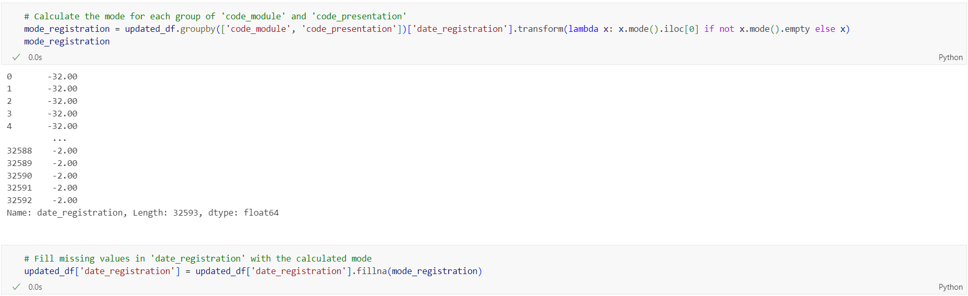

Figure 84: Source Code and Output of Imputing Mode to Missing Values in ‘date_registration’

The code shown in Figure 84 calculates the mode of date_registration for each combination of code_module and code_presentation. It then fills any missing values in the date_registration column with the corresponding mode for its group. This imputation strategy uses the most common registration date within each group to handle missing values, ensuring the dataset remains consistent and complete.

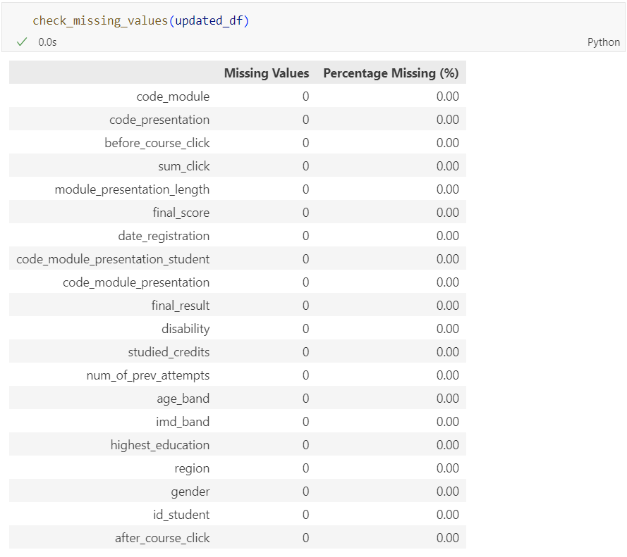

Figure 85: Source Code and Output of Checking Missing Values

The code shown in Figure 85 checks for missing values in the ‘updated_df’ DataFrame after performing various imputation steps. The output shows that there are no missing values left in any of the columns, indicating that the missing data has been completely and effectively handled. This ensures that the dataset is now clean and ready for further modelling without the complications introduced by missing values.

#### Drop Columns



Figure 86: Source Code of Dropping Unnecessary Columns

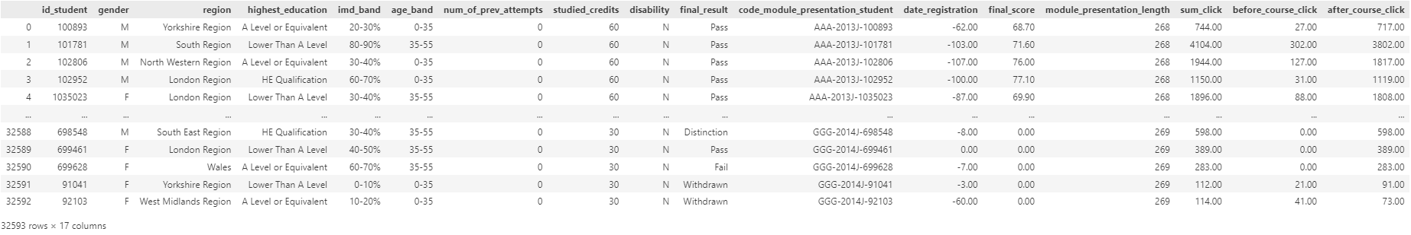

Figure 87: Output of DataFrame after Dropping Columns

The code shown in Figure 86 removes the code_module, code_presentation and code_module_presentation columns from the ‘updated_df’ DataFrame, creating a new DataFrame called ‘final_df’. These columns are removed as the code_module_presentation_student combined these columns. The number of columns remaining is 17, as shown in Figure 87.

#### Feature Engineering

##### Feature Creation

###### Create New Feature – at_risk

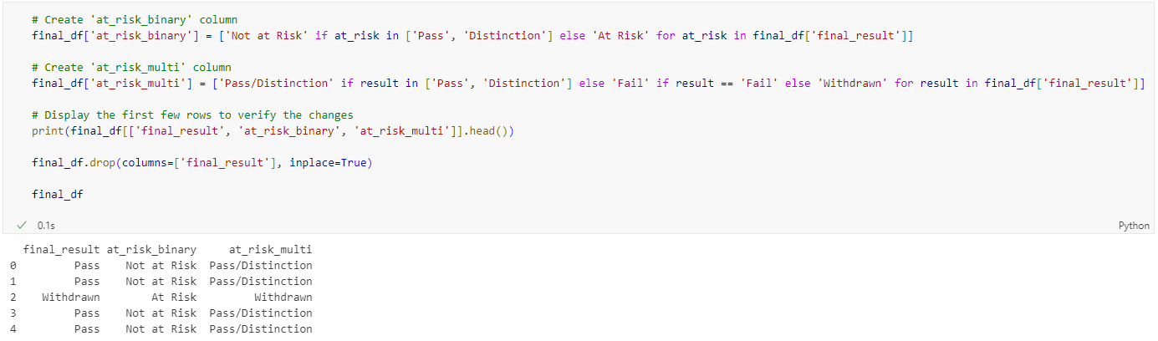

Figure 88: Source Code of Creating New Feature

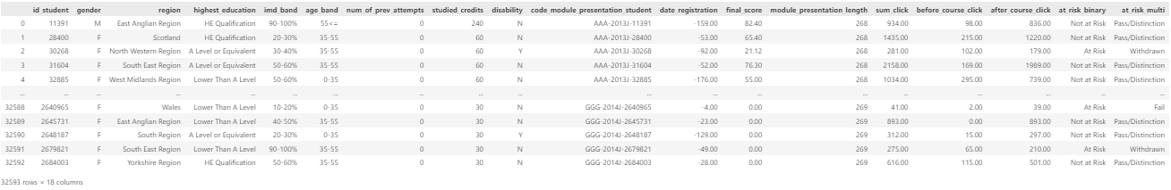

Figure 89: Output of Creating New Feature

Figure 88 shows the code creating a new column at_risk in the ‘final_df’ DataFrame, assigning a value of 0 for rows where ‘final_result’ is either ‘Pass’ or ‘Distinction’, and 1 for all other values. It then drops the final result column for the DataFrame. This transformation helps to create a binary indicator of student risk, making it easier to use this information in predictive models.

##### Feature Encoding

Encoding categorical columns is necessary in order to compatible with machine learning algorithms as machine learning algorithms are designed to work with numerical data.



Figure 90: Source Code of Making a Copy from ‘final_df’

A copy is created from final_df and is being assigned to new variable named ‘encoded_df’ as shown in Figure 90. By creating a copy, the original final_df remains unchanged during the encoding process.

###### Label Encoding

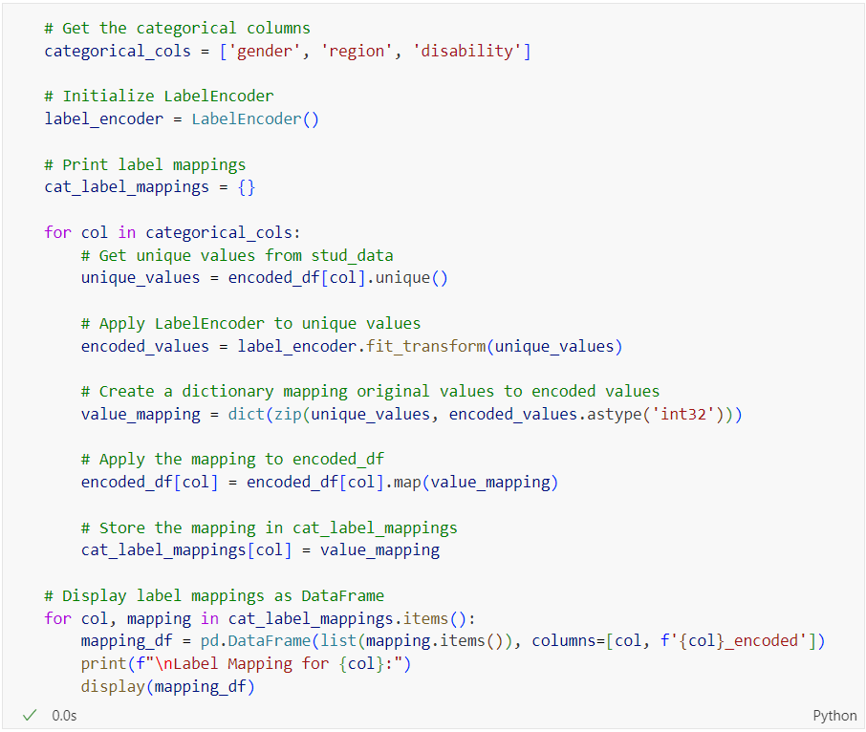

Figure 91: Source Code to Encode the Categorical Columns and Print the Label Mappings for Each Encoded Columns

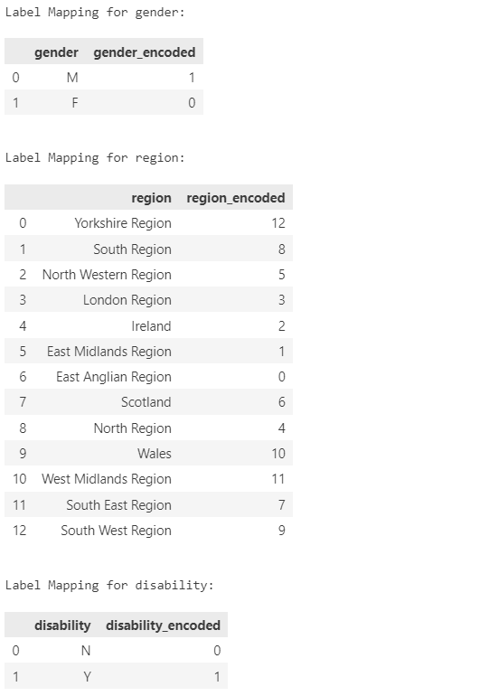

Figure 92: Output of Label Mappings for Categorical Columns using LabelEncoder

Categorical columns are encoded using LabelEncoder() and Figure 92 shows the output of the label mappings for each categorical column.

###### Ordinal Encoding

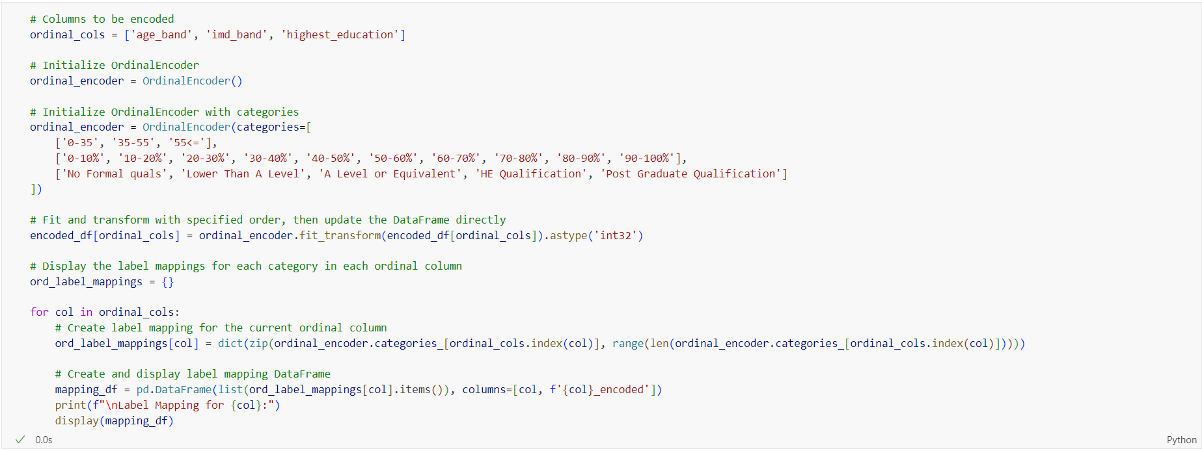

Figure 93: Source Code to Encode the Categorical Columns in Ordinal Way and Print the Label Mappings for Each Encoded Columns

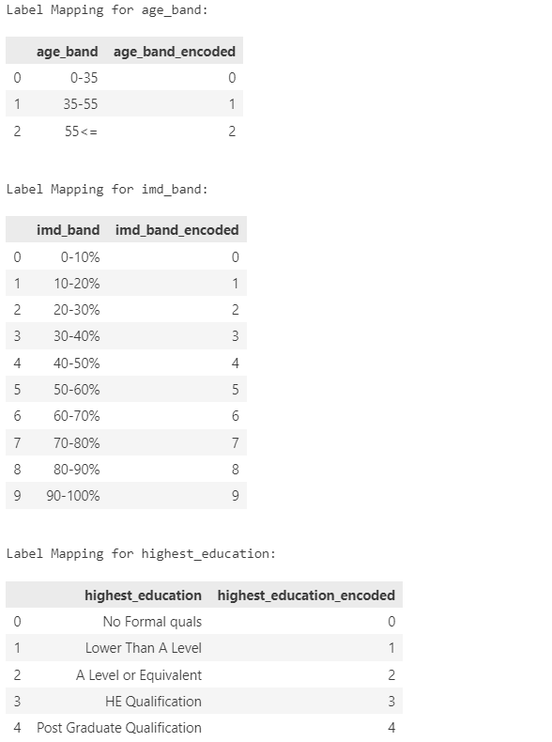

Figure 94: Output of Label Mappings for Categorical Columns using OrdinalEncoder

Ordinal encoding is done for age_band, imd_band and highest_education. This is to retains the inherent order or ranking of categories (Fulmyk, 2023).

###### Filter DataFrame

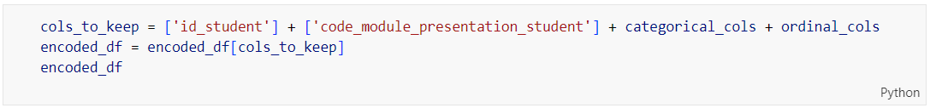

Figure 95: Source Code of Filtering DataFrame

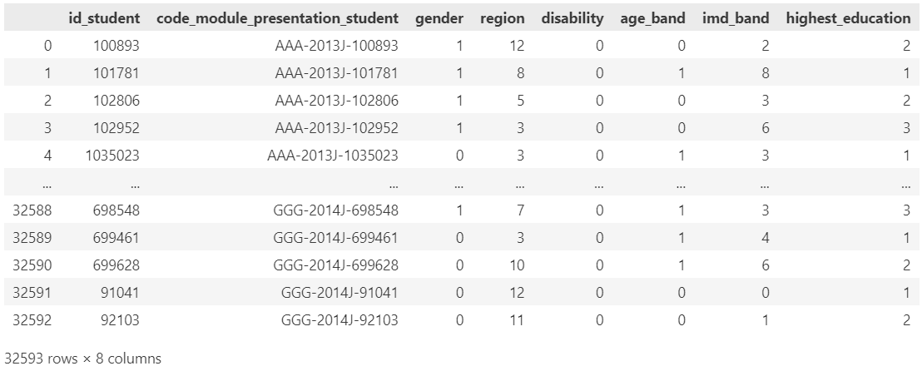

Figure 96: Output of Filtered DataFrame

The code shown in Figure 95 selects and keep specific columns from the DataFrame ‘encoded_df’. It creates a list of columns to retain, which include ‘id_student’, ‘code_module_presentation_student’, the columns listed in ‘categorical_cols’ and columns listed in ‘ordinal_cols’. The DataFrame ‘encoded_df’ is then filtered to keep only these specified columns. Lastly, the updated DataFrame is displayed as shown in Figure 96.

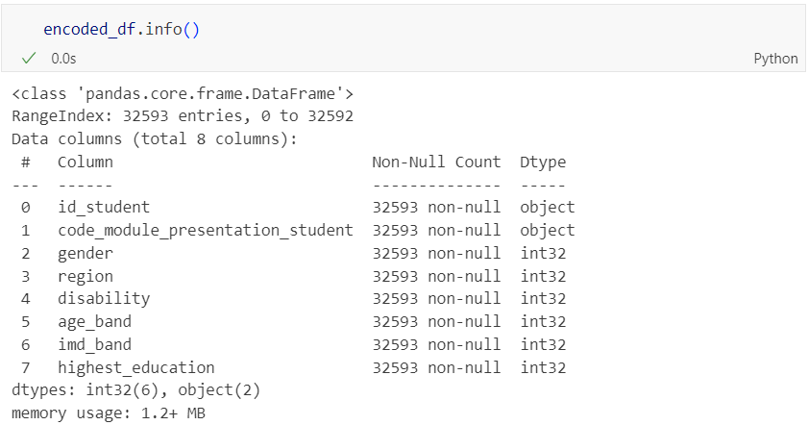

Figure 97: Source Code and Output of Informative Summary

The code shown in Figure 97 provides a concise summary of the DataFrame ‘encoded_df’, including the index range, the total number of entries, the column names and their data types, the number of non-null values in each column and the memory usage of the DataFrame.

###### Merge final_df and encoded_df

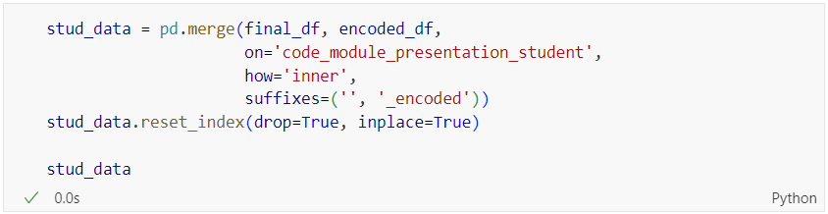

Figure 98: Source Code of Merging final_df and encoded_df

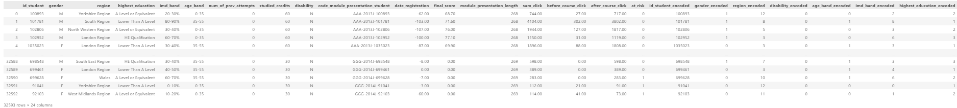

Figure 99: Output of Data Merging

The code shown in Figure 98 merges two DataFrames, ‘final_df’ and ‘encoded_df’, based on a common column called ‘code_module_presentation_student’. It performs an inner join, which means only the matching rows from both DataFrames are included. The resulting merged DataFrame, ‘stud_data’, includes all columns from both original DataFrames, with a suffix ‘_encoded’ added to columns from ‘encoded_df’ that have the same name as columns in ‘final_df’. Finally, the index of the merged DataFrame is reset and the output is as shown in Figure 99.

##### Drop ‘index’ Column

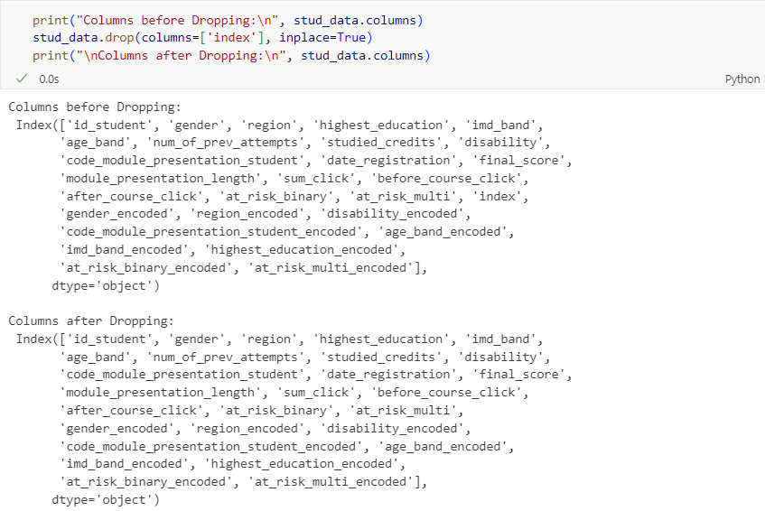

Figure 100: Source Code and Output of Dropping ‘index’ Column

The code shown in Figure 100 first prints the columns names of the ‘stud_data’ DataFrame before dropping any columns. It then removes the column named index, which was used solely for merging purposes, from the DataFrame using the ‘drop’ method. Finally, it prints the column names of the DataFrame after the ‘index’ column has been removed.

### Data Manipulation

#### Rearrange Columns

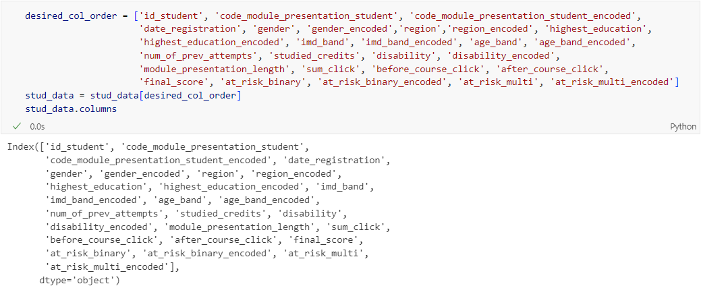

Figure 101: Source Code and Output of Rearranging Columns

The code shown in Figure 101 rearranges the columns of the ‘stud_data’ DataFrame according to the specified order in the ‘desired_col_order’ list. The purpose of this reordering is to ensure a consistent and logical sequence of columns, making the DataFrame easier to read and work with for subsequent analysis or processing. It then assigns this reordered DataFrame back to ‘stud_data’ and prints the updated column arrangements.

## Data Understanding

### Variables

#### Before Data Pre-Processing

As mentioned in Section 4.2, there are 7 csv files that will be used to combine and create new dataset. Each variable can be categorized as either categorical or numerical, with further distinctions into nominal, ordinal, discrete or continuous types.

##### assessments.csv

|  |  |  |  |
| --- | --- | --- | --- |
| **Types of Variables** | | **Variables** | **Description** |
| Categorical | Nominal | id_assessment | Unique identifier for each assessment |
| code_module | code of the module |
| code_presentation | code of the presentation (semester) |
| assessment_type | Type of assessment |
| Numerical | Discrete | date | information about the final submission date of the assessment calculated as the number of days since the start of the module-presentation |
| weight | weight of the assessment in % |

##### courses.csv

|  |  |  |  |
| --- | --- | --- | --- |
| **Types of Variables** | | **Variables** | **Description** |
| Categorical | Nominal | code_module | Code of the module |
| code_presentation | Code of the presentation (semester) |
| Numerical | Discrete | module_presentation_length | Length of the module presentation in days |

##### vle.csv

|  |  |  |  |
| --- | --- | --- | --- |
| **Types of Variables** | | **Variables** | **Description** |
| Categorical | Nominal | code_module | Code of the module |
| code_presentation | Code of the presentation (semester) |
| id_site | Identifier of the VLE site |
| activity_type | Type of activity (e.g., resource, quiz, forum) |
| Numerical | Discrete | week_from | Start week of the activity |
| week_to | End week of the activity |

##### studentAssessment.csv

|  |  |  |  |
| --- | --- | --- | --- |
| **Types of Variables** | | **Variables** | **Description** |
| Categorical | Nominal | id_assessment | Unique identifier for each assessment |
| id_student | Unique identifier for each student |
| is_banked | Indicates if the assessment is banked (1 for yes, 0 for no) |
| Numerical | Discrete | date_submitted | Date when the assessment was submitted (number of days since the start of the module presentation) |
| Continuous | score | Score obtained by the student in the assessment |

##### studentInfo.csv

|  |  |  |  |
| --- | --- | --- | --- |
| **Types of Variables** | | **Variables** | **Description** |
| Categorical | Nominal | id_student | Unique identifier for each student |
| gender | the gender of the student (‘M’ for male, ‘F’ for female) |
| region | Geographical region where the student resides |
| disability | Whether the student has declared a disability (Y for yes, N for no) |
| Ordinal | highest_education | The highest level of education achieved by the student (‘No Formal quals,’ ‘Lower Than A Level’, ‘A Level or Equivalent’, ‘HE Qualification’, ‘Post Graduate Qualification’) |
| imd_band | Index of multiple deprivation band of the student's area (‘0-10%’, ‘10-20%’, ..., ‘90-100%’) |
| age_band | Age group of the student (‘0-35’, ‘35-55’, ‘55<=’) |
| final_result | Final result of the student in the module (‘Withdrawn’, ‘Fail’, ‘Pass’, ‘Distinction’) |
| Numerical | Discrete | num_of_prev_attempts | Number of previous attempts at the module |
| studied_credits | Number of credits the student is currently studying |

##### studentRegistration.csv

|  |  |  |  |
| --- | --- | --- | --- |
| **Types of Variables** | | **Variables** | **Description** |
| Categorical | Nominal | id_student | Unique identifier for each student |
| code_module | Code of the module |
| code_presentation | Code of the presentation (semester) |
| Numerical | Discrete | date_registration | Date of student's registration (number of days since the start of the module presentation) |
| date_unregistration | Date of student's unregistration (number of days since the start of the module presentation) |

##### studentVle.csv

|  |  |  |  |
| --- | --- | --- | --- |
| **Types of Variables** | | **Variables** | **Description** |
| Categorical | Nominal | id_student | Unique identifier for each student |
| code_module | Code of the module |
| code_presentation | Code of the presentation (semester) |
| id_site | Identifier of the VLE site |
| Numerical | Discrete | date | Date of the interaction (number of days since the start of the module presentation) |
| Continuous | sum_click | Number of clicks/interactions made by the student |

#### After Pre-Processing

The dataset, after preprocessing, contains various variables providing detailed information about students, their demographics, academic performance, and interactions with the Virtual Learning Environment (VLE). These variables can be categorized as either categorical or numerical, with further distinctions into nominal, ordinal discrete, or continuous types.

|  |  |  |  |
| --- | --- | --- | --- |
| **Types of Variables** | | **Variables** | **Description** |
| Categorical | Nominal | id_student | Unique identifier for each student |
| code_module_presentation_student | Combination of module code, presentation, and student ID |
| gender | Code of the presentation (semester) |
| region | Identifier of the VLE site |
| disability | Whether the student has declared a disability (Y for yes, N for no) |
| imd_band | Index of multiple deprivation band of the student's area |
| at_risk_binary | Indicates if the student is at risk (‘At Risk’, ‘Not at Risk’) |
| Ordinal | highest_education | The highest level of education achieved by the student (‘No Formal quals’, ‘Lower Than A Level’, ‘A Level or Equivalent’, ‘HE Qualification’, ‘Post Graduate Qualification’) |
| age_band | Age group of the student (‘0-35’, ‘35-55’, ‘55<=’). |
| at_risk_multi | Final result or risk status of the student (‘Withdrawn’, ‘Fail’, ‘Pass’, ‘Distinction’) |
| Numerical | Discrete | num_of_prev_attempts | Number of previous attempts at the module |
| studied_credits | Number of credits the student is currently studying |
| module_presentation_length | Length of the module presentation in days |
| Continuous | date_registration | Date of student's registration (number of days since the start of the module presentation) |
| sum_click | Total number of clicks/interactions made by the student in the VLE |
| before_course_click | Number of clicks/interactions made before the course start |
| after_course_click | Number of clicks/interactions made after the course start |
| final_score | Final score obtained by the student in the module |

### Observations

#### Before Pre-Processing

##### Shape – Number of Rows and Columns

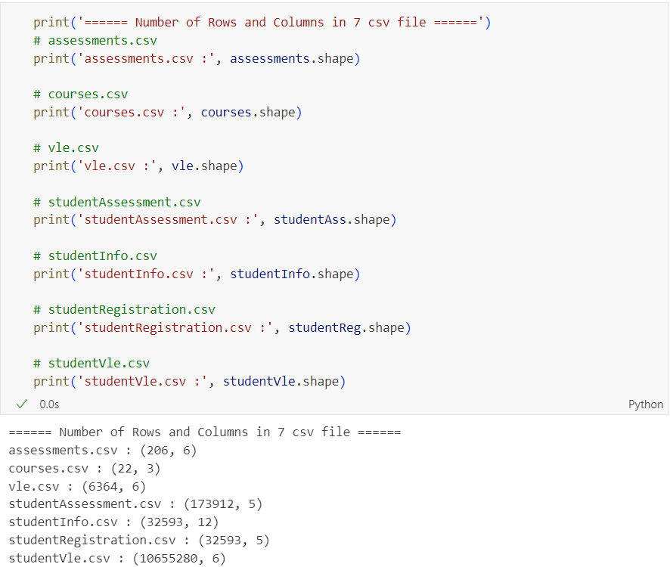

Figure 102: Source Code and Output of Showing Number of Rows and Columns in Each Dataset

Figure 102 showed the number of rows and columns in each dataset. The dataset consists of seven CSV files with varying numbers of rows and columns. The `assessments.csv` file has 206 rows and 6 columns, while the `courses.csv` file contains 22 rows and 3 columns. The `vle.csv` file has 6364 rows and 6 columns. The `studentAssessment.csv` file is considerably larger, with 173912 rows and 5 columns. The `studentInfo.csv` and `studentRegistration.csv` files both contain data on 32593 students, with 12 columns and 5 columns respectively. Lastly, the `studentVle.csv` file is the largest, containing 10655280 rows and 6 columns.

##### Information Summary

Table 6: Information about Each Dataset

|  |  |
| --- | --- |
| **Dataset** | **Source Code and Output** |
| assessments |  |
| courses |  |
| vle |  |
| studentAssessment |  |
| studentInfo |  |
| studentRegistration |  |
| studentVle |  |

Table 6 shows the information summary of the dataset. This information summary shows the data types of the data frame’s index and the names and data types of each column. Total number of non-null values for each column is also showed. This can be used to identify potential missing values in the dataset.

##### First and Last 5 Rows

Table 7: First and Last 5 Rows Data in Each Dataset

|  |  |
| --- | --- |
| **Dataset** | **Source Code and Output** |
| assessments |  |
| courses |  |
| vle |  |
| studentAssessment |  |
| studentInfo |  |
| studentRegistration |  |
| studentVle |  |

Table 7 shows the first 5 and last 5 rows of the data in each dataset. Showing the first and last 5 rows of the data in each dataset allowed a basic understanding of how the data would look like.

##### Check for Unique Values

Table 8: Unique Values in Each Dataset

|  |  |
| --- | --- |
| **Dataset** | **Source Code and Output** |
| assessments |  |
| courses |  |
| vle |  |
| studentAssessment |  |
| studentInfo |  |
| studentRegistration |  |
| studentVle |  |

Table 8 shows the number of unique values in the columns with the data type of ‘object’. Unique value is checked to extract the distinct values, providing insights into the diversity of the data (Nik, 2023). For ‘studentAssessment’ dataset, there is no column with ‘object’ data type so is_banked column is chosen to see its unique values. In ‘studentInfo’, imd_band column contains inconsistent format of the data and this will be handled in the section of data standardization.

##### Check for Duplication

Table 9: Duplication in Each Dataset

|  |  |
| --- | --- |
| **Dataset** | **Source Code and Output** |
| assessments |  |
| courses |  |
| vle |  |
| studentAssessment |  |
| studentInfo |  |
| studentRegistration |  |
| studentVle |  |

Table 9 shows the sum count of duplicated values in each dataset. For studentVle, it is shown that there are 787,170 duplicated rows because these duplications are due to the nature of the recorded information, which encapsulates the cumulative engagement of students on the site over multiple instances.

##### Check for Missing Values and Percentages of Missing Values

Table 10: Missing Values and Percentages of Missing Values in Each Dataset

|  |  |
| --- | --- |
| **Dataset** | **Source Code and Output** |
| assessments |  |
| courses |  |
| vle |  |
| studentAssessment |  |
| studentInfo |  |
| studentRegistration |  |
| studentVle |  |

Table 10 shows the number of missing values and percentages of that missing values in each dataset. Missing values need to be checked because missing values can significantly impact the performance of models which lead to incorrect predictions or conclusion, as the algorithms may not be able to accurately learn from the data without complete information (Keita, 2023). The percentage of missing values is shown so that decision can be made on how to handle the missing data (whether to impute, drop or use specific imputation methods.

##### Descriptive Statistical for Numerical and Categorial Columns

Table 11: Descriptive Statistics for Numerical and Categorical Columns in Each Dataset

|  |  |
| --- | --- |
| **Dataset** | **Source Code and Output** |
| assessments |  |
| courses |  |
| vle |  |
| studentAssessment |  |
| studentInfo |  |
| studentRegistration |  |
| studentVle |  |

Table 11 shows the descriptive statistics of each numerical and categorical columns in each dataset. Descriptive statistics provide a summary of the central tendency, dispersion, and shape of the dataset’s distribution (Chaudhari, 2021). Descriptive statistics help in identifying missing values, outliers, and skewed distribution, allowing for appropriate data cleaning strategies (Curtin University Library, n.d.).

#### After Pre-Processing

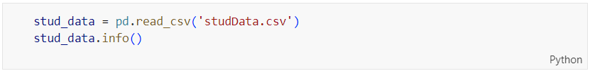

Figure 103: Source Code of Informative Summary

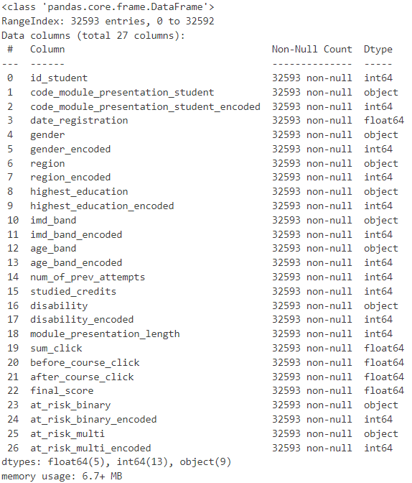

Figure 104: Output of Informative Summary

Figure 104 shows the DataFrame contains a comprehensive dataset detailing various attributes related to students and their academic performance. It includes 32,593 entries and 27 columns, encompassing identifiers, demographic information, educational background, and engagement metrics. Key columns include unique student IDs, encoded and original module presentation identifiers, registration dates, gender, region, highest education level, and age bands, all with corresponding encoded versions for numerical analysis. Additionally, it tracks the number of previous attempts, studied credits, disability status, module presentation length, total clicks, and clicks before and after the course start. The final score and binary as well as multi-class risk indicators are also present, both in original and encoded formats. This dataset, utilizing about 6.74 MB of memory, is primed for detailed statistical and machine learning analysis. This helps in assessing the data’s completeness and understanding its structure.

### Data Visualization (After Pre-Processing)

#### Gender Distribution

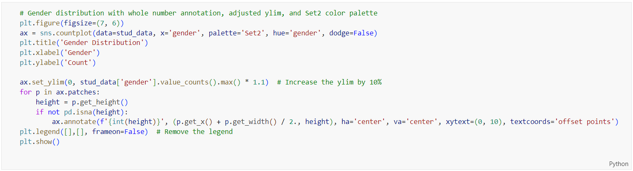

Figure 105: Source Code of Plotting Gender Distribution by Bar Chart

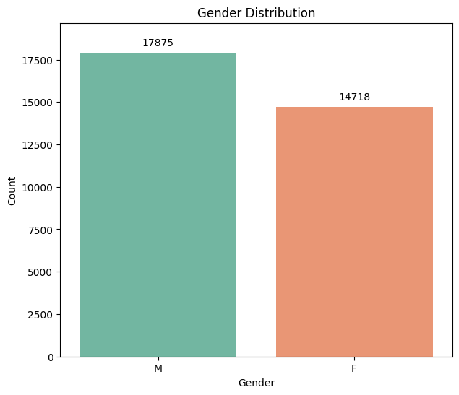

Figure 106: Bar Chart of Gender Distribution

The bar chart shown in Figure 106 illustrates the count of individuals categorized by gender, specifically male and female. The chart reveals that there are 17,875 males and 14,718 females. This indicates a higher number of males compared to females. The vertical axis represents the count of individuals, while the horizontal axis denotes the gender categories. The data visualized in the chart helps to understand the gender composition of the population being studied, highlighting a noticeable gender imbalance with a larger male population.

#### Region Distribution

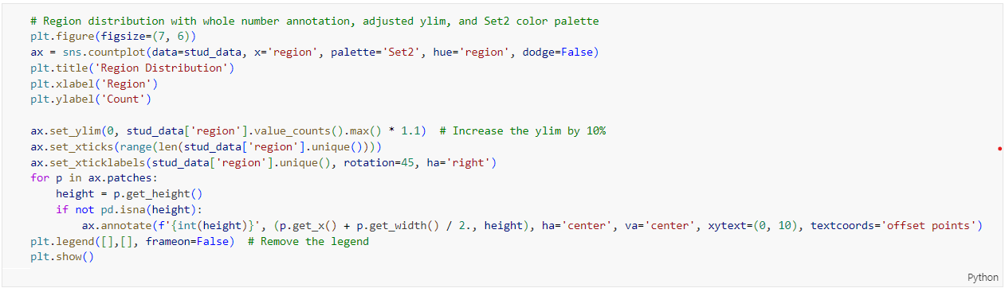

Figure 107: Source Code of Plotting Region Distribution by Bar Chart

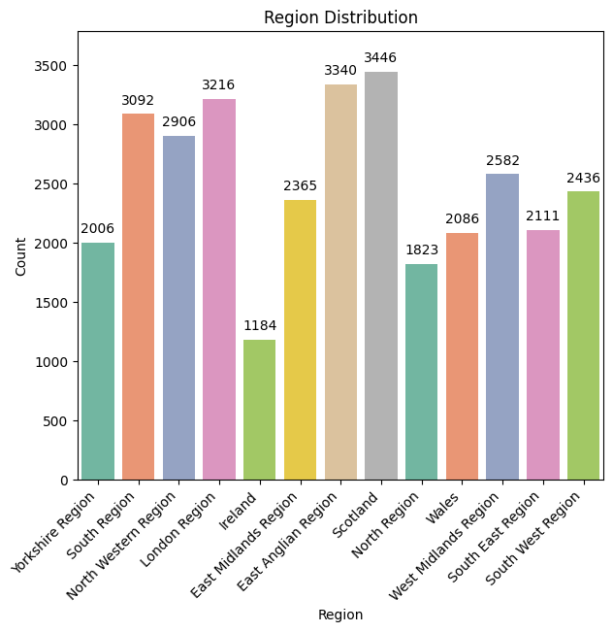

Figure 108: Bar Chart of Region Distribution

The chart shown in Figure 108 illustrates the distribution of individuals across various regions. Each bar represents a different region, and the height of the bars corresponds to the number of individuals at that region. The regions include Yorkshire Region, South Region, North Western Region, London Region, Ireland, East Midlands Region, East Anglian Region, Scotland, North Region, Wales, West Midlands Region, South East Region, and South West Region.

The data shows that the highest population is in Scotland with 3,446 individuals, followed closely by the North Region with 3,340 individuals, and the London Region with 3,216 individuals. On the other end, Ireland has the lowest count with 1,184 individuals. Other notable regions include the South Region (3,092), North Western Region (2,906) and South East Region (2,582).

This chart helps visualize the population distribution across these regions, highlighting areas with higher and lower densities of individuals.

#### Highest Education Distribution

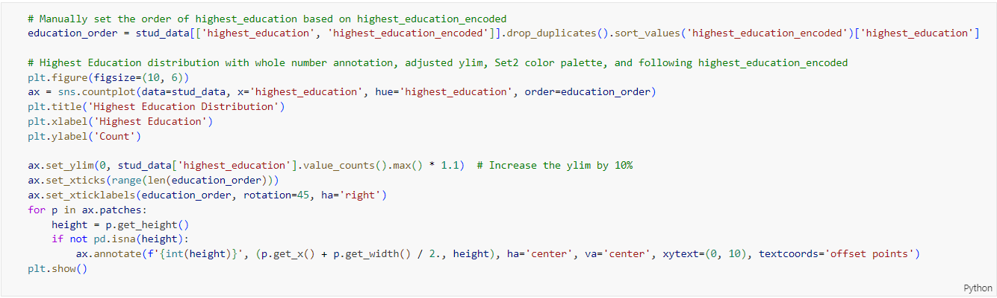

Figure 109: Source Code of Plotting Highest Education Distribution by Bar Chart

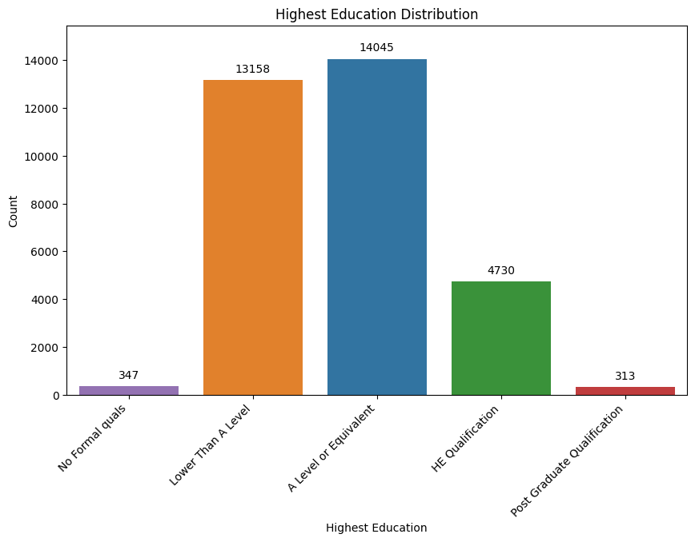

Figure 110: Bar Chart of Highest Education Distribution

The bar chart shown in Figure 110 showcases the distribution of individuals based on their highest level of education attained. The horizontal axis represents different education levels, while the vertical axis indicates the count of individuals within each category.

The data reveals that the majority of individuals have either “A Level or Equivalent” (14,045) or “Lower Than A level” (13,158) qualifications. These two categories dominate the distribution, indicating that a significant portion of the population has achieved secondary education levels. “HE Qualification” (Higher Education) follows with 4,730 individuals, highlighting a smaller group with higher education degrees. A relatively small number of individuals have “No Formal Qualifications” (347) and “Post-Graduate Qualification” (313), indicating that very few have not completed any formal education or have pursued advanced degrees. This distribution provides insights into the educational attainment within the population.

#### Disability Distribution

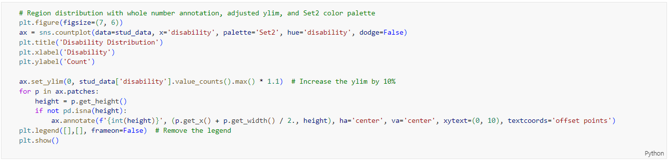

Figure 111: Source Code of Plotting Disability Distribution by Bar Chart

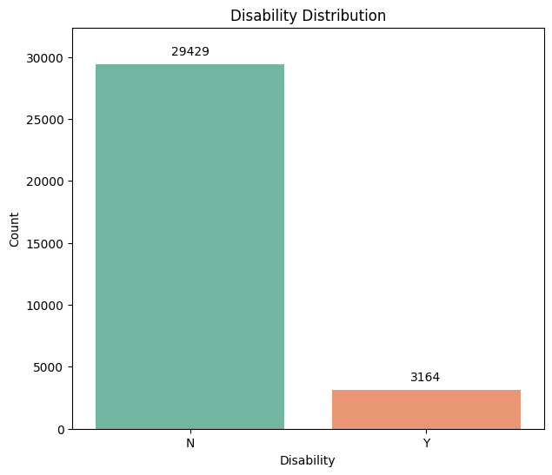

Figure 112: Bar Chart of Disability Distribution

The bar chart shown in Figure 112 visually represents the count of students categorized based on whether they have a disability. The chart shows a significant disparity between the groups, which are 29,429 students without a disability and 3,164 students with a disability. This indicates that approximately 90% of the student population does not have a disability, while around 10% does. The substantial difference in these figures suggests that the majority of students do not require specialized support or accommodations. However, the presence of over three thousand students with disabilities highlights the importance of inclusive education practices and the ned for adequate support services. Understanding this demographic distribution is crucial for educational institutions to plan and allocate resources effectively, ensuring that all students receive the support they need to succeed.

#### IMD Band Distribution

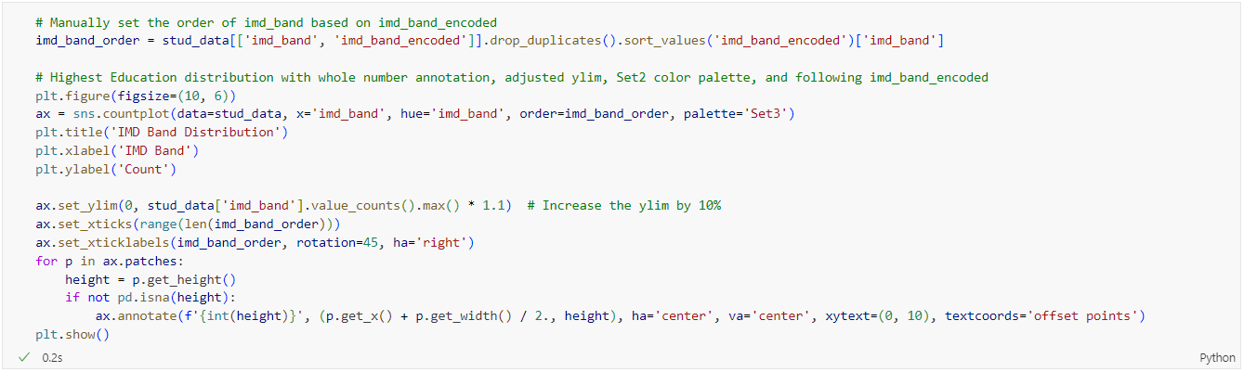

Figure 113: Source Code of Plotting IMD Band Distribution by Bar Chart

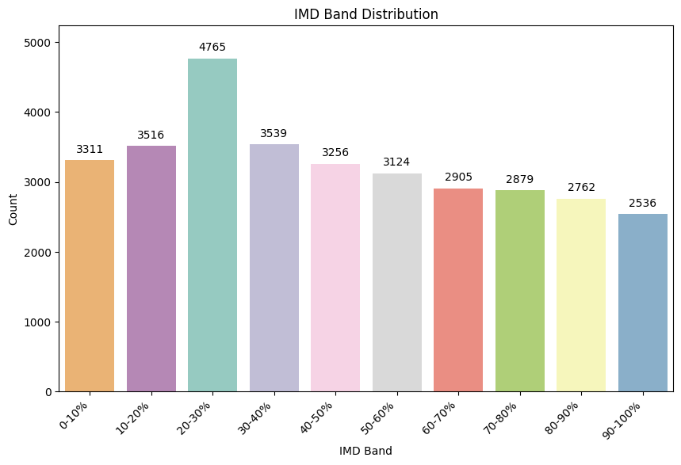

Figure 114: Bar Chart of IMD Band Distribution

The “IMD Band Distribution” graph shown in Figure 114 shows student counts across different socio-economic deprivation levels. The highest number of students, 4,765, is in the 20-30% IMD Band, indicating moderate deprivation. The 10-20% and 30-40% bands also have high counts, with 3,516 and 3,539 students, respectively. As deprivation decreases, student numbers gradually decline, with the least deprived 90-100% band having the lowest count of 2,536. This distribution suggests a need for targeted support for student sin the moderately deprived 20-40% bands. Recognizing these socio-economic disparities is essential for educational institutions to provide equitable support and resources.

#### At Risk Distribution

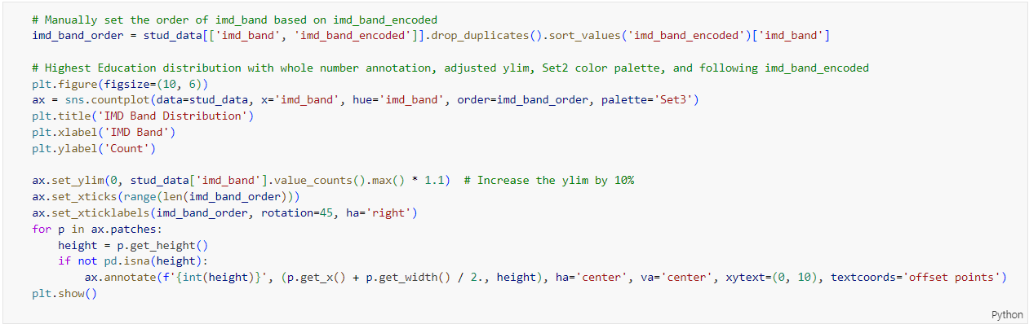

Figure 115: Source Code of Plotting At Risk Distribution by Bar Chart

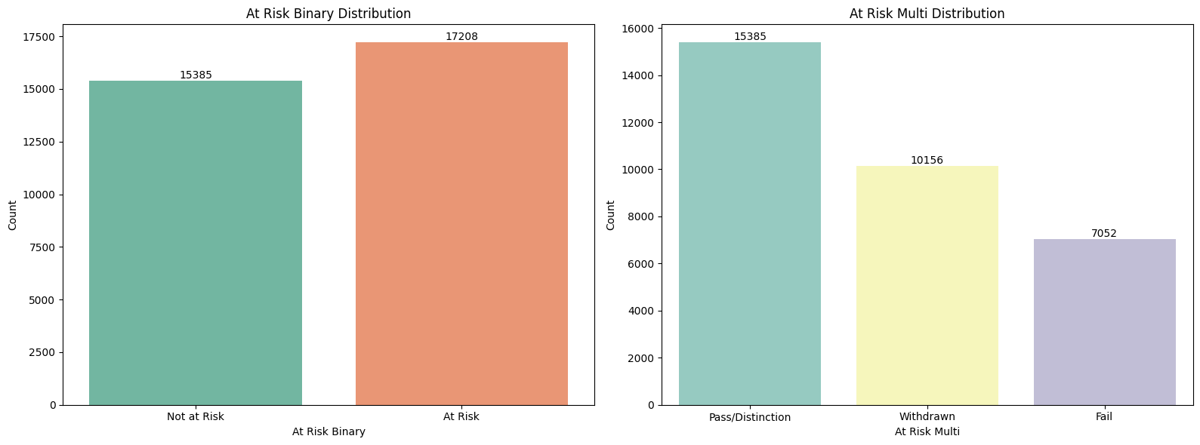

Figure 116: Bar Chart of At Risk Distribution for Both Binary and Multi Class

The “At Risk Binary Distribution” graph shown in Figure 116 shows the number of students categorized as “Not At Risk” and “At Risk”. There are 15,385 students not at risk and 17,208 students at risk, indicating a higher count of students considered at risk.

The “At Risk Multi Distribution” graph provides a more detailed breakdown of student outcomes within the at-risk category. There are 15,385 students who achieved a pass or distinction, 10,156 students who have withdrawn, and 7,052 students who failed. This distribution highlights the varying outcomes for at-risk students, with a significant portion managing to pass or achieve distinction, but also notable numbers withdrawing or failing.

#### Final Score Distribution

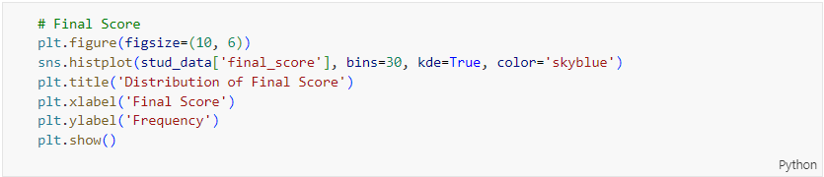

Figure 117: Source Code of Plotting Final Score Distribution by Histogram

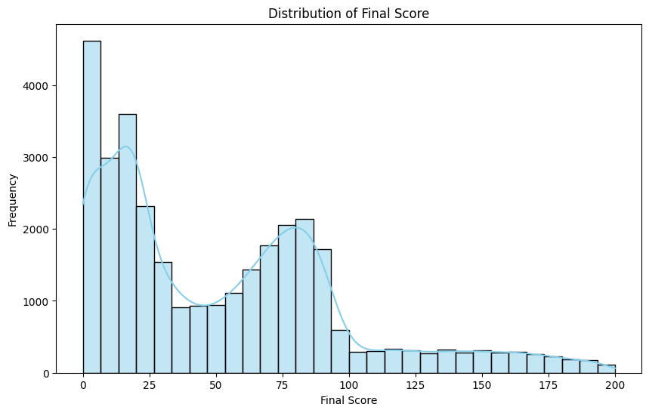

Figure 118: Histogram of Final Score Distribution

The “Distribution of Final Score” graph shown in Figure 118 illustrates the frequency of students’ final scores, highlighting several important trends. There is a significant peak around a score of 0, indicating a large number of students achieved very low scores. Another concentration of scores is seen around the 25-30 range, further emphasizing the prevalence of lower scores. Additionally, there is a moderate rise in scores around 70-80, suggesting that substantial number of students performed well but not exceptionally. As scores increase beyond 100, the frequency of students achieving these higher scores steadily declines, with very few students reaching the maximum score of 200. This varied performance distribution indicates that while some students excel, a notable portion of the student population struggles significantly. Understanding these patterns can help educational institutions identify areas where interventions may be needed to support lower-performing students and improve overall academic outcomes.

#### Sum Click Distribution

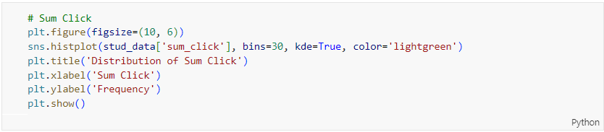

Figure 119: Source Code of Plotting Sum Click Distribution by Histogram

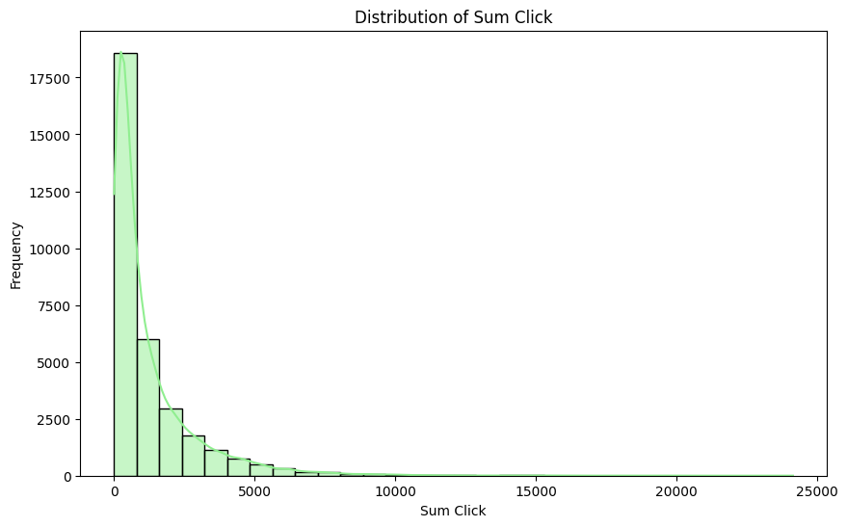

Figure 120: Histogram of Sum Click Distribution

The “Distribution of Sum Click” graph shown in Figure 120 illustrates the frequency distribution of total clicks recorded by students. The graph reveals a highly right-skewed distribution where the vast majority of students have low click counts, clustered around zero. There is a steep decline in frequency as the click counts increase, with very few students reaching higher click counts beyond 5,000. The highest recorded clicks are just under 25,000, but these are outliers in the dataset. This pattern suggests that most students engage minimally, while a small number show exceptionally high engagement. Understanding these distributions can help in identifying student engagement levels and tailoring interventions to boost overall participation.

#### Before Course Click Distribution

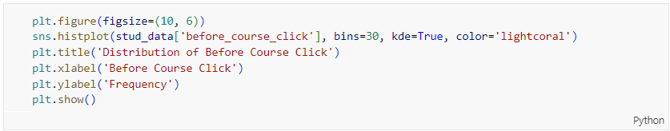

Figure 121: Source Code of Plotting Before Course Click Distribution by Histogram

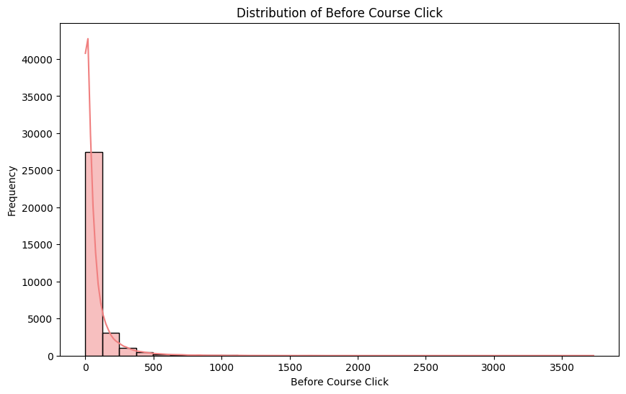

Figure 122: Histogram of Before Course Click Distribution

The “Distribution of Before Course Click” graph shown in Figure 122 depicts the frequency of clicks students made before the course started. The graph reveals a high right-skewed distribution, with the majority of students having click counts close to zero. This indicates minimal engagement before the course starts for most students. There is a steep drop in frequency as the number of clicks increases, with only a few students reaching higher click counts up to 3,500. The sharp peak at low click counts and the long tail extending towards higher counts suggest that pre-course engagement is limited for most, but a small group of students are highly engaged even before the course begins.

#### After Course Click Distribution

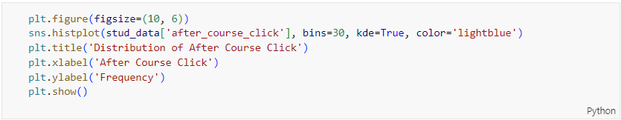

Figure 123: Source Code of Plotting After Course Click Distribution by Histogram

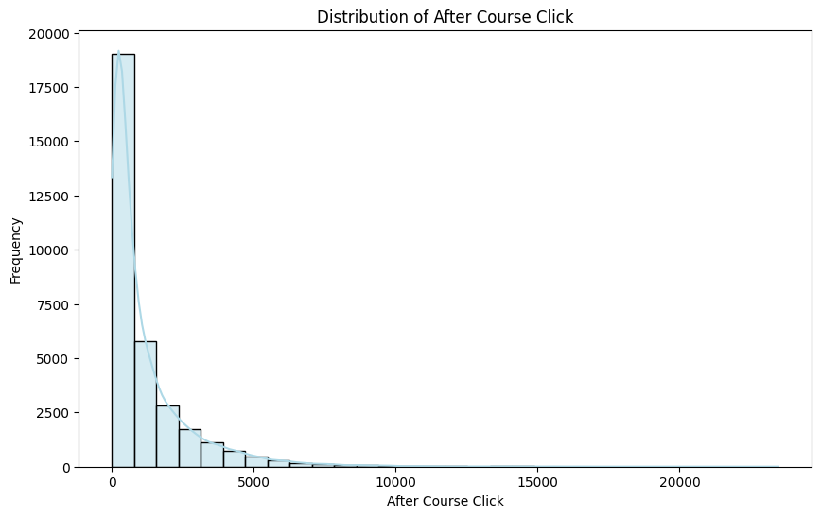

Figure 124: Histogram of After Course Click Distribution

The “Distribution of After Course Click” graph shown in Figure 124 illustrates the frequency of clicks students made after the course started. The distribution is highly right-skewed, indicating that the majority of students have very low click counts, clustered near zero. This suggests that most students engage minimally after the course ends. However, there is a long tail extending towards higher click counts, with some students reaching up to 20,000 clicks. This pattern highlights that while post-course engagement is generally low, a small subset of students continues to engage extensively.

#### Correlation Matrix

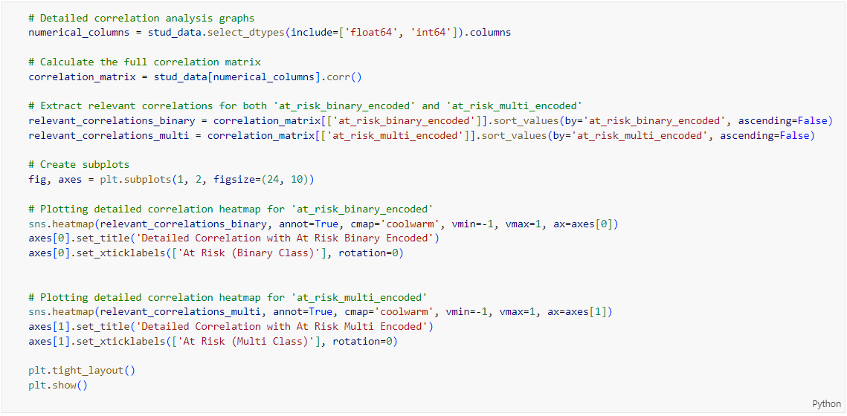

Figure 125: Source Code of Plotting Correlation Matrix of At Risk with Other Variables

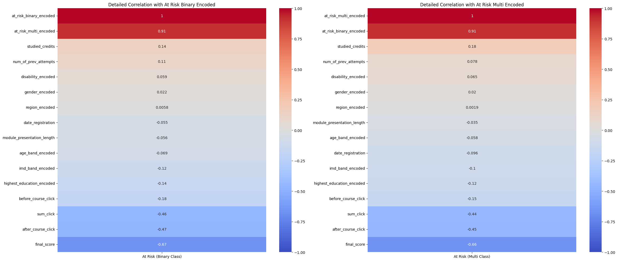

Figure 126: Correlation Matrix of At Risk with Other Variables

The correlation heatmaps shown in Figure 126 depict the relationships between various student features and their at-risk statuses, both in binary and multi-class formats. Several features show significant correlations with the at-risk statuses. For instance, the final score has a strong negative correlation (-0.67), indicating that higher final scores are associated with a lower risk of being classified as at-risk. Similarly, the sum of clicks also has a notable negative correlation (-0.46), implying that greater engagement (as measured by clicks) correlates with a reduced risk. Other features, such as the number of previous attempts and studied credits, exhibit moderate positive correlations, while demographic factors like age, gender and region show weaker correlations.

### Additional Analysis

#### Gender Split by At Risk Indicators

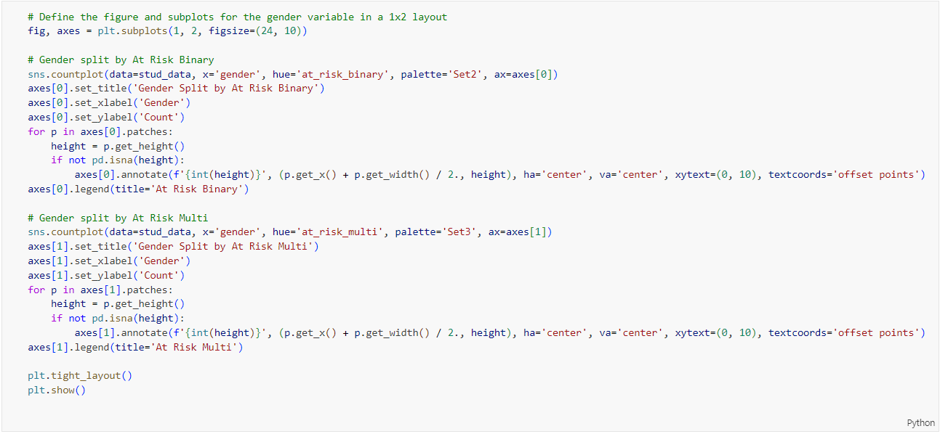

Figure 127: Source Code of Plotting Gender vs At Risk Indicators by Bar Chart

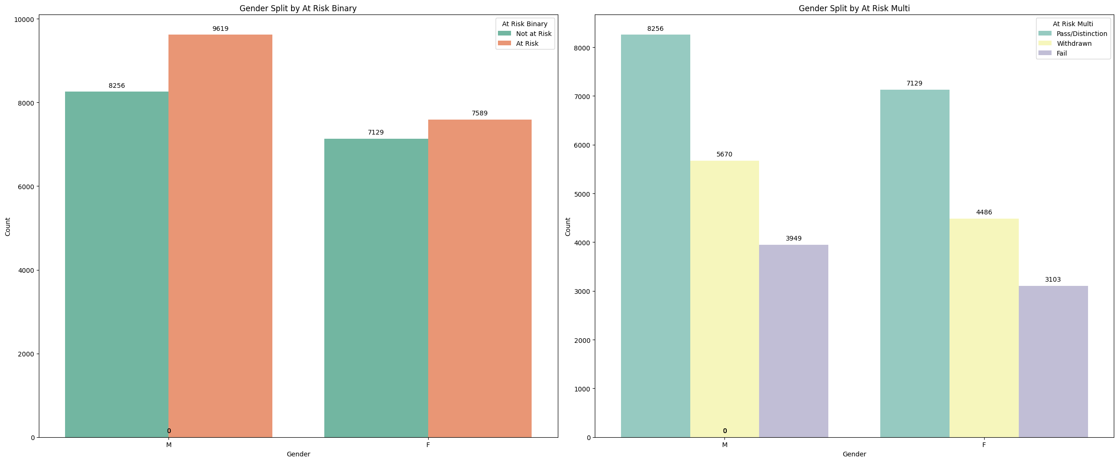

Figure 128: Bar Chart of Gender vs At Risk Indicators

The “Gender Split by At Risk Binary” graph shown in Figure 128 presents the distribution of male and female students categorized as either “Not at Risk” or “At Risk”. Among male students, 8,256 are not at risk while 9,619 are at risk, indicating a slightly higher number of at-risk students. For female students, 7,129 are not at risk and 7,589 are at risk, also showing a higher at-risk count but less pronounced than males. This suggests that both genders have a significant proportion of at-risk students, with males having a marginally higher absolute number of at-risk individuals.

The “Gender Split by At Risk Multi” graph further breaks down the at-risk categories into “Pass/Distinction”, “Withdrawn”, and “Fail”. For males, 8,256 students achieved a pass or distinction, 5,670 withdrew and 3,949 failed. For females, 7,129 achieved a pass of distinction, 4,486 withdrew, and 3,103 failed. This breakdown shows that, despite a significant number of at-risk students, a substantial portion manages to succeed academically. The data also highlights notable withdrawal and failure rates, with males having higher absolute counts in all categories.

#### Region Split by At Risk Indicators

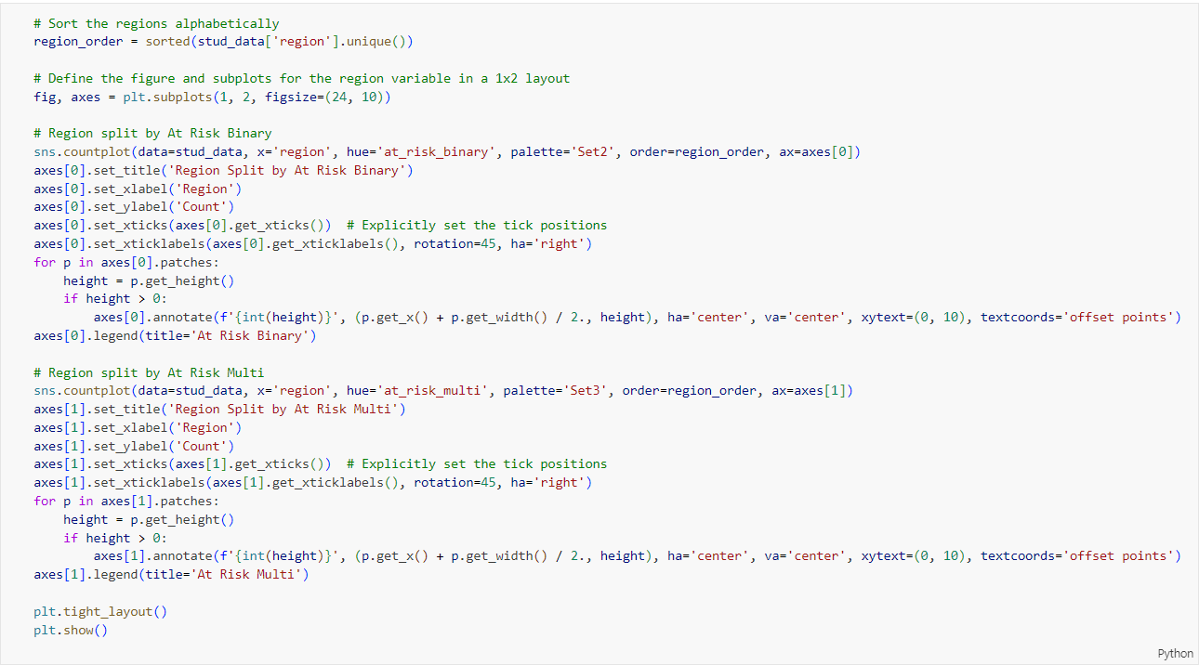

Figure 129: Source Code of Plotting Region vs At Risk Indicators by Bar Chart

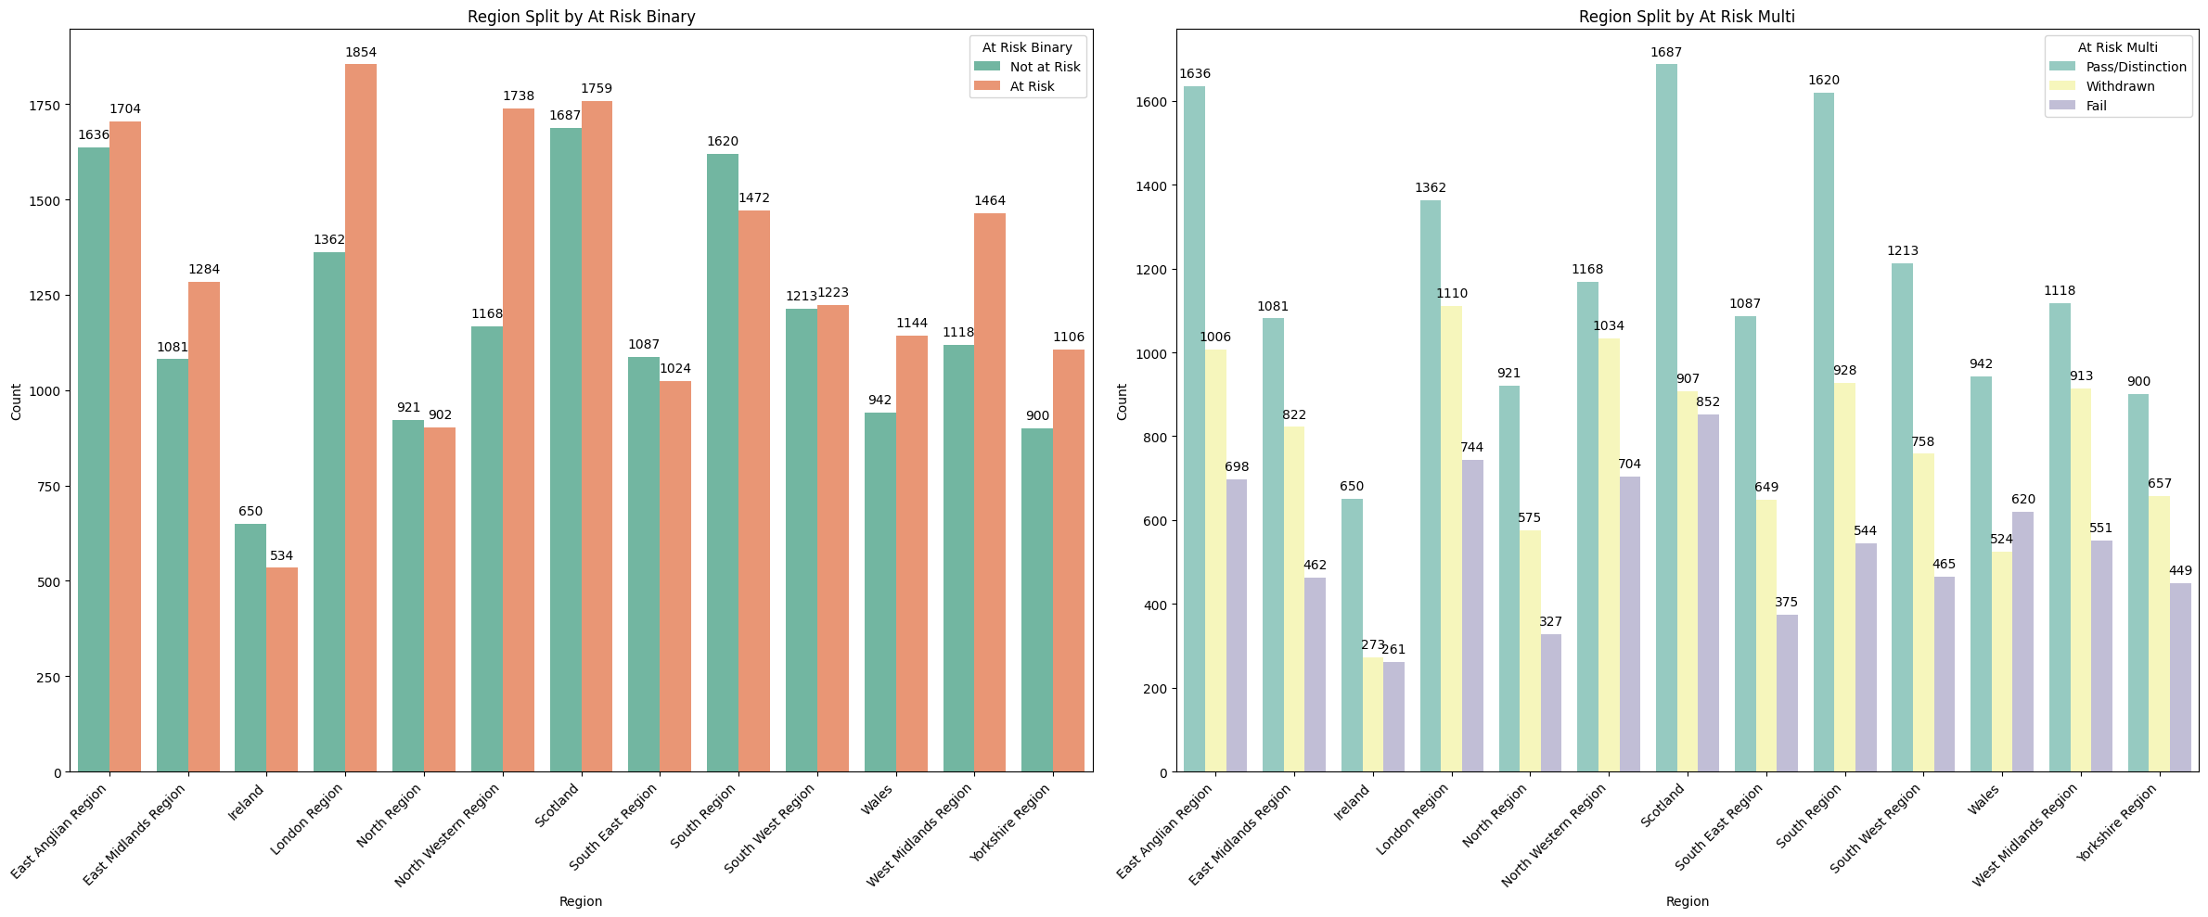

Figure 130: Bar Chart of Region vs At Risk Indicators

Based on Figure 130, the "Region Split by At Risk Binary" graph displays the distribution of students categorized as "Not at Risk" and "At Risk" across various regions. Each region shows a significant number of at-risk students, with notable variations. For example, the London Region has 1,854 at-risk students compared to 1,362 not at risk. Similar patterns are observed in other regions, such as the North Western Region with 1,738 at-risk and 1,168 not at risk. This suggests regional disparities in student risk levels, requiring targeted interventions based on geographic location.

The "Region Split by At Risk Multi" graph further breaks down these categories into "Pass/Distinction," "Withdrawn," and "Fail." For instance, in the Scotland, out of the total at-risk students, 1,687 achieved pass/distinction, 907 withdrew, and 852 failed. Similar detailed breakdowns are provided for other regions, showing varying success, withdrawal, and failure rates.

#### Highest Education Split by At Risk Indicators

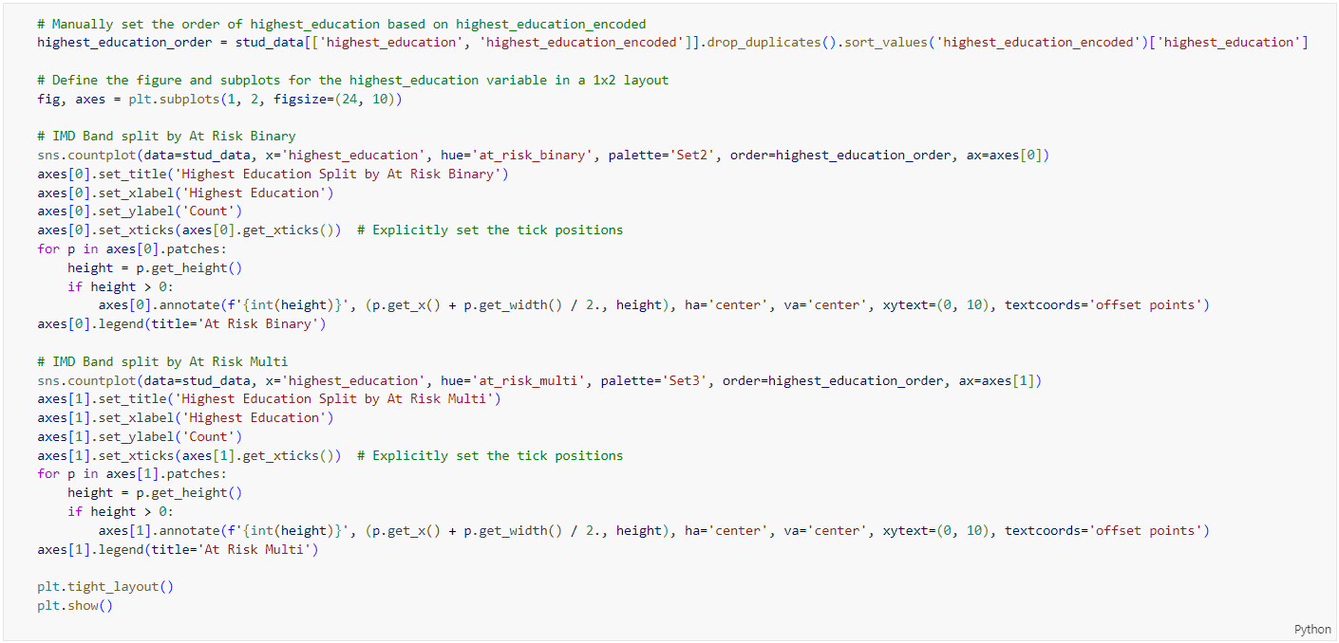

Figure 131: Source Code of Plotting Highest Education vs At Risk Indicators by Bar Chart

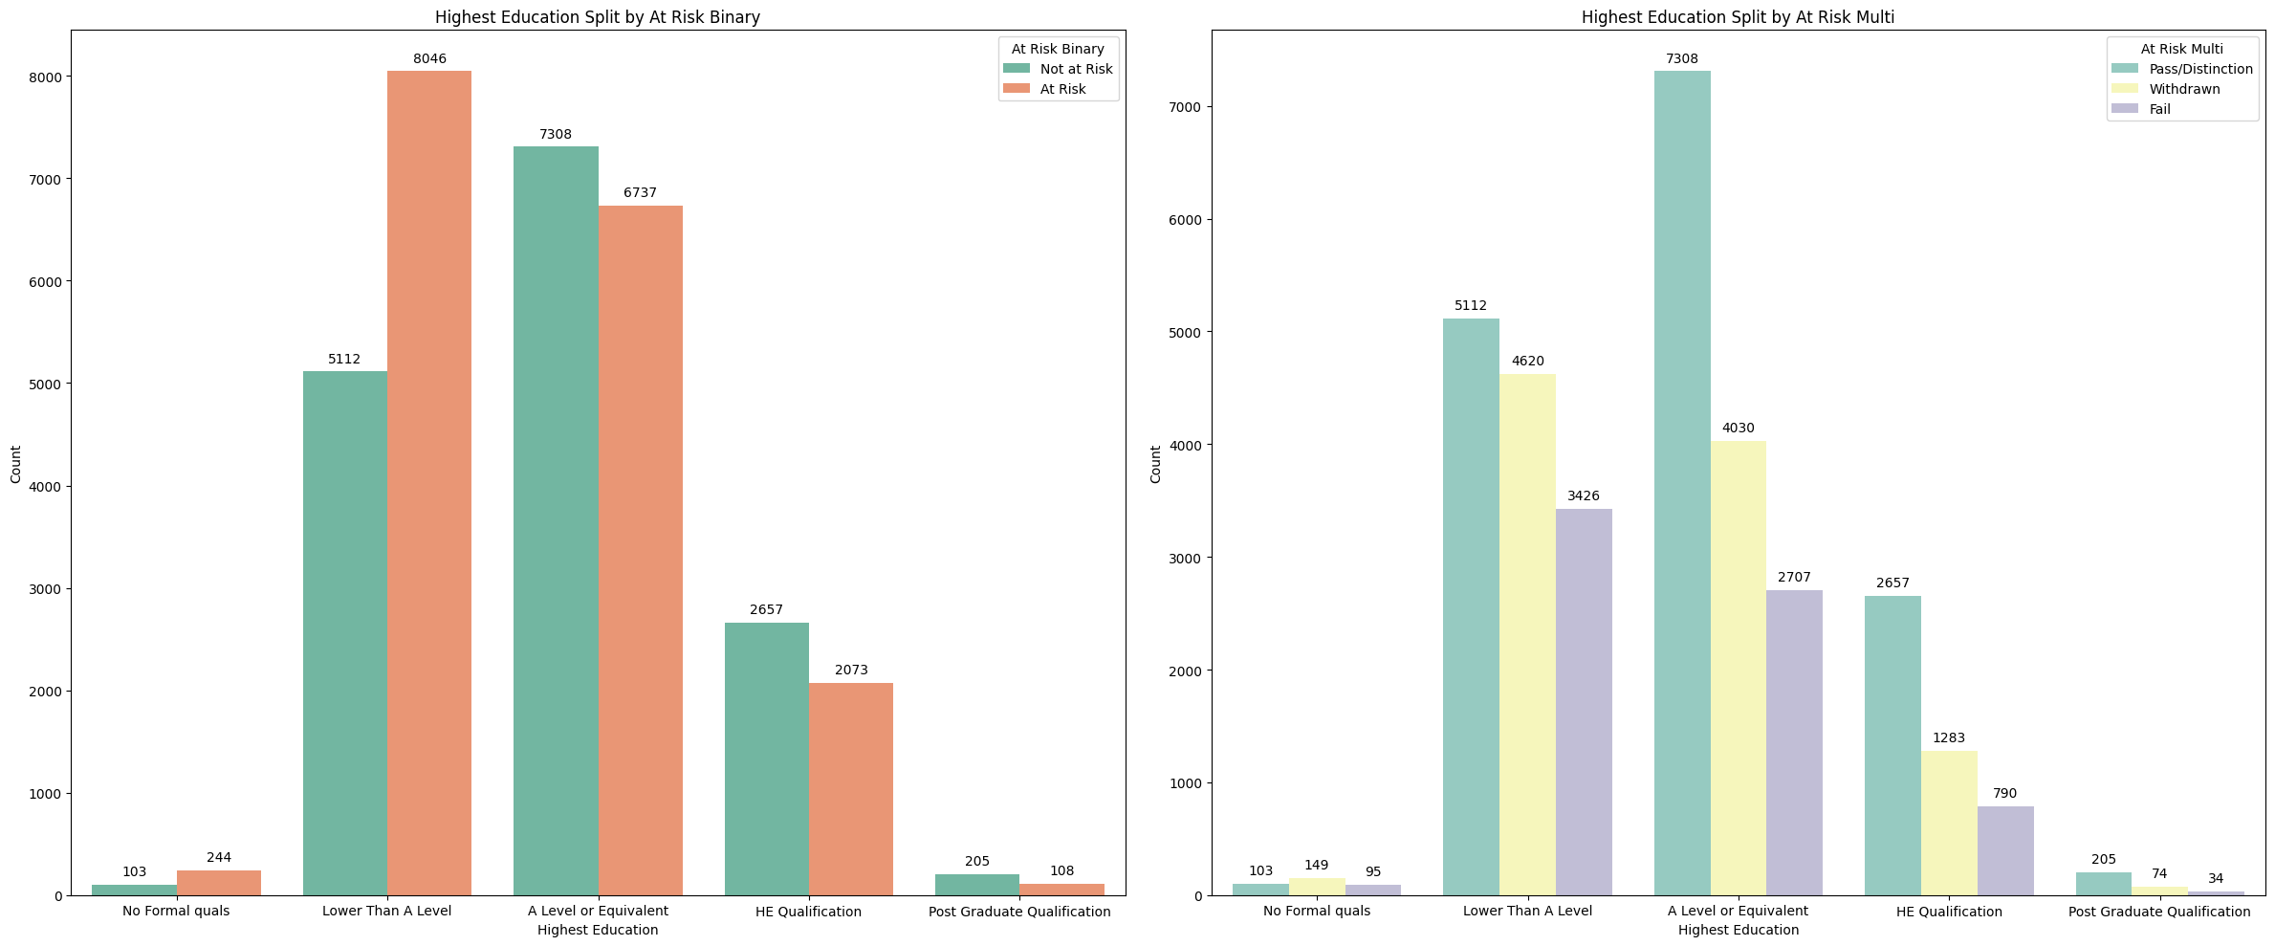

Figure 132: Bar Chart of Highest Education vs At Risk Indicators

Figure 132 presents two bar charts that analyse the highest level of education attained by individuals, segmented by their risk status. The first graph categorizes individuals by their highest level of education and whether they are at risk, divided into "Not at Risk" and "At Risk." Among individuals with no formal qualifications, 103 are not at risk while 244 are at risk. For those with qualifications lower than A-level, 5,112 are not at risk while 8,046 are at risk, showing a higher number of at-risk individuals. At the A-level or equivalent, there are 7,308 individuals not at risk and 6,737 at risk, indicating a relatively balanced distribution with a slight majority not at risk. For higher education (HE) qualifications, 2,657 individuals are not at risk compared to 2,073 at risk, showing more individuals not at risk. Lastly, among those with postgraduate qualifications, 205 are not at risk and 108 are at risk, with a clear majority not at risk.

Conversely, the right chart, “Highest Education Split by At Risk Multi”, provides a detailed categorization by splitting individuals into three risk categories: "Pass/Distinction," "Withdrawn," and "Fail." Among those with no formal qualifications, 103 have passed, 149 have withdrawn, and 95 have failed. For individuals with qualifications lower than A-level, 5,112 have passed, 4,620 have withdrawn, and 3,426 have failed, showing significant numbers in all categories with the highest in the pass category. At the A-level or equivalent, 7,308 have passed, 4,030 have withdrawn, and 2,707 have failed, indicating the highest number of passes. For higher education (HE) qualifications, 2,657 have passed, 1,283 have withdrawn, and 790 have failed, with the majority passing. Lastly, among those with postgraduate qualifications, 205 have passed, 74 have withdrawn, and 34 have failed, showing the highest success rate with fewer withdrawals and failures.

The first graph highlights that individuals with lower educational qualifications are more likely to be at risk, while those with higher qualifications are less likely to be at risk. The second graph provides a more detailed view, showing that higher education levels are associated with higher pass rates and lower rates of withdrawal and failure. Overall, higher educational qualifications correlate with better academic outcomes and fewer risks of academic failure or withdrawal.

#### Disability Split by At Risk Indicators

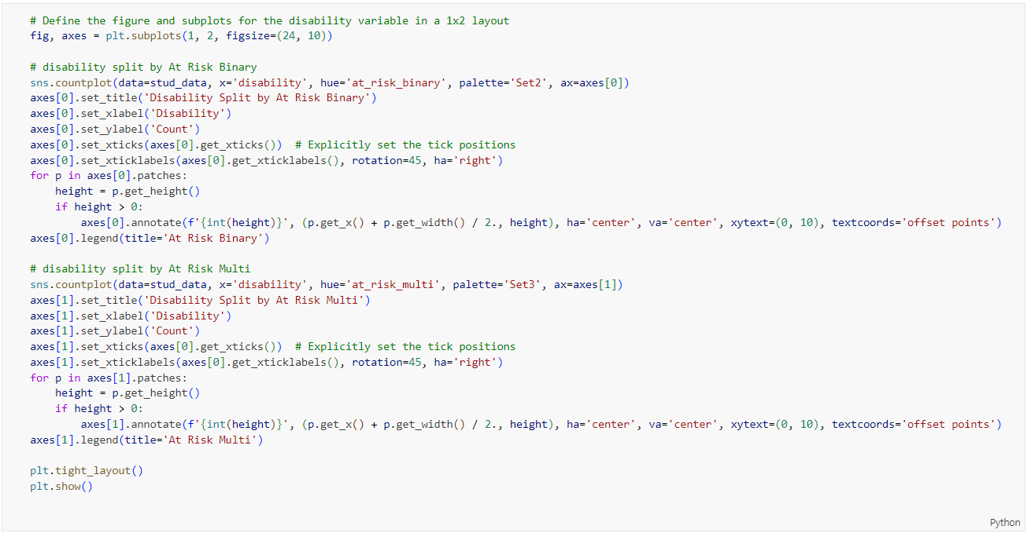

Figure 133: Source Code of Plotting Disability vs At Risk Indicators by Bar Chart

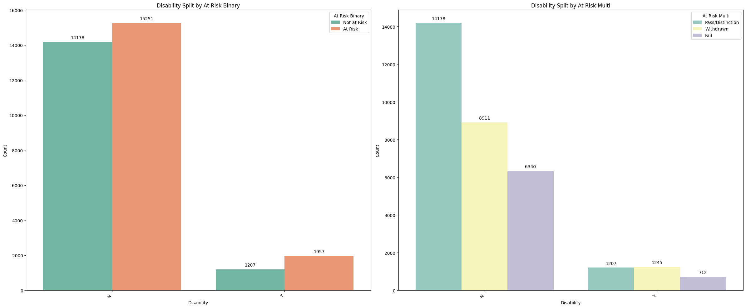

Figure 134: Bar Chart of Disability vs At Risk Indicators

The first graph shown in Figure 134 categorizes individuals by their disability status and whether they are at risk. For those without a disability, 14,178 are not at risk, while 15,251 are at risk, showing a higher number of at-risk individuals. Among those with a disability, 1,207 are not at risk, and 1,957 are at risk, again indicating more individuals at risk than not.

The second graph provides a detailed categorization of individuals by their disability status into three risk categories: "Pass/Distinction," "Withdrawn," and "Fail." Among individuals without a disability, 14,178 are classified as "Pass/Distinction," 8,911 as "Withdrawn," and 6,340 as "Fail." For individuals with a disability, 1,207 are "Pass/Distinction," 1,245 are "Withdrawn," and 712 are "Fail."

Both graphs highlight a higher proportion of at-risk individuals among both disabled and non-disabled groups. The first graph shows that individuals without a disability are more likely to be at risk than not, and this trend is also seen among those with a disability. The second graph breaks down the at-risk categories further, showing that a significant number of individuals withdraw or fail, particularly among those without a disability. The "Pass/Distinction" rate is higher for non-disabled individuals, while the disabled group has more balanced proportions among the three risk categories.

#### IMD Band Split by At Risk Indicators

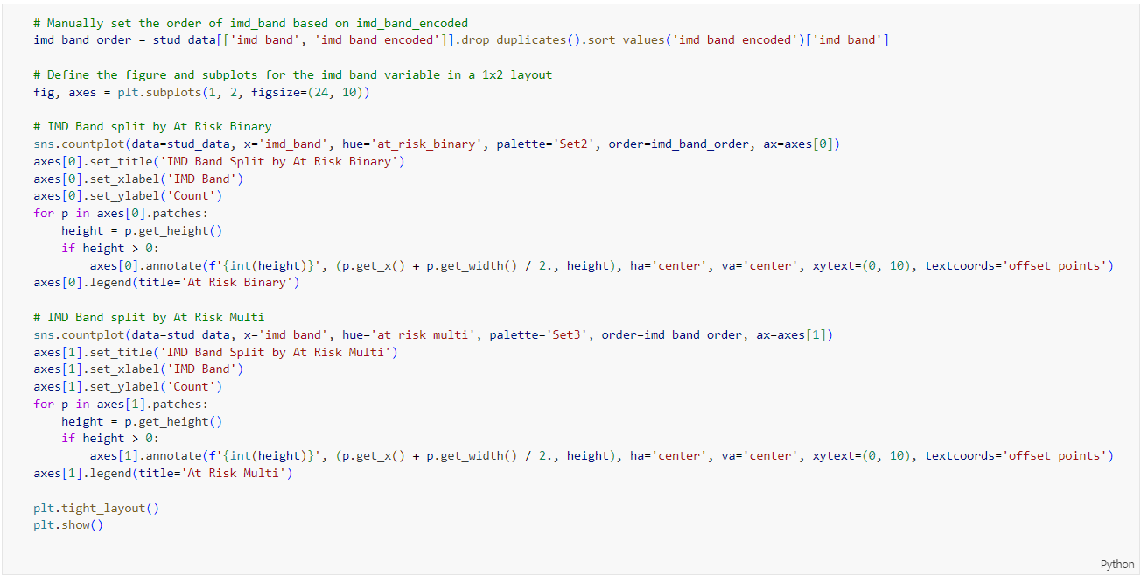

Figure 135: Source Code of Plotting IMD Band vs At Risk Indicators by Bar Chart

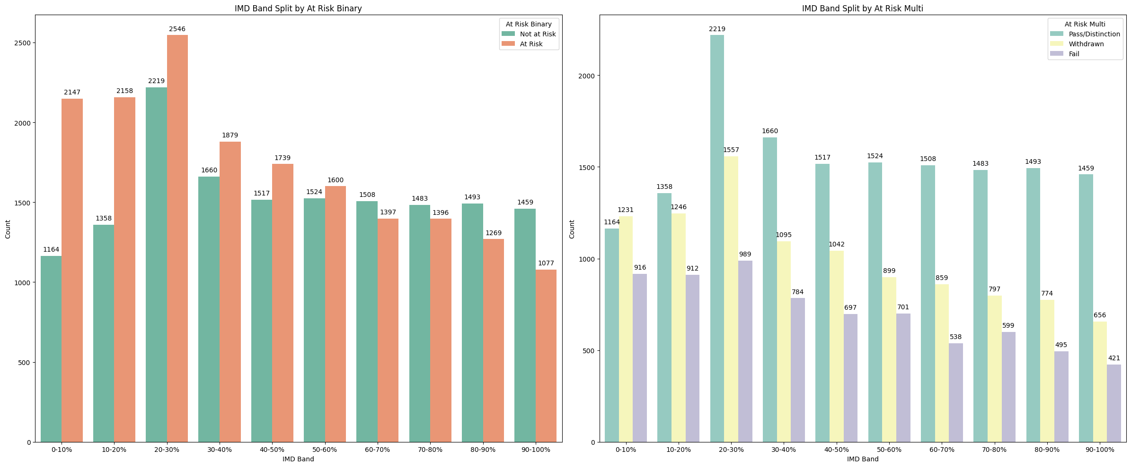

Figure 136: Bar Chart of IMD Band vs At Risk Indicators

The first graph shown in Figure 136 categorizes individuals by their IMD (Index of Multiple Deprivation) band and their at-risk status, split into “Not at Risk” and At Risk”. The most notable observation is within the 20-30% IMD band, where 2,546 individuals are at risk compared to 2,219 not at risk. This indicates a significantly higher number of at-risk individuals in this band. Another clear disparity is in the 0-10% IMD band, where 2,147 individuals are at risk compared to 1,164 not at risk, highlighting a considerable at-risk population among the most deprived.

The second graph provides a detailed categorization by splitting individuals into three risk categories: "Pass/Distinction," "Withdrawn," and "Fail." The 20-30% IMD band shows a significant number of individuals who have failed, with 2,219 failing compared to 1,557 passing and 989 withdrawing. Another notable observation is in the 0-10% IMD band, where 1,231 individuals have passed, 916 have withdrawn, and 912 have failed, indicating a relatively high failure and withdrawal rate among the most deprived.

Both graphs reveal that individuals in the 20-30% IMD band are significantly more at risk, with a higher number of failures compared to passes and withdrawals. Similarly, the 0-10% IMD band shows a high at-risk population, with substantial failure and withdrawal rates. These findings suggest that individuals in more deprived IMD bands face greater academic risks and challenges, highlighting the need for targeted support and intervention for these groups.

#### Final Score Split by At Risk Indicators

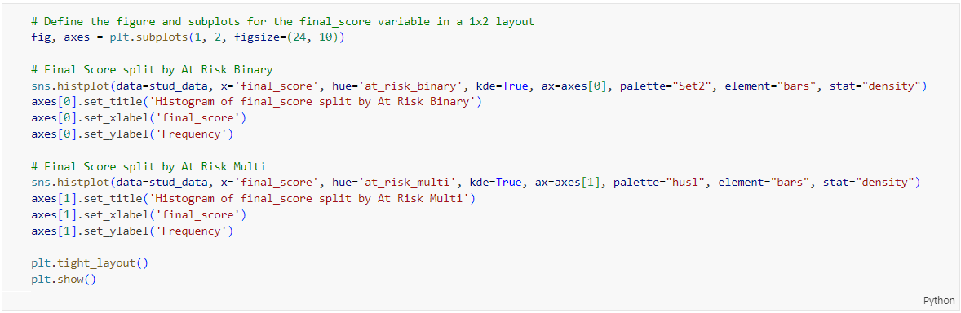

Figure 137: Source Code of Final Score vs At Risk Indicators by Histogram

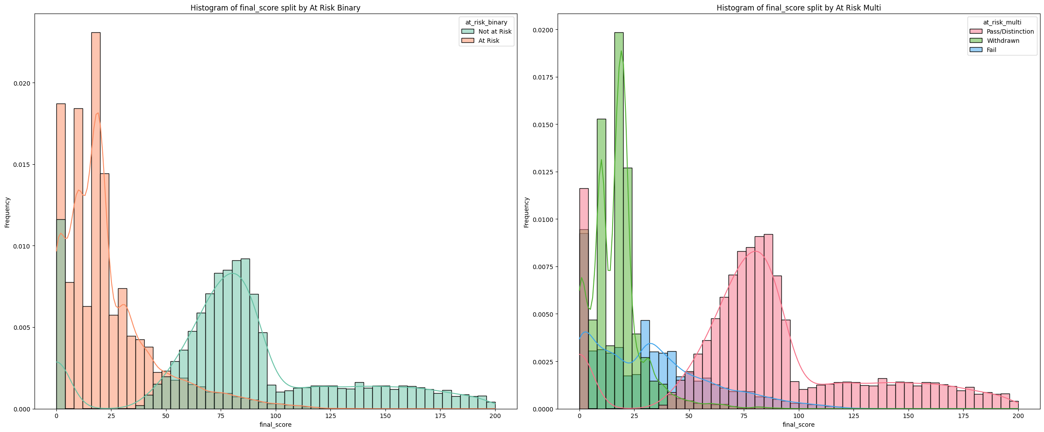

Figure 138: Histogram of Final Score vs At Risk Indicators

The first graph shown in Figure 138 shows the distribution of final scores split into "Not at Risk" and "At Risk" categories. The at-risk group has a higher concentration of individuals with lower final scores, peaking around the 0-25 range. In contrast, the not at-risk group shows a higher concentration of individuals with higher final scores, with a notable peak around the 75-100 range. This indicates that individuals at risk tend to have significantly lower final scores compared to those not at risk.

The second graph provides a more detailed categorization by splitting final scores into three risk categories: "Pass/Distinction," "Withdrawn," and "Fail." Individuals who passed or received a distinction are concentrated in the higher final score range, primarily around 75-100. The withdrawn and fail categories show higher concentrations in the lower final score ranges, particularly around 0-25. The fail category also has a significant presence in the 25-50 range, indicating a spread of lower scores. This distribution highlights that higher final scores are strongly associated with passing, while lower scores are more common among those who withdraw or fail.

The histograms reveal a clear distinction in final scores based on risk status. The at-risk group predominantly has lower final scores, peaking around 0-25, while the not at-risk group has higher scores, peaking around 75-100. In the more detailed categorization, those who pass or receive distinctions are concentrated in the higher final score range (75-100), whereas those who withdraw or fail are primarily in the lower score ranges (0-25 and 25-50). This underscores the correlation between higher academic performance and reduced risk, with lower scores indicating a higher likelihood of withdrawal or failure.

#### Before Course Click Split by At Risk Indicators

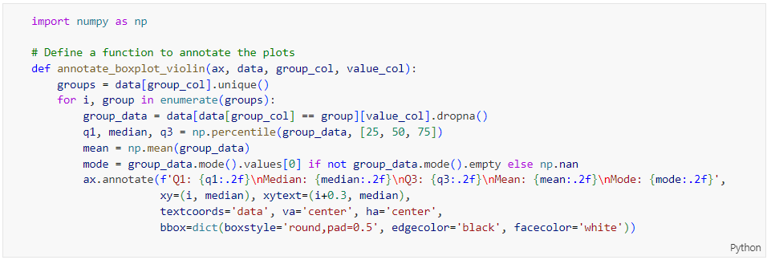

Figure 139: Source Code of Annotating Boxplot

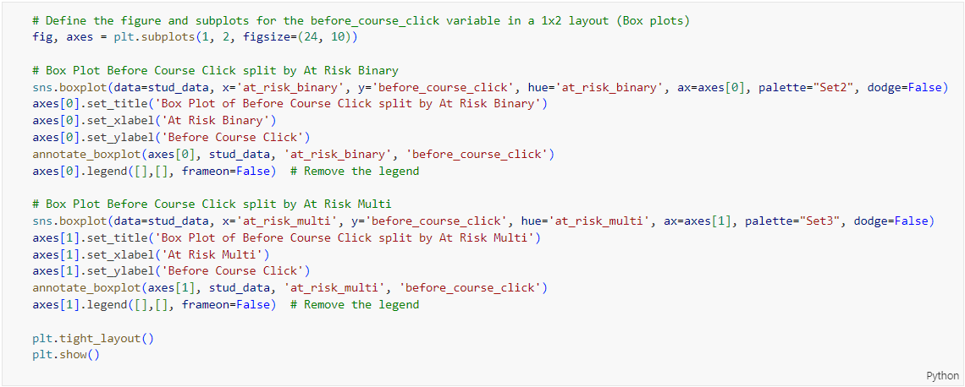

Figure 140:Source Code of Plotting Before Course Click vs At Risk Indicators by Boxplot

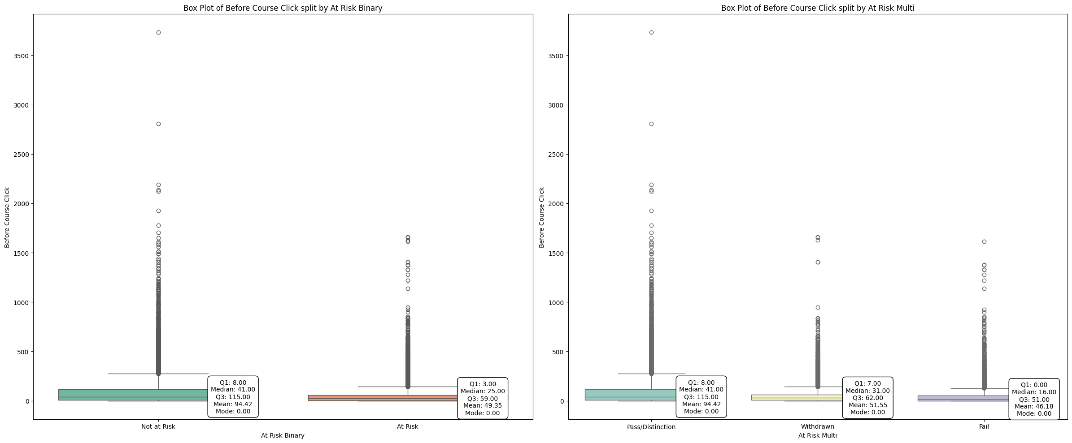

Figure 141: Boxplot of before Course Click vs At Risk Indicators

The first box plot shown in Figure 141 comparing "Not at Risk" and "At Risk" categories reveals a significant difference in engagement levels before the course started. For individuals classified as "Not at Risk," the median number of clicks is 41, with a mean of 94.42. There are notable outliers, with some click counts reaching up to around 3500, indicating a few highly engaged individuals. Conversely, the "At Risk" group has a lower median of 25 clicks and a mean of 49.35, showing less engagement. This suggests that individuals who are not at risk tend to engage more with the course material before it begins.

The box plot on the right shown in Figure 141 breaks down the engagement levels into "Pass/Distinction," "Withdrawn," and "Fail" categories. The "Pass/Distinction" group shows a higher median of 41 clicks and a mean of 94.42, indicating strong engagement before the course. The "Withdrawn" group has a median of 31 clicks and a mean of 51.55, showing moderate engagement levels. The "Fail" group has the lowest median of 16 clicks and a mean of 46.18, indicating the least engagement before the course.

The box plots clearly show that higher engagement before the course starts is associated with better academic outcomes. Individuals who are not at risk or who achieve a pass/distinction tend to have higher median and mean click counts before the course begins. In contrast, those at risk, who withdraw, or who fail have significantly lower engagement levels. This suggests that encouraging more interaction with course materials before the course starts could potentially lead to better academic performance and reduce the likelihood of being at risk, withdrawing, or failing.

#### After Course Click Split by At Risk Indicators

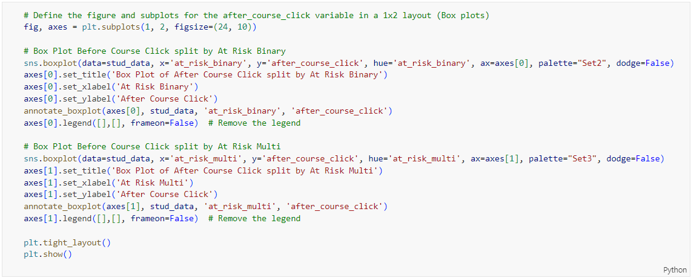

Figure 142: Source Code of Plotting After Course Click vs At Risk Indicators by Boxplot

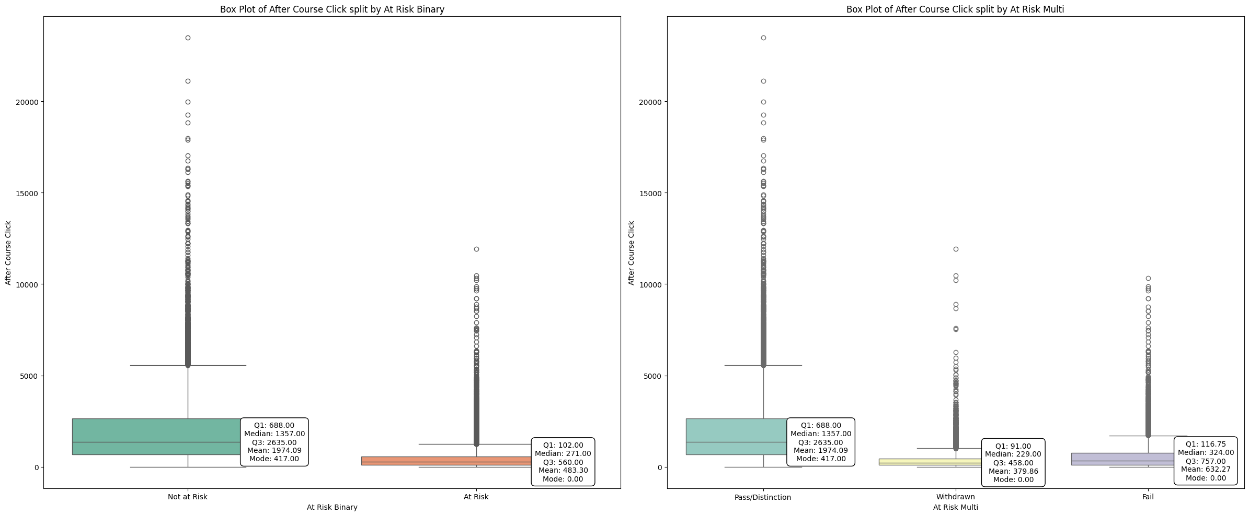

Figure 143: Boxplot of After Course Click vs At Risk Indicators

The first box plot for "Not at Risk" vs "At Risk" categories shown in Figure 143 reveals a significant difference in post-course engagement. The "Not at Risk" group has a median of 1,357 clicks and a mean of 1,974.09 clicks, indicating higher engagement after the course. In contrast, the "At Risk" group has a much lower median of 271 clicks and a mean of 488.30 clicks. This suggests that individuals who are not at risk tend to engage more with the course materials after the course ends.

In the second box plot, focusing on the "Pass/Distinction" and "Withdrawn" categories, the "Pass/Distinction" group has a median of 1,357 clicks and a mean of 1,974.09 clicks, showing high engagement levels post-course. The "Withdrawn" group has a median of 229 clicks and a mean of 379.86 clicks, indicating significantly lower engagement. This stark difference highlights that continued engagement after the course is strongly associated with passing, while lower engagement is linked to withdrawal.

The box plots highlight that individuals who are not at risk or who pass the course with distinction show significantly higher engagement levels after the course ends, as reflected in their higher median and mean click counts. Conversely, those at risk or who withdraw from the course exhibit much lower engagement levels. This suggests that post-course engagement is a critical factor in academic success and reducing the risk of withdrawal.

#### Sum Click Split by At Risk Indicators

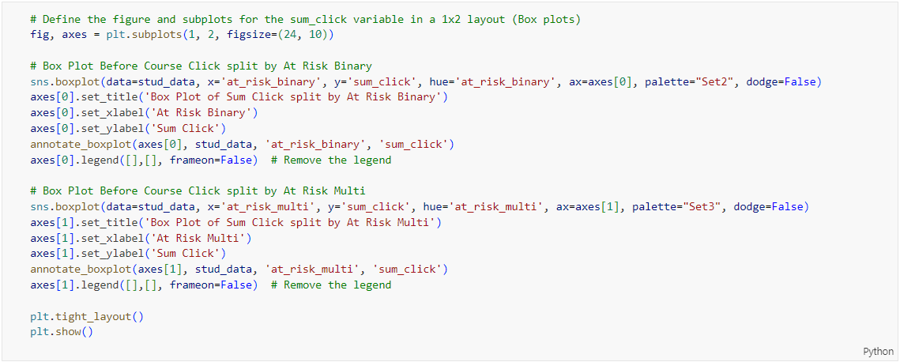

Figure 144: Source Code of Plotting Sum Click vs At Risk Indicators by Boxplot

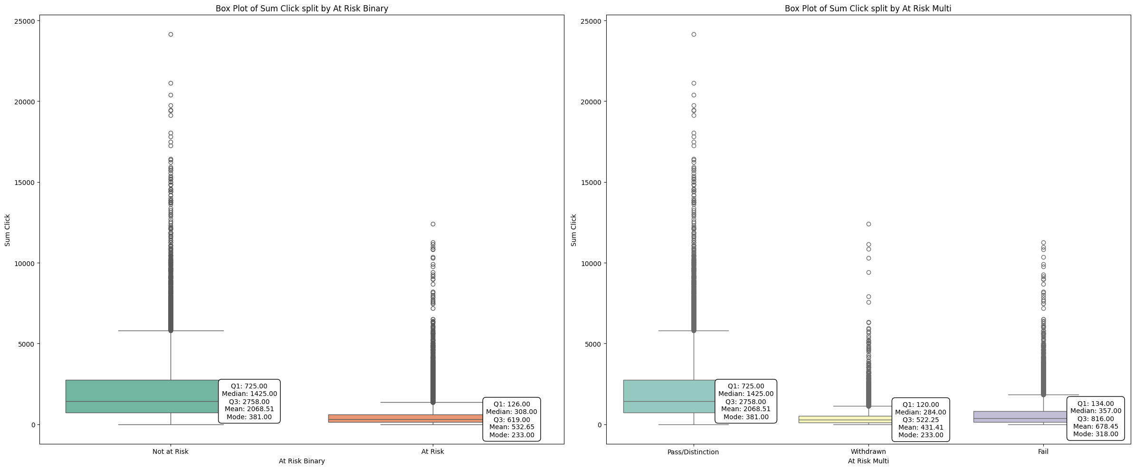

Figure 145: Boxplot of Sum Click vs At Risk Indicators

The box plot for "Not at Risk" vs "At Risk" categories shown in Figure 145 reveals a significant difference in total engagement levels. The "Not at Risk" group has a median of 1,425 clicks and a mean of 2,068.51 clicks, with outliers reaching up to 25,000 clicks. This indicates a high level of overall engagement. In contrast, the "At Risk" group shows a much lower median of 308 clicks and a mean of 532.65 clicks, suggesting significantly less engagement.

When breaking down the total clicks into "Pass/Distinction" and "Withdrawn" categories, the "Pass/Distinction" group shows a median of 1,425 clicks and a mean of 2,068.51 clicks, reflecting high engagement. The "Withdrawn" group has a median of 284 clicks and a mean of 431.41 clicks, indicating much lower engagement. This stark difference highlights that continued engagement is associated with passing, while lower engagement is linked to withdrawal.

The box plots clearly show that individuals who are not at risk or who achieve a pass or distinction have significantly higher engagement levels, as indicated by their higher median and mean click counts. Those who are at risk or who withdraw from the course exhibit much lower engagement levels. This suggests that high levels of interaction with course materials are crucial for academic success and reducing the risk of withdrawal.

## Model Building

### Binary Classification

#### Data Preparation

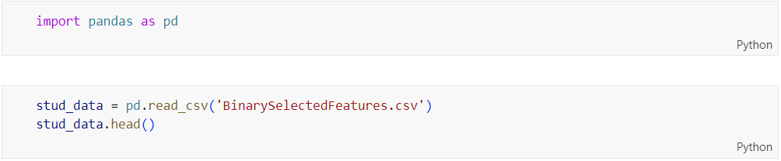

Figure 146: Source Code of Importing Library and Reading Dataset

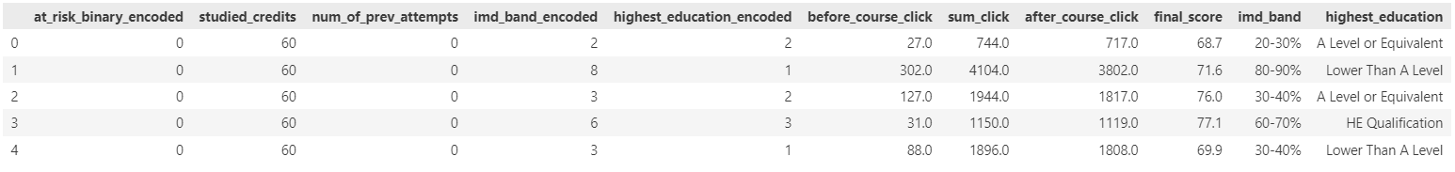

Figure 147: Output of Showing First 5 Rows of the Dataset

The code shown in Figure 146 reads a CSV file named ‘BinarySelectedFeatures.csv’ into a pandas DataFrame called ‘**stud_data**’ and then displays the first five rows of this DataFrame using the ‘**head()**’ method as shown in Figure 147. This CSV file is the output of preprocessing steps on the OULAD (Open University Learning Analytics Dataset), containing only the selected features based on the correlation matrix.

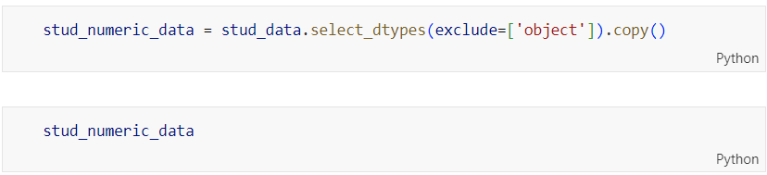

Figure 148: Source Code of Excluding Object Data Types

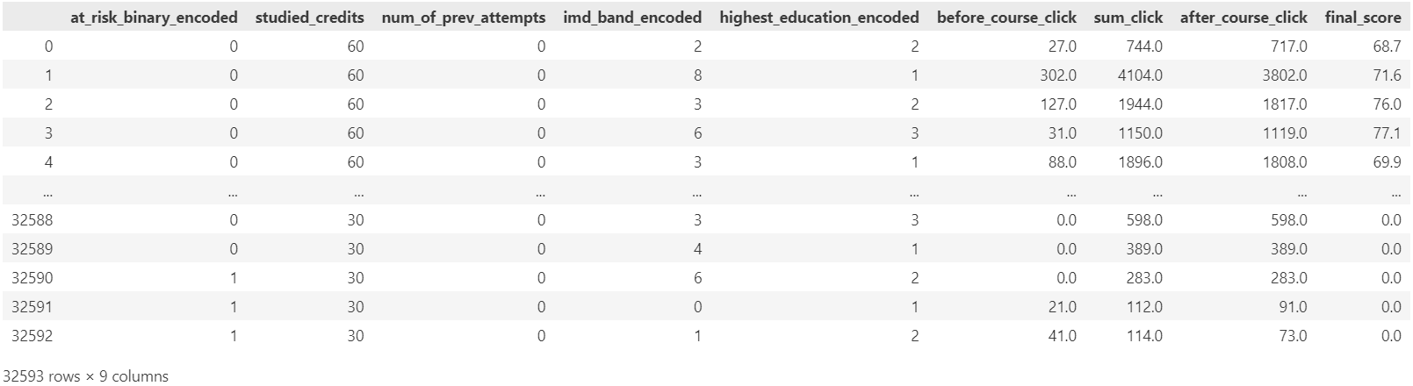

Figure 149: Output of ‘stud_numeric_data’ DataFrame

The code shown in Figure 148 selects only the numeric columns from the DataFrame ‘**stud_data**’, excluding any columns with data type ‘object’. It then creates a copy of this subset of the DataFrame and stores it in a new DataFrame called ‘**stud_numeric_data**’. Finally, it displays the ‘**stud_numeric_data**’ DataFrame. This step is useful for focusing on numerical data for machine learning tasks. The displayed output shown in Figure 149 shows the ‘**stud_numeric_data**’ DataFrame, which consist of 32,593 rows and 9 columns.

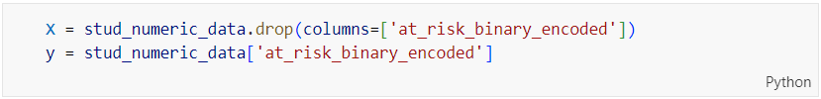

Figure 150: Source Code of Separating into X (features) and y (target)

Figure 150 shows the code separating the features and the target variable from the ‘**stud_numeric_data**’ DataFrame for use in machine learning models in next step. It first creates a new DataFrame ’**X**’ that contains all the columns from ‘**stud_numeric_data**’ except the at_risk_binary_encoded column. This DataFrame ‘**X**’ will serve as the feature set for the model. The second line extracts the at_risk_binary_encoded column from ‘**stud_numeric_data**’ and stores it in the variable ‘**y**’, which will serve as the target variable for the model. This separation is essential for supervised learning tasks, where ‘**X**’ contains the input features and ‘**y**’ contains the labels to be predicted.

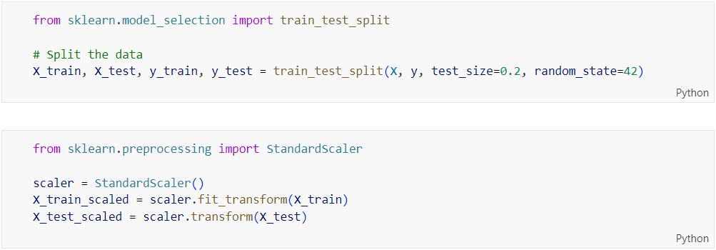

Figure 151: Source Code of Splitting and Scaling Training and Testing Set

The code shown in Figure 151 performs data splitting and scaling, which are essential steps in preparing data for machine learning models. It first imports the ‘**train_test_split**’ function from ‘**sklearn.model_selection**’ to divide the dataset into training and testing sets. The ‘**train_test_split**’ function is used to split the features and target variable into training sets (‘**X_train**’, ‘**y_train**’) and testing sets (‘**X_test**’, ‘**y_test**’). The ‘**test_size=0.2**’ parameter specifies that 20% of the data will be used for testing, while the remaining 80% will be used for training. The ‘**random_state=42**’ parameter ensures that the split is reproducible. In other words, every time the code is executed with the same data and the same ‘**random_state**’ value, the same split of data will be obtained. This consistency is important for comparing results across different runs of experiments.

Next, the code imports ‘**StandardScaler**’ from ‘**sklearn.preprocessing**’ and creates an instance of it called ‘**scaler**’. The ‘**StandardScaler**’ standardizes the features by removing the mean and scaling to unit variance. The ‘**fit_transform**’ method is applied to ‘**X_train**’ to compute the mean and standard deviation on the training data and then scale it. The ‘**transform**’ method is then applied to ‘**X_test**’ to scale the test data using the same parameters obtained from the training data. This ensures that the training and testing data are scaled consistently.

#### Model Building with Logistic Regression

##### Before Hyperparameter Tuning

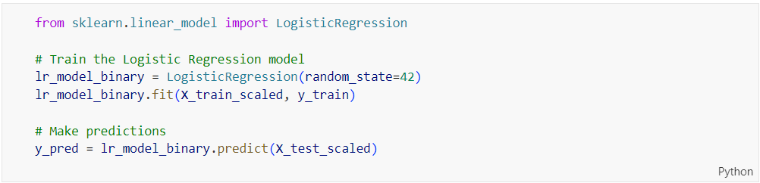

Figure 152: Source Code of Building Logistic Regression Model

The code shown in Figure 152 imports the ‘**LogisticRegression**’ class from ‘**sklearn.linear_model**’ and uses it to train a logistic regression model on the scaled training data. A logistic regression model instance, ‘**lr_model_binary**’, is created with ‘**random_state=42**’ to ensure reproducibility. The model is then trained using the ‘**fit**’ method, which takes the scaled training features (‘**X_train**’) and the corresponding target values (‘**y_train**’). After training, the model is used to make predictions on the scaled test features (‘**X_test_scaled**’) using the ‘**predict**’ method. The predictions are stored in the variable ‘**y_pred**’. The performances of all models including the source codes are evaluated on next chapter, specifically on Chapter 5.2.

##### After Hyperparameter Tuning

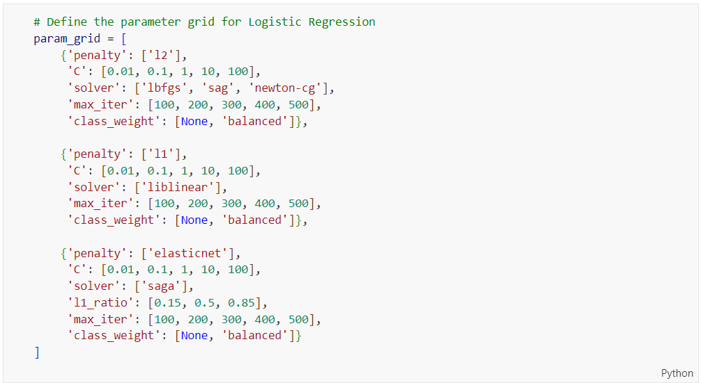

Figure 153: Source Code of Defining the Parameter Grid for Logistic Regression Model

The code shown in Figure 153 defines a parameter grid ‘**param_grid**’ for tuning a Logistic Regression model using grid search. Three different penalty types (‘**l2**’, ‘**l1**’, ‘**elasticnet**’) are specified, each with their respective compatible solvers (‘**lbfgs**’, ‘**sag**’, ‘**newton-cg**’ for ‘**l2**’; ‘**liblinear**’ for ‘**l1**’; ‘**saga**’ for ‘**elasticnet**’). For each penalty type, a range of regularization strengths (‘**C**’ values), maximum iterations (‘**max_iter**’) and class weights (‘**class_weight**’) are provided. Additionally, for the ‘**elasticnet**’ penalty, different values for the ‘**l1_ratio**’ parameter are included.

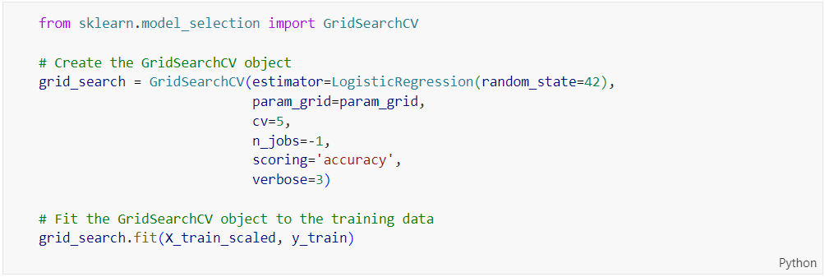

Figure 154: Source Code of Performing Hyperparameter Tuning using GridSearchCV for Logistic Regression

The code shown in Figure 154 creates a ‘**GridSearchCV**’ object for tuning the hyperparameters of a Logistic Regression model. The ‘**GridSearchCV**’ is initialized with the logistic regression estimator, the previously defined parameter grid (‘**param_grid**’), 5-fold-cross-validation (‘**cv=5**’), parallel processing (‘**n_jobs=-1**’), accuracy as the scoring metric (‘**scoring=’accuracy’**’), and verbosity level 3 (‘**verbose=3**’). The ‘**fit**’ method is then called on the ‘**GridSearchCV**’ object to perform the grid search on the scaled training data (‘**X_train_scaled**’, ‘**y_train**’), finding the best combination of hyperparameters.

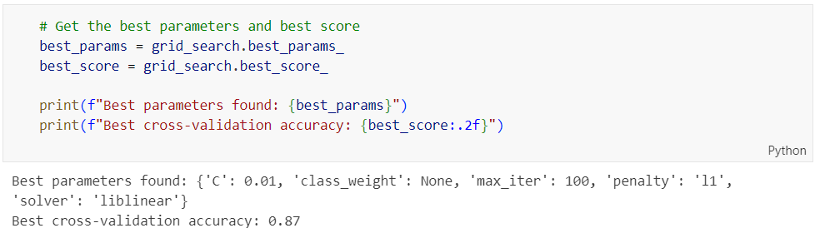

Figure 155: Source Code of Retrieving the Best Parameters and Score from GridSearchCV for Logistic Regression

The code shown in Figure 155 retrieves the best hyperparameters and the best score found by the ‘**GridSearchCV**’ object after fitting it to the training data. The best parameters are accessed using ‘**grid_search.best_params_**’, and the best cross-validation accuracy is accessed using ‘**grid_search.best_score_**’. These values are then printed, with the best parameters displayed in a dictionary format and the best score formatted to two decimal places.

The optimal set of hyperparameters for the Logistic Regression model are ‘**c**’: 0.01, ‘**class_weight**’: None, ‘**max_iter**’: 100, ‘**penalty**’: ‘l1’, and ‘**solver**’: ‘liblinear’. These parameters were chosen because they resulted in the best performance during the cross-validation process. The highest accuracy achieved during the 5-fold cross-validation process is 0.87, indicating the model’s ability to correctly classify 87% of the samples on average during cross-validation.

#### Model Building with Decision Tree

##### Before Hyperparameter Tuning

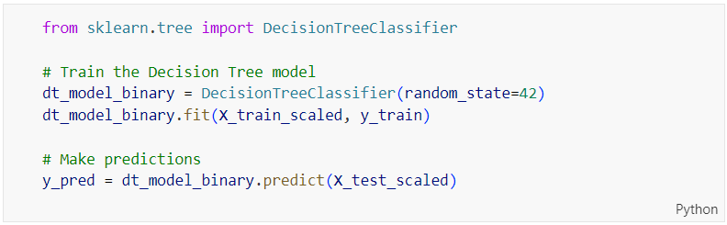

Figure 156: Source Code of Training and Making Predictions with a Decision Tree Model

The code shown in Figure 156 imports the ‘**DecisionTreeClassifier**’ from ‘**sklearn.tree**’ and uses it to train a decision tree model. The model is instantiated with ‘**random_state=42**’ to ensure reproducibility and is trained using the ‘**fit’** method on the scaled training data (‘**X_train_scaled**’, ‘**y_train**’). After training, the model makes predictions on the scaled test data (‘**X_test_scaled**’) using the ‘**predict**’ method, with the predictions stored in ‘**y_pred**’

##### After Hyperparameter Tuning

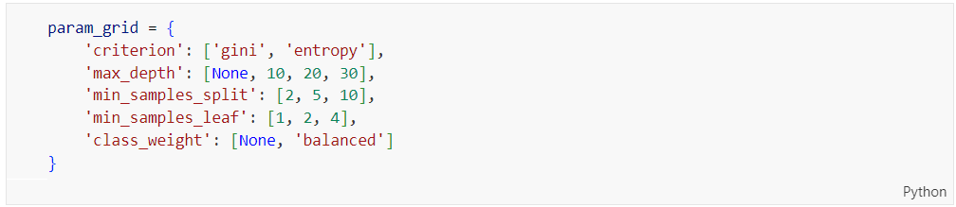

Figure 157: Source Code of Defining the Parameter Grid for Decision Tree Tuning

The code shown in Figure 157 defines a parameter grid ‘**param_grid**’ for tuning a Decision Tree model using grid search. This grid includes various hyperparameters and their potential values: ‘**criterion**’, which can be either ‘gini’ or ‘entropy’, determines the function used to measure the quality of a split; ‘**max_depth**’, which includes values None, 10, 20 and 30, specifies the maximum depth of the tree; ‘**min_samples_split**’, with values 2, 5, and 10, sets the minimum number of samples required to split an internal node; ‘**min_samples_leaf**’, with values 1,2 and 4, defines the minimum number of samples required to be at a leaf node; and ‘**class_weight**’, which can be None or ‘balanced’, handle class imbalance. These parameters are used to find the optimal combination for the Decision Tree model through the grid search process.

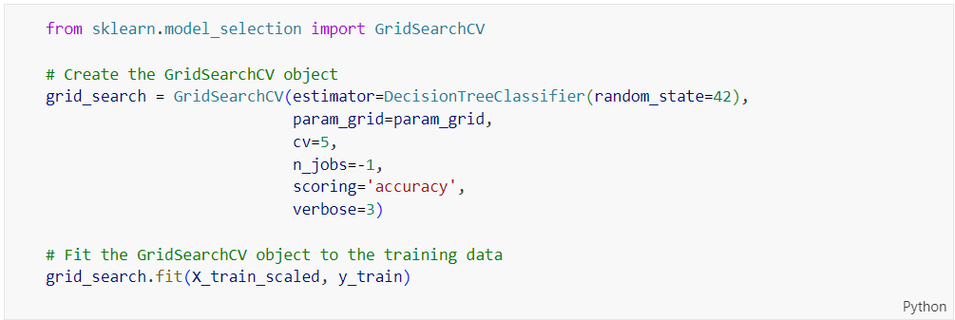

Figure 158: Source Code of Performing Hyperparameter Tuning using GridSearchCV for Decision Tree

The code shown in Figure 158 creates a ‘**GridSearchCV**’ object for tuning the hyperparameters of a Decision Tree model. The ‘**GridSearchCV**’ is initialized with the decision tree estimator, the previously defined parameter grid (‘**param_grid**’), 5-fold cross-validation (‘**cv=5**’), parallel processing (‘**n_jobs=-1**’), accuracy as the scoring metric (‘**scoring=’accuracy’**), and verbosity level 3 (‘**verbose=3**’). The ‘**fit**’ method is then called on the ‘**GridSearchCV**’ object to perform the grid search on the scaled training data (‘**X_train_scaled**’, ‘**y_train**’), finding the best combination of hyperparameters.

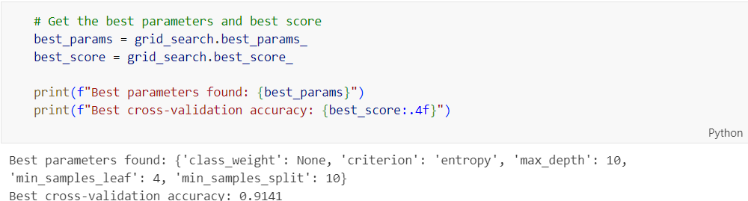

Figure 159: Source Code of Retrieving the Best Parameters and Score from GridSearchCV for Decision Tree

The code shown in Figure 159 retrieves and displays the best hyperparameters and the corresponding cross-validation accuracy found by ‘**GridSearchCV**’ after fitting it to the training data. The best hyperparameters are accessed using ‘**grid_search.best_params_**’, and the best cross-validation accuracy is accessed using ‘**grid_search.best_score_**’. These values are then printed, with the best parameters displayed in a dictionary format and the best score formatted to four decimal places. The optimal hyperparameters for the Decision Tree model are ‘**class_weight**’: None, ‘**criterion**’: ‘entropy’, ‘**max_depth**’: 10, ‘**min_samples_leaf**’: 4, and ‘**min_samples_split**’: 10. These parameters were chosen because they resulted in the best performance during the cross-validation process. The highest accuracy achieved during the 5-fold cross-validation process is 0.9141, indicating the model’s ability to correctly classify 91.41% of the samples on average during cross-validation.

#### Model Building with Random Forest

##### Before Hyperparameter Tuning

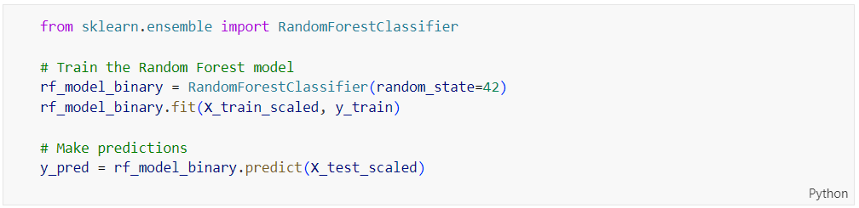

Figure 160: Source Code of Training and Making Predictions with a Random Forest Model

The code shown in Figure 160 trains a Random Forest model and makes predictions using the trained model. It begins by importing the ‘**RandomForestClassifier**’ from ‘**sklearn.ensemble**’. The model ‘**rf_model_binary**’ is instantiated with a ‘**random_state**’ of 42 to ensure reproducibility. The ‘**fit**’ method is then used to train the model on the scaled training data (‘**X_train_scaled**’, ‘**y_train**’). After training, the model makes predictions on the scaled test data (‘**X_test_scaled**’) using the ‘**predict**’ method, and these predictions are stored in ‘**y_pred**’.

##### After Hyperparameter Tuning

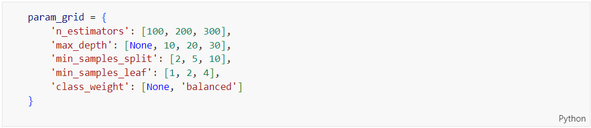

Figure 161: Source Code of Defining the Parameter Grid for Random Forest Tuning

The code shown in Figure 161 defines a parameter grid ‘**param_grid**’ for tuning a Random Forest model using grid search. This grid includes various hyperparameters and their potential values: ‘**n_estimators**’ with values 100, 200, and 300, specifies the number of trees in the forest; ‘**max_depth**’ with values None, 10, 20, and 30, specifies the maximum depth of the tree; ‘**min_samples_split**’ with values 2, 5, and 10, sets the minimum number of samples required to split an internal node; ‘**min_samples_leaf**’ with values 1, 2, and 4, defines the minimum number of samples required to be at a leaf node; and ‘**class_weight**’ with values None and 'balanced', handles class imbalance. These parameters are used to find the optimal combination for the Random Forest model through the grid search process.

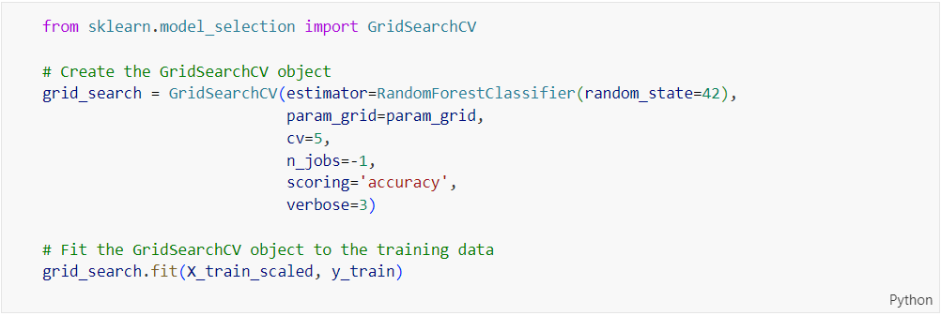

Figure 162: Source Code of Performing Hyperparameter Tuning Using GridSearchCV for Random Forest

The code shown in Figure 162 creates a ‘**GridSearchCV**’ object for tuning the hyperparameters of a Random Forest model. The GridSearchCV is initialized with the Random Forest estimator, the previously defined parameter grid (‘**param_grid**’), 5-fold cross-validation (‘**cv=5**’), parallel processing (‘**n_jobs=-1**’), accuracy as the scoring metric (‘**scoring='accuracy'**’), and verbosity level 3 (‘**verbose=3**’). The fit method is then called on the ‘**GridSearchCV**’ object to perform the grid search on the scaled training data (‘**X_train_scaled**’, ‘**y_train**’), finding the best combination of hyperparameters.

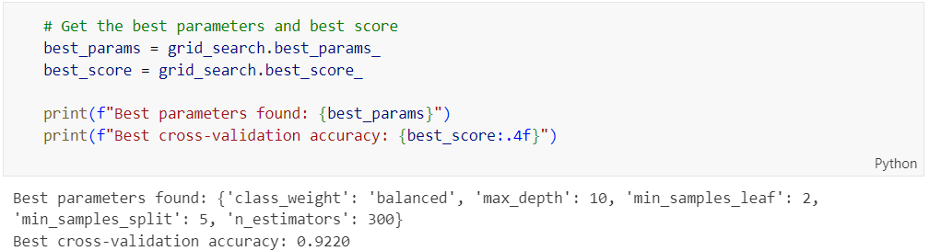

Figure 163: Source Code of Retrieving the Best Parameters and Score from GridSearchCV for Random Forest

The code shown in Figure 163 retrieves and displays the best hyperparameters and the corresponding cross-validation accuracy found by ‘**GridSearchCV**’ after fitting it to the training data. The best hyperparameters are accessed using grid_search.best_params_, and the best cross-validation accuracy is accessed using ‘**grid_search.best_score_**’. These values are then printed, with the best parameters displayed in a dictionary format and the best score formatted to four decimal places. The optimal hyperparameters for the Random Forest model are ‘**class_weight**’: 'balanced', ‘**max_depth**’: 10, ‘**min_samples_leaf**’: 2, ‘**min_samples_split**’: 5, and ‘**n_estimators**’: 300. The highest accuracy achieved during the 5-fold cross-validation process is 0.9220, indicating the model's ability to correctly classify 92.20% of the samples on average during cross-validation.

#### Model Building with Gradient Boosting

##### Before Hyperparameter Tuning

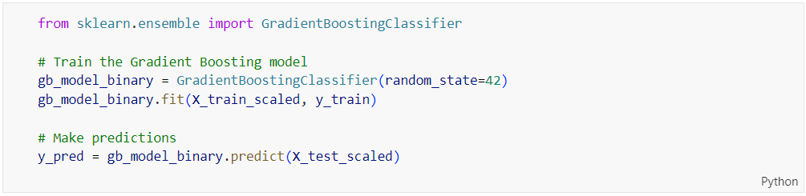

Figure 164: Source Code of Training and Making Predictions with a Gradient Boosting Model

The code above trains a Gradient Boosting model and makes predictions using the trained model. It begins by importing the ‘**GradientBoostingClassifier**’ from ‘**sklearn.ensemble’**. The model ‘**gb_model_binary**’ is instantiated with a ‘**random_state**’ of 42 to ensure reproducibility. The ‘**fit**’ method is then used to train the model on the scaled training data (‘**X_train_scaled**’, ‘**y_train**’). After training, the model makes predictions on the scaled test data (‘**X_test_scaled**’) using the predict method, and these predictions are stored in ‘**y_pred**’.

##### After Hyperparameter Tuning

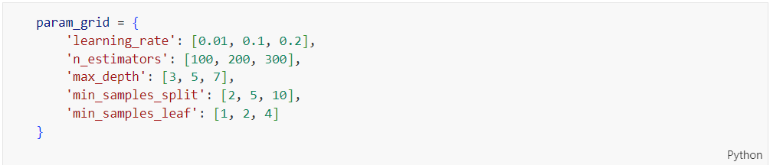

Figure 165: Source Code of Defining the Parameter Grid for Gradient Boosting Tuning

The code above defines a parameter grid ‘**param_grid**’ for tuning a Gradient Boosting model using grid search. This grid includes various hyperparameters and their potential values: ‘**learning_rate**’ with values 0.01, 0.1, and 0.2, specifies the learning rate; ‘**n_estimators**’ with values 100, 200, and 300, specifies the number of boosting stages; ‘**max_depth**’ with values 3, 5, and 7, specifies the maximum depth of the individual estimators; ‘**min_samples_split**’ with values 2, 5, and 10, sets the minimum number of samples required to split an internal node; and ‘**min_samples_leaf**’ with values 1, 2, and 4, defines the minimum number of samples required to be at a leaf node. These parameters are used to find the optimal combination for the Gradient Boosting model through the grid search process.

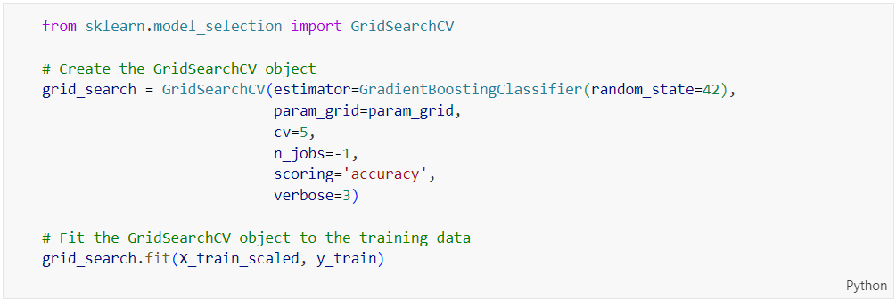

Figure 166: Source Code of Performing Hyperparameter Tuning Using GridSearchCV for Gradient Boosting

The code above creates a ‘**GridSearchCV**’ object for tuning the hyperparameters of a Gradient Boosting model. The GridSearchCV is initialized with the Gradient Boosting estimator, the previously defined parameter grid (‘**param_grid**’), 5-fold cross-validation (‘**cv=5**’), parallel processing (‘**n_jobs=-1**’), accuracy as the scoring metric (‘**scoring='accuracy'**’), and verbosity level 3 (‘**verbose=3**’). The fit method is then called on the ‘**GridSearchCV**’ object to perform the grid search on the scaled training data (‘**X_train_scaled**’, ‘**y_train**’), finding the best combination of hyperparameters.

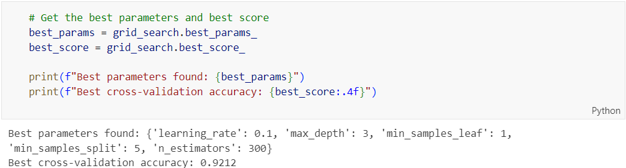

Figure 167: Source Code of Retrieving the Best Parameters and Score from GridSearchCV for Gradient Boosting

The code above retrieves and displays the best hyperparameters and the corresponding cross-validation accuracy found by ‘**GridSearchCV**’ after fitting it to the training data. The best hyperparameters are accessed using ‘**grid_search.best_params_**’, and the best cross-validation accuracy is accessed using ‘**grid_search.best_score_**’. These values are then printed, with the best parameters displayed in a dictionary format and the best score formatted to four decimal places. The optimal hyperparameters for the Gradient Boosting model are ‘**learning_rate**’: 0.1, ‘**max_depth**’: 3, ‘**min_samples_leaf**’: 1, ‘**min_samples_split**’: 5, and ‘**n_estimators**’: 300. The highest accuracy achieved during the 5-fold cross-validation process is 0.9212, indicating the model's ability to correctly classify 92.12% of the samples on average during cross-validation.

#### Model Building with XGBoost

##### Before Hyperparameter Tuning

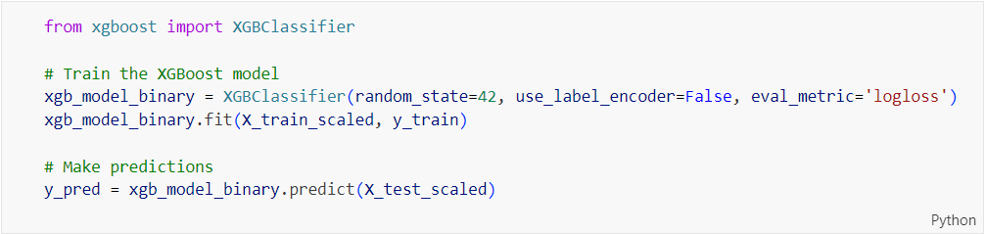

Figure 168:Source Code of Training and Making Predictions with XGBoost Model

The code above trains an XGBoost model and makes predictions. It begins by importing the ‘**XGBClassifier**’ from the ‘**xgboost**’ library. The model ‘**xgb_model_binary**’ is instantiated with several parameters: ‘**random_state=42**’ to ensure reproducibility, ‘**use_label_encoder=False**’ to disable label encoding that is deprecated, and ‘**eval_metric='logloss'**’ to use log loss as the evaluation metric. The ‘**fit**’ method is then used to train the model on the scaled training data (‘**X_train_scaled**’, ‘**y_train**’). After training, the model makes predictions on the scaled test data (‘**X_test_scaled**’) using the predict method, and these predictions are stored in ‘**y_pred**’.

##### After Hyperparameter Tuning

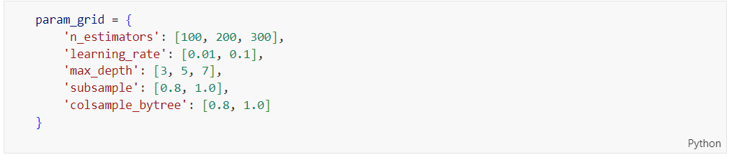

Figure 169: Source Code of Defining the Parameter Grid for XGBoost Tuning

The code above defines a parameter grid ‘**param_grid**’ for tuning an XGBoost model using grid search. This grid includes various hyperparameters and their potential values: ‘**n_estimators**’ with values 100, 200, and 300, specifies the number of boosting rounds; ‘**learning_rate**’ with values 0.01 and 0.1, specifies the step size shrinkage used to prevent overfitting; ‘**max_depth**’ with values 3, 5, and 7, specifies the maximum depth of a tree; ‘**subsample**’ with values 0.8 and 1.0, specifies the fraction of samples to be used for fitting the individual base learners; and ‘**colsample_bytree**’ with values 0.8 and 1.0, specifies the fraction of features to be used for each tree. These parameters are used to find the optimal combination for the XGBoost model through the grid search process.

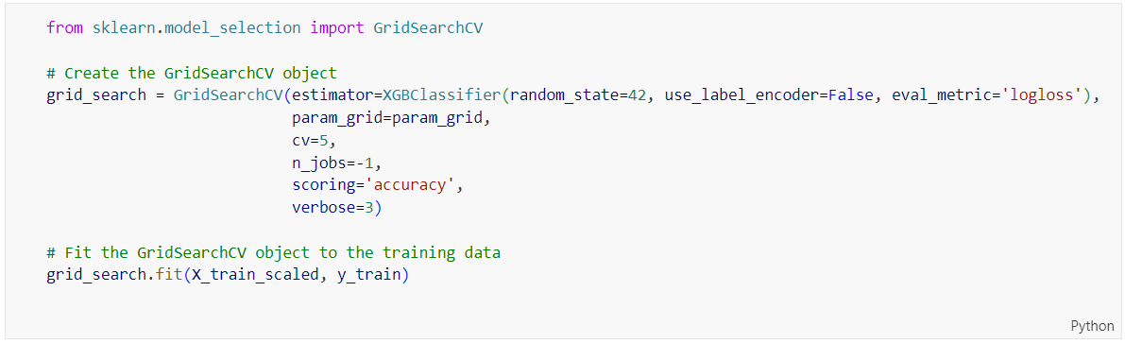

Figure 170: Source Code of Hyperparameter Tuning Using GridSearchCV for XGBoost

The code above creates and fits a ‘**GridSearchCV**’ object for hyperparameter tuning of an XGBoost model. The ‘**GridSearchCV**’ is initialized with the XGBoost estimator and the previously defined parameter grid (‘**param_grid**’). It also uses 5-fold cross-validation (‘**cv=5**’), parallel processing (‘**n_jobs=-1**’), accuracy as the scoring metric (‘**scoring='accuracy'**’), and verbosity level 3 (‘**verbose=3**’). The fit method is then called on the ‘**GridSearchCV**’ object to perform the grid search on the scaled training data (‘**X_train_scaled**’, ‘**y_train**’), finding the best combination of hyperparameters.

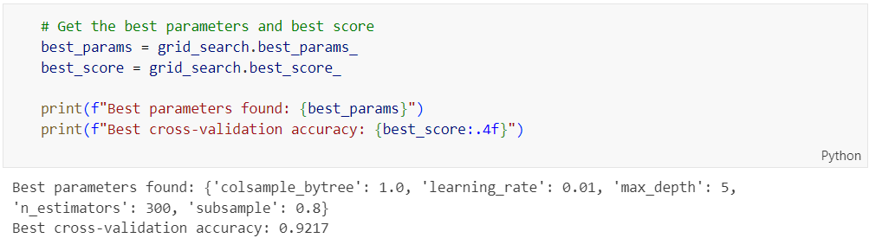

Figure 171: Source Code of Retrieving the Best Parameters and Score from GridSearchCV for XGBoost

The code above retrieves and displays the best hyperparameters and the corresponding cross-validation accuracy found by ‘**GridSearchCV**’ after fitting it to the training data. The best hyperparameters are accessed using ‘**grid_search.best_params_**’, and the best cross-validation accuracy is accessed using ‘**grid_search.best_score_**’. These values are then printed, with the best parameters displayed in a dictionary format and the best score formatted to four decimal places. The optimal hyperparameters for the XGBoost model are ‘**colsample_bytree**’: 1.0, ‘**learning_rate**’: 0.01, ‘**max_depth**’: 5, ‘**n_estimators**’: 300, and ‘**subsample**’: 0.8. The highest accuracy achieved during the 5-fold cross-validation process is 0.9217, indicating the model's ability to correctly classify 92.17% of the samples on average during cross-validation.

#### Model Building with Artificial Neural Network (ANN)

##### Before Hyperparameter Tuning

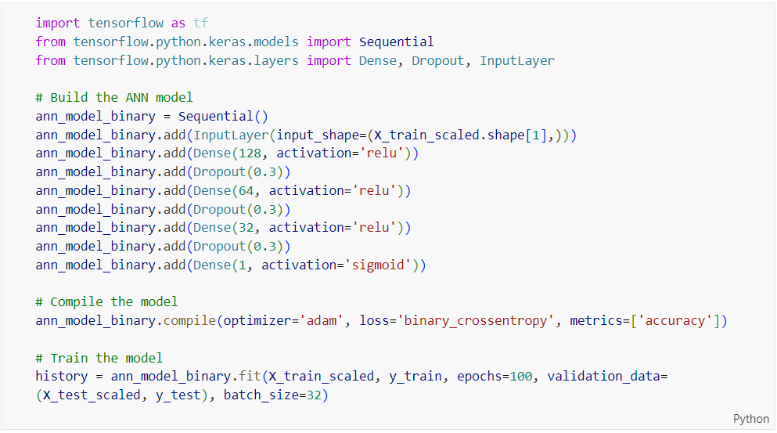

Figure 172: Source Code of Building, Compiling, and Training an ANN Model

The code above builds, compiles, and trains an Artificial Neural Network (ANN) model using TensorFlow and Keras. The model is built sequentially, starting with an input layer, followed by three dense layers with ReLU activation and dropout for regularization, and a final dense layer with sigmoid activation for binary classification. The model is compiled using the Adam optimizer and binary cross-entropy loss. The model is then trained on the scaled training data (‘**X_train_scaled**’, ‘**y_train**’) for 100 epochs, with validation data (‘**X_test_scaled**’, ‘**y_test**’).

##### After Hyperparameter Tuning

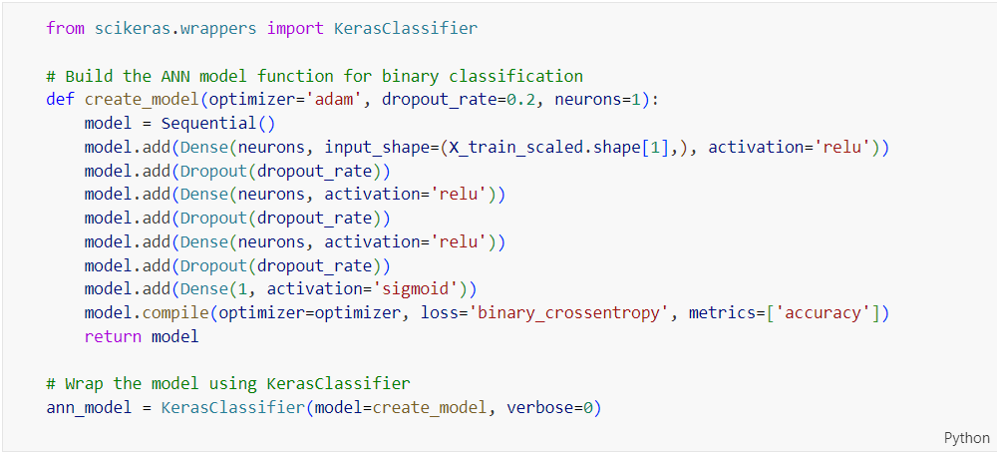

Figure 173: Source Code of Defining and Wrapping an ANN Model Function for Binary Classification

The code above defines a function ‘**create_model**’ to build an ANN model for binary classification. The function allows specifying the optimizer, dropout rate, and number of neurons in each layer. The model is wrapped using ‘**KerasClassifier**’ to make it compatible with scikit-learn for hyperparameter tuning.

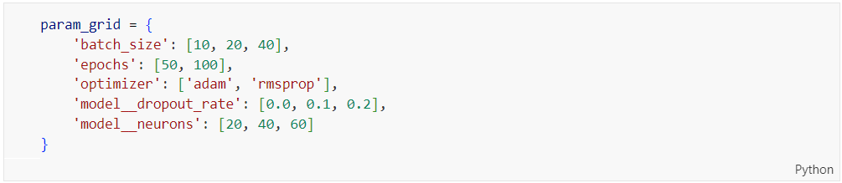

Figure 174: Source Code of Defining the Parameter Grid for ANN Model Tuning

The code above defines a parameter grid ‘**param_grid**’ for tuning the ANN model using grid search. It includes various hyperparameters and their potential values: ‘**batch_size**’, ‘**epochs**’, ‘**optimizer**’, ‘**model__dropout_rate**’, and ‘**model__neurons**’.

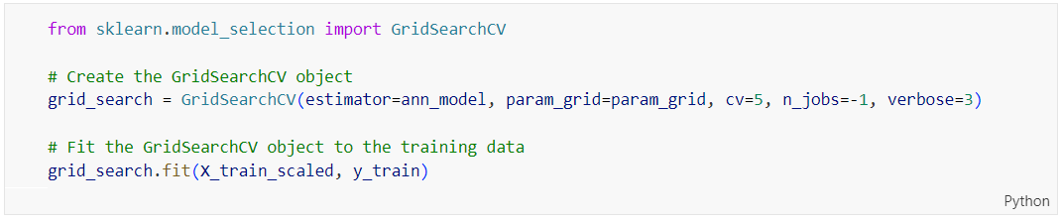

Figure 175: Source Code of Hyperparameter Tuning Using GridSearchCV for ANN Model

The code above creates and fits a ‘**GridSearchCV**’ object for hyperparameter tuning of the ANN model. The ‘**GridSearchCV**’ is initialized with the ANN model, parameter grid (‘**param_grid**’), 5-fold cross-validation (‘**cv=5**’), parallel processing (‘**n_jobs=-1**’), and verbosity level 3 (‘**verbose=3**’). The ‘**fit**’ method is called to perform the grid search on the scaled training data (‘**X_train_scaled**’, ‘**y_train**’).

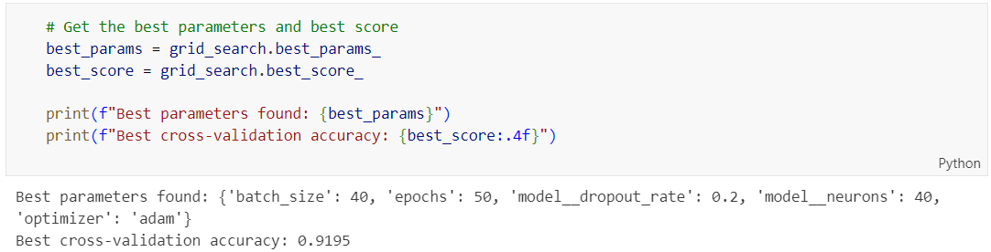

Figure 176: Source Code of Retrieving the Best Parameters and Score from GridSearchCV for ANN Model

The code retrieves and displays the best hyperparameters and the corresponding cross-validation accuracy found by ‘**GridSearchCV**’ after fitting it to the training data. The best hyperparameters are accessed using ‘**grid_search.best_params_’**, and the best cross-validation accuracy is accessed using **grid_search.best_score_**’. These values are printed, with the best parameters displayed in a dictionary format and the best score formatted to four decimal places. The optimal hyperparameters for the ANN model are ‘**batch_size**’: 40, ‘**epochs**’: 50, ‘**model__dropout_rate**’: 0.2, ‘**model__neurons**’: 40, and ‘**optimizer**’: ‘adam’. These parameters were chosen because they resulted in the best performance during the cross-validation process. The highest accuracy achieved during the 5-fold cross-validation process is 0.9195, indicating the model's ability to correctly classify 91.95% of the samples on average during cross-validation.

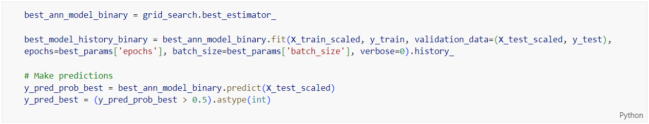

Figure 177: Source Code of Retraining the Best ANN Model and Making Predictions

The code above uses the best ANN model identified by ‘**GridSearchCV**’ to make predictions on the test data. The best estimator is retrieved using ‘**grid_search.best_estimator_**’ and re-trained on the training data with the best parameters. Predictions are made on the test data, and the predicted probabilities are converted to binary predictions.

### Multi-Class Classification

#### Data Preparation

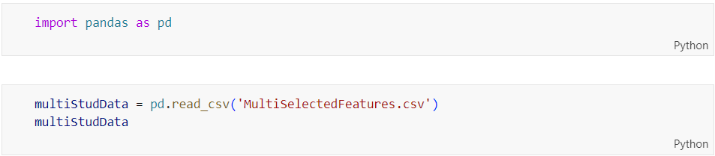

Figure 178: Source Code of Importing Pandas and Reading the MultiSelectedFeatures.csv Dataset into a DataFrame

The code above reads a CSV file into a pandas DataFrame. The ‘**pandas**’ library is imported as ‘**pd**’, and the ‘**read_csv**’ method is used to load the data from ‘**MultiSelectedFeatures.csv’** into the DataFrame ‘**multiStudData**’. This process has been explained previously in Chapter 4.5.1.1, with the only difference being the dataset being read.

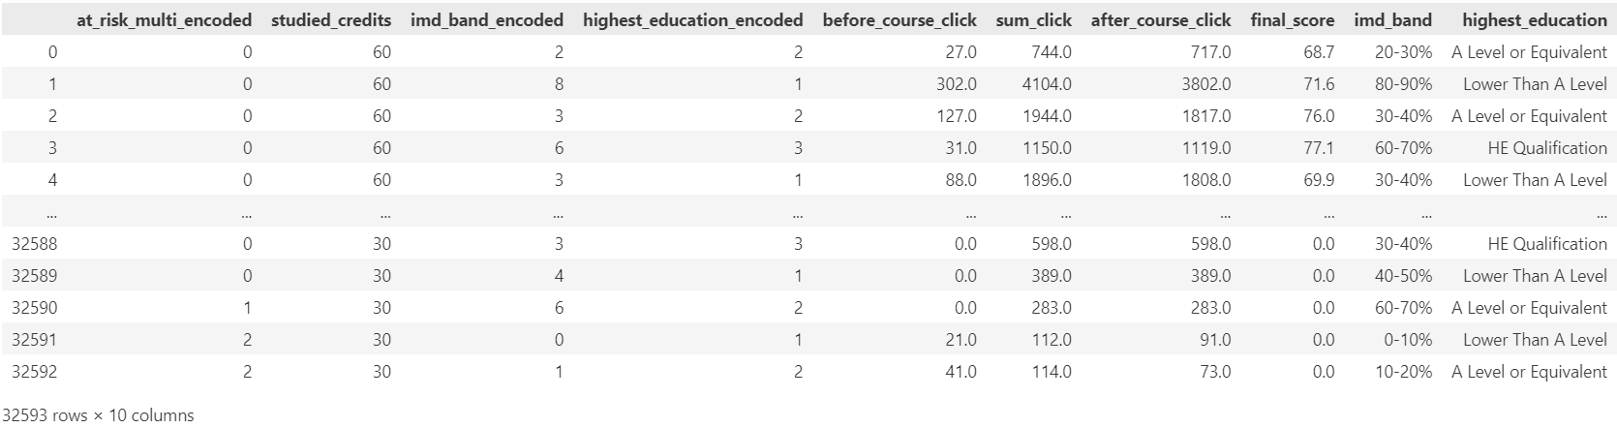

Figure 179: Output of Displaying the First and Last Five Rows of the multiStudData DataFrame

The resulting DataFrame is displayed, showing the first and last five rows of the data.

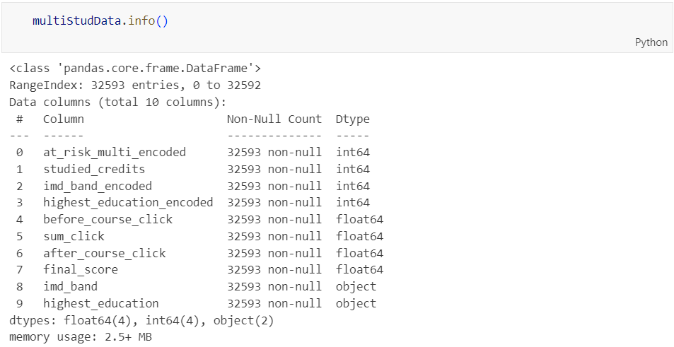

Figure 180: Output of Showing Information About the MultiSelectedFeatures.csv Dataset

The code displays information about the DataFrame ‘**multiStudData**’ by using the ‘**info()**’ method. This method provides details about the DataFrame's structure, including the number of entries, columns, non-null counts, and data types.

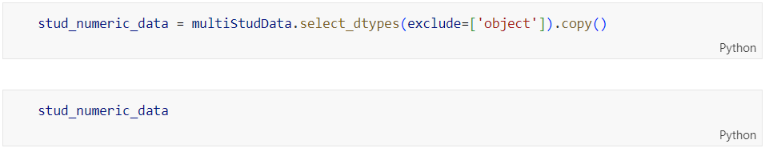

Figure 181: Source Code of Selecting Numeric Columns from the DataFrame and Creating a Copy

The code selects only the numeric columns from the DataFrame ‘**multiStudData**’ and creates a copy of this subset, storing it in ‘**stud_numeric_data**’. The ‘**select_dtypes**’ method is used with ‘**exclude=['object']**’ to filter out non-numeric columns. The explanation has been covered previously in Chapter 4.5.1.1, with the only difference being the dataset being processed.

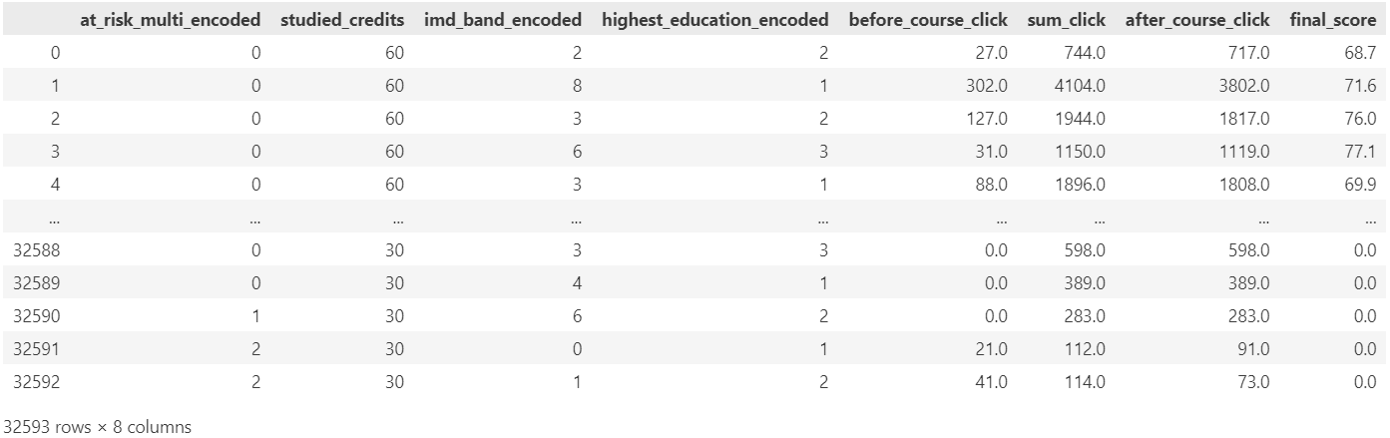

Figure 182: Output of Displaying the Numeric Columns from the MultiSelectedFeatures.csv Dataset

The resulting DataFrame stud_numeric_data is displayed, showing the first and last few rows of the numeric data.

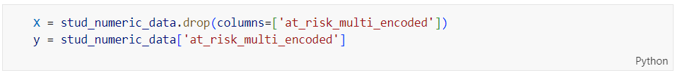

Figure 183: Source Code of Separating Features and Target Variable from the DataFrame

The code above separates the features and the target variable from the ‘**stud_numeric_data**’ DataFrame. The target variable, ‘**at_risk_multi_encoded**’, is extracted and stored in ‘**y**’, while the remaining features are stored in ‘**X**’ by dropping the ‘**at_risk_multi_encoded**’ column from ‘**stud_numeric_data’**.

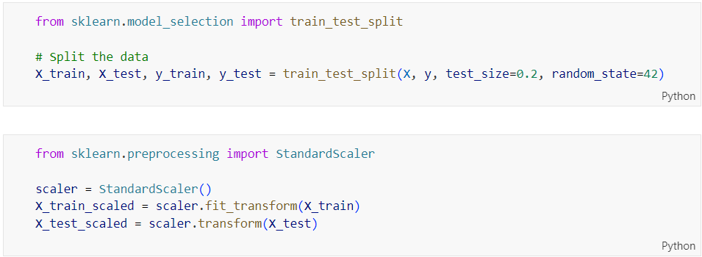

Figure 184: Source Code of Splitting the Dataset and Scaling the Features

The code splits the dataset into training and testing sets, then scales the features. This process is the same as previously explained for binary classification prediction. The ‘**train_test_split**’ function from ‘**sklearn.model_selection**’ is used to split the data, and the ‘**StandardScaler**’ from ‘**sklearn.preprocessing**’ is used to standardize the features by removing the mean and scaling to unit variance.

#### Model Building with Logistic Regression

##### Before Hyperparameter Tuning

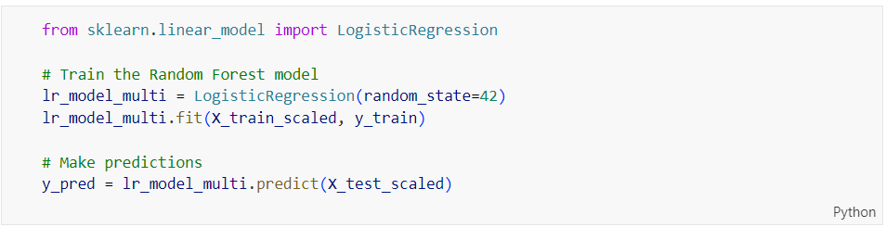

Figure 185: Source Code of Training and Making Predictions with Logistic Regression Model for Multi Classification

The code above trains a Logistic Regression model and makes predictions. The process is similar to what was previously in Chapter 4.5.1.2 explained for binary classification, but here it is applied to a multi-class classification problem. The **LogisticRegression**’ model is imported from ‘**sklearn.linear_model**’, initialized with ‘**random_state=42**’ for reproducibility, and trained on the scaled training data (‘**X_train_scaled**’, ‘**y_train**’). Predictions are then made on the scaled test data (‘**X_test_scaled**’).

##### After Hyperparameter Tuning

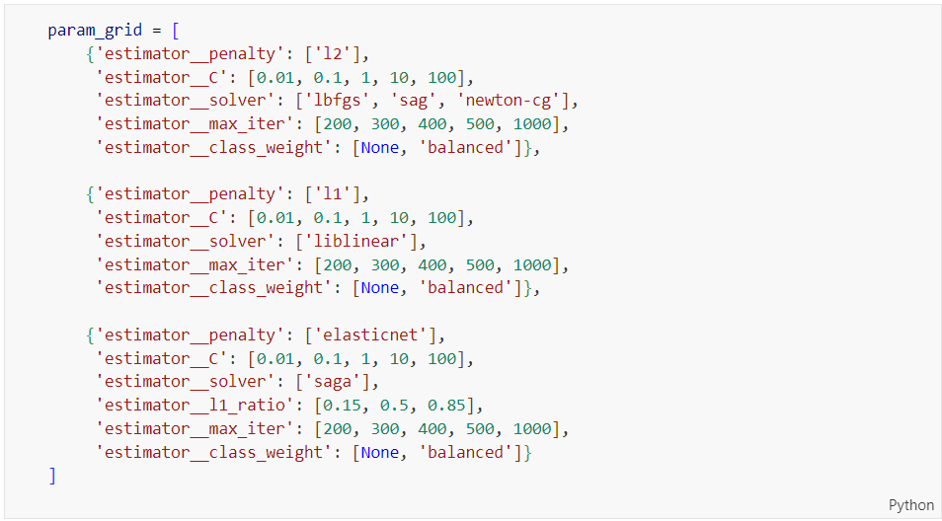

Figure 186: Source Code of Defining the Parameter Grid for Logistic Regression Tuning

The code above defines a parameter grid for tuning a Logistic Regression model using grid search. This process is similar to what was previously explained, but here it is adapted for multi-class classification. The ‘**param_grid**’ includes various hyperparameters and their potential values: ‘**penalty**’ specifies the norm used in the penalization (‘**l1**’, ‘**l2**’, ‘**elasticnet**’); ‘**C**’ represents the inverse of regularization strength; ‘**solver**’ specifies the algorithm to use in the optimization problem; ‘**max_iter**’ indicates the maximum number of iterations; ‘**class_weight**’ adjusts weights inversely proportional to class frequencies; and ‘**l1_ratio**’ is used when the penalty is ‘**elasticnet**’.

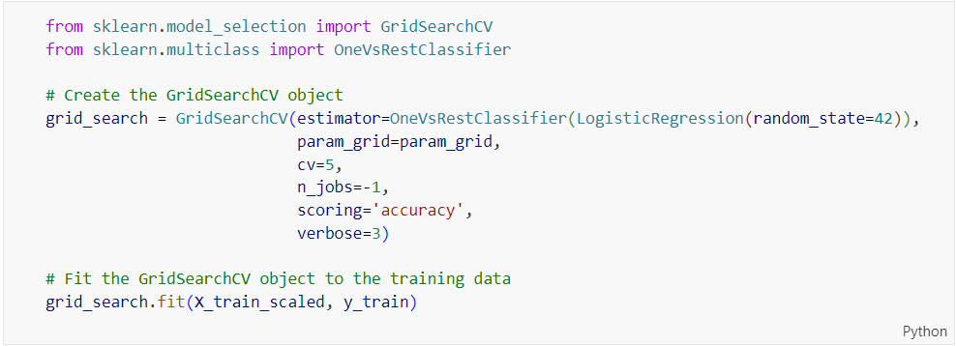

Figure 187: Source Code of Hyperparameter Tuning Using GridSearchCV for Multi-Class Logistic Regression

The code above creates and fits a ‘**GridSearchCV**’ object for hyperparameter tuning of a multi-class Logistic Regression model wrapped in a ‘**OneVsRestClassifier**’. This process is similar to the one explained previously in Chapter 4.5.1.2, but here it is adapted for multi-class classification. The ‘**GridSearchCV**’ is initialized with the ‘**OneVsRestClassifier**’, which is a strategy for multi-class classification in which one classifier is trained per class, containing a ‘**LogisticRegression**’ estimator and the previously defined parameter grid (‘**param_grid**’). It also uses 5-fold cross-validation (‘**cv=5**’), parallel processing (‘**n_jobs=-1**’), accuracy as the scoring metric (‘**scoring='accuracy'**’), and verbosity level 3 (‘**verbose=3**’). The fit method is called to perform the grid search on the scaled training data (‘**X_train_scaled**’, ‘**y_train**’).

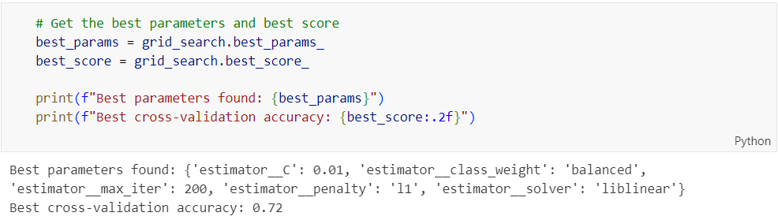

Figure 188: Source Code of Retrieving the Best Parameters and Score from GridSearchCV for Multi-Class Logistic Regression

The code above retrieves and displays the best hyperparameters and the corresponding cross-validation accuracy found by ‘**GridSearchCV**’ after fitting it to the training data. The best hyperparameters are accessed using ‘**grid_search.best_params_**’, and the best cross-validation accuracy is accessed using ‘**grid_search.best_score_**’. These values are then printed, with the best parameters displayed in a dictionary format and the best score formatted to two decimal places. The optimal hyperparameters for the ‘**OneVsRestClassifier**’ with the ‘**LogisticRegression**’ model are ‘**C**’: 0.01, ‘**class_weight**’: 'balanced', ‘**max_iter**’: 200, penalty: 'l1', and ‘**solver**’: 'liblinear'. These parameters were chosen because they resulted in the best performance during the cross-validation process. The highest accuracy achieved during the 5-fold cross-validation process is 0.72, indicating the model's ability to correctly classify 72% of the samples on average during cross-validation.

#### Model Building with Decision Tree

##### Before Hyperparameter Tuning

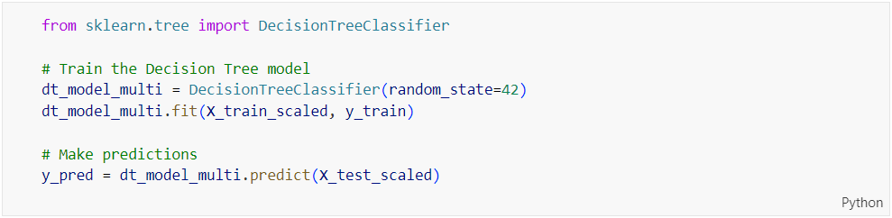

Figure 189: Source Code of Training and Making Predictions with Decision Tree Model

The code shown in Figure 189 trains a Decision Tree model and makes predictions. The ‘**DecisionTreeClassifier**’ is imported from ‘**sklearn.tree**’, initialized with ‘**random_state=42**’ for reproducibility, and trained on the scaled training data (‘**X_train_scaled**’, ‘**y_train**’). Predictions are then made on the scaled test data (‘**X_test_scaled**’).

##### After Hyperparameter Tuning

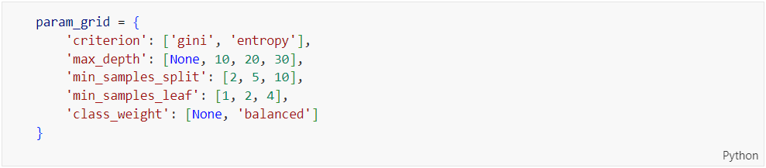

Figure 190: Source Code of Defining the Parameter Grid for Decision Tree Tuning

The code shown in Figure 190 defines a parameter grid ‘**param_grid**’ for tuning a Decision Tree model using grid search. The grid includes various hyperparameters and their potential values: ‘**criterion**’ specifies the function to measure the quality of a split (‘**gini**’ for the Gini impurity and ‘**entropy**’ for the information gain); ‘**max_depth**’ defines the maximum depth of the tree; ‘**min_samples_split**’ specifies the minimum number of samples required to split an internal node; ‘**min_samples_leaf**’ specifies the minimum number of samples required to be at a leaf node; and ‘**class_weight**’ allows the model to adjust weights inversely proportional to class frequencies.

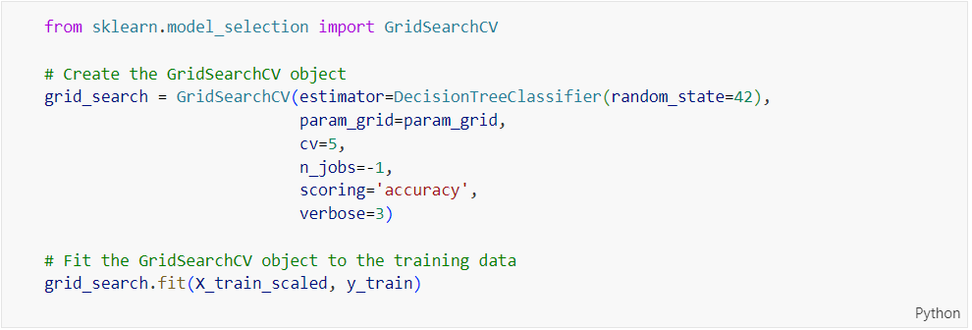

Figure 191: Source Code of Hyperparameter Tuning Using GridSearchCV for Decision Tree Model

The code above creates and fits a ‘**GridSearchCV**’ object for hyperparameter tuning of a Decision Tree model. The ‘**GridSearchCV**’ is initialized with the ‘**DecisionTreeClassifier**’ estimator and the previously defined parameter grid (‘**param_grid**’). It uses 5-fold cross-validation (‘**cv=5**’), parallel processing (‘**n_jobs=-1**’), accuracy as the scoring metric (‘**scoring='accuracy'**’), and verbosity level 3 (‘**verbose=3**’). The ‘**fit**’ method is called to perform the grid search on the scaled training data (‘**X_train_scaled**’, ‘**y_train**’).

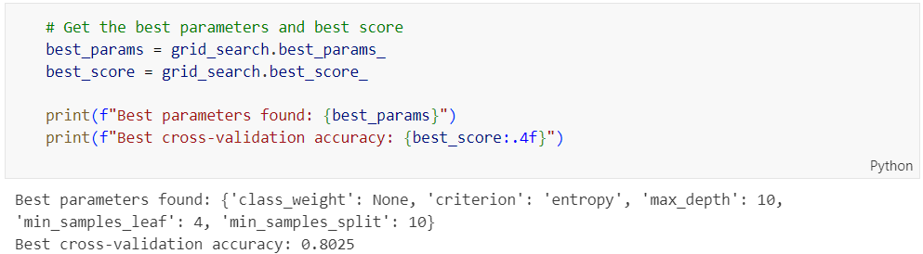

Figure 192: Source Code of Retrieving the Best Parameters and Score from GridSearchCV for Decision Tree Model

The code above retrieves and displays the best hyperparameters and the corresponding cross-validation accuracy found by ‘**GridSearchCV**’ after fitting it to the training data. The optimal hyperparameters for the ‘**DecisionTreeClassifier**’ are ‘**class_weight**’: None, ‘**criterion**’: ‘entropy’, ‘**max_depth**’: 10, ‘**min_samples_leaf**’: 4, and ‘**min_samples_split**’: 10. The highest accuracy achieved during the 5-fold cross-validation process is 0.8025.

#### Model Building with Random Forest

##### Before Hyperparameter Tuning

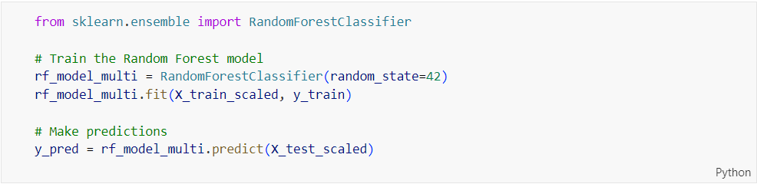

Figure 193: Source Code of Training and Making Predictions with Random Forest Model

The code above trains a Random Forest model and makes predictions. The ‘**RandomForestClassifier**’ is imported from ‘**sklearn.ensemble**’, initialized with ‘**random_state=42**’ for reproducibility, and trained on the scaled training data (‘**X_train_scaled**’, ‘**y_train**’). Predictions are then made on the scaled test data (‘**X_test_scaled**’).

##### After Hyperparameter Tuning

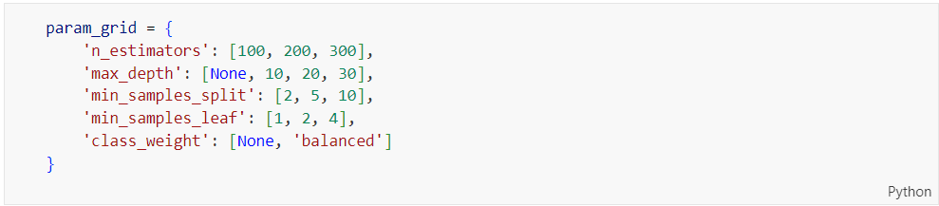

Figure 194: Source Code of Defining the Parameter Grid for Random Forest Tuning

Figure 194 show the code of the parameter grid ‘**param_grid**’ for tuning a Random Forest model using grid search includes a range of hyperparameters and their potential values. These hyperparameters are: ‘**n_estimators**’, specifying the number of trees in the forest with values of 100, 200, and 300; ‘**max_depth**’, defining the maximum depth of the trees with values of None, 10, 20, and 30; ‘**min_samples_split**’, which is the minimum number of samples required to split an internal node with values of 2, 5, and 10; ‘**min_samples_leaf**’, the minimum number of samples required to be at a leaf node with values of 1, 2, and 4; and ‘**class_weight**’, which allows the model to adjust weights inversely proportional to class frequencies with potential values of None and 'balanced'.

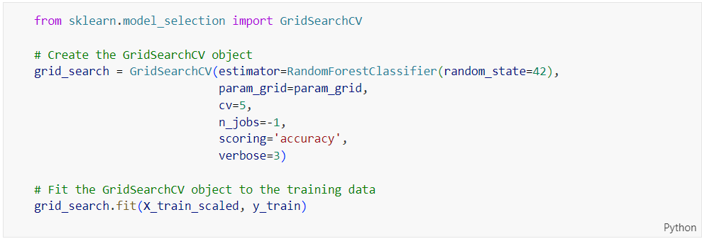

Figure 195: Source Code of Hyperparameter Tuning Using GridSearchCV for Random Forest Model

The code creates and fits a ‘**GridSearchCV**’ object for hyperparameter tuning of a Random Forest model. The ‘**GridSearchCV**’ is initialized with a ‘**RandomForestClassifier**’ estimator and the previously defined parameter grid (‘**param_grid**’). It uses 5-fold cross-validation (‘**cv=5**’), parallel processing (‘**n_jobs=-1**’), accuracy as the scoring metric (‘**scoring='accuracy'**’), and verbosity level 3 (‘**verbose=3**’). The ‘**fit**’ method is called to perform the grid search on the scaled training data (‘**X_train_scaled**’, ‘**y_train**’).

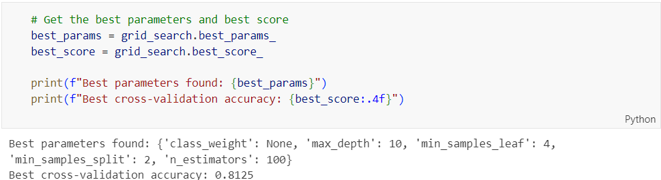

Figure 196: Output of Showing the Best Parameters and Cross-Validation Accuracy for Random Forest Model

The best hyperparameters and the corresponding cross-validation accuracy found by ‘**GridSearchCV**’ after fitting it to the training data are retrieved and displayed. The optimal hyperparameters for the ‘**RandomForestClassifier**’ are ‘**class_weight**’: None, ‘**max_depth**’: 10, ‘**min_samples_leaf**’: 4, ‘**min_samples_split**’: 2, and ‘**n_estimators**’: 100. The highest accuracy achieved during the 5-fold cross-validation process is 0.8125.

#### Model Building with Gradient Boosting

##### Before Hyperparameter Tuning

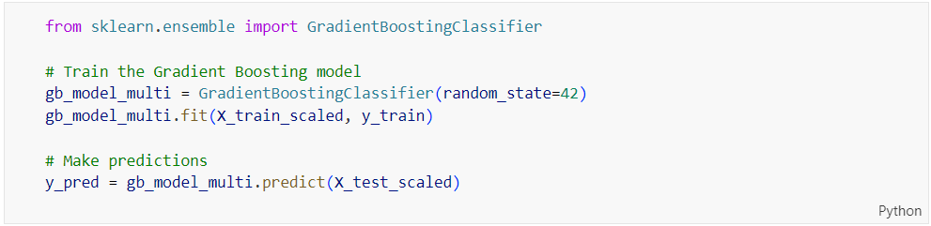

Figure 197: Source Code of Training and Making Predictions with Gradient Boosting Model

The code above trains a Gradient Boosting model and makes predictions. The ‘**GradientBoostingClassifier**’ is imported from ‘**sklearn.ensemble**’, initialized with ‘**random_state=42**’ for reproducibility, and trained on the scaled training data (‘**X_train_scaled**’, ‘**y_train**’). Predictions are then made on the scaled test data (‘**X_test_scaled**’).

##### After Hyperparameter Tuning

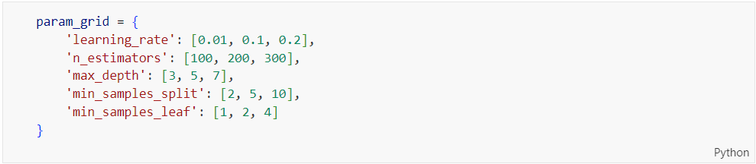

Figure 198: Source Code of Parameter Grid for Gradient Boosting Hyperparameter Tuning

The parameter grid ‘**param_grid**’ for tuning a Gradient Boosting model using grid search is defined. It includes a range of hyperparameters and their potential values: ‘**learning_rate**’ specifies the step size at each iteration with values of 0.01, 0.1, and 0.2; ‘**n_estimators**’ specifies the number of boosting stages to be run with values of 100, 200, and 300; ‘**max_depth**’ defines the maximum depth of the individual regression estimators with values of 3, 5, and 7; ‘**min_samples_split**’ is the minimum number of samples required to split an internal node with values of 2, 5, and 10; and ‘**min_samples_leaf**’ specifies the minimum number of samples required to be at a leaf node with values of 1, 2, and 4.

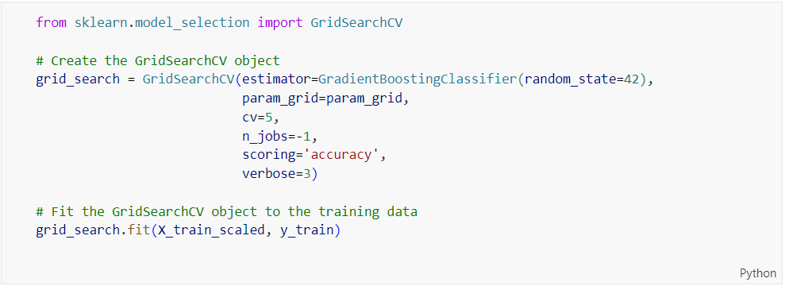

Figure 199: Source Code of Hyperparameter Tuning Using GridSearchCV for Gradient Boosting Model

The code above creates and fits a ‘**GridSearchCV**’ object for hyperparameter tuning of a Gradient Boosting model. The ‘**GridSearchCV**’ is initialized with a ‘**GradientBoostingClassifier**’ estimator and the previously defined parameter grid (‘**param_grid**’). It uses 5-fold cross-validation (‘**cv=5**’), parallel processing (‘**n_jobs=-1**’), accuracy as the scoring metric (‘**scoring='accuracy'**’), and verbosity level 3 (‘**verbose=3**’). The ‘**fit’** method is called to perform the grid search on the scaled training data (‘**X_train_scaled**’, ‘**y_train**’).

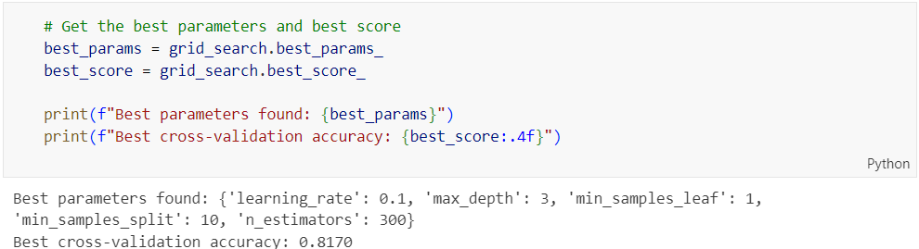

Figure 200: Output Showing the Best Parameters and Cross-Validation Accuracy for Gradient Boosting Model

The best hyperparameters and the corresponding cross-validation accuracy found by ‘**GridSearchCV**’ after fitting it to the training data are retrieved and displayed. The optimal hyperparameters for the ‘**GradientBoostingClassifier**’ are ‘**learning_rate**’: 0.1, ‘**max_depth**’: 3, ‘**min_samples_leaf**’: 1, ‘**min_samples_split**’: 10, and ‘**n_estimators**’: 300. The highest accuracy achieved during the 5-fold cross-validation process is 0.8170.

#### Model Building with XGBoost

##### Before Hyperparameter Tuning

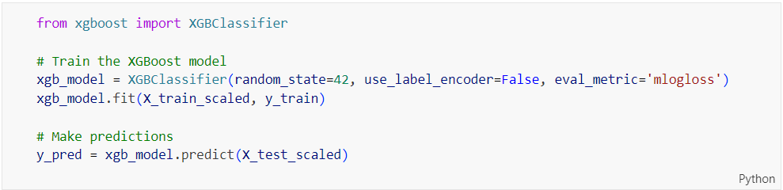

Figure 201: Source Code of Training and Making Predictions with XGBoost Model

The code above trains an XGBoost model and makes predictions. The ‘**XGBClassifier**’ is imported from ‘**xgboost**’, initialized with ‘**random_state=42**’ for reproducibility, ‘**use_label_encoder=False**’ to avoid warnings, and ‘**eval_metric='mlogloss'**’ to specify the evaluation metric. The model is trained on the scaled training data (‘**X_train_scaled**’, ‘**y_train**’). Predictions are then made on the scaled test data (‘**X_test_scaled**’).

##### After Hyperparameter Tuning

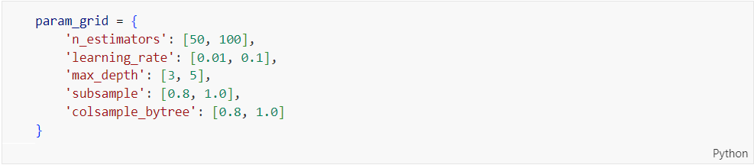

Figure 202: Source Code of Parameter Grid for XGBoost Hyperparameter Tuning

The parameter grid ‘**param_grid**’ for tuning an XGBoost model using grid search is defined. It includes a range of hyperparameters and their potential values: ‘**n_estimators**’ specifies the number of boosting stages with values of 50 and 100; ‘**learning_rate’** specifies the step size at each iteration with values of 0.01 and 0.1; ‘**max_depth**’ defines the maximum depth of the trees with values of 3 and 5; ‘**subsample**’ is the fraction of samples to be used for fitting the individual base learners with values of 0.8 and 1.0; and ‘**colsample_bytree**’ specifies the fraction of features to be used for each tree with values of 0.8 and 1.0.

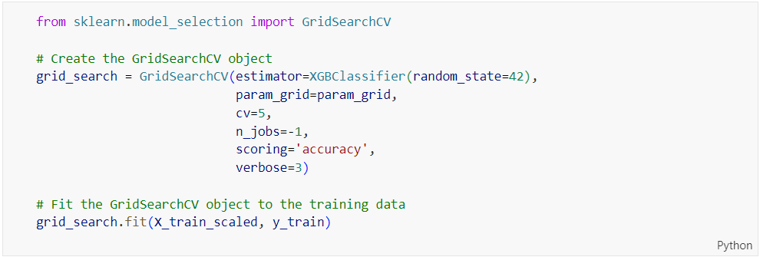

Figure 203: Source Code of Hyperparameter Tuning Using GridSearchCV for XGBoost Model

The code above creates and fits a ‘**GridSearchCV**’ object for hyperparameter tuning of an XGBoost model. The ‘**GridSearchCV**’ is initialized with an ‘**XGBClassifier**’ estimator and the previously defined parameter grid (‘**param_grid**’). It uses 5-fold cross-validation (‘**cv=5**’), parallel processing (‘**n_jobs=-1**’), accuracy as the scoring metric (‘**scoring='accuracy'**’), and verbosity level 3 (‘**verbose=3**’). The fit method is called to perform the grid search on the scaled training data (‘**X_train_scaled**’, ‘**y_train**’).

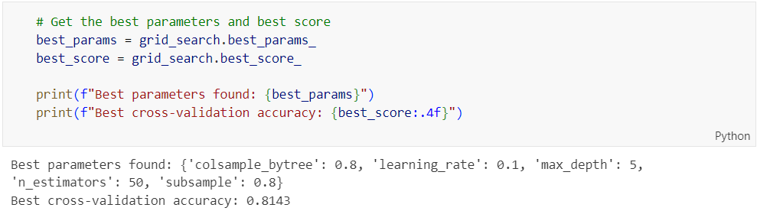

Figure 204: Output of Showing the Best Parameters and Cross-Validation Accuracy for XGBoost Model

The best hyperparameters and the corresponding cross-validation accuracy found by ‘**GridSearchCV**’ after fitting it to the training data are retrieved and displayed. The optimal hyperparameters for the ‘**XGBClassifier**’ are ‘**colsample_bytree**’: 0.8, ‘**learning_rate**’: 0.1, ‘**max_depth**’: 5, ‘**n_estimators**’: 50, and ‘**subsample**’: 0.8. The highest accuracy achieved during the 5-fold cross-validation process is 0.8143.

#### Model Building with Artificial Neural Network (ANN)

##### Before Hyperparameter Tuning

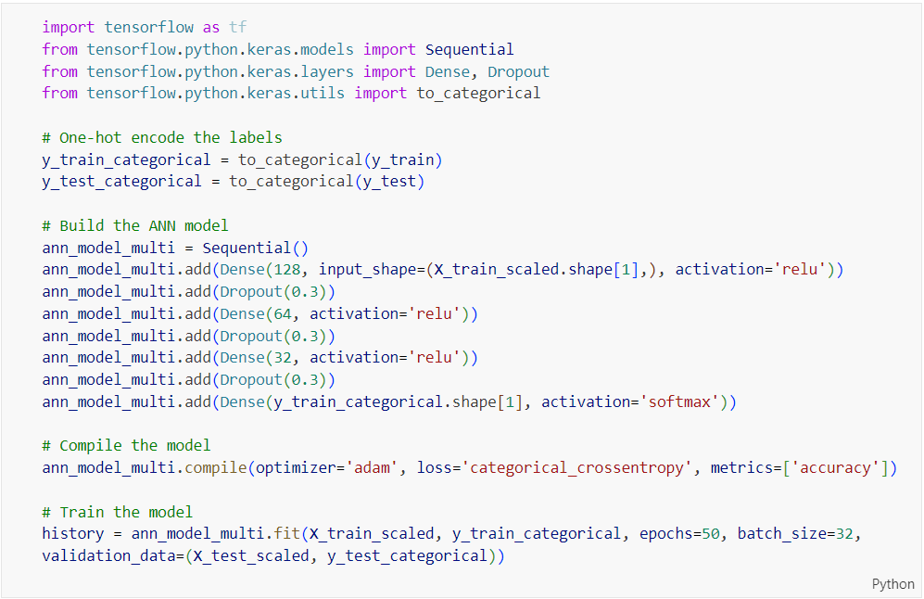

Figure 205: Source Code of Building, Compiling, and Training an ANN Model for Multiclass Classification

The code above imports necessary libraries from TensorFlow and Keras, encodes the labels, builds an Artificial Neural Network (ANN) model, compiles it, and then trains it. The ‘**y_train**’ and ‘**y_test**’ labels are one-hot encoded using ‘**to_categorical**’. The ANN model is built using the ‘**Sequential**’ class from Keras, consisting of multiple layers with ReLU activations and dropout for regularization. The model is compiled with the Adam optimizer and categorical crossentropy loss, and accuracy as the metric. The model is then trained with the specified number of epochs and batch size, using the scaled training data and one-hot encoded labels for validation.

##### After Hyperparameter Tuning

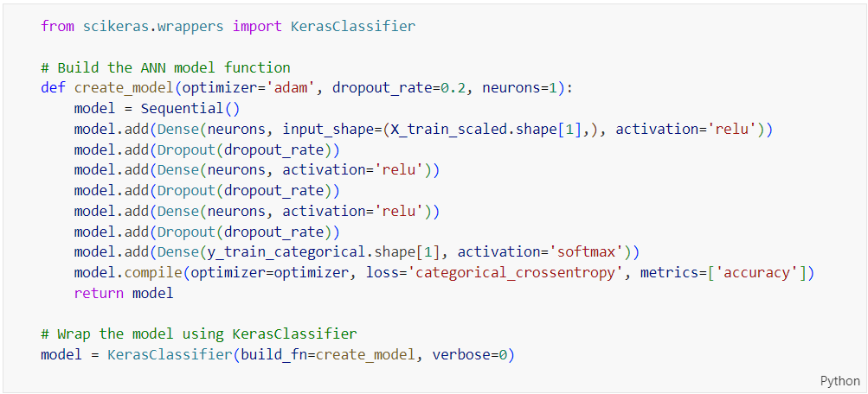

Figure 206: Source Code of Defining and Wrapping an ANN Model Function Using KerasClassifier

The code above defines a function to build an Artificial Neural Network (ANN) model and wraps it using KerasClassifier for compatibility with scikit-learn. The create_model function takes optimizer, dropout rate, and number of neurons as parameters, constructs a Sequential model with specified layers and dropout rates, compiles the model with the specified optimizer and loss function, and returns it. The KerasClassifier is then created using this model-building function, allowing the ANN model to be used with scikit-learn's API for tasks like grid search and cross-validation.

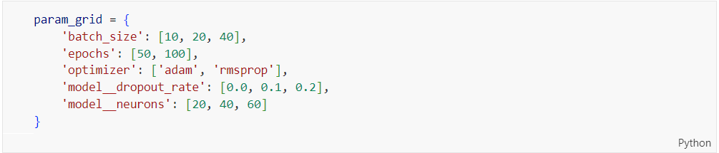

Figure 207: Source Code of Parameter Grid for Hyperparameter Tuning of ANN Model

The code above defines a parameter grid for hyperparameter tuning of the ANN model using grid search. It includes various options for batch size, number of epochs, optimizer type, dropout rate, and number of neurons in the dense layers.

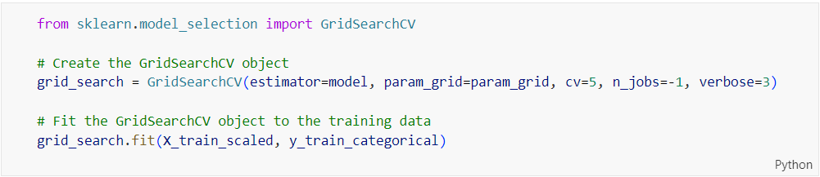

Figure 208: Source Code of GridSearchCV for Hyperparameter Tuning of ANN Model

The code above creates and fits a ‘**GridSearchCV**’ object to the training data for hyperparameter tuning. It uses a specified parameter grid, performs cross-validation with 5 folds, and fits the model to the training data.

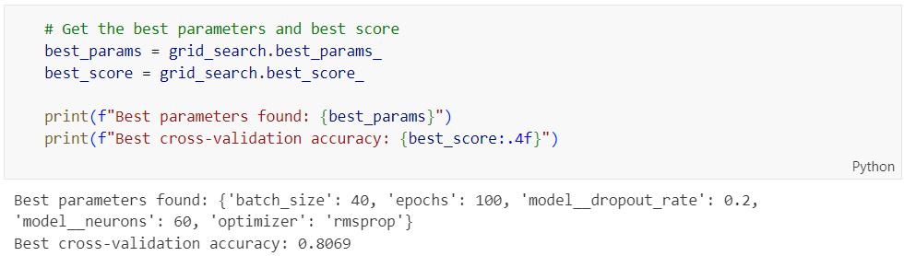

Figure 209: Source Code and Output of Best Parameters and Cross-Validation Accuracy for ANN Model

The code above retrieves and prints the best parameters and best cross-validation score from the GridSearchCV object after it has been fitted to the training data. The output shows the best parameters found during the grid search, which include ‘**batch_size**’, ‘**epochs**’, ‘**model__dropout_rate**’, ‘**model__neurons**’, and ‘**optimizer**’, along with the best cross-validation accuracy score.

## Summary

Chapter 4 provides a detailed overview of the design and implementation process for creating a predictive model aimed at identifying at-risk students. The journey begins with an exploration of the problem domain, emphasizing the need to understand the factors contributing to academic risk and the importance of collaboration with educational experts for feature selection.

Data collection is meticulously planned to ensure the dataset includes all relevant variables. This is followed by an extensive data pre-processing phase, where techniques for handling missing values, outliers, and data normalization are applied to prepare the data for analysis.

Exploratory Data Analysis (EDA) is conducted to gain insights into the data's underlying patterns and relationships. Visualization and correlation analysis are employed to understand data distribution and feature importance, guiding the model-building process.

The model-building phase involves implementing and tuning various machine learning algorithms, including Logistic Regression, Decision Tree, Random Forest, Gradient Boosting, XGBoost, and Neural Networks. Each model is carefully tuned using GridSearchCV and cross-validation techniques to enhance their predictive performance.

The chapter concludes with the development of a robust predictive model ready for integration into educational systems. This model aims to provide real-time predictions of at-risk students, enabling educational institutions to implement targeted interventions. The evaluation of the model's performance will be discussed in detail in the next chapter, ensuring a comprehensive understanding of its predictive capabilities and practical applicability.

# CHAPTER 5: result and discussion



## Introduction

Chapter 5, "Results and Discussion," critically evaluates the predictive models developed for identifying at-risk students. This chapter is essential as it transitions from the theoretical framework and practical implementation to the empirical analysis of the models' effectiveness. By examining various machine learning algorithms, the chapter aims to provide a thorough understanding of their predictive capabilities and real-world applicability.

The evaluation process employs multiple metrics such as accuracy, precision, recall, F1-score, and ROC AUC. These metrics are pivotal in determining how well the models can distinguish between at-risk and non-at-risk students. The chapter begins by explaining the rationale behind the selection of these metrics and their significance in the context of educational data analytics, setting the stage for a systematic and rigorous analysis.

Binary classification models are then explored in detail. Algorithms such as Logistic Regression, Decision Tree, Random Forest, Gradient Boosting, XGBoost, and Artificial Neural Networks are evaluated based on their performance before and after hyperparameter tuning. The analysis uses visual aids like confusion matrices, ROC curves, and classification reports to provide a clear and intuitive understanding of each model's performance. Additionally, multi-class classification models are examined to assess their effectiveness in predicting multiple risk levels or categories.

The chapter concludes with a comparative analysis of the models, highlighting their strengths and weaknesses. It also discusses the importance of feature selection, identifying which factors are most indicative of at-risk students. This section provides actionable insights for educators and administrators, offering guidance on the most effective models for practical implementation. The findings of this chapter bridge the gap between theoretical model development and real-world application, contributing to enhanced educational support systems and improved student outcomes.

## Model Evaluation and Discussions

### Evaluation Method

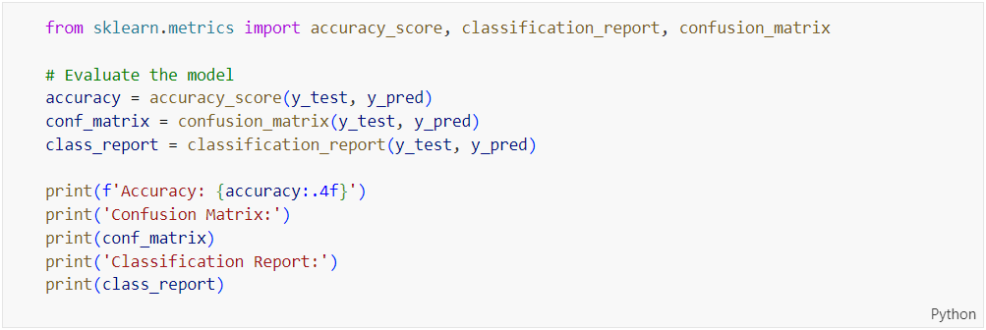

Figure 210: Source Code of Evaluating Base Models except ANN (Both Binary and Multi Classification)

Figure 210 shows the code importing evaluation metrics from ‘**’sklearn.metrics**’ to assess the performance of the models built in Chapter 4.5 excepts for Artificial Neural Network model. The **‘accuracy_score**’ function calculates the accuracy of the model’s predictions by comparing the true labels (‘**y_test**’) with the predicted labels (‘**y_pred**’). the ‘**confusion_matrix**’ function generates a confusion matrix, which provides a summary of prediction results, showing the counts of true positive, true negative, false positive, and false negative classifications. The ‘**classification_report**’ function creates a detailed report including precision, recall, F1-score, and support for each class.

The accuracy, confusion matrix, and classification report are then printed. The accuracy score is formatted to four decimal places for clarity.

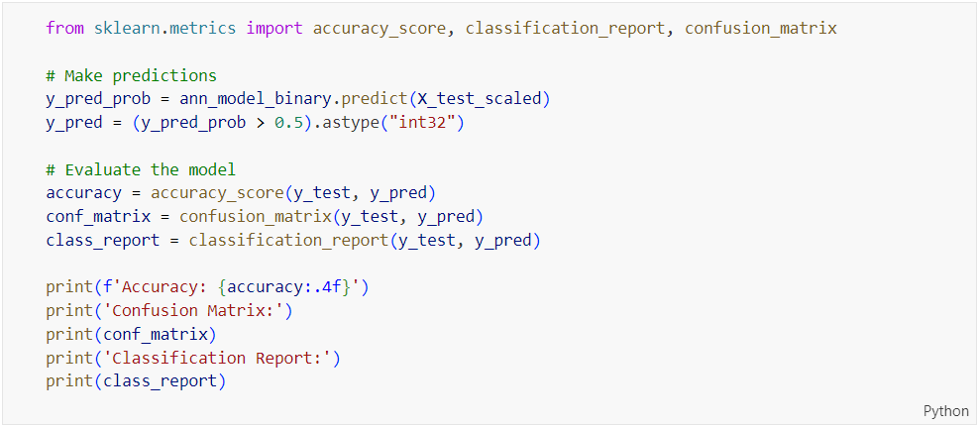

Figure 211: Source Code of Evaluating Base ANN Model (Binary Classification)

The code above evaluates the performance of a binary classification model. It first makes predictions using the trained Artificial Neural Network (ANN) model on the test dataset. The predicted probabilities are converted into binary predictions using a threshold of 0.5. This means any predicted probability greater than 0.5 is classified as 1, and anything below or equal to 0.5 is classified as 0.

The model's performance is then evaluated using three metrics: accuracy, confusion matrix, and classification report. The accuracy score measures the proportion of correctly predicted instances out of the total instances. The confusion matrix provides a breakdown of true positive, true negative, false positive, and false negative counts, offering insight into the types of errors made by the model. The classification report includes precision, recall, and F1-score for each class, giving a detailed view of the model's performance. Finally, these metrics are printed out for review.

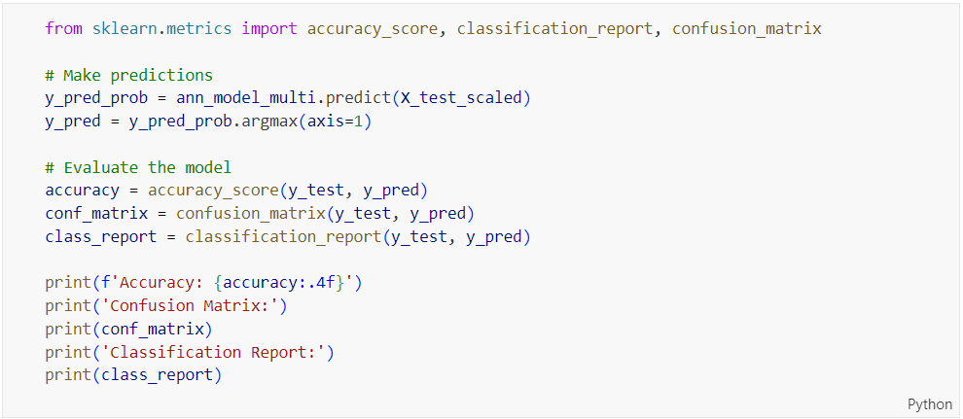

Figure 212: Source Code of Evaluating Base ANN Model (Multi Classification)

The code above is similar to the previous code in Figure 211. The difference is that in the code above, it modifies the prediction step for a multi-class classification problem. Instead of using a threshold to convert predicted probabilities into class predictions as in Figure 211, it uses ‘**argmax(axis=1)**’ to select the class with the highest probability for each instance. This method is appropriate for multi-class classification where each instance belongs to one of several classes. The rest of the evaluation steps remain the same, involving the calculation and printing of accuracy, confusion matrix, and classification report.

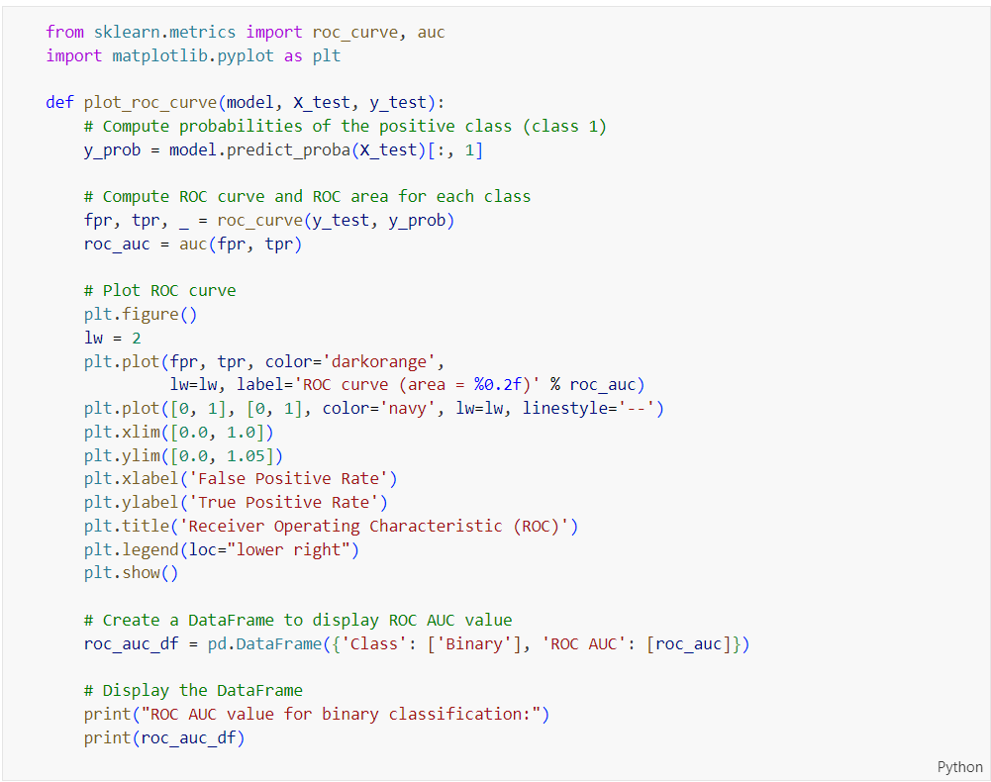

Figure 213: Source Code of Plotting the ROC Curve and Displaying ROC AUC Value for Models except ANN (Both Binary and Multi Classification)

The code shown in Figure 213 defines a function ‘**plot_roc_curve**’ that calculates and plots the Receiver Operating Characteristic (ROC) curve for a given model and test dataset. The function first computes the predicted probabilities of the positive class (class 1) using the ‘**predict_proba**’ method of the model. The ROC curve is then computed using the ‘**roc_curve**’ function, which returns the false positive rate (FPR), true positive rate (TPR), and thresholds. The area under the curve (AUC) is calculated using the ‘**auc**’ function, which provides a single metric to summarize the performance of the classifier.

The ROC curve is plotted using ‘**matplotlib**’, where the FPR is plotted against the TPR. A diagonal dashed line represents a random classifier. The ROC curve’s AUC value is displayed in the plot legend. The function also creates a DataFrame to display the ROC AUC value, which is printed to the console for easy reference.

This function provides a visual representation of the classifier’s performance in distinguishing between the positive and negative classes, and the AUC value serves as a quantitative measure of the model’s ability to discriminate between classes.

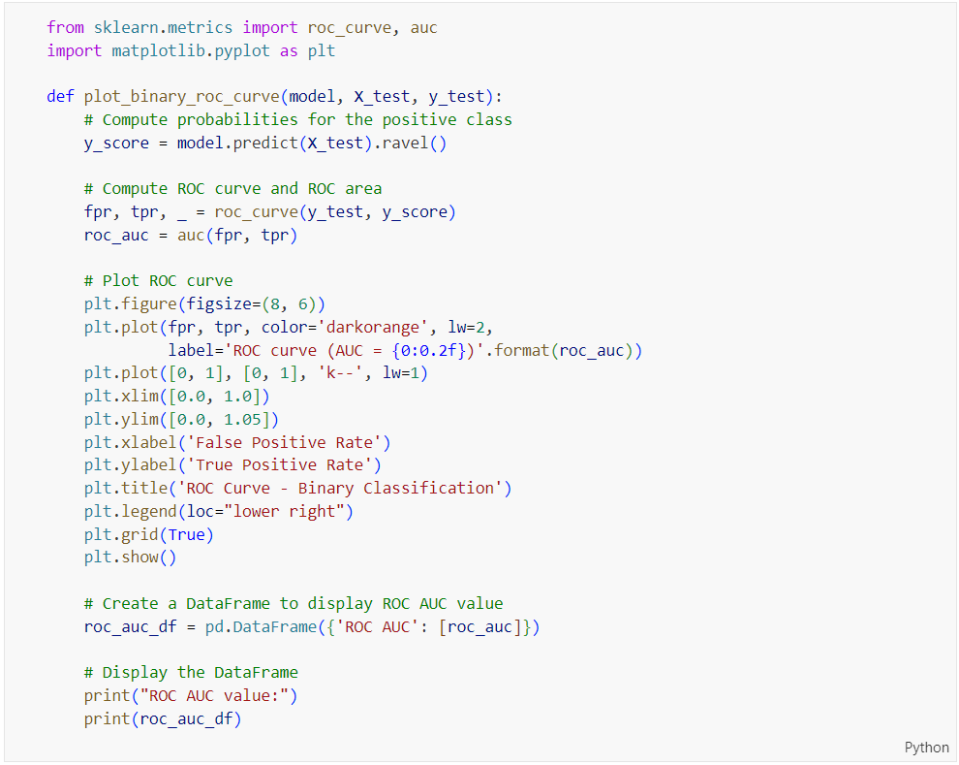

Figure 214: Source Code of Plotting the ROC Curve and Displaying ROC AUC Value for ANN Model (Binary Classification)

The code above defines a function ‘**plot_binary_roc_curve**’ that evaluate an Artificial Neural Network (ANN) model for binary classification by plotting the ROC curve and calculating the ROC AUC score. It computes the predicted probabilities for the positive class using the ANN model’s predictions on the test dataset. The ‘**roc_curve**’ function from ‘**sklearn.metrics**’ calculates the false positive rate (FPR) and true positive rate (TPR), and the ‘**auc**’ function computes the ROC AUC score. The ROC curve is plotted with the false positive rate on the x-axis and the true positive rate on the y-axis, including a diagonal line to represent random guessing. The plot includes labels, a title, and a legend displaying the AUC score. Finally, the ROC AUC score is displayed in a DataFrame format.

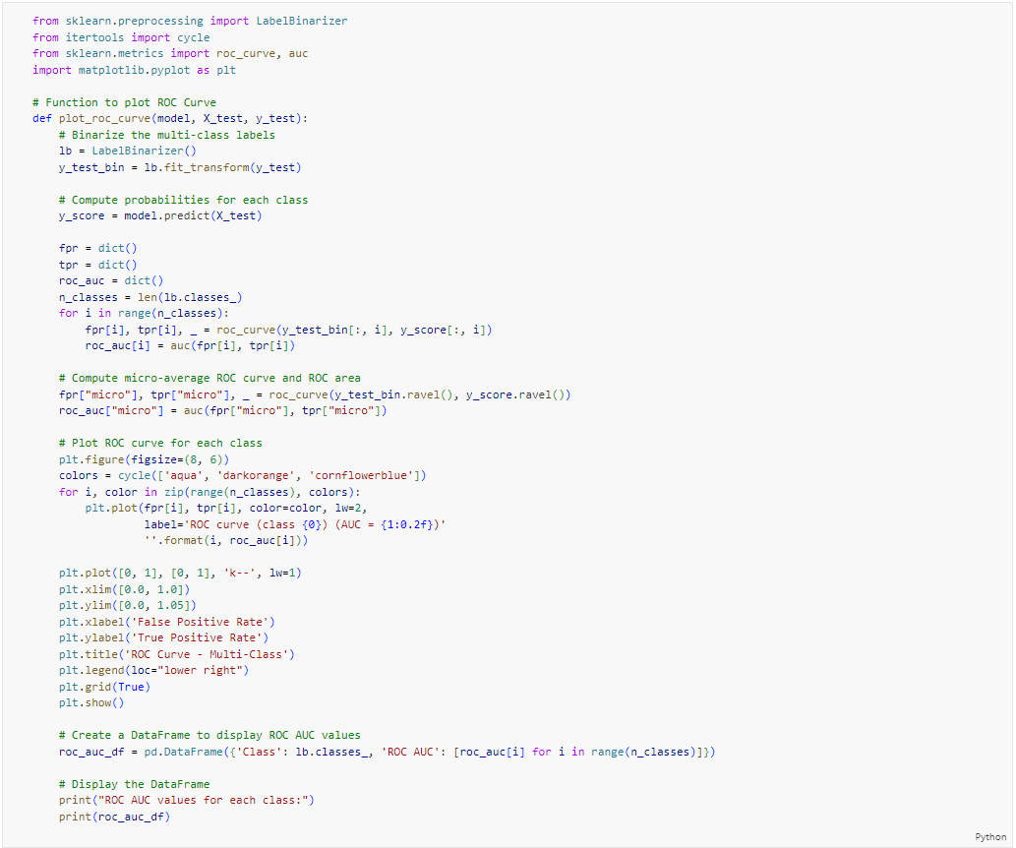

Figure 215: Source Code of Plotting the ROC Curve and Displaying ROC AUC Value for ANN Model (Multi Classification)

The code above evaluates a multi-class classification model, specifically an Artificial Neural Network (ANN) model, by plotting the ROC curves and calculating the ROC AUC scores for each class. It begins by binarizing the multi-class labels using ‘**LabelBinarizer**’ to convert multi-class labels into a binary format and computing the predicted probabilities for each class. The ‘**roc_curve**’ function calculates the false positive rate (FPR) and true positive rate (TPR) for each class, and the ‘**auc**’ function computes the ROC AUC scores. The code also computes the micro-average ROC and its AUC score, which considers all classes collectively. The ROC curves for each class are plotted with different colours, and a combined plot is created with the false positive rate on the x-axis and the true positive rate on the y-axis. The plot includes labels, a title, and a legend displaying the AUC scores for each class. Finally, the ROC AUC scores for each class are displayed in a DataFrame format.

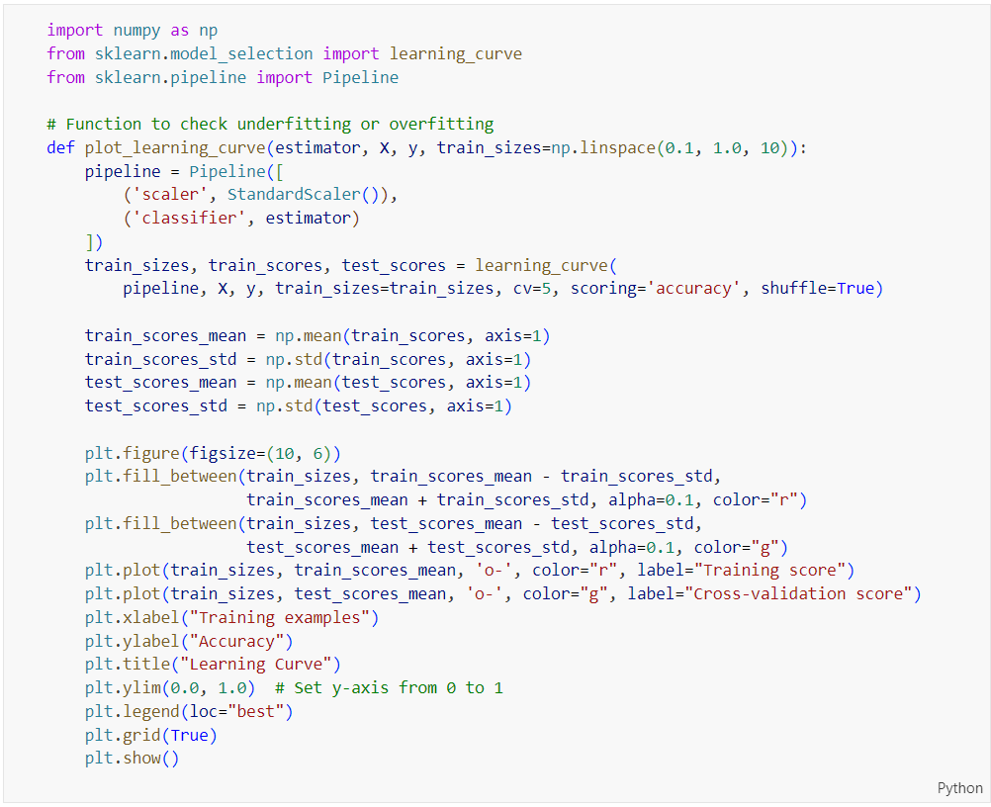

Figure 216: Source Code of Plotting the Learning Curve to Check for Underfitting or Overfitting for Models except ANN (Both Binary and Multi Classification)

The code shown in Figure 216 defines a function ‘**plot_learning_curve**’ to visualise learning curves and diagnose underfitting or overfitting. It uses ‘**Pipeline**’ to standardize data and fit an estimator, then calculates training and cross-validation scores with ‘**learning_curve**’. The function plots these scores, including means and standard deviations, using ‘**matplotlib**’ to show how model performance changes with different training set sizes.

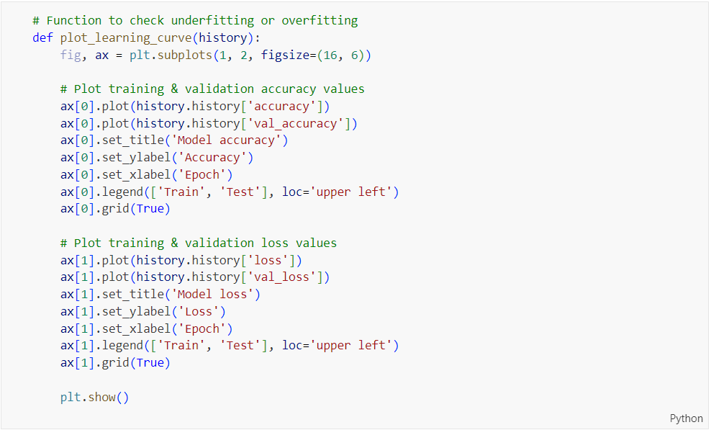

Figure 217: Source Code of Plotting the Learning Curve to Check for Underfitting or Overfitting for ANN Model (Both Binary and Multi Classification)

The code above defines a function named ‘**plot_learning_curve**’ that is used to check for underfitting or overfitting in Artificial Neural Network (ANN) model by plotting the training and validation accuracy and loss values over epochs. The function takes the model’s training history as input and uses Matplotlib to create two subplots in a single figure, each with a size of (16, 6).

In the first subplot, the function plots the training and validation accuracy values against the number of epochs. The plot includes a title, axis labels, a legend, and a grid for better readability. In the second subplot, the function plots the training and validation loss values in a similar way. The ‘**plt.show()**’ method is used to display the generated plots.

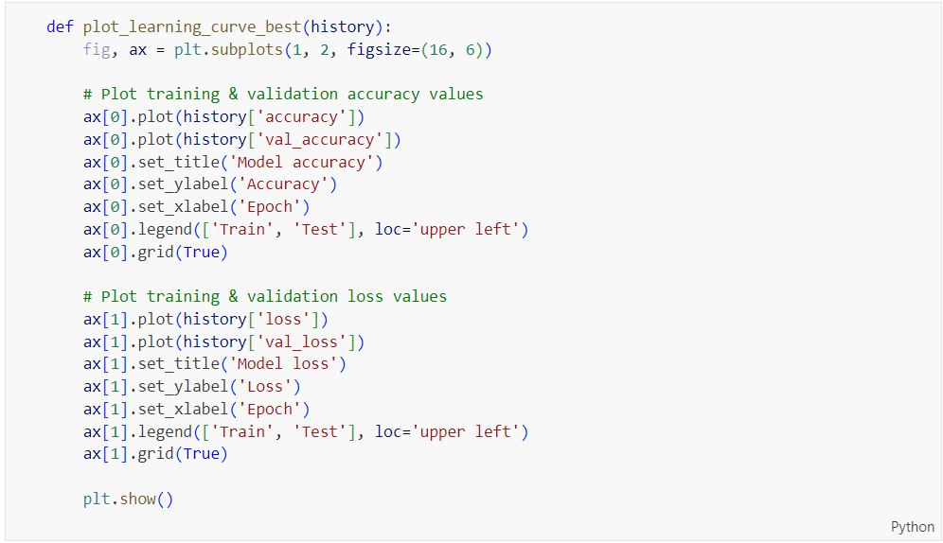

Figure 218: Source Code of Plotting the Learning Curve to Check for Underfitting or Overfitting for ANN Model (Both Binary and Multi Classification)

The code in Figure 218 is similar to the code in Figure 217. The only difference lies in how the history data is accessed. In Figure 217, the code uses the ‘**history.history**’ attribute , while the code in Figure 218 uses a simpler direct access method to retrieve the same values. This difference is due to the method of history data being accessed.

### Binary Classification

#### Logistic Regression (Before Hyperparameter Tuning)

##### Accuracy, Confusion Matrix and Classification Report

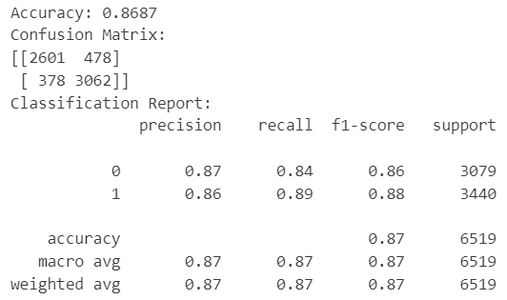

Figure 219: Base Logistic Regression Model Performance on Binary Classification

The output of the logistic regression model on binary classification includes accuracy, a confusion matrix, and a classification report. The model’s accuracy is 0.8687, meaning it correctly predicts 86.87% of the cases. The confusion matrix indicates the model correctly predicted 2601 instances of not at risk (class 0) and 3062 instances of at risk (class 1). On the other hand, there were 478 instances incorrectly predicted as class 1 and 378 instances incorrectly predicted as class 0.

The classification report provides a detailed breakdown of precision, recall and F1-score for each class (0 and 1). For class 0, which indicates not at risk, the precision is 0.87, indicating the proportion of correct positive predictions, and the recall is 0.84, showing the proportion of actual positives correctly predicted. The F1-score for class 0, which is the harmonic mean of precision and recall, is 0.86, with a support of 3079, which is the number of true instances for this class. For class 1, the precision is 0.86, recall is 0.89, and the F1-score is 0.88, with a support of 3440.

##### ROC Curve



Figure 220: plot_roc_curve Function Call for Base Logistic Regression on Binary Classification

The code shown in Figure 220 calls the ‘**plot_roc_curve**’ function, passing the trained logistic regression model (‘**lr_model_binary**’), the scaled test features (‘**X_test_scaled**’), and the test labels (‘**y_test**’) as arguments. This function computes the predicted probabilities of the positive class (class 1) and uses them to generate the ROC curve and calculate the area under the curve (AUC). It then plots the ROC curve, displaying the true positive rate against the false positive rate, and includes the AUC value in the plot legend. Finally, the ROC AUC value is printed in a DataFrame for easy reference.



Figure 221: ROC Curve for Base Logistic Regression on Binary Classification

The graph above is a Receiver Operating Characteristic (ROC) curve, which is used to evaluate the performance of a logistic regression model in predicting a binary class. The curve plots the True Positive Rate against the False Positive Rate at various threshold settings. The area under the curve (AUC) is 0.93, indicating a high level of model performance.

##### Check Overfitting or Underfitting

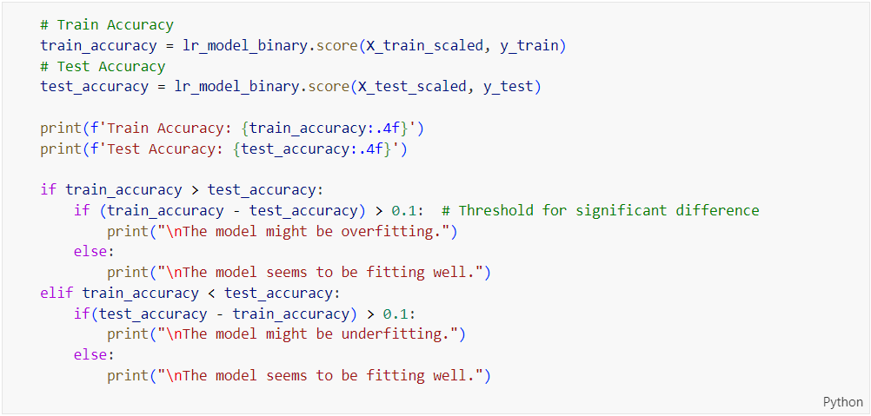

Figure 222: Train and Test Accuracy Evaluation Code for Base Logistic Regression on Binary Classification

The code shown in Figure 222 evaluates the logistic regression model’s performance by calculating its accuracy on both the training and testing datasets. The ‘**score**’ method of the logistic regression model is used to compute he accuracy, which is stored in ‘**train_accuracy**’ and ‘**test_accuracy**’ for the training and testing data, respectively. These accuracy values are then printed, formatted to four decimal places.

Next, the code checks for overfitting or underfitting by comparing the training accuracy to the testing accuracy. If the training accuracy is significantly higher than the testing accuracy (with a difference greater than 0.1), it suggests that the model might be overfitting. Conversely, if the testing accuracy is significantly higher than the training accuracy, it suggests that the model might be underfitting. If the difference between the training and testing accuracy is not significant, the model is considered to be fitting well.

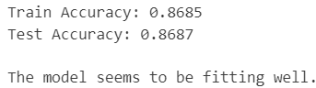

Figure 223: Base Logistic Regression Performance on Binary Prediction

The output shown in Figure 223 indicates the performance of a logistic regression model for binary class prediction. The model achieved a training accuracy of 0.8685, meaning it correctly predicted the binary class for 86.85% of the instances in the training dataset. Similarly, the model attained a testing accuracy of 0.8687, correctly predicting the binary class for 86.87% of the instances in the testing dataset. The very close values of training and testing accuracy with a different of only 0.0002 suggest that the model generalises well to new, unseen data, without significant overfitting or underfitting. This balance between the training and testing performance indicates that the model is well-fitted, proving reliable and robust predictions across different datasets.

##### Learning Curve



Figure 224: plot_learning_curve Function Call for Base Logistic Regression on Binary Classification

The code shown in Figure 224 calls the ‘**plot_learning_curve**’ function, passing the trained logistic regression model (‘**lr_model_binary**’), the feature matrix (‘**X**’), and the target variable (‘**y**’). this function generates and displays a learning curve, which helps in diagnosing whether the model is underfitting or overfitting by showing the training and cross-validation accuracy as the training set size increases.

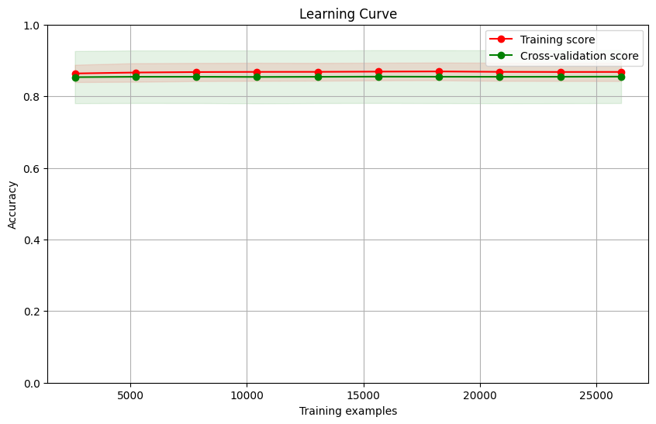

Figure 225: Learning Curve for Base Logistic Regression on Binary Classification

Figure 225 shows that the logistic regression model performs well on both the training and validation datasets. The model’s accuracy on the training data is around 86% to 87%, and it remains consistent as the number of training examples increases. Similarly, the accuracy on the validation data is also steady in the same range, indicating that the model is reliable when tested on new data. The small difference between the training and validation accuracy means the model is not overfitting or underfitting. This stability suggests that adding more training data does not significantly improve the model’s performance as it has already reached its optimal accuracy. Overall, the model is effective and dependable for binary classification tasks.

#### Logistic Regression (After Hyperparameter Tuning)

##### Accuracy, Confusion Matrix and Classification Report

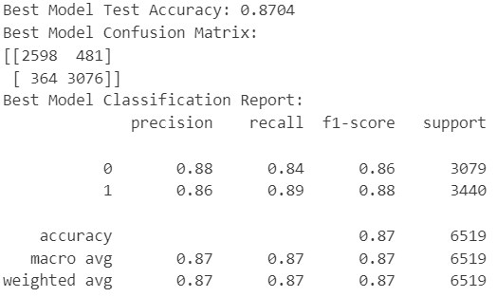

Figure 226: Tuned Logistic Regression Model Performance on Binary Classification

The best model's test accuracy is 87.04%, meaning it correctly predicts 87.04% of the test data. The confusion matrix reveals that out of 3079 actual negatives, the model correctly predicts 2598 and incorrectly predicts 481 as positives. For the 3440 actual positives, the model correctly predicts 3076 and incorrectly predicts 364 as negatives. The classification report shows precision, recall, and F1-score for Class 0 as 0.88, 0.84, and 0.86, respectively, and for Class 1 as 0.86, 0.89, and 0.88, respectively. With an overall accuracy of 0.87, and both macro and weighted averages for precision, recall, and F1-score at 0.87, the model demonstrates reliable performance in correctly predicting both classes.

Table 12: Base vs. Tuned Logistic Regression Model on Binary Classification

|  |  |  |  |  |  |  |
| --- | --- | --- | --- | --- | --- | --- |
| **Model Type** | **Accuracy** | **Precision (Class 0)** | **Precision (Class 1)** | **Recall (Class 0)** | **Recall (Class 1)** | **F1-Score (Macro Average)** |
| Logistic Regression (Base Model) | 0.8687 | 0.87 | 0.86 | 0.84 | 0.89 | 0.87 |
| Logistic Regression (Tuned Model) | 0.8704 | 0.88 | 0.86 | 0.84 | 0.89 | 0.87 |

Table 12 shows that after hyperparameter tuning, the logistic regression model’s accuracy improved slightly from 86.87% to 87.04%. Precision for Class 0 also saw a small increase from 0.87 to 0.88, while other metrics such as precision for Class 1, recall for both classes, and the overall F1-score remained unchanged when showing in two decimal places. This indicates that while tuning helped slightly improve the model’s correctness for predicting Class 0, the overall balanced performance between precision and recall stayed the same. The tuned model, therefore, offers a marginal improvement over the base model, particularly in making correct predictions for Class 0.

##### ROC Curve



Figure 227: plot_roc_curve Function Call for Tuned Logistic Regression on Binary Classification

The code shown in Figure 227 calls the ‘**plot_roc_curve**’ function defined in Figure 213 to generate and display the ROC curve for the best logistic regression model (‘**best_lr_model_binary**’) using the test data (‘**X_test_scaled**’ and ‘**y_test**’). This function computes the predicted probabilities, calculates the true positive rate and false positive rate, and plots the ROC curve, which helps in evaluating the model’s performance in distinguishing between classes.



Figure 228: ROC Curve for Tuned Logistic Regression on Binary Classification

The ROC curve for the tuned Logistic Regression model has an AUC value of 0.922974. This curve illustrates the model's ability to distinguish between the positive and negative classes. The curve stays close to the top-left corner, which indicates a high true positive rate and a low false positive rate. An AUC value of approximately 0.92 signifies that the model has excellent discriminative power and is effective at correctly predicting the positive class while minimizing false positives. This high AUC value reflects the model's strong performance in classification tasks.

Table 13: ROC AUC Comparison for Logistic Regression on Binary Classification

|  |  |
| --- | --- |
| **Model Type** | **ROC AUC Value** |
| Logistic Regression (Base Model) | 0.925678 |
| Logistic Regression (Tuned Model) | 0.922974 |

The comparison table shown in Table 13 shows that the base logistic regression model has a slightly better ability to distinguish between the two classes compared to the tuned model, as indicated by the marginally higher ROC AUC value (0.925678 vs 0.922974). The ROC curves visually confirm this, with both models performing well but the base model shown in Figure 221 having a slight edge. Despite the minor difference in AUC values, both models demonstrate strong predictive performance with high areas under the ROC curve. The base model is slightly more effective at correctly classifying instances.

##### Check Overfitting or Underfitting

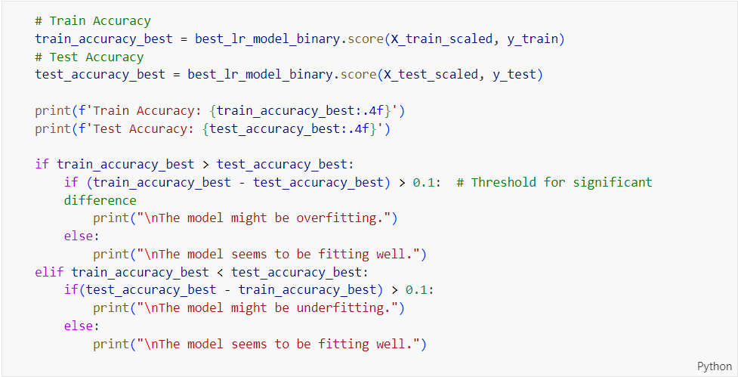

Figure 229: Train and Test Accuracy Evaluation Code for Tuned Logistic Regression on Binary Classification

The code shown in Figure 229 evaluates the training and testing accuracy of the best logistic regression model identified by ‘**GridSearchCV**’. The ‘**score**’ method is used to calculate the accuracy on the training data (‘**X_train_scaled**’, ‘**y_train**’) and the test data (‘**X_test_scaled**’, ‘**y_test**’), storing the results in ‘**train_accuracy_best**’ and ‘**test_accuracy_best**’, respectively. These accuracy values are then printed, formatted to four decimal places.

As mentioned in the explanation on Figure 222, the code checks for overfitting or underfitting by comparing the training accuracy to the testing accuracy.

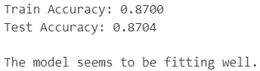

Figure 230: Tuned Logistic Regression Performance on Binary Prediction

Figure 230 shows the train accuracy of 0.8700 and the test accuracy of 0.8704 for the tuned Logistic Regression model, indicating that the model performs consistently well on both the training and test datasets. The minimal difference between the train and test accuracies suggests that the model is not overfitting or underfitting. The message “The model seems to be fitting well” confirms that the model has achieved a good balance between bias and variance, generalizing effectively to new, unseen data.

Table 14: Training and Testing Accuracy Comparison for Logistic Regression on Binary Classification

|  |  |
| --- | --- |
| **Model Type** | **Difference in Accuracies** |
| Logistic Regression (Base Model) | 0.0002 |
| Logistic Regression (Tuned Model) | 0.0004 |

Table 14 compares the differences in training and testing accuracy between the base and tuned Logistic Regression models. The “Difference in Accuracies” column shows how much the training and testing accuracies differ for each model type. The small differences in accuracies for both models imply that both the base and tuned Logistic Regression models generalize well to unseen data, with the tuned model showing a marginally higher discrepancy.

##### Learning Curve



Figure 231: plot_learning_curve Function Call for Tuned Logistic Regression on Binary Classification

The code shown in Figure 231 calls the ‘**plot_learning_curve**’ function defined in Figure 216 to generate and display the learning curve for the best logistic regression model (‘**best_lr_model_binary**’). The function is passed the full feature matrix (‘**X**’) and target variable (‘**y**’). This learning curve helps in diagnosing whether the model is underfitting or overfitting by showing the training and cross-validation accuracy as the training set size increases.

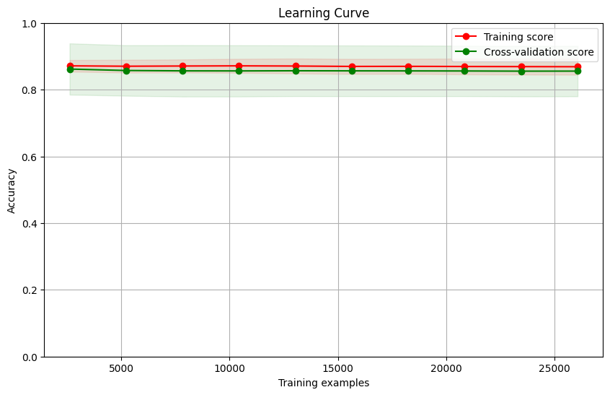

Figure 232: Learning Curve for Tuned Logistic Regression on Binary Classification

Figure 232 shows the learning curve for the tuned logistic regression model. The learning curves for both the base (Figure 225) and tuned logistic regression models show that they perform similarly well on both the training and cross-validation datasets. Both models maintain high accuracy around 87% on the training data and slightly lower but still high accuracy on the validation data, indicating good generalization. The stability and narrow variability in the cross-validation scores for both models suggest consistent performance. Overall, hyperparameter tuning did not significantly after the learning curve, and both models demonstrate robust and reliable predictive capabilities for binary classification tasks.

##### Comparison between Base and Tuned Logistic Regression on Binary Classification

The comparison reveals that both the base and tuned logistic regression models perform well, with the tuned model showing a slight improvement in accuracy (87.04% vs 86.87%) and precision for Class 0. However, the base model has a slightly higher ROC AUC value (0.925678 vs 0.922974), indicating better class distinction. Both models generalize well with similar accuracies on training and test datasets, and stable learning curves. Overall, the base model, with its marginally better ROC AUC and comparable generalization, stands out as the more effective choice for logistic regression model on binary classification task.

#### Decision Tree (Before Hyperparameter Tuning)

##### Accuracy, Confusion Matrix and Classification Report

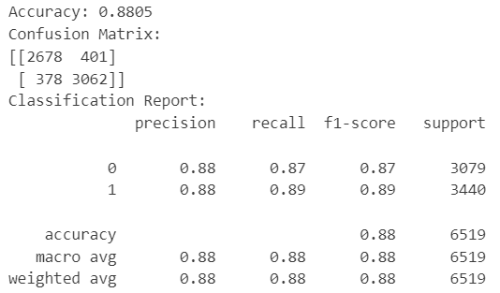

Figure 233: Base Decision Tree Model Performance on Binary Classification

Before hyperparameter tuning, the decision tree model achieved an accuracy of 88.05%. the confusion matrix shows that the model correctly predicted most instances for both classes, with 2678 correct predictions for class 0 and 3062 for class 1, alongside some misclassifications. The classification report indicates balanced performance with precision, recall, and F1-scores all around 88% for both classes. The model shows consistent and reliable performance, providing accurate predictions for binary classification tasks.

##### ROC Curve



Figure 234: plot_roc_curve Function Call for Base Decision Tree on Binary Classification

The code shown in Figure 234 is used to plot the Receiver Operating Characteristic (ROC) curve for a binary classification model, specifically a decision tree model. It takes three arguments: ‘**dt_model_binary**’ (the decision tree model), ‘**X_test_scaled**’ (the scaled test set features), and ‘**y_test**’ (the true labels for the test set). The ROC curve visualizes the model's performance by plotting the true positive rate against the false positive rate at various threshold levels.



Figure 235: ROC Curve for Base Decision Tree on Binary Classification

The ROC curve for the decision tree model shown in Figure 235 demonstrates good performance in predicting binary classes. The curve stays close to the top left corner of the plot, indicating high sensitivity and low false positive rates across different thresholds. The model’s AUC is 0.88, meaning it has an 88% probability of correctly distinguishing between the two classes.

##### Check Overfitting or Underfitting

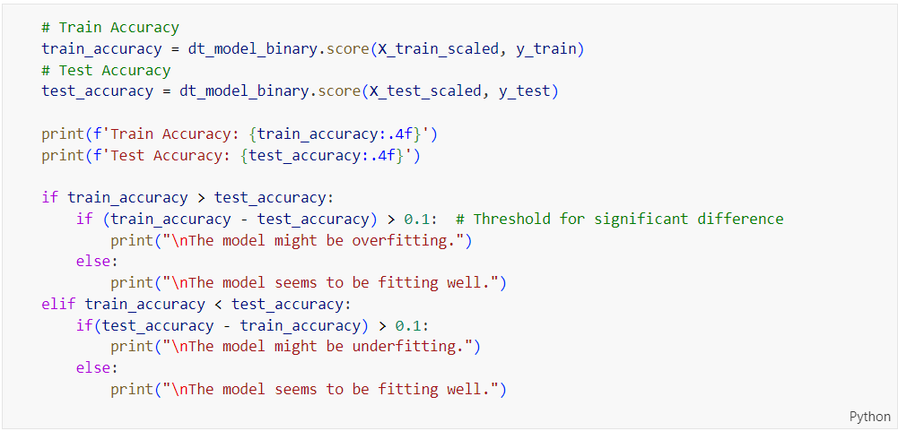

Figure 236: Train and Test Accuracy Evaluation Code for Base Decision Tree on Binary Classification

This code above evaluates the training and testing accuracy of a Decision Tree model (dt_model_binary). It calculates the accuracies on both the training and testing datasets and prints them. It then checks for overfitting or underfitting by comparing the differences between the train and test accuracies. If the difference exceeds 0.1, it indicates potential overfitting or underfitting; otherwise, it suggests that the model is fitting well. The key difference from the previously explained code is the use of a Decision Tree model instead of a Random Forest model.

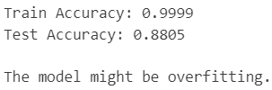

Figure 237: Base Decision Tree Performance on Binary Prediction

The decision tree model shows a very high training accuracy of 99.99%, indicating that it has almost perfectly memorized the training data. However, the test accuracy drops to 99.08%, suggesting that the model struggles to make accuracy predictions on new data. This large discrepancy between training and test accuracy indicates that the model is overfitting, meaning it performs well on the training data but fails to generalize to unseen data. Hyperparameter tuning techniques will be used to address the overfitting issue observed in Figure 237.

##### Learning Curve



Figure 238: plot_learning_curve Function Call for Base Decision Tree on Binary Classification

The similar code has been explained previously for Figure 231.The only difference from the previously explain code is that the code in Figure 238 uses a Decision Tree model instead of Logistic Regression model.

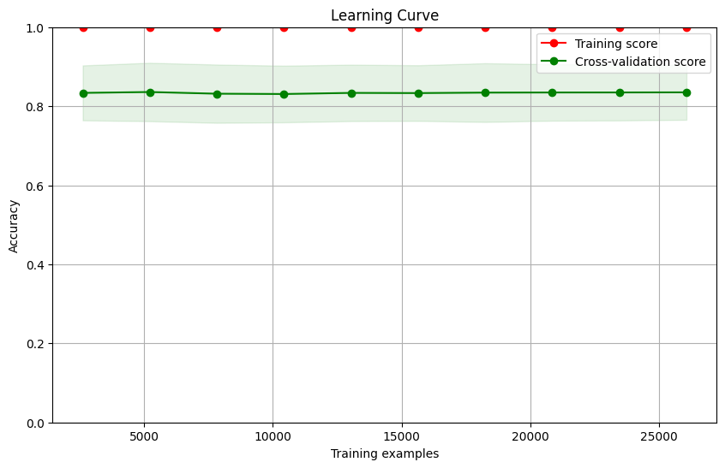

Figure 239: Learning Curve for Base Decision Tree on Binary Classification

The learning curve for the decision tree model before hyperparameter tuning shows that the model is highly accurate on the training data, with an accuracy close to 100%. However, the model’s accuracy drops to around 80% – 82% on the cross-validation data, indicating that it is overfitting. This means that the model has learned the training data too well, including noise and specific details that do not generalize to new data. As a result, it performs much worse on unseen data, demonstrating the need for hyperparameter tuning to improve its generalization ability.

#### Decision Tree (After Hyperparameter Tuning)

##### Accuracy, Confusion Matrix and Classification Report

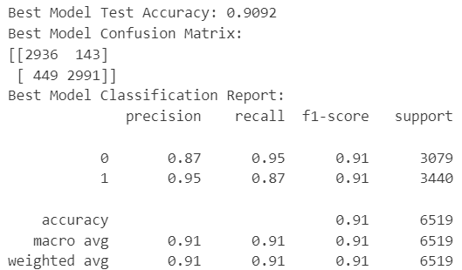

Figure 240: Tuned Decision Tree Model Performance on Binary Classification

Figure 240 shows the model performance of the tuned Decision Tree model. The tuned model’s test accuracy is 0.9092, indicating it correctly predicts 90.92% of the test data. The confusion matrix shows that for Class 0, 2936 instances are correctly predicted, while 143 are incorrectly predicted. For Class 1, 2991 instances are correctly predicted, while 449 are incorrectly predicted. The classification report shows precision, recall and F1-score for Class 0 as 0.87, 0.95, and 0.91, respectively. Both classes have an overall accuracy, macro average, and weighted average of 0.91 for precision, recall and F1-score, indicating a well-balanced and effective model in classifying both classes with high accuracy and minimal bias.

Table 15: Base vs. Tuned Decision Tree Model on Binary Classification

|  |  |  |  |  |  |  |
| --- | --- | --- | --- | --- | --- | --- |
| **Model Type** | **Accuracy** | **Precision (Class 0)** | **Precision (Class 1)** | **Recall (Class 0)** | **Recall (Class 1)** | **F1-Score (Macro Average)** |
| Decision Tree (Base Model) | 0.8805 | 0.88 | 0.88 | 0.87 | 0.89 | 0.88 |
| Decision Tree (Tuned Model) | 0.9092 | 0.87 | 0.95 | 0.95 | 0.87 | 0.91 |

Table 15 compares the performance metrics of decision tree model for binary class prediction before and after hyperparameter tuning. The table shows that after hyperparameter tuning, the decision tree model’s accuracy increased from 88.05% to 90.92%, indicating it makes more correct predictions. Precision for class 0 remained similar but slightly decreased, while precision for Class 1 improved significantly from 088 to 0.95. Recall for Class 0 saw a notable improvement from 0.87 to 0.95, while recall for Class 1 slightly decreased from 0.89 to 0.87. the overall F1-score, which balances precision and recall, improved from 0.88 to 0.91, suggesting that the tuned model has better overall performance and reliability for binary classification tasks. The tuning process has effectively enhanced the model’s ability to correctly identify and classify the instances, particularly improving its precision for Class 1 and recall for Class 0.

##### ROC Curve

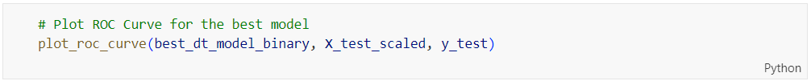

Figure 241: plot_roc_curve Function Call for Tuned Decision Tree on Binary Classification

The code above plots the ROC curve for the best-performing decision tree model. It uses the scaled test features (‘**X_test_scaled**’) and the true test labels (‘**y_test**’) to visualize the model's performance, showing the trade-off between the true positive rate and the false positive rate at different thresholds.



Figure 242: ROC Curve for Tuned Decision Tree on Binary Classification

The ROC curve in Figure 242 evaluates the performance of a binary classification model, plotting the True Positive Rate (TPR) against the False Positive Rate (FPR) at various threshold settings. The curve stays close to the top-left corner, indicating a high TPR and a low FPR, which suggests the model performs well in distinguishing between the positive and negative classes. The Area Under the Curve (AUC) value is approximately 0.953952, signifying excellent discriminative ability. An AUC value close to 1 indicates the model is highly effective at correctly identifying both classes. Overall, the ROC curve and the high AUC value demonstrate the model's strong classification accuracy and reliable performance in distinguishing between the two classes.

Table 16: ROC AUC Comparison for Decision Tree on Binary Classification

|  |  |
| --- | --- |
| **Model Type** | **ROC AUC Value** |
| Decision Tree (Base Model) | 0.879922 |
| Decision Tree (Tuned Model) | 0.953952 |

After hyperparameter tuning, the decision tree model performs much better. The tuned model’s ability to correctly classify the two classes has improved significantly. The ROC AUC value increased from 0.88 to 0.95, meaning the tuned model is better at distinguishing between the classes. The ROC curve for the tuned model is closer to the top-left corner, indicating that it makes more correct predictions and fewer mistakes compared to the base model. This improvement shows that hyperparameter tuning has made the model more accurate and reliable for binary classification tasks.

##### Check Overfitting or Underfitting

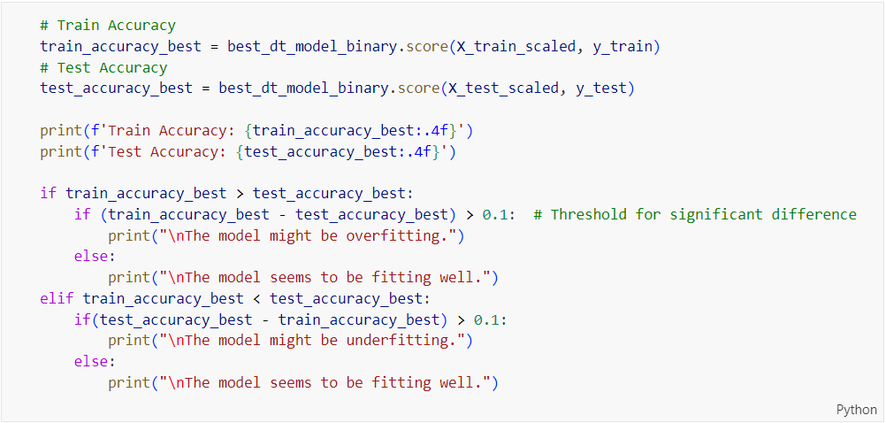

Figure 243: Train and Test Accuracy Evaluation Code for Tuned Decision Tree on Binary Classification

Figure 243 shows the code evaluating the training and testing accuracy of a tuned decision tree model (‘**best_dt_model_binary**’). The model's accuracies on both the training (‘**X_train_scaled**’, ‘**y_train**’) and testing datasets (‘**X_test_scaled**’, ‘**y_test**’) are calculated and printed. The code then compares the training and testing accuracies to determine if the model is overfitting or underfitting. If the difference between the train and test accuracies is greater than 0.1, it suggests potential overfitting or underfitting; otherwise, it indicates that the model is fitting well. This approach helps ensure that the decision tree model generalizes effectively to new data.

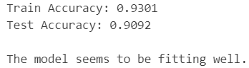

Figure 244: Tuned Decision Tree Performance on Binary Prediction

Figure 244 presents the train and test accuracy for the tuned decision tree model, showing a train accuracy of 0.9301 and a test accuracy of 0.9092. This slight difference indicates that the model performs slightly better on the training data than on the test data, but the difference is minimal, suggesting that the model generalizes well to unseen data.

Table 17: Training and Testing Accuracy Comparison for Decision Tree on Binary Classification

|  |  |
| --- | --- |
| **Model Type** | **Difference in Accuracies** |
| Decision Tree (Base Model) | 0.1194 |
| Decision Tree (Tuned Model) | 0.0209 |

Based on Table 17, the base model has a significant difference in accuracies of 0.1194, while tuned model shows a much smaller difference of 0.0209. this substantial reduction in the difference for the tuned model indicates that hyperparameter tuning has significantly improved the model’s generalization performance, reducing overfitting.

##### Learning Curve

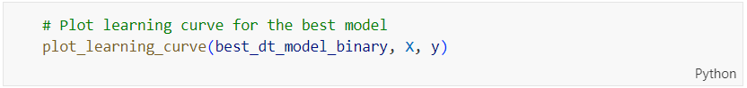

Figure 245: plot_learning_curve Function Call for Tuned Decision Tree on Binary Classification

Figure 245 shows the code plotting the learning curve for the best decision tree model (‘**best_dt_model_binary**’). It takes the model and the dataset (‘**X**’ for features and ‘**y**’ for labels) as inputs. The learning curve visualizes the model’s performance over varying sizes of the training dataset, helping to assess how well the model is learning and generalizing as more training data is provided. This aids in identifying issues like overfitting or underfitting and in understanding the model's capacity to learn from the data.

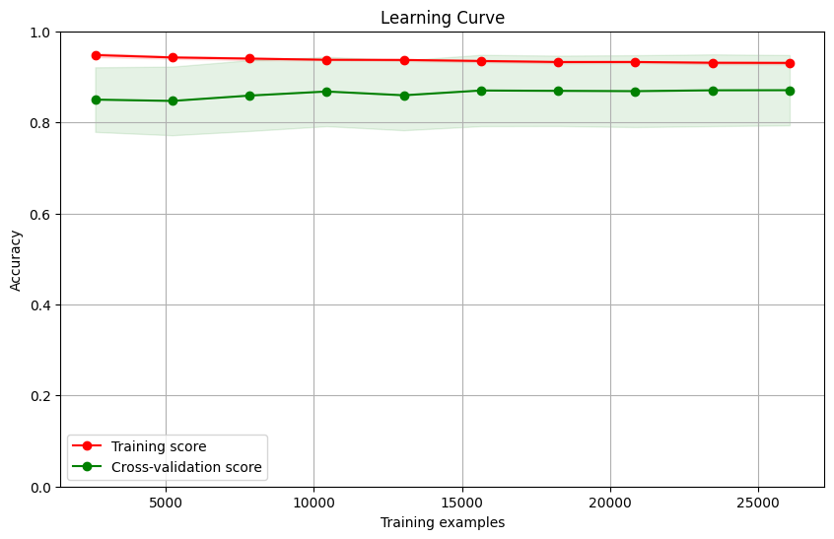

Figure 246: Learning Curve for Tuned Decision Tree on Binary Classification

Figure 246 shows the learning curve for a tuned decision tree model. The training score remains consistently high, close to 1.0, indicating that the model performs well on the training data. The cross-validation score is around 0.85, with a slight upward trend as the number of training examples increases. This suggests that the model generalizes well to unseen data and that its performance improves with more training examples.

In comparison, the base decision tree model shows a similar high training score close to 1.0 but with a cross-validation score around 0.82. The base model’s cross-validation score remains stable, showing minimal improvement with additional training examples, which indicates higher overfitting and limited generalization compared to tuned model.

##### Comparison between Base and Tuned Decision Tree on Binary Classification

The tuned decision tree model is the better choice for binary class prediction due to its improved performance metrics. It has higher accuracy (90.92% vs 88.05%), better precision for Class 1 (0.95 vs 0.88), and improved recall for Class 0 (0.95 vs 0.87), resulting in a higher overall F1-score (0.91 vs 0.88). The ROC AUC value also increased from 0.88 to 0.95, showing better discrimination between classes. Additionally, the tuned model has a smaller gap between training and test accuracy, indicating reduced overfitting and better generalization. Overall, these improvements make the tuned decision tree model more accurate and reliable for binary class prediction.

#### Random Forest (Before Hyperparameter Tuning)

##### Accuracy, Confusion Matrix and Classification Report

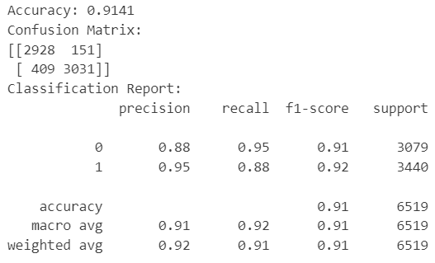

Figure 247: Base Random Forest Model Performance on Binary Classification

The classification report shows a strong performance for the model with an overall accuracy of 91.41%. The confusion matrix indicates that the model correctly identified 2928 instances of Class 0 and 3031 instances of Class 1, while it misclassified 151 instances of Class 0 and 409 instances of Class 1. Precision and recall for Class 0 are both high at 0.88 and 0.95 respectively, leading to an F1-score of 0.91. For Class 1, precision is excellent at 0.95, while recall is slightly lower at 0.88, resulting in an F1-score of 0.92. The macro and weighted averages of precision, recall and F1-score all hover around 0.91 to 0.92, indicating balanced performance across both classes. This suggest that the model is well-calibrated, making accurate predictions and effectively distinguishing between the two classes.

##### ROC Curve



Figure 248: plot_roc_curve Function Call for Base Random Forest on Binary Classification

Figure 248 shows the code calling ‘**plot_roc_curve()**’ function to plot the ROC curve for the random forest binary classification model using the scaled test features and true test labels. The output is shown in Figure 249.



Figure 249: ROC Curve for Base Random Forest on Binary Classification

The ROC (Receiver Operating Characteristic) curve shown in Figure 249 represents the performance of a binary classification model. The curve plots the True Positive Rate (sensitivity) against the False Positive Rate (1-specificity) at various threshold settings. The ROC curve's proximity to the top-left corner indicates a high level of performance. The AUC (Area Under the Curve) value of approximately 0.96441 signifies excellent discrimination capability, meaning the model is highly effective at distinguishing between the positive and negative classes. This high AUC value, close to 1, indicates that the model has a strong ability to predict the correct class labels.

##### Check Overfitting or Underfitting

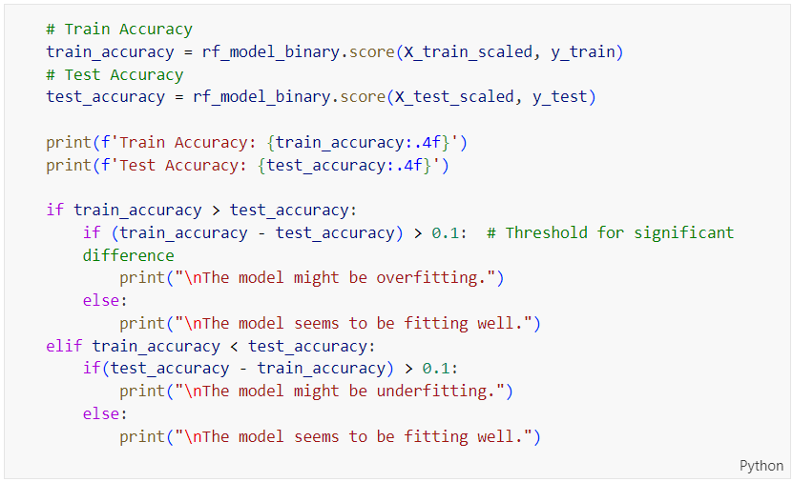

Figure 250: Train and Test Accuracy Evaluation Code for Base Random Forest on Binary Classification

The code in Figure 250 evaluates the training and testing accuracy of the base Random Forest model (‘**rf_model_binary**’). It calculates and prints the accuracies on both the training (‘**X_train_scaled**’, ‘**y_train**’) and testing datasets (‘**X_test_scaled**’, ‘**y_test**’). The code then checks for overfitting or underfitting by comparing the differences between the train and test accuracies. If the difference exceeds 0.1, it indicates potential overfitting or underfitting; otherwise, it suggests that the model is fitting well. This helps ensure that the base Random Forest model generalizes effectively to new data.

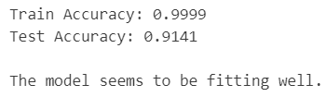

Figure 251: Base Random Forest Performance on Binary Prediction

The high training accuracy of 0.9999 indicates that the model performs exceptionally well on the training data, nearly perfectly classify the training examples. The test accuracy of 0.9141 shows that the model also performs well on unseen data, with a slight drop in accuracy compared to training set.

##### Learning Curve

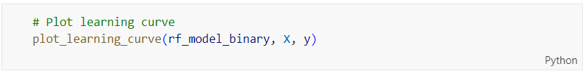

Figure 252: plot_learning_curve Function Call for Base Random Forest on Binary Classification

The function has been explained previously in Figure 216. The similar code here uses the base Random Forest model (‘**rf_model_binary**’) to plot the learning curve.

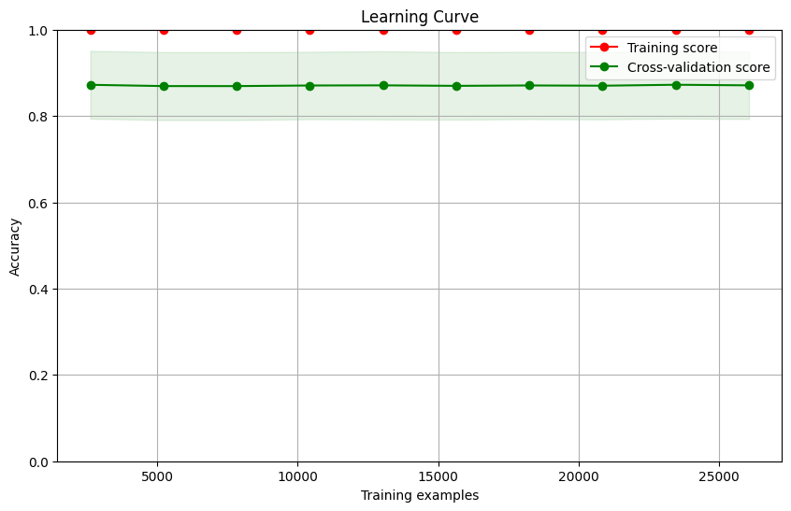

Figure 253: Learning Curve for Base Random Forest on Binary Classification

The learning curve shown in Figure 253 indicates that the model is fitting the data well. There is a significant difference between the training and cross-validation scores, suggesting potential overfitting. However, since the cross-validation score is high and stable, the model generalizes well to new data despite the high training score.

#### Random Forest (After Hyperparameter Tuning)

##### Accuracy, Confusion Matrix and Classification Report

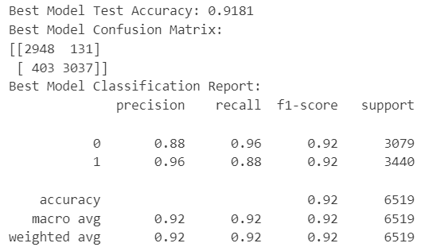

Figure 254: Tuned Random Forest Model Performance on Binary Classification

Figure 254 shows the performance of the Random Forest model after hyperparameter tuning. The model achieves a test accuracy of 0.9181, indicating that it correctly predicts 91.81% of the test data. The confusion matrix reveals that out of 3079 actual negatives, the model correctly predicts 2948 and incorrectly predicts 131 as positives. Out of 3440 actual positives, the model correctly predicts 3037 and incorrectly predicts 403 as negatives. The classification report shows precision, recall, and F1-score for Class 0 as 0.88, 0.96, and 0.92, respectively, and for Class 1 as 0.96, 0.88, and 0.92, respectively. The overall accuracy, macro average, and weighted average for precision, recall, and F1-score are all 0.92, indicating a well-balanced model with excellent performance in correctly predicting both classes.

Table 18: Base vs. Tuned Random Forest Model on Binary Classification

|  |  |  |  |  |  |  |
| --- | --- | --- | --- | --- | --- | --- |
| **Model Type** | **Accuracy** | **Precision (Class 0)** | **Precision (Class 1)** | **Recall (Class 0)** | **Recall (Class 1)** | **F1-Score (Macro Average)** |
| Random Forest (Base Model) | 0.9141 | 0.88 | 0.95 | 0.95 | 0.88 | 0.91 |
| Random Forest (Tuned Model) | 0.9181 | 0.88 | 0.96 | 0.96 | 0.88 | 0.92 |

Table 18 compares the performance metrics of the base and tuned Random Forest models. The tuned Random Forest model shows a slight improvement over the base model. The accuracy increases from 0.9141 to 0.9181. Precision for Class 1 improves from 0.95 to 0.96, while precision for Class 0 remains at 0.88. Recall for Class 0 increases from 0.95 to 0.96, with recall for Class 1 staying at 0.88. The F1-Score (Macro Average) also sees an improvement, rising from 0.91 to 0.92. These enhancements suggest that the tuning process has made the model more accurate and slightly better at identifying positive instances, thus improving overall performance.

##### ROC Curve

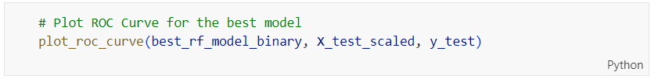

Figure 255: plot_roc_curve Function Call for Tuned Random Forest on Binary Classification

Figure 255 shows the code calling ‘**plot_roc_curve()**’ function to plot the ROC curve for the tuned random forest binary classification model using the scaled test features and true test labels. The output is shown in Figure 256.



Figure 256: ROC Curve for Tuned Random Forest on Binary Classification

Figure 256 shows the ROC curve for the Decision tree model after hyperparameter tuning. The curve plots the True Positive Rate (TPR) against the False Positive Rate (FPR) at various threshold settings. The ROC curve remains close to the top-left corner, indicating a high TPR and a low FPR, suggesting the model performs well in distinguishing between the positive and negative classes. The AUC (Area Under the Curve) value is 0.966488, which signifies excellent discriminative ability. An AUC value close to 1 indicates the model is very effective at correctly identifying positive instances while minimizing false positives. Overall, the ROC curve and high AUC value demonstrate the Decision Tree model's strong classification performance after hyperparameter tuning.

Table 19: ROC AUC Comparison for Random Forest on Binary Classification

|  |  |
| --- | --- |
| **Model Type** | **ROC AUC Value** |
| Random Forest (Base Model) | 0.96441 |
| Random Forest (Tuned Model) | 0.966488 |

Table 19 compares the ROC AUC values of the base and tuned Random Forest models. The base model has an AUC value of 0.96441, while the tuned model has a slightly higher AUC value of 0.966488. This small increase in the AUC value indicates that hyperparameter tuning has marginally improved the model's ability to distinguish between the positive and negative classes.

##### Check Overfitting or Underfitting

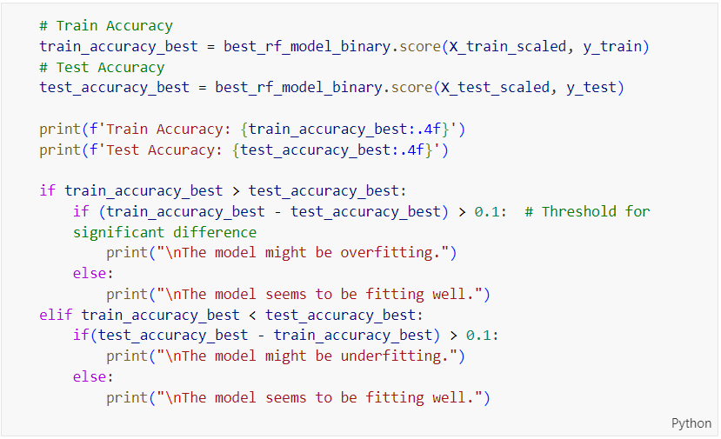

Figure 257: Train and Test Accuracy Evaluation Code for Tuned Random Forest on Binary Classification

The code above evaluates the training and testing accuracy of the tuned Random Forest model (‘**best_rf_model_binary**’). It calculates the accuracies on both the training (‘**X_train_scaled**’, ‘**y_train**’) and testing datasets (‘**X_test_scaled**’, ‘**y_test**’) and prints them. The code then checks for overfitting or underfitting by comparing the difference between train and test accuracies. If the difference exceeds 0.1, it indicates potential overfitting or underfitting; otherwise, it suggests that the model is fitting well. The only difference from the previously explained code is the use of the tuned Random Forest model for prediction.

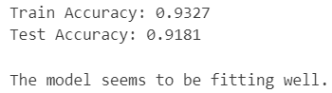

Figure 258: Tuned Random Forest Performance on Binary Prediction

The output shown in Figure 258 indicates that the best Random Forest model has a train accuracy of 0.9327 and a test accuracy of 0.9181. The small difference between these two accuracies (0.0146) suggests that the model is not overfitting or underfitting. This indicates that the model generalizes well from the training data to unseen test data, maintaining a high level of performance. The message "The model seems to be fitting well" confirms that the model has achieved a good balance between bias and variance, effectively predicting both the training and test datasets.

Table 20: Training and Testing Accuracy Comparison for Random Forest on Binary Classification

|  |  |
| --- | --- |
| **Model Type** | **Difference in Accuracies** |
| Random Forest (Base Model) | 0.0858 |
| Random Forest (Tuned Model) | 0.0146 |

Table 20 compares the differences in training and testing accuracy between the base and tuned Random Forest models. The base model shows a difference in accuracies of 0.0858, indicating a more significant gap between its performance on the training and testing datasets, which could suggest slight overfitting. In contrast, the tuned model has a much smaller difference in accuracies of 0.0146, indicating that it generalizes better from the training data to unseen test data. This reduction in the difference after hyperparameter tuning suggests that the tuning process has effectively improved the model's ability to maintain consistent performance across both training and testing datasets, reducing overfitting and enhancing generalization.

##### Learning Curve

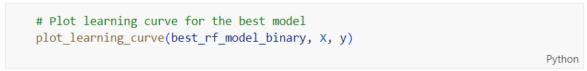

Figure 259: plot_learning_curve Function Call for Tuned Random Forest on Binary Classification

The code above plots the learning curve for the best Random Forest model (‘**best_rf_model_binary**’) using the feature matrix ‘**X**’ and target vector ‘**y**’. This visualization helps assess the model's performance on the training and cross-validation datasets as the number of training examples increases.

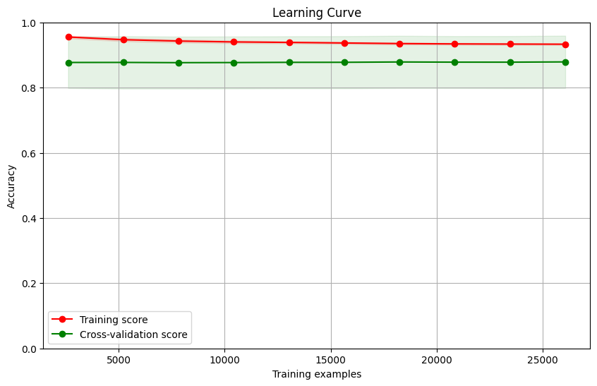

Figure 260: Learning Curve for Tuned Random Forest on Binary Classification

Figure 260 shows the learning curve for the Random Forest model after hyperparameter tuning. The red line represents the training score, which remains consistently high, close to 1, indicating excellent performance on the training data. The green line represents the cross-validation score, which stabilizes around 0.92, showing good performance on unseen data. The small gap between the training and cross-validation scores suggests that the model is not overfitting and generalizes well to new data. The stability of both lines across increasing numbers of training examples further indicates that the model's performance is robust and consistent, demonstrating effective learning and generalization after tuning.

##### Comparison between Base and Tuned Random Forest on Binary Classification

Based on the comparisons presented in Table 18, Table 19 and Table 20, the tuned Random Forest model is the best choice. It demonstrates improvements in several key performance metrics compared to the base model: accuracy increases from 0.9141 to 0.9181, precision for Class 1 improves from 0.95 to 0.96, recall for Class 0 improves from 0.95 to 0.96, and the F1-Score (Macro Average) rises from 0.91 to 0.92. Additionally, the ROC AUC value for the tuned model is slightly higher (0.966488) than the base model (0.96441), indicating a marginally better discriminative ability. Furthermore, the difference in training and testing accuracy for the tuned model is significantly smaller (0.0146) compared to the base model (0.0858), suggesting better generalization and reduced overfitting. These enhancements confirm that the hyperparameter tuning process has effectively optimized the Random Forest model, making it more accurate and reliable for classification tasks.

#### Gradient Boosting (Before Hyperparameter Tuning)

##### Accuracy, Confusion Matrix and Classification Report

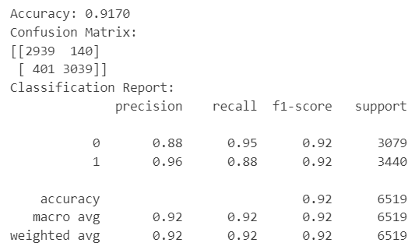

Figure 261: Base Gradient Boosting Model Performance on Binary Classification

Figure 261 shows the performance of the Gradient Boosting model before hyperparameter tuning. The model's accuracy is 0.9170, indicating it correctly predicts 91.70% of the test data. The confusion matrix reveals that for Class 0, 2939 instances are correctly predicted, while 140 are incorrectly predicted as Class 1. For Class 1, 3039 instances are correctly predicted, while 401 are incorrectly predicted as Class 0. The classification report shows precision, recall, and F1-score for Class 0 as 0.88, 0.95, and 0.92, respectively, and for Class 1 as 0.96, 0.88, and 0.92, respectively. Both the macro and weighted averages for precision, recall, and F1-score are 0.92, indicating a well-balanced model that performs consistently well across both classes.

##### ROC Curve



Figure 262: plot_roc_curve Function Call for Base Gradient Boosting on Binary Classification

The code above is plotting the ROC (Receiver Operating Characteristic) curve for the Gradient Boosting model (‘**gb_model_binary**’) using the test dataset (‘**X_test_scaled**’, ‘**y_test**’).



Figure 263: ROC Curve for Base Gradient Boosting on Binary Classification

Figure 263 presents the ROC (Receiver Operating Characteristic) curve for the Gradient Boosting model before hyperparameter tuning. The curve illustrates the model's ability to differentiate between the positive and negative classes by plotting the True Positive Rate (TPR) against the False Positive Rate (FPR) at various threshold settings. The ROC curve is close to the top-left corner, indicating a high TPR and a low FPR, which signifies strong model performance. The AUC (Area Under the Curve) value of 0.969526 indicates that the model has excellent discriminative ability, meaning it is highly effective at correctly classifying the positive and negative classes. This high AUC value demonstrates the model's robust performance even before hyperparameter tuning.

##### Check Overfitting or Underfitting

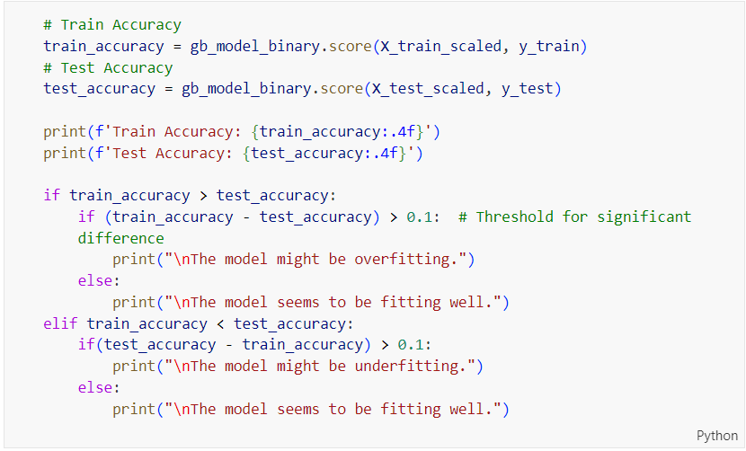

Figure 264: Train and Test Accuracy Evaluation Code for Base Gradient Boosting on Binary Classification

The code above calculates the training and testing accuracy for the Gradient Boosting model (‘**gb_model_binary**’). It then compares the train and test accuracies to check for overfitting or underfitting. If the difference between train and test accuracy is greater than 0.1, it indicates potential overfitting or underfitting; otherwise, it suggests the model fits well. The primary difference from the previously explained code is the use of the Gradient Boosting model instead of another model.

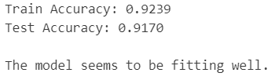

Figure 265: Base Gradient Boosting Performance on Binary Prediction

The output shown in Figure 265 shows that the Gradient Boosting model has a training accuracy of 0.9239 and a test accuracy of 0.9170. The small difference between the training and testing accuracies (0.0069) indicates that the model is neither overfitting nor underfitting, suggesting a good generalization from the training data to the unseen test data. The message "The model seems to be fitting well" confirms that the model has achieved a balanced performance with minimal variance between training and testing datasets, demonstrating effective learning and prediction capabilities.

##### Learning Curve

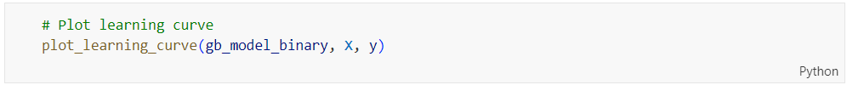

Figure 266: plot_learning_curve Function Call for Base Gradient Boosting on Binary Classification

The code above plots the learning curve for the best Random Forest model (‘**gb_model_binary**’) using the feature matrix ‘**X**’ and target vector ‘**y**’. This visualization helps assess the model's performance on the training and cross-validation datasets as the number of training examples increases.

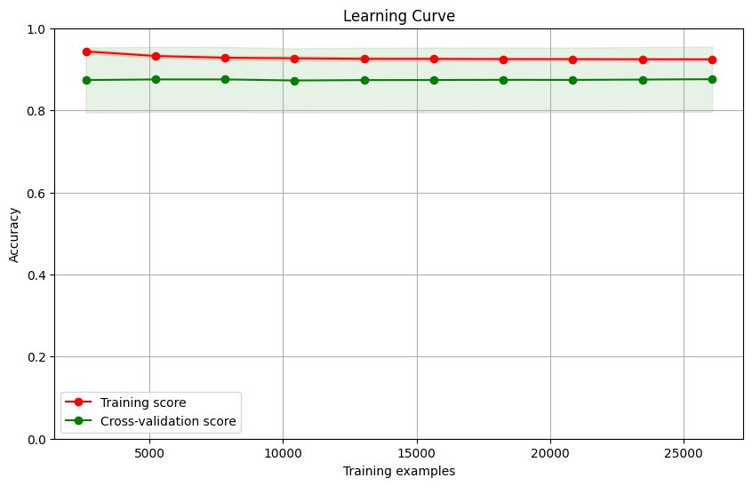

Figure 267: Learning Curve for Base Gradient Boosting on Binary Classification

Figure 267 shows the learning curve for the Gradient Boosting model before hyperparameter tuning. The training score (red line) is consistently high, close to 1, indicating excellent performance on the training data. The cross-validation score (green line) hovers around 0.88, reflecting stable and strong performance on unseen data. The small gap between the training and cross-validation scores suggests that the model generalizes well, with minimal overfitting or underfitting. This indicates that the Gradient Boosting model effectively balances bias and variance, providing reliable predictions on both the training and test datasets.

#### Gradient Boosting (After Hyperparameter Tuning)

##### Accuracy, Confusion Matrix and Classification Report

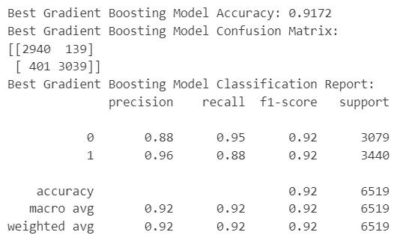

Figure 268: Tuned Gradient Boosting Model Performance on Binary Classification

The tuned Gradient Boosting model achieves an accuracy of 91.72%, correctly predicting 91.72% of the test data. The confusion matrix shows that for the Class 0, 2940 instances are correctly predicted, while 139 are incorrectly predicted. For the Class 1, 3039 instances are correctly predicted, while 401 are incorrectly predicted. The classification report indicates precision, recall, and F1-score for Class 0 as 0.88, 0.95, and 0.92, respectively, and for Class 1 as 0.96, 0.88, and 0.92, respectively. The overall accuracy, macro average, and weighted average for precision, recall, and F1-score are all 0.92, demonstrating that the model is well-balanced and performs consistently well across both classes.

Table 21: Base vs. Tuned Gradient Boosting Model on Binary Classification

|  |  |  |  |  |  |  |
| --- | --- | --- | --- | --- | --- | --- |
| **Model Type** | **Accuracy** | **Precision (Class 0)** | **Precision (Class 1)** | **Recall (Class 0)** | **Recall (Class 1)** | **F1-Score (Macro Average)** |
| Gradient Boosting  (Base Model) | 0.9170 | 0.88 | 0.96 | 0.95 | 0.88 | 0.92 |
| Gradient Boosting  (Tuned Model) | 0.9172 | 0.88 | 0.96 | 0.95 | 0.88 | 0.92 |

Table 21 compares the performance metrics of the base and tuned Gradient Boosting models. The accuracy of the tuned model shows a very slight improvement from 0.9170 to 0.9172. Precision for Class 0 remains consistent at 0.88, and for Class 1 it remains at 0.96 for both models. Recall for Class 0 also remains unchanged at 0.95, as does recall for Class 1 at 0.88. The F1-SScore (Macro Average) remains constant at 0.92 for both models. These metrics indicate that hyperparameter tuning had a minimal impact on the Gradient Boosting model's performance, with only a negligible improvement in accuracy and no change in other performance metrics.

##### ROC Curve

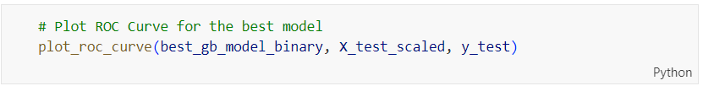

Figure 269: plot_roc_curve Function Call for Tuned Gradient Boosting on Binary Classification

The code above plots the ROC (Receiver Operating Characteristic) curve for the tuned Gradient Boosting model (‘**best_gb_model_binary**’) using the test dataset (‘**X_test_scaled**’, ‘**y_test**’).



Figure 270: ROC Curve for Tuned Gradient Boosting on Binary Classification

The ROC curve in Figure 270 illustrates the performance of the Gradient Boosting model after hyperparameter tuning. The curve plots the True Positive Rate (sensitivity) against the False Positive Rate (1-specificity) at various threshold settings. The ROC curve's proximity to the top-left corner indicates a high level of performance, with the model achieving a True Positive Rate close to 1 while maintaining a low False Positive Rate. The Area Under the Curve (AUC) value of 0.969327 signifies excellent discrimination capability, indicating the model is highly effective at distinguishing between the positive and negative classes. This high AUC value reflects the model's strong predictive performance, showing that it reliably identifies the correct class labels after hyperparameter tuning.

Table 22: ROC AUC Comparison for Gradient Boosting on Binary Classification

|  |  |
| --- | --- |
| **Model Type** | **ROC AUC Value** |
| Gradient Boosting (Base Model) | 0.969526 |
| Gradient Boosting (Tuned Model) | 0.969327 |

Table 22 compares the ROC AUC values of the base and tuned Gradient Boosting models. The base model has an AUC value of 0.969526, while the tuned model has a very similar AUC value of 0.969327. This marginal difference in AUC values suggests that hyperparameter tuning has had little to no impact on the model's ability to discriminate between positive and negative classes. Both models exhibit excellent performance with AUC values very close to 1, indicating a high level of accuracy in classification. The similarity in AUC values implies that the base model was already well-optimized, and further tuning did not significantly enhance its discriminative power.

##### Check Overfitting or Underfitting

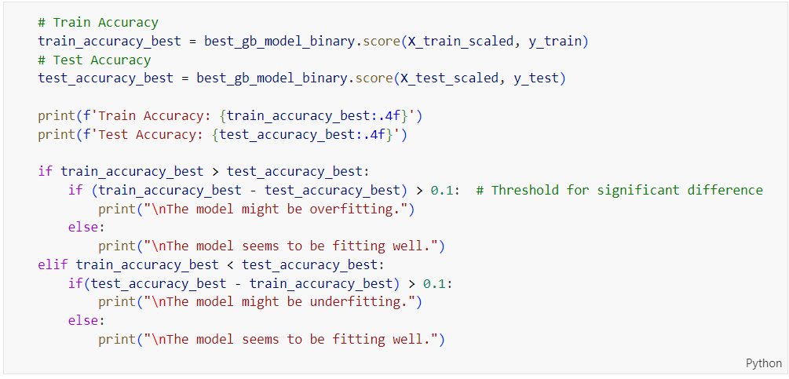

Figure 271: Train and Test Accuracy Evaluation Code for Tuned Gradient Boosting on Binary Classification

Figure 271 presents the source code for evaluating train and test accuracy and checking for overfitting or underfitting for a Gradient Boosting model after hyperparameter tuning. The only difference from previously explained code is the model being used. Here, the code calculates the training accuracy (‘**train_accuracy_best**’) and test accuracy (‘**test_accuracy_best**’) for the ‘**best_gb_model_binary**’ using scaled training and test datasets. It prints these accuracies and then checks if the model is overfitting or underfitting by comparing the difference between the train and test accuracies to a threshold of 0.1. If the difference exceeds 0.1, it indicates potential overfitting or underfitting; otherwise, it confirms that the model is fitting well.

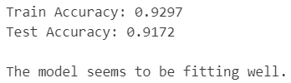

Figure 272: Tuned Gradient Boosting Performance on Binary Prediction

Figure 272 shows the output of the Gradient Boosting model for binary class prediction after hyperparameter tuning. The model achieves a train accuracy of 0.9297 and a test accuracy of 0.9172. The small difference between these two accuracies (0.0125) suggests that the model is not overfitting or underfitting, indicating a good balance between bias and variance. The message "The model seems to be fitting well" confirms that the model generalizes effectively to new, unseen data, maintaining high performance on both the training and test datasets. This result suggests that the hyperparameter tuning has successfully optimized the model, ensuring its robustness and reliability in predictions.

Table 23: Training and Testing Accuracy Comparison for Gradient Boosting on Binary Classification

|  |  |
| --- | --- |
| **Model Type** | **Difference in Accuracies** |
| Gradient Boosting (Base Model) | 0.0069 |
| Gradient Boosting (Tuned Model) | 0.0125 |

Table 23 compares the differences in training and testing accuracy between the base and tuned Gradient Boosting models. The base model has a difference in accuracies of 0.0069, indicating a very small discrepancy between its performance on the training and testing datasets, suggesting excellent generalization from the training data to unseen test data. The tuned model, however, shows a slightly larger difference in accuracies of 0.0125, which is still relatively small and indicates good generalization ability. The slight increase in the difference for the tuned model may reflect the adjustments made during hyperparameter tuning, which can sometimes lead to marginal increases in discrepancy between training and testing performance. Overall, both models demonstrate strong generalization capabilities, with the base model showing a marginally better balance.

##### Learning Curve

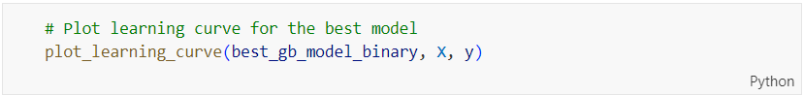

Figure 273: plot_learning_curve Function Call for Tuned Gradient Boosting on Binary Classification

The code above plots the learning curve for the best Random Forest model (‘**best_gb_model_binary**’) using the feature matrix ‘**X**’ and target vector ‘**y**’. This visualization helps assess the model's performance on the training and cross-validation datasets as the number of training examples increases.

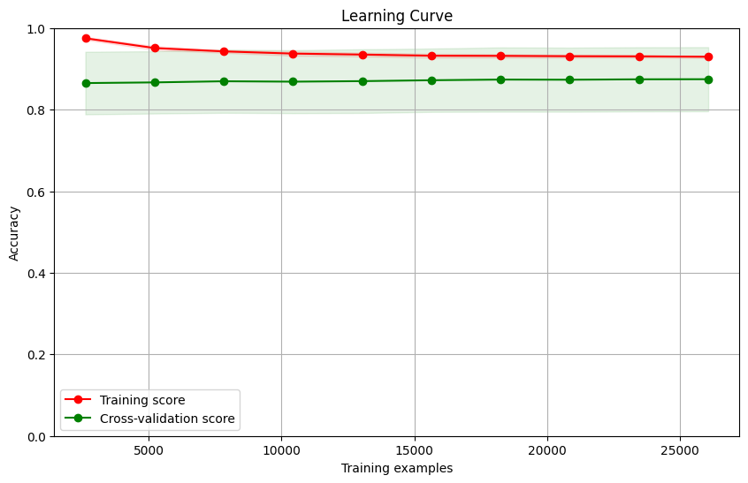

Figure 274: Learning Curve for Tuned Gradient Boosting on Binary Classification

Figure 274 shows the learning curve for the Gradient Boosting model after hyperparameter tuning. The training score remains consistently high, indicating strong performance on the training data. The cross-validation score is lower but stable, suggesting reasonable generalization to unseen data. The gap between the training and cross-validation scores points to some overfitting, though the stable cross-validation score indicates that the model maintains consistent performance as the number of training examples increases. Overall, the model demonstrates good generalization with slight overfitting.

##### Comparison between Base and Tuned Gradient Boosting on Binary Classification

Based on the comparisons in Table 21, Table 22 and Table 23, the base Gradient Boosting model is the better choice for further analysis. This conclusion is drawn because the base model demonstrates nearly identical accuracy, precision, recall, and F1-Score (Macro Average) compared to the tuned model, with the only difference being a negligible increase in accuracy from 0.9170 to 0.9172 for the tuned model. The ROC AUC values for both models are also nearly identical, indicating that the base model's ability to discriminate between positive and negative classes is already highly optimized. Furthermore, the base model shows a smaller discrepancy between training and testing accuracies (0.0069) compared to the tuned model (0.0125), suggesting that the base model has slightly better generalization capabilities and maintains a more consistent performance across different datasets. Therefore, the base Gradient Boosting model is preferred for its strong generalization ability and excellent performance metrics.

#### XGBoost (Before Hyperparameter Tuning)

##### Accuracy, Confusion Matrix and Classification Report

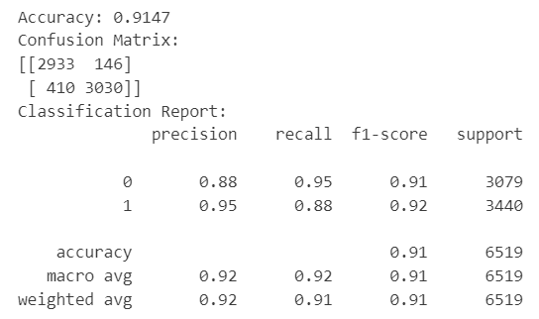

Figure 275: Base XGBoost Model Performance on Binary Classification

The base XGBoost model achieves an accuracy of 0.9147, indicating that it correctly predicts approximately 91.47% of the test data. The confusion matrix shows that out of 3079 actual negatives, the model correctly predicts 2933 and incorrectly predicts 146 as positives. Out of 3440 actual positives, the model correctly predicts 3030 and incorrectly predicts 410 as negatives. The classification report provides precision, recall, and F1-score for Class 0 as 0.88, 0.95, and 0.91, respectively, and for Class 1 as 0.95, 0.88, and 0.92, respectively. The overall accuracy is 0.91, with both macro and weighted averages for precision, recall, and F1-score being 0.92, 0.92, and 0.91, respectively. These results indicate that the model performs well with a balanced performance across both classes, demonstrating strong classification capabilities.

##### ROC Curve



Figure 276: plot_roc_curve Function Call for Base XGBoost on Binary Classification

The code above is plotting the ROC curve for the binary classification model (‘**xgb_model_binary**’) using the test dataset (‘**X_test_scaled**’, ‘**y_test**’).



Figure 277: ROC Curve for Base XGBoost on Binary Classification

The ROC curve for the XGBoost model before hyperparameter tuning, as shown in Figure 277, illustrates the model's performance in distinguishing between positive and negative classes. The curve remains close to the top-left corner of the plot, indicating a high true positive rate and a low false positive rate across various threshold values. The Area Under the Curve (AUC) value is 0.966769, which signifies excellent discrimination ability. An AUC value close to 1 suggests that the model is highly effective in correctly predicting the positive class while minimizing false positives. This high AUC value reflects the model's strong performance in classification tasks even before hyperparameter tuning.

##### Check Overfitting or Underfitting

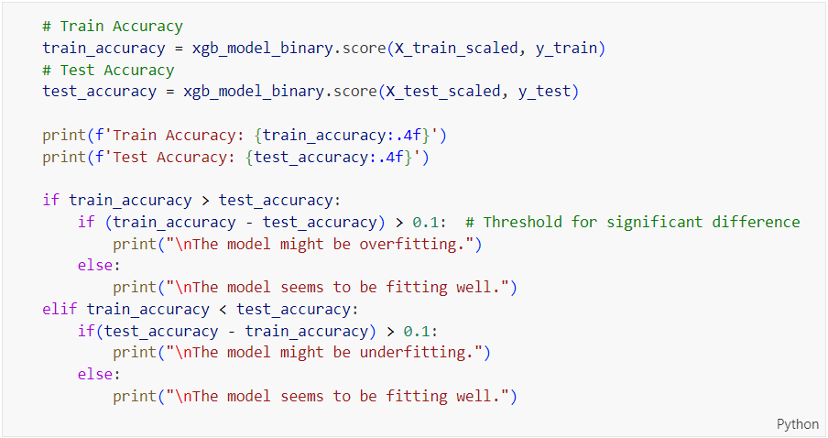

Figure 278: Train and Test Accuracy Evaluation Code for Base XGBoost on Binary Classification

The code in Figure 278 has been explained previously, and the only difference is the model being used. Here, the XGBoost model (‘**xgb_model_binary**’) is evaluated for train and test accuracy. The code calculates the train and test accuracies, prints them, and checks for overfitting or underfitting by comparing the differences between the train and test accuracies. If the difference exceeds 0.1, it indicates potential overfitting or underfitting; otherwise, it suggests that the model is fitting well. This process ensures that the XGBoost model generalizes effectively to new data.

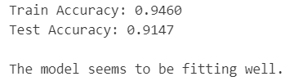

Figure 279: Base XGBoost Performance on Binary Prediction

Figure 279 shows the output of the XGBoost model for binary class prediction before hyperparameter tuning. The model achieves a train accuracy of 0.9460 and a test accuracy of 0.9147. The small difference between the train and test accuracies (0.0313) suggests that the model is not significantly overfitting or underfitting. The message "The model seems to be fitting well" confirms that the model has achieved a good balance between bias and variance, effectively generalizing to new, unseen data. This indicates that the XGBoost model is performing reliably on both the training and test datasets.

##### Learning Curve

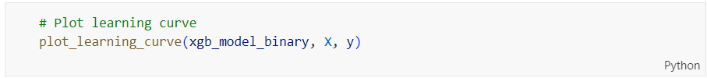

Figure 280: plot_learning_curve Function Call for Base XGBoost on Binary Classification

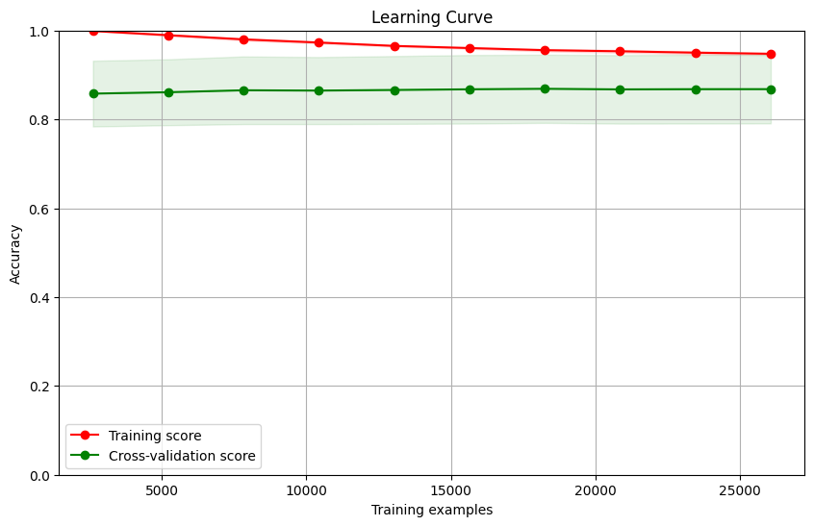

Figure 281: Learning Curve for Base XGBoost on Binary Classification

Figure 281 shows the learning curve for the XGBoost model before hyperparameter tuning. The graph plots the training score (red line) and the cross-validation score (green line) against the number of training examples. The training score is consistently high, close to 1, indicating that the model fits the training data very well. However, the cross-validation score is lower, around 0.88, and remains stable as the number of training examples increases. This gap between the training and cross-validation scores suggests that the model is overfitting, performing well on training data but not as well on unseen data. The narrow-shaded area around the cross-validation score line indicates low variance and stable performance across different training sizes. Overall, while the model shows excellent training performance, the relatively lower and stable cross-validation score suggests a need for hyperparameter tuning to improve its generalization ability and reduce overfitting.

#### XGBoost (After Hyperparameter Tuning)

##### Accuracy, Confusion Matrix and Classification Report

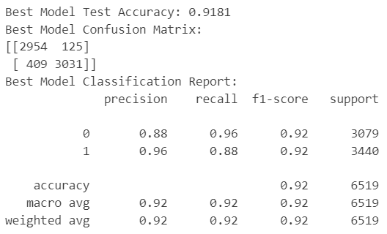

Figure 282: Tuned XGBoost Model Performance on Binary Classification

Figure 282 shows the performance of the XGBoost model after hyperparameter tuning. The model achieves a test accuracy of 0.9181, indicating it correctly predicts 91.81% of the test data. The confusion matrix reveals that out of 3079 actual negatives, the model correctly predicts 2954 and incorrectly predicts 125 as positives. Out of 3440 actual positives, the model correctly predicts 3031 and incorrectly predicts 409 as negatives. The classification report shows precision, recall, and F1-score for Class 0 as 0.88, 0.96, and 0.92, respectively, and for Class 1 as 0.96, 0.88, and 0.92, respectively. The overall accuracy, macro average, and weighted average for precision, recall, and F1-score are all 0.92, indicating a well-balanced model with excellent performance in correctly predicting both classes.

Table 24: Base vs. Tuned XGBoost Model on Binary Classification

|  |  |  |  |  |  |  |
| --- | --- | --- | --- | --- | --- | --- |
| **Model Type** | **Accuracy** | **Precision (Class 0)** | **Precision (Class 1)** | **Recall (Class 0)** | **Recall (Class 1)** | **F1-Score (Macro Average)** |
| XGBoost  (Base Model) | 0.9147 | 0.88 | 0.95 | 0.95 | 0.88 | 0.91 |
| XGBoost  (Tuned Model) | 0.9181 | 0.92 | 0.88 | 0.96 | 0.88 | 0.92 |

Table 24 compares the performance metrics of the base and tuned XGBoost models. The tuned model shows an improvement in overall accuracy, increasing from 0.9147 to 0.9181. Precision for Class 0 improves significantly from 0.88 to 0.92, while precision for Class 1 decreases from 0.95 to 0.88. Recall for Class 0 improves slightly from 0.95 to 0.96 and recall for Class 1 remains unchanged at 0.88. The F1-Score (Macro Average) also sees an improvement, rising from 0.91 to 0.92. These results indicate that the hyperparameter tuning process has enhanced the model's performance, particularly in terms of precision for Class 0, while maintaining a good balance between precision, recall, and F1-scores across both classes.

##### ROC Curve

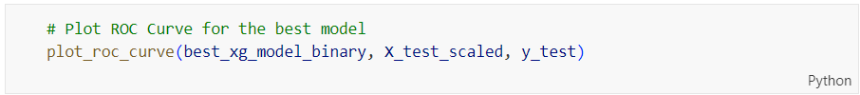

Figure 283: plot_roc_curve Function Call for Tuned XGBoost on Binary Classification

The code in Figure 283 is plotting the ROC curve for the tuned XGBoost model to evaluate its performance in correctly predicting the test data.



Figure 284: ROC Curve for Tuned XGBoost on Binary Classification

The ROC curve for the XGBoost model after hyperparameter tuning demonstrates a strong performance in distinguishing between the positive and negative classes. The curve remains close to the top-left corner, indicating a high True Positive Rate and a low False Positive Rate. The Area Under the Curve (AUC) value of 0.969848 signifies that the model has excellent discriminative ability. This high AUC value close to 1 reflects the model's efficacy in correctly predicting the classes, confirming that hyperparameter tuning has maintained or slightly improved the model's already high performance.

Table 25: ROC AUC Comparison for XGBoost on Binary Classification

|  |  |
| --- | --- |
| **Model Type** | **ROC AUC Value** |
| XGBoost (Base Model) | 0.966769 |
| XGBoost (Tuned Model) | 0.969848 |

Table 25 shows the comparison of ROC AUC values between the base and tuned XGBoost models. The base model has an AUC of 0.966769, while the tuned model shows a slight improvement with an AUC of 0.969848. This small increase indicates that hyperparameter tuning has enhanced the model's ability to correctly predict positive and negative classes. Even though the improvement is minor, it suggests that the tuned model is a bit better at distinguishing between the classes, resulting in slightly better overall performance.

##### Check Overfitting or Underfitting

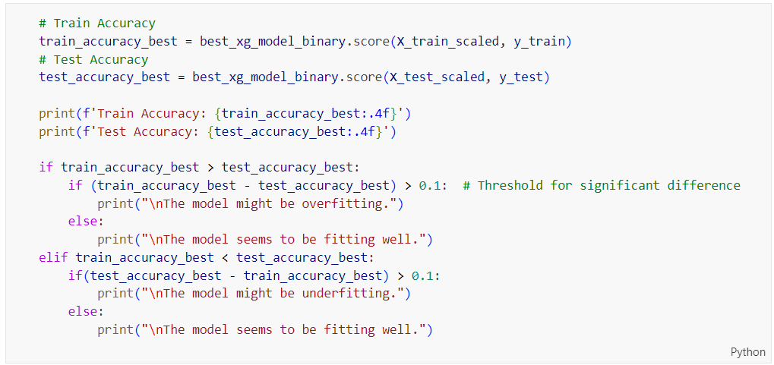

Figure 285: Train and Test Accuracy Evaluation Code for Tuned XGBoost on Binary Classification

The source code shown in Figure 285 evaluates the train and test accuracy for the XGBoost model after hyperparameter tuning and checks for overfitting or underfitting. This explanation applies the same logic as previously described for other models, focusing on assessing the model's performance and ensuring it generalizes well without overfitting or underfitting.

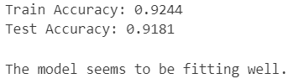

Figure 286: Tuned XGBoost Performance on Binary Prediction

The output shown in Figure 286 presents the accuracy metrics of an XGBoost model for binary classification after hyperparameter tuning. The model achieves a training accuracy of 92.44% and a test accuracy of 91.81%. This indicates that the model performs well on both the training and test datasets, suggesting that it generalizes effectively and is not overfitting. The small difference between training and test accuracy implies that the hyperparameters chosen for the model are effective in balancing bias and variance, resulting in a well-fitting model.

Table 26: Training and Testing Accuracy Comparison for XGBoost on Binary Classification

|  |  |
| --- | --- |
| **Model Type** | **Difference in Accuracies** |
| XGBoost (Base Model) | 0.0313 |
| XGBoost (Tuned Model) | 0.0063 |

Table 26 compares the performance of the base and tuned XGBoost models in terms of the difference in accuracies between the training and testing datasets. The base model exhibits a difference of 0.0313, indicating a higher disparity between its train and test accuracies. In contrast, the tuned model shows a much smaller difference of 0.0063, suggesting that it generalizes better to unseen data. This reduced difference for the tuned model indicates an improved balance between bias and variance, resulting in a more reliable and robust model.

##### Learning Curve

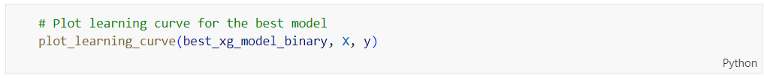

Figure 287: plot_learning_curve Function Call for Tuned XGBoost on Binary Classification

The code above calls the plot_learning_curve function with the best XGBoost model (‘**best_xg_model_binary**’) and the features (‘**X**’) and target (‘**y**’) data to visualize the learning curve, which helps in assessing whether the model is overfitting or underfitting.

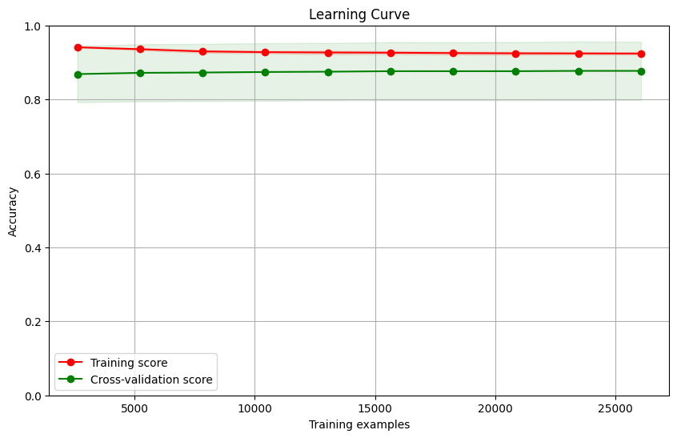

Figure 288: Learning Curve for Tuned XGBoost on Binary Classification

Figure 288 shows the training score (in red) and the cross-validation score (in green) plotted against the number of training examples. Both the training and cross-validation scores are consistently high, with the training score being slightly higher than the cross-validation score. The small gap between these two curves indicates that the model is performing well with minimal overfitting. The high and stable accuracy across increasing training examples suggests that the model is robust and generalizes well to new data. This visual evidence supports the conclusion that the tuned XGBoost model is well-fitted.

##### Comparison between Base and Tuned XGBoost on Binary Classification

Based on the comparisons presented in Table 24, Table 25 and Table 26, the tuned XGBoost model is better suited for further evaluation. The tuned model demonstrates improved overall accuracy (0.9181 vs. 0.9147) and a higher macro-average F1-Score (0.92 vs. 0.91), indicating better balance and performance across both classes. Moreover, the precision for Class 0 has significantly improved, and the recall for Class 0 has also slightly increased, suggesting better performance in correctly identifying true negatives. Additionally, the ROC AUC value is slightly higher for the tuned model (0.969848 vs. 0.966769), indicating improved ability to distinguish between classes. Importantly, the difference in accuracies between training and testing datasets is much smaller for the tuned model (0.0063 vs. 0.0313), signifying better generalization to unseen data and reduced overfitting. These improvements collectively make the tuned XGBoost model the preferred choice for further analysis and application.

#### Artificial Neural Network (Before Hyperparameter Tuning)

##### Accuracy, Confusion Matrix and Classification Report

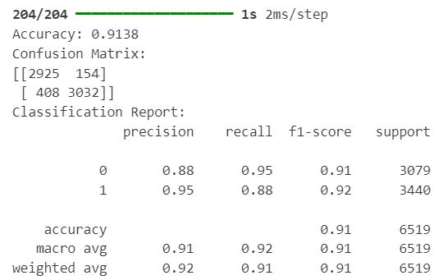

Figure 289: Base ANN Model Performance on Binary Classification

The output from the Artificial Neural Network (ANN) model before hyperparameter tuning shows an overall accuracy of 91.38%. The confusion matrix indicates that out of 3,079 instances of Class 0, 2,925 were correctly classified, and out of 3,440 instances of Class 1, 3,032 were correctly classified. The classification report reveals that the precision, recall, and F1-score for Class 0 are 0.88, 0.95, and 0.91, respectively, while for Class 1, they are 0.95, 0.88, and 0.92, respectively. The macro-average values for precision, recall, and F1-score are 0.91, 0.92, and 0.91, respectively, and the weighted-average values are 0.92, 0.91, and 0.91. These metrics demonstrate a well-balanced model performance across both classes. Despite the strong metrics, there is room for improvement, especially in recall for Class 1 and precision for Class 0, which may be addressed through hyperparameter tuning.

##### ROC Curve



Figure 290: plot_roc_curve Function Call for Base ANN on Binary Classification

The ‘**plot_binary_roc_curve()**’ function has been explained in the section of showing Figure 214. The code in Figure 290 calls the ‘**plot_binary_roc_curve**’ function to evaluate the performance of the ANN model on the test data. This function takes three arguments: ‘**ann_model_binary**’, which is the trained binary classification ANN model; ‘**X_test_scaled**’, which represents the scaled test features; and ‘**y_test**’, the true labels for the test data and generates the Receiver Operating Characteristic (ROC) curve, which visually represents the trade-off between the true positive rate and false positive rate across different threshold settings, thereby helping to assess the model's ability to distinguish between classes.



Figure 291: ROC Curve for Base ANN on Binary Classification

Figure 291 shows a strong performance in binary classification, with an Area Under the Curve (AUC) of 0.97. This high AUC value indicates that the model has an excellent ability to distinguish between the positive and negative classes. The curve is close to the top-left corner, demonstrating a high true positive rate and a low false positive rate across various threshold levels. This performance suggests that even before tuning, the ANN model is effectively identifying true positives while minimizing false positives, making it a reliable model for classification tasks.

##### Check Overfitting or Underfitting

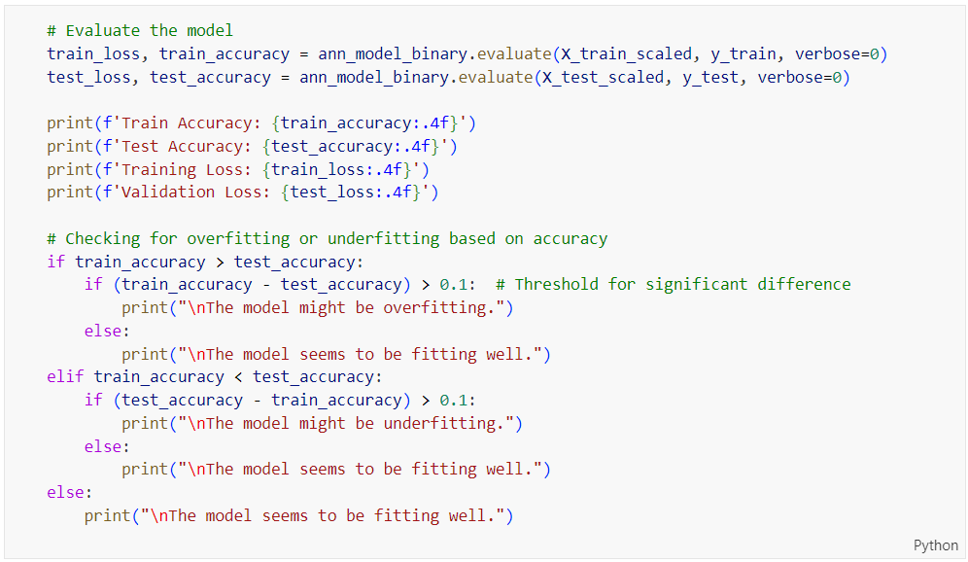

Figure 292: Train and Test Accuracy Evaluation Code for Base ANN on Binary Classification

The code in Figure 292 evaluates the training and test performance of an Artificial Neural Network (ANN) model to check for overfitting or underfitting before hyperparameter tuning. The model's training and test accuracy, along with the corresponding losses, are calculated using the ‘**evaluate**’ method and printed with four decimal places of precision. The code then compares the training and test accuracies. If the training accuracy exceeds the test accuracy by more than 0.1, it indicates potential overfitting, and an appropriate message is printed; if the test accuracy exceeds the training accuracy by more than 0.1, it indicates potential underfitting, and an appropriate message is printed. If the difference between training and test accuracies is within 0.1, the model is considered to be fitting well, and a corresponding message is printed. This approach helps diagnose whether the model is generalizing well to new data or if adjustments are needed.

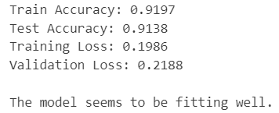

Figure 293: Base ANN Performance on Binary Prediction

The output in Figure 293 indicates that the model is performing well. The train accuracy is 91.97%, and the test accuracy is 91.38%, with a small difference of 0.59%, suggesting that the model generalizes well to unseen data. The training loss is 0.1986, and the validation loss is 0.218, both of which are relatively low and close to each other, further indicating a good fit without significant overfitting or underfitting. Overall, the model seems to be well-balanced and robust, making it a reliable classifier before any further optimization.

##### Learning Curve



Figure 294: plot_learning_curve Function Call for Base ANN on Binary Classification

The code shown in Figure 294 calls the ‘**plot_learning_curve**’ function with the history object as its argument. The ‘**history**’ object typically contains the training history of the model, including metrics such as accuracy and loss for both training and validation datasets over each epoch. By passing this ‘**history**’ object to the ‘**plot_learning_curve**’ function, the code aims to visualize the learning curve of the model, which helps in diagnosing whether the model is overfitting, underfitting, or fitting well. This plot will show how the training and validation metrics evolve over time, providing insights into the model's learning process and performance.

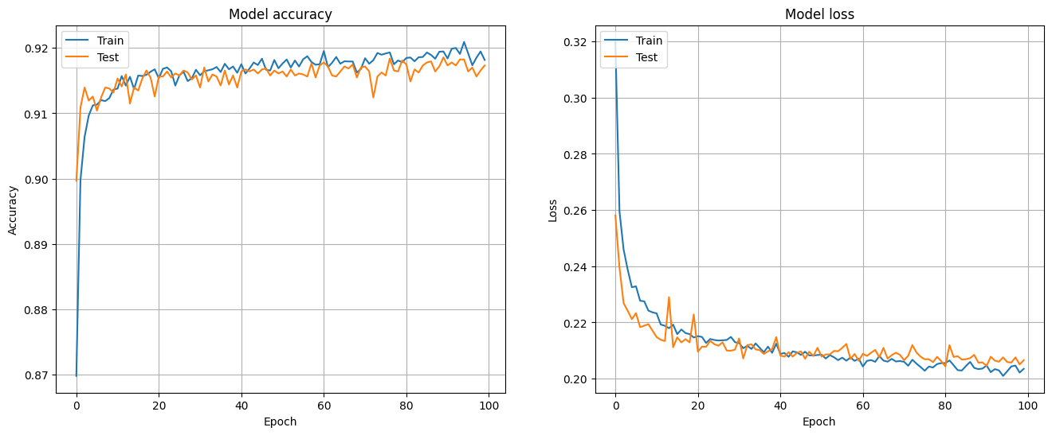

Figure 295: Learning Curve for Base ANN on Binary Classification

The learning curves in Figure 295 illustrate the performance of the ANN model before hyperparameter tuning over 100 epochs. The left graph shows the model accuracy for both training and test datasets, where both curves steadily increase and converge around 92%, indicating good learning behavior and minimal overfitting. The right graph depicts the model loss, where both training and test losses decrease sharply during the initial epochs and then stabilize, with the training loss consistently slightly lower than the test loss. The close alignment of training and test curves for both accuracy and loss suggests that the model is fitting the data well without significant overfitting or underfitting issues, indicating a robust initial model performance.

#### Artificial Neural Network (After Hyperparameter Tuning)

##### Accuracy, Confusion Matrix and Classification Report

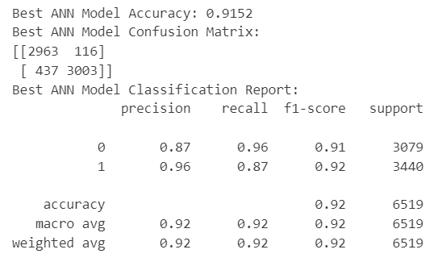

Figure 296: Tuned ANN Model Performance on Binary Classification

The output of the ANN model after hyperparameter tuning shows an overall accuracy of 91.52%. The confusion matrix indicates that out of 3,079 instances of Class 0, 2,963 were correctly classified, and out of 3,440 instances of Class 1, 3,003 were correctly classified. The classification report reveals that the precision, recall, and F1-score for Class 0 are 0.87, 0.96, and 0.91, respectively, while for Class 1, they are 0.96, 0.87, and 0.92, respectively. The macro-average and weighted-average values for precision, recall, and F1-score are all 0.92, demonstrating a well-balanced model performance across both classes. The model maintains strong performance metrics, indicating that the tuning process has helped in achieving a balanced and robust model.

Table 27: Base vs. Tuned ANN Model on Binary Classification

|  |  |  |  |  |  |  |
| --- | --- | --- | --- | --- | --- | --- |
| **Model Type** | **Accuracy** | **Precision (Class 0)** | **Precision (Class 1)** | **Recall (Class 0)** | **Recall (Class 1)** | **F1-Score (Macro Average)** |
| Artificial  Neural Network  (Base Model) | 0.9138 | 0.88 | 0.95 | 0.95 | 0.88 | 0.91 |
| Artificial  Neural Network (Tuned Model) | 0.9152 | 0.87 | 0.96 | 0.96 | 0.87 | 0.92 |

Table 27 shows the comparison between the base and tuned ANN models on binary classification. The tuned model has a higher overall accuracy (91.52% vs 91.38%) and a better macro average F1-Score (0.92 vs 0.91). The precision for Class 0 is slightly lower in the tuned model (0.87 vs 0.88), while the precision for Class 1 is higher (0.96 vs 0.95). The recall for Class 0 is higher in the tuned model (0.96 vs 0.95), but the recall for Class 1 is slightly lower (0.87 vs 0.88). These results indicate that the tuned model performs better overall, achieving a more balanced performance across both classes.

##### ROC Curve



Figure 297: plot_roc_curve Function Call for Tuned ANN on Binary Classification

The code shown in Figure 297 calls the ‘**plot_binary_roc_curve**’ function to evaluate the performance of the tuned ANN model (‘**best_ann_model_binary**’) using the scaled test features (‘**X_test_scaled**’) and the true test labels (‘**y_test**’).



Figure 298: ROC Curve for Tuned ANN on Binary Classification



Figure 298 shows a high level of performance in binary classification, with an Area Under the Curve (AUC) of 0.92. This indicates that the model has a strong ability to discriminate between the positive and negative classes. The curve is close to the top-left corner of the plot, demonstrating a high true positive rate and a low false positive rate across different threshold values. Despite a slightly lower AUC compared to the pre-tuning model, the tuned model still maintains excellent classification capability, suggesting that hyperparameter tuning has resulted in a well-balanced model with effective generalization to the test data.

Table 28: ROC AUC Comparison for ANN on Binary Classification

|  |  |
| --- | --- |
| **Model Type** | **ROC AUC Value** |
| Artificial Neural Network (Base Model) | 0.967855 |
| Artificial Neural Network (Tuned Model) | 0.917645 |

Table 28 compares the ROC AUC values of the ANN model before and after hyperparameter tuning. The base model has an ROC AUC value of 0.967855, indicating excellent performance in distinguishing between the positive and negative classes. In contrast, the tuned model has an ROC AUC value of 0.917645, which is slightly lower than the base model. This comparison suggests that while hyperparameter tuning may have improved other aspects of the model's performance, it has resulted in a decrease in the model's ability to discriminate between classes as measured by the ROC AUC. Thus, according to the ROC AUC metric, the base model shows a better capability in binary classification.

##### Check Overfitting or Underfitting

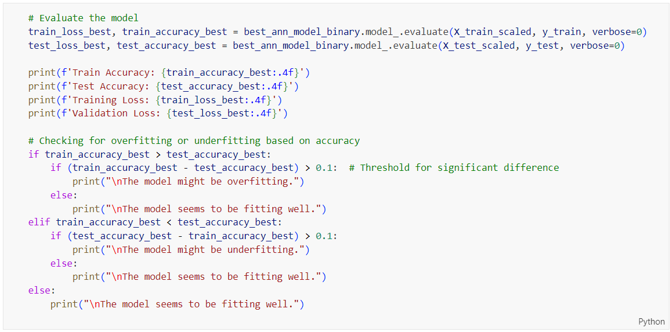

Figure 299: Train and Test Accuracy Evaluation Code for Tuned ANN on Binary Classification

The code shown in Figure 299 evaluates the performance of an Artificial Neural Network (ANN) model on both the training and test datasets and checks for signs of overfitting or underfitting. It first computes the accuracy and loss for the training set (‘**train_accuracy_best**’, ‘**train_loss_best**’) and the test set (‘**test_accuracy_best**’, ‘**test_loss_best**’). These values are then printed out. The code then compares the training and test accuracies: if the difference between them is greater than 0.1, it suggests the model might be overfitting (training accuracy significantly higher than test accuracy) or underfitting (test accuracy significantly higher than training accuracy). If the difference is within 0.1, it indicates the model is fitting well.

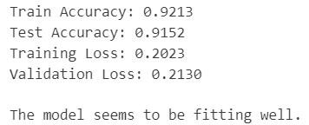

Figure 300: Tuned ANN Performance on Binary Prediction

The output shown in Figure 300 indicates that the ANN model for binary class prediction performs well after hyperparameter tuning. The training accuracy is 0.9213, and the test accuracy is 0.9152, showing a very small difference (0.0061), which suggests that the model is not overfitting. The training loss is 0.2023, and the validation loss is 0.2130, both of which are relatively low and close to each other, further indicating that the model generalizes well to new, unseen data. The overall assessment confirms that the model is fitting the data appropriately without significant issues of overfitting or underfitting.

Table 29: Training and Testing Accuracy Comparison for ANN on Binary Classification

|  |  |
| --- | --- |
| **Model Type** | **Difference in Accuracies** |
| Artificial Neural Network (Base Model) | 0.0059 |
| Artificial Neural Network (Tuned Model) | 0.0061 |

Table 29 compares the differences in training and testing accuracies between the base and tuned models of an Artificial Neural Network (ANN) for binary classification. The base model shows a difference of 0.0059, indicating a small discrepancy between its training and testing accuracies. After tuning the hyperparameters, the difference in accuracies for the tuned model is slightly higher at 0.0061. This minor increase in the difference suggests that while the tuned model performs well, the base model demonstrates slightly better consistency between training and testing data, indicating marginally better generalization.

##### Learning Curve

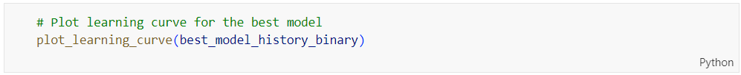

Figure 301: plot_learning_curve Function Call for Tuned ANN on Binary Classification

The ‘**plot_learning_curve_best()**’ function has been explained in the explanation on the code in Figure 218. The code in Figure 301 calls the ‘**plot_learning_curve**’ function with the ‘**best_model_history_binary**’ parameter to visualize the learning curves and check for overfitting or underfitting of the best model.

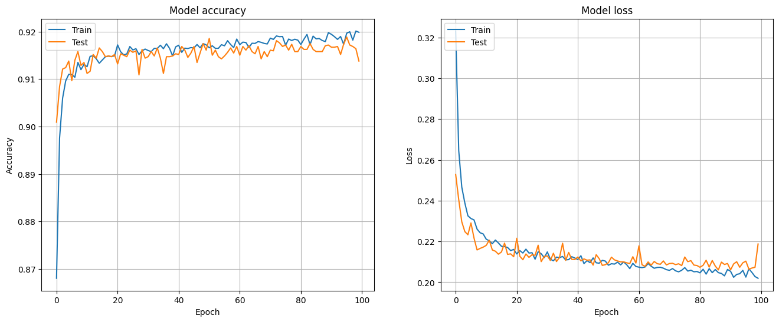

Figure 302: Learning Curve for Tuned ANN on Binary Classification

Figure 302 indicate that the model is performing well. The accuracy plot shows that both training and test accuracy quickly rise and stabilize around 0.92, with the training accuracy slightly higher than the test accuracy, suggesting good generalization without significant overfitting. The loss plot demonstrates that both training and validation loss decrease rapidly and then flatten out, with the training loss slightly lower than the validation loss. This consistency between training and validation metrics indicates that the model is well-tuned, fitting the training data effectively while also maintaining its performance on unseen test data.

##### Comparison between Base and Tuned ANN on Binary Classification

Based on the comparisons above, the base model should be chosen for further comparison with other models to find the best model to deploy. The base model demonstrates slightly better performance with a higher ROC AUC value (0.967855 vs 0.917645), indicating superior capability in distinguishing between positive and negative classes. Although the tuned model has a marginally higher overall accuracy (91.52% vs. 91.38%) and better macro average F1-Score (0.92 vs 0.91), the base model shows better precision for Class 0 (0.88 vs 0.87) and recall for Class 1 (0.88 vs 0.87), which are crucial metrics for effective classification. Additionally, the base model exhibits slightly better consistency between training and testing data, with a smaller difference in accuracies (0.0059 vs 0.0061). These factors make the base model a more reliable candidate for deployment and further comparison with other models.

### Multi-Class Classification

#### Logistic Regression (Before Hyperparameter Tuning)

##### Accuracy, Confusion Matrix and Classification Report

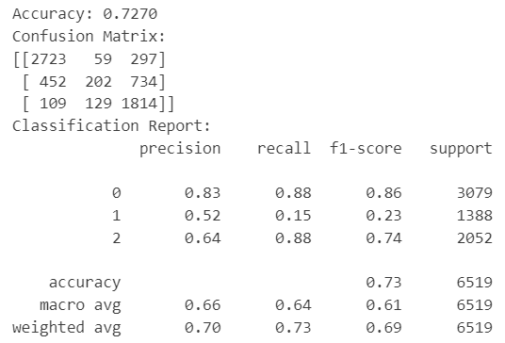

Figure 303: Base Logistic Regression Model Performance on Multi-Class Classification

Figure 303 shows the performance of a Logistic Regression model before hyperparameter tuning on a multi-class classification problem. The model achieves an overall accuracy of 72.70%, with the confusion matrix indicating that the model performs well on class 0 but struggles with class 1. The precision, recall, and F1-score for class 0 are relatively high (0.83, 0.88, and 0.86, respectively), indicating good performance. However, for class 1, these metrics are quite low (precision: 0.52, recall: 0.15, F1-score: 0.23), suggesting significant misclassification. Class 2 shows moderate performance with precision, recall, and F1-score of 0.64, 0.88, and 0.74, respectively. The macro average metrics (precision: 0.66, recall: 0.64, F1-score: 0.61) indicate the overall ability of the model to balance performance across all classes, while the weighted average metrics (precision: 0.70, recall: 0.73, F1-score: 0.69) reflect the influence of class distribution. These results highlight the need for hyperparameter tuning to improve the model's performance, particularly for class 1.

##### ROC Curve



Figure 304: plot_roc_curve Function Call for Base Logistic Regression on Multi-Class Classification

Figure 304 shows the source code of calling the ‘**plot_roc_curve**’ function to evaluate the performance of the logistic regression model (‘**lr_model_multi**’) on the multi-class classification task by using the scaled test dataset (‘**X_test_scaled**’, ‘**y_test**’). This function will plot the ROC curve, providing a visual representation of the model's ability to discriminate between the different classes, which is essential for understanding its performance in terms of sensitivity and specificity across the various thresholds.



Figure 305: ROC Curve for Base Logistic Regression on Multi-Class Classification

Figure 305 shows the ROC curves for a logistic regression model before hyperparameter tuning on a multi-class classification task, highlighting the model's performance for each class. The ROC AUC values indicate that the model performs well for class 0, with an AUC of 0.93, demonstrating strong discrimination capability for this class. For class 2, the model also performs reasonably well, with an AUC of 0.89. However, the performance for class 1 is notably lower, with an AUC of 0.71, indicating weaker discrimination between true positive and false positive rates for this class. The ROC curves visually confirm these results, showing that the model's ability to distinguish between classes varies significantly, with class 1 requiring the most improvement. These insights suggest that targeted hyperparameter tuning could enhance the model's performance, particularly for class 1.

##### Check Overfitting or Underfitting

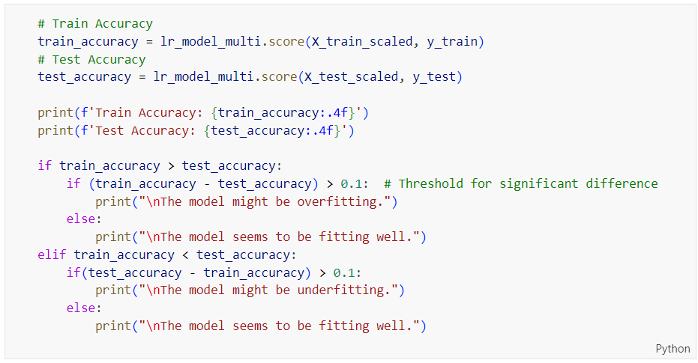

Figure 306: Train and Test Accuracy Evaluation Code for Base Logistic Regression on Multi-Class Classification

Figure 306 presents the source code for evaluating the train and test accuracy of a logistic regression model and checking for overfitting or underfitting before hyperparameter tuning on a multi-class classification task. The code calculates the training accuracy (‘**train_accuracy**’) and test accuracy (‘**test_accuracy**’) by scoring the model on the scaled training and test datasets, respectively. It then prints these accuracy values. The code further checks if there is a significant difference (greater than 0.1) between training and test accuracies to identify potential overfitting or underfitting. If the training accuracy is significantly higher than the test accuracy, it suggests overfitting. Conversely, if the test accuracy is significantly higher than the training accuracy, it suggests underfitting. If neither condition is met, the model is deemed to be fitting well.

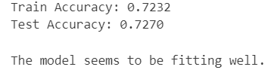

Figure 307: Base Logistic Regression Performance on Multi-Class Prediction

Figure 307 shows the output of logistic regression performance before hyperparameter tuning on multi-class prediction, where the training accuracy is 0.7232 and the test accuracy is 0.7270. The close values of these accuracies indicate that the model generalizes well from the training data to the test data, with no significant signs of overfitting or underfitting. The small difference between training and test accuracy (0.0038) suggests that the model has learned the patterns in the data effectively and can make reliable predictions on new, unseen data. This result implies that the model's current performance is balanced, though further improvements might be achieved through hyperparameter tuning.

##### Learning Curve

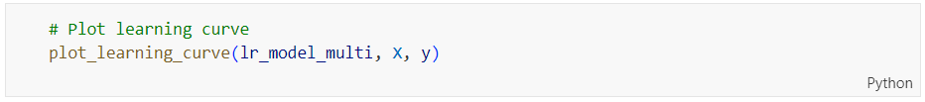

Figure 308: plot_learning_curve Function Call for Base Logistic Regression

Figure 308 shows the source code calling the ‘**plot_learning_curve**’ function with the logistic regression model (‘**lr_model_multi**’) and datasets (‘**X**’, ‘**y**’) to visualize the learning curves and check for overfitting or underfitting.

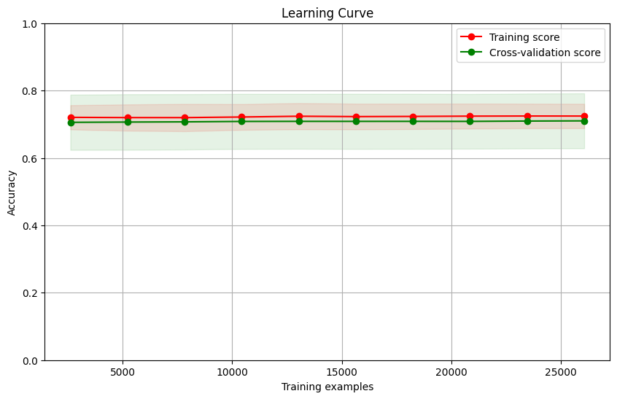

Figure 309: Learning Curve for Base Logistic Regression on Multi-Class Classification

Figure 309 presents the learning curve for logistic regression before hyperparameter tuning on multi-class classification. The plot shows both the training score and the cross-validation score as a function of the number of training examples. The training and cross-validation scores are very close to each other, hovering around an accuracy of 0.73 to 0.75, with the cross-validation score slightly lower but consistent across the range of training examples. The small gap between the training and cross-validation scores indicates that the model is well-generalized, with no significant signs of overfitting or underfitting. The stability of the scores as the number of training examples increases suggests that adding more data may not significantly improve the model's performance, highlighting the potential benefit of hyperparameter tuning or more advanced techniques to enhance accuracy.

#### Logistic Regression (After Hyperparameter Tuning)

##### Accuracy, Confusion Matrix and Classification Report

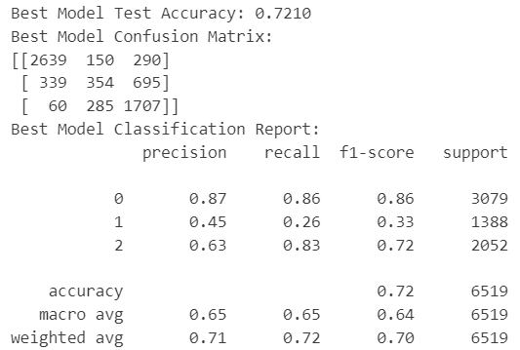

Figure 310: Tuned Logistic Regression Model Performance on Multi-Class Classification

Figure 310 shows the performance of the logistic regression model after hyperparameter tuning on multi-class classification. The tuned model achieves a test accuracy of 72.10%, with the confusion matrix indicating decent performance across classes. Class 0 has high precision (0.87), recall (0.86), and F1-score (0.86). Class 1 shows improvement but remains lower with a precision of 0.45, recall of 0.26, and F1-score of 0.33. Class 2 performs moderately with a precision of 0.63, recall of 0.83, and F1-score of 0.72. Overall, the macro average precision, recall, and F1-score are balanced at 0.65, reflecting improved but still varied performance across classes. The weighted average metrics (precision: 0.71, recall: 0.72, F1-score: 0.70) indicate that while there is some improvement, further tuning or more advanced methods might be needed for better results.

Table 30: Base vs. Tuned Logistic Regression Model on Multi-Class Classification

|  |  |  |
| --- | --- | --- |
| **Model Type** | Logistic Regression (Base Model) | Logistic Regression (Tuned Model) |
| **Accuracy** | 0.7270 | 0.7210 |
| **Precision (Class 0)** | 0.83 | 0.87 |
| **Precision (Class 1)** | 0.52 | 0.45 |
| **Precision (Class 2)** | 0.64 | 0.63 |
| **Recall**  **(Class 0)** | 0.88 | 0.86 |
| **Recall**  **(Class 1)** | 0.15 | 0.26 |
| **Recall**  **(Class 2)** | 0.88 | 0.83 |
| **F1-Score (Macro Average)** | 0.61 | 0.64 |

Table 30 compares the performance of the base and tuned logistic regression models on multi-class classification. The base model has a slightly higher accuracy (72.70% vs. 72.10%), but the tuned model shows improved precision for Class 0 (0.87 vs. 0.83) and recall for Class 1 (0.26 vs. 0.15), although it has a lower precision for Class 1 (0.45 vs. 0.52) and slightly lower recall for Classes 0 and 2. The F1-score macro average for the tuned model is higher (0.64 vs. 0.61), indicating a better overall balance between precision and recall across all classes. While the base model performs better in terms of accuracy and precision for Class 1, the tuned model offers improved performance in precision for Class 0 and recall for Class 1, suggesting a more balanced model after hyperparameter tuning.

##### ROC Curve

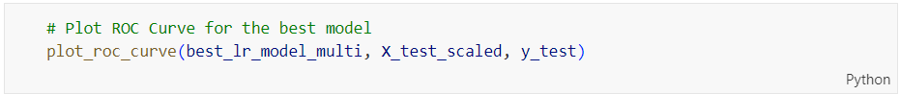

Figure 311: plot_roc_curve Function Call for Tuned Logistic Regression on Multi-Class Classification

Figure 311 shows the source code for calling the ‘**plot_roc_curve**’ function to evaluate the performance of the best logistic regression model (‘**best_lr_model_multi**’) on the multi-class classification task using the scaled test dataset (‘**X_test_scaled**’, ‘**y_test**’) by plotting the ROC curve.



Figure 312: ROC Curve for Tuned Logistic Regression on Multi-Class Classification

Figure 312 shows the ROC curves for the logistic regression model after hyperparameter tuning on a multi-class classification task, illustrating the model's ability to distinguish between the classes. The ROC AUC values for each class indicate that the model performs best for class 0, with an AUC of 0.92, demonstrating strong discrimination capability. Class 2 also shows good performance with an AUC of 0.89. However, the model struggles with class 1, which has a significantly lower AUC of 0.70, indicating weaker discrimination between the true positive rate and false positive rate for this class. The ROC curves visually confirm these results, showing that the model's ability to distinguish between classes varies significantly, with class 1 requiring further improvement.

Table 31: ROC AUC Comparison for Logistic Regression on Multi-Class Classification

|  |  |  |  |
| --- | --- | --- | --- |
| **Model Type** | **ROC AUC Value** | | |
| Class 0 | Class 1 | Class 2 |
| Logistic Regression (Base Model) | 0.925532 | 0.714894 | 0.890559 |
| Logistic Regression (Tuned Model) | 0.922632 | 0.699078 | 0.889446 |

Table 31 compares the ROC AUC values of the base and tuned logistic regression models for multi-class classification. For Class 0, the base model has a slightly higher ROC AUC value (0.925532) compared to the tuned model (0.922632), indicating marginally better performance in distinguishing this class. For Class 1, the base model also performs better with a ROC AUC of 0.714894, whereas the tuned model has a lower ROC AUC of 0.699078, suggesting that tuning did not improve and slightly degraded the model's ability to differentiate Class 1. For Class 2, the ROC AUC values are very close, with the base model at 0.890559 and the tuned model at 0.889446, indicating similar performance. Overall, the base model exhibits slightly better performance across all classes, particularly for Class 1, where the difference is most pronounced.

##### Check Overfitting or Underfitting

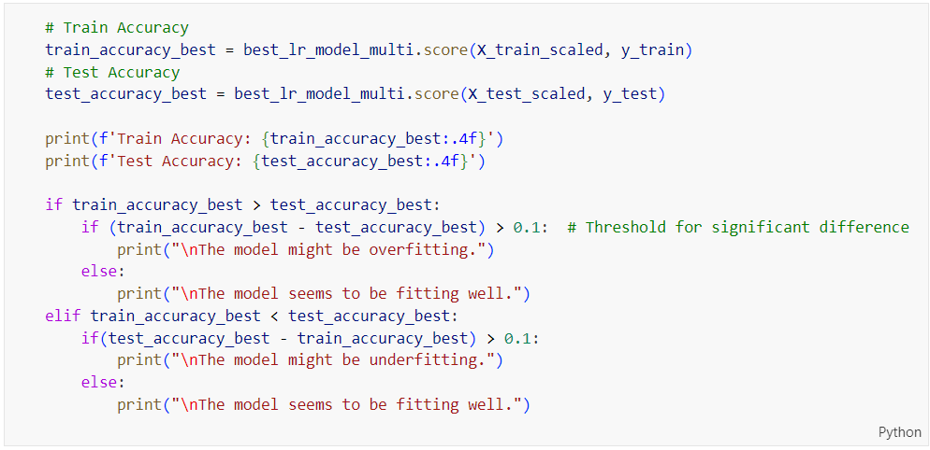

Figure 313: Train and Test Accuracy Evaluation Code for Tuned Logistic Regression on Multi-Class Classification

Figure 313 presents the code for evaluating the train and test accuracy of a tuned logistic regression model on multi-class classification. The code calculates the training accuracy (train_accuracy_best) and test accuracy (test_accuracy_best) by scoring the model on the scaled training and test datasets, respectively. These accuracy values are printed. The code then checks for overfitting or underfitting by comparing the training and test accuracies. If the training accuracy significantly exceeds the test accuracy by more than 0.1, the model may be overfitting. Conversely, if the test accuracy significantly exceeds the training accuracy by more than 0.1, the model may be underfitting. If neither condition is met, the model is considered to be fitting well.

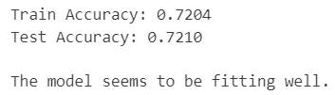

Figure 314: Tuned Logistic Regression Performance on Multi-Class Prediction

Figure 314 shows the performance of the tuned logistic regression model on multi-class prediction, with a training accuracy of 72.04% and a test accuracy of 72.10%. The close proximity of these accuracy values indicates that the model generalizes well from the training data to the test data, with no significant signs of overfitting or underfitting. The small difference between the training and test accuracy (0.0006) suggests that the model has learned the patterns in the data effectively and can make reliable predictions on new, unseen data. This result implies that the hyperparameter tuning has successfully optimized the model, achieving a good balance between fitting the training data and maintaining performance on the test data.

Table 32: Training and Testing Accuracy Comparison for Logistic Regression on Multi-Class Classification

|  |  |
| --- | --- |
| **Model Type** | **Difference in Accuracies** |
| Logistic Regression (Base Model) | 0.0038 |
| Logistic Regression (Tuned Model) | 0.0006 |

Table 32 presents the comparison of training and testing accuracy differences for the logistic regression model on multi-class classification, before and after hyperparameter tuning. The base model exhibits a difference in accuracies of 0.0038, indicating a minor discrepancy between its training and testing performance. After hyperparameter tuning, the tuned model shows a significantly reduced difference of 0.0006, demonstrating an even closer alignment between training and testing accuracies. This reduction suggests that the tuning process has effectively enhanced the model's generalization capability, ensuring that it performs consistently well on both the training and testing datasets. The small difference in the tuned model's accuracies indicates minimal overfitting or underfitting, confirming the model's robustness and reliability in making predictions on new data.

##### Learning Curve

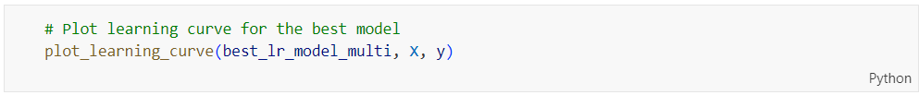

Figure 315: plot_learning_curve Function Call for Tuned Logistic Regression

Figure 315 shows the source code for calling the ‘**plot_learning_curve**’ function to visualize the learning curve of the tuned logistic regression model (‘**best_lr_model_multi**’) using the dataset (‘**X**’, ‘**y**’).

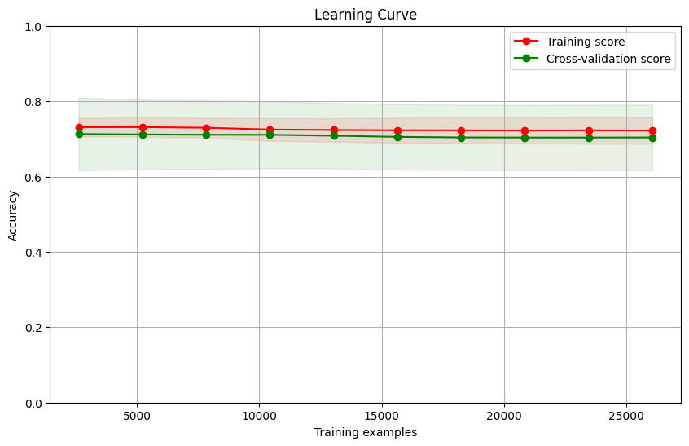

Figure 316: Learning Curve for Tuned Logistic Regression on Multi-Class Classification

Figure 316 shows the learning curve for the tuned logistic regression model on multi-class classification. The plot illustrates both the training score and the cross-validation score as a function of the number of training examples. The training and cross-validation scores are very close to each other, consistently around an accuracy of 0.72 to 0.73, with minimal variance as the number of training examples increases. This close alignment between the training and cross-validation scores indicates that the model generalizes well and exhibits no significant signs of overfitting or underfitting. The stability of the scores across different training set sizes suggests that the model's performance is reliable and robust, and additional training data is unlikely to significantly improve accuracy. This result confirms that hyperparameter tuning has successfully optimized the model, achieving a balanced fit that performs consistently well on both the training and validation datasets.

##### Comparison between Base and Tuned Logistic Regression on Multi-Class Classification

Based on the comparisons from Table 30, Table 31 and Table 32, the tuned logistic regression model should be chosen for further comparison purposes. Despite the base model having a slightly higher overall accuracy (72.70% vs. 72.10%) and better performance in distinguishing Class 1 as evidenced by the ROC AUC values, the tuned model demonstrates a higher F1-score macro average (0.64 vs. 0.61), indicating a better overall balance between precision and recall across all classes. Additionally, the tuned model has a significantly reduced difference in training and testing accuracies (0.0006 vs. 0.0038), suggesting improved generalization and minimal overfitting or underfitting. This enhanced consistency between training and testing performance confirms the robustness and reliability of the tuned model, making it a more balanced and generalizable choice for further analysis.

#### Decision Tree (Before Hyperparameter Tuning)

##### Accuracy, Confusion Matrix and Classification Report

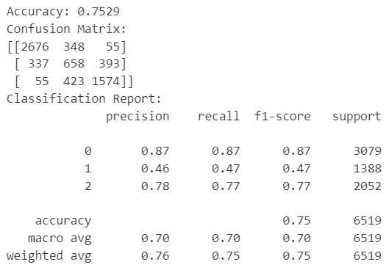

Figure 317: Base Decision Tree Model Performance on Multi-Class Classification

Figure 318 presents the performance metrics of a base Decision Tree model applied to a multi-class classification problem. The model achieves an overall accuracy of 75.29%. The confusion matrix reveals the counts of true positive, false positive, and false negative predictions for each class, indicating that the model performs well for class 0 with high precision (0.87), recall (0.87), and F1-score (0.87). However, it struggles with class 1, achieving significantly lower precision (0.46), recall (0.47), and F1-score (0.47). For class 2, the model's performance is intermediate with a precision of 0.78, recall of 0.77, and f1-score of 0.77. The macro average F1-score is 0.70, and the weighted average f1-score is 0.75, suggesting that the model's performance is better for more frequent classes.

##### ROC Curve



Figure 318: plot_roc_curve Function Call for Base Decision Tree on Multi-Class Classification

Figure 318 shows a function call to plot_roc_curve for evaluating the performance of the base Decision Tree model (‘**dt_model_multi**’) on the scaled test data (‘**X_test_scaled**’) and corresponding labels (‘**y_test**’) in a multi-class classification context.



Figure 319: ROC Curve for Base Decision Tree on Multi-Class Classification

Figure 319 illustrates the ROC curves for the base Decision Tree model's performance in a multi-class classification scenario. The ROC curves for each class demonstrate how well the model distinguishes between the classes. Class 0 has the highest AUC (Area Under the Curve) of 0.88, indicating strong model performance in distinguishing this class. Class 2 follows with an AUC of 0.83, showing relatively good performance as well. However, Class 1 has a much lower AUC of 0.66, suggesting the model struggles significantly more to correctly classify instances of this class compared to the other two. This aligns with the precision, recall, and f1-score metrics from the previous classification report, highlighting the model's varying effectiveness across different classes.

##### Check Overfitting or Underfitting

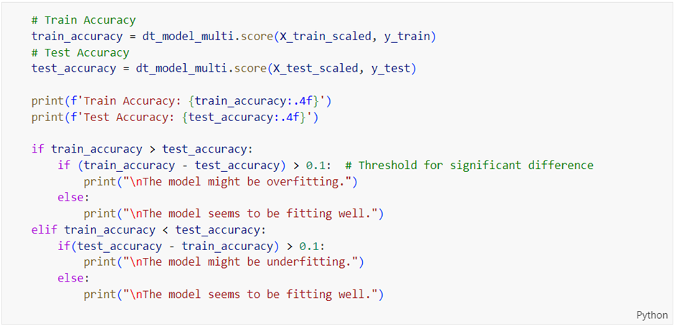

Figure 320: Train and Test Accuracy Evaluation Code for Base Decision Tree on Multi-Class Classification

Figure 320 contains code that calculates and prints the training and test accuracies of a base Decision Tree model on a multi-class classification task, then checks for overfitting or underfitting based on the difference between these accuracies, and prints the corresponding evaluation result.

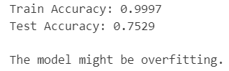

Figure 321: Base Decision Tree Performance on Multi-Class Prediction

Figure 321 shows that the base Decision Tree model performs almost perfectly on the training data with an accuracy of 99.97%, but its accuracy drops to 75.29% on the test data. This big gap between the training and test accuracies indicates that the model is likely overfitting. In simpler terms, the model is learning the training data too well, including noise and specific details that don't generalize to new, unseen data. As a result, it doesn't perform as well when making predictions on the test data, which suggests it needs to be simplified or tuned to improve its ability to generalize.

##### Learning Curve



Figure 322: plot_learning_curve Function Call for Base Decision Tree

Figure 322 shows a function call to plot_learning_curve for the base Decision Tree model (‘**dt_model_multi**’) using the features (‘**X**’) and labels (‘**y**’) to visualize the model's learning performance over different training set sizes.

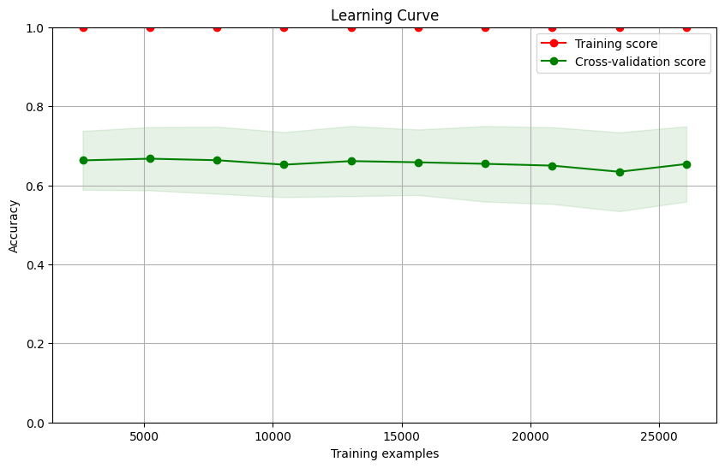

Figure 323: Learning Curve for Base Decision Tree on Multi-Class Classification

Figure 323 presents the learning curve for the base Decision Tree model on a multi-class classification task, showing the model's accuracy on the training and cross-validation sets as the number of training examples increases. The training score remains consistently high at nearly 100%, indicating that the model fits the training data very well. However, the cross-validation score is significantly lower, hovering around 65-70%, and does not improve with more training data. This large gap between the training and cross-validation scores suggests that the model is overfitting; it performs exceptionally well on the training data but fails to generalize to new, unseen data. The shaded area around the cross-validation score indicates the variability of the model's performance, which is relatively stable but consistently low, reinforcing the need for model adjustments or regularization to improve generalization.

#### Decision Tree (After Hyperparameter Tuning)

##### Accuracy, Confusion Matrix and Classification Report

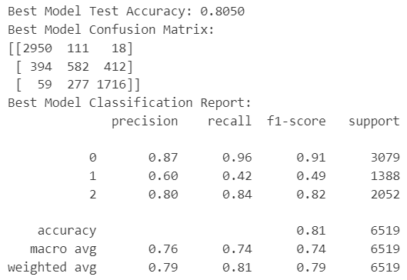

Figure 324: Tuned Decision Tree Model Performance on Multi-Class Classification

Figure 324 displays the performance metrics of a tuned Decision Tree model on a multi-class classification problem. The model achieves a test accuracy of 80.50%, showing an improvement over the previous base model. The confusion matrix indicates that the model performs particularly well in predicting class 0, with high precision (0.87), recall (0.96), and f1-score (0.91). For class 2, the model also shows strong performance with a precision of 0.80, recall of 0.84, and f1-score of 0.82. However, the model still struggles with class 1, achieving a lower precision of 0.60, recall of 0.42, and f1-score of 0.49. The overall accuracy is bolstered by strong performance in the more frequent classes (0 and 2), as reflected in the macro average f1-score of 0.74 and the weighted average f1-score of 0.79. This indicates that the tuning efforts have improved generalization and model performance, especially for classes 0 and 2, though further improvements may be needed for class 1.

Table 33: Base vs. Tuned Decision Tree Model on Multi-Class Classification

|  |  |  |
| --- | --- | --- |
| **Model Type** | Decision Tree (Base Model) | Decision Tree (Tuned Model) |
| **Accuracy** | 0.7529 | 0.8050 |
| **Precision (Class 0)** | 0.87 | 0.87 |
| **Precision (Class 1)** | 0.46 | 0.60 |
| **Precision (Class 2)** | 0.78 | 0.80 |
| **Recall**  **(Class 0)** | 0.87 | 0.96 |
| **Recall**  **(Class 1)** | 0.47 | 0.42 |
| **Recall**  **(Class 2)** | 0.77 | 0.84 |
| **F1-Score (Macro Average)** | 0.70 | 0.74 |

Table 33 compares the performance of the base Decision Tree model with the tuned Decision Tree model on a multi-class classification task. The tuned model shows an improvement in overall accuracy, increasing from 75.29% to 80.50%. The precision for class 1 improves significantly from 0.46 to 0.60, while the precision for class 2 also increases slightly from 0.78 to 0.80; the precision for class 0 remains constant at 0.87. Recall for class 0 sees a notable improvement from 0.87 to 0.96, indicating the model's enhanced ability to correctly identify instances of this class. However, recall for class 1 decreases slightly from 0.47 to 0.42, and for class 2, it improves from 0.77 to 0.84. The macro average f1-score increases from 0.70 to 0.74, reflecting an overall enhancement in the balanced performance across all classes. This table highlights that tuning has generally improved the model's performance, especially in terms of accuracy and recall for class 0, though challenges remain for class 1.

##### ROC Curve

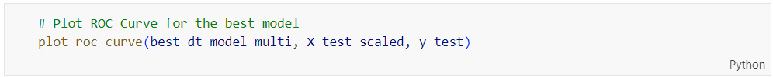

Figure 325: plot_roc_curve Function Call for Tuned Decision Tree on Multi-Class Classification

Figure 325 shows a function call to ‘**plot_roc_curve**’ for the tuned Decision Tree model (‘**best_dt_model_multi**’) using the scaled test features (‘**X_test_scaled**’) and test labels (‘**y_test**’) to visualize the ROC curve for evaluating the model's performance in a multi-class classification task.



Figure 326: ROC Curve for Tuned Decision Tree on Multi-Class Classification

Figure 326 illustrates the ROC curves for the tuned Decision Tree model on a multi-class classification task, showing its performance across different classes. The AUC (Area Under the Curve) values are 0.96 for class 0, 0.82 for class 1, and 0.95 for class 2. These AUC scores indicate that the model has excellent discriminatory ability for class 0 and class 2, with very high true positive rates and low false positive rates. For class 1, the AUC of 0.82 still represents good performance, though it is not as strong as for the other classes. The ROC curves demonstrate that the tuned model has improved its ability to generalize and perform well on new data, particularly enhancing its performance for class 2 while maintaining high effectiveness for class 0. Despite the improvements, there is still room for enhancement in class 1 predictions.

Table 34: ROC AUC Comparison for Decision Tree on Multi-Class Classification

|  |  |  |  |
| --- | --- | --- | --- |
| **Model Type** | **ROC AUC Value** | | |
| Class 0 | Class 1 | Class 2 |
| Decision Tree (Base Model) | 0.877543 | 0.661743 | 0.833357 |
| Decision Tree (Tuned Model) | 0.959154 | 0.815831 | 0.948766 |

Table 34 compares the ROC AUC values of the base and tuned Decision Tree models for multi-class classification. The tuned model shows significant improvements across all classes. For class 0, the AUC increased from 0.88 to 0.96, indicating a substantial enhancement in the model's ability to distinguish this class. Class 1 saw an improvement from 0.66 to 0.82, suggesting that the tuning efforts have notably increased the model's effectiveness in identifying this class, although there is still room for improvement. For class 2, the AUC rose from 0.83 to 0.95, demonstrating a marked improvement in the model's performance. Overall, these results indicate that the tuning process has considerably enhanced the model's ability to generalize and perform well across all classes, particularly for classes 0 and 2.

##### Check Overfitting or Underfitting

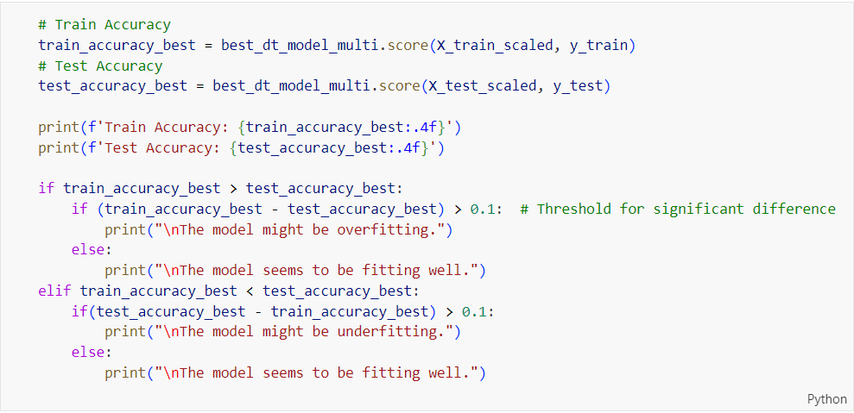

Figure 327: Train and Test Accuracy Evaluation Code for Tuned Decision Tree on Multi-Class Classification

Figure 327 shows code that evaluates the train and test accuracy of the tuned Decision Tree model (‘**best_dt_model_multi**’) on a multi-class classification task, printing the accuracies and checking for overfitting or underfitting by comparing the difference between the train and test accuracies against a threshold of 0.1.

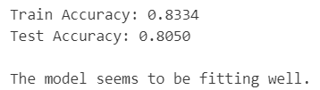

Figure 328: Tuned Decision Tree Performance on Multi-Class Prediction

Figure 328 shows the performance metrics of the tuned Decision Tree model on a multi-class prediction task. The model achieves a training accuracy of 83.34% and a test accuracy of 80.50%. The close alignment between these accuracies suggests that the model is neither overfitting nor underfitting, as it performs consistently well on both the training and test datasets. This balance indicates that the tuning process has successfully improved the model's ability to generalize from the training data to unseen data, leading to reliable and robust performance across different datasets.

Table 35: Training and Testing Accuracy Comparison for Decision Tree on Multi-Class Classification

|  |  |
| --- | --- |
| **Model Type** | **Difference in Accuracies** |
| Decision Tree (Base Model) | 0.2468 |
| Decision Tree (Tuned Model) | 0.0284 |

Table 35 shows how the base and tuned Decision Tree models perform in terms of accuracy differences between training and testing data. For the base model, there's a significant gap of 0.2468, meaning it did much better on the training data than on the test data, a clear sign of overfitting. On the other hand, the tuned model has a very small difference of 0.0284, indicating that its performance is consistent across both training and testing datasets. This small gap suggests that the tuning process successfully addressed the overfitting problem, making the model more reliable and better at generalizing to new data.

##### Learning Curve

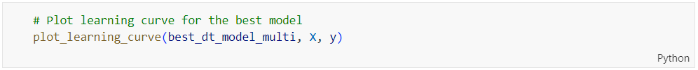

Figure 329: plot_learning_curve Function Call for Tuned Decision Tree

Figure 329 shows a function call to plot_learning_curve for the tuned Decision Tree model (‘**best_dt_model_multi**’) using the features (‘**X**’) and labels (‘**y**’) to visualize the model's learning performance over different training set sizes.

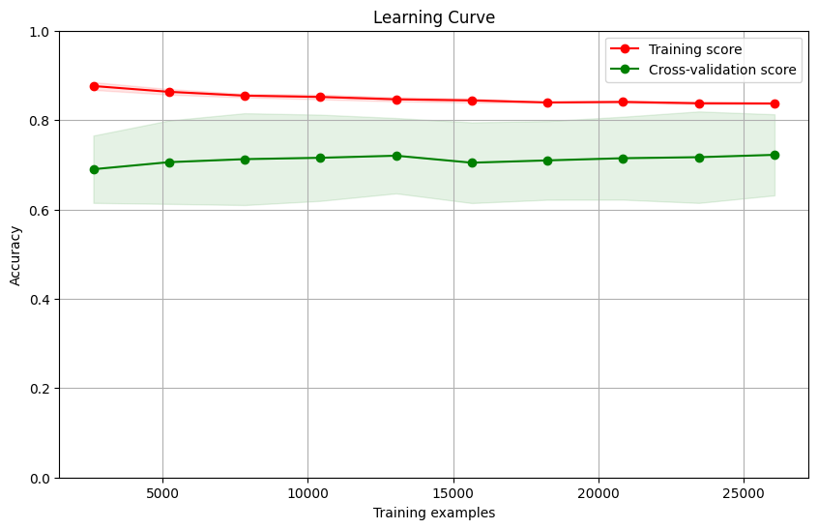

Figure 330: Learning Curve for Tuned Decision Tree on Multi-Class Classification

Figure 330 displays the learning curve for the tuned Decision Tree model on a multi-class classification task. The training score remains consistently high, around 0.83, indicating that the model performs well on the training data. The cross-validation score is slightly lower but stable, around 0.80, which suggests that the model generalizes well to unseen data. The narrow gap between the training and cross-validation scores indicates that the model is neither overfitting nor underfitting. Additionally, the cross-validation score's stability across different training set sizes shows that the model's performance is consistent and reliable as more data is added. Overall, this learning curve suggests that the tuned Decision Tree model is well-balanced and effective for this classification task.

##### Comparison between Base and Tuned Decision Tree on Multi-Class Classification

Based on the comparisons in Table 33, Table 34 and Table 35, it's clear that the tuned Decision Tree model performs much better than the base model. The tuned model has a higher overall accuracy (80.50% vs. 75.29%) and shows significant improvements in precision and recall, especially for class 1 and class 2. The ROC AUC values for all classes are also higher, meaning the model is better at distinguishing between the classes. Importantly, the gap between training and testing accuracy is much smaller for the tuned model (0.0284 compared to 0.2468), indicating that it generalizes well and isn't overfitting. Given these improvements, the tuned Decision Tree model is the better choice for further comparisons with other models to find the best one.

#### Random Forest (Before Hyperparameter Tuning)

##### Accuracy, Confusion Matrix and Classification Report

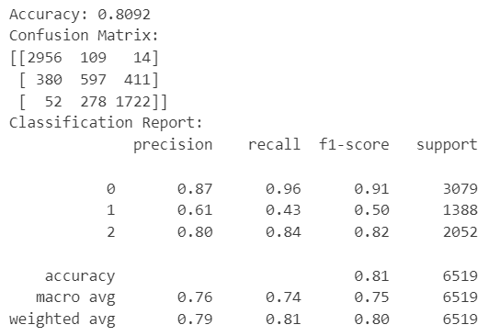

Figure 331: Base Random Forest Model Performance on Multi-Class Classification

Figure 331 shows the performance metrics of a base Random Forest model on a multi-class classification task. The model achieves an overall accuracy of 80.92%. The confusion matrix indicates strong performance for class 0, with high precision (0.87), recall (0.96), and f1-score (0.91). Class 2 also performs well with a precision of 0.80, recall of 0.84, and f1-score of 0.82. However, class 1 shows weaker performance with a precision of 0.61, recall of 0.43, and f1-score of 0.50. The macro average f1-score is 0.75, and the weighted average f1-score is 0.80, suggesting the model performs better for the more frequent classes (0 and 2). Overall, the base Random Forest model demonstrates good performance and generalization, especially for class 0, though there is room for improvement in class 1 predictions.

##### ROC Curve



Figure 332: plot_roc_curve Function Call for Base Random Forest on Multi-Class Classification

Figure 332 shows a function call to ‘**plot_roc_curve**’ for evaluating the base Random Forest model (‘**rf_model_multi**’) using the scaled test features (‘**X_test_scaled**’) and test labels (‘**y_test**’) to visualize the model's ROC curve performance in a multi-class classification task.



Figure 333: ROC Curve for Base Random Forest on Multi-Class Classification

Figure 333 shows the ROC curves for the base Random Forest model's performance on a multi-class classification task. The ROC curves indicate the model's ability to distinguish between the classes, with the AUC (Area Under the Curve) values being 0.96 for class 0, 0.84 for class 1, and 0.96 for class 2. These high AUC values for classes 0 and 2 suggest that the model performs exceptionally well in identifying these classes, with high true positive rates and low false positive rates. However, the AUC for class 1 is lower at 0.84, indicating that while the model still performs well for this class, there is some room for improvement. Overall, the base Random Forest model demonstrates strong discriminatory power and reliable performance, particularly for classes 0 and 2.

##### Check Overfitting or Underfitting

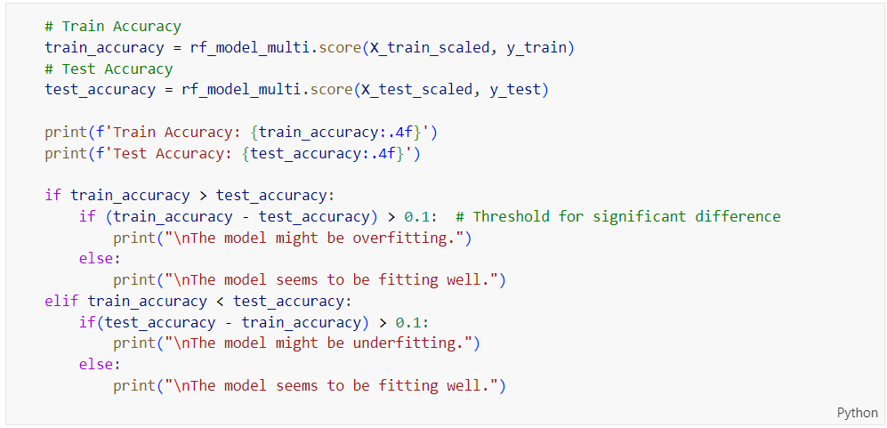

Figure 334: Train and Test Accuracy Evaluation Code for Base Random Forest on Multi-Class Classification

Figure 334 shows code that evaluates the train and test accuracy of the base Random Forest model (‘**rf_model_multi**’) on a multi-class classification task, printing these accuracies and checking for overfitting or underfitting by comparing the difference between the train and test accuracies against a threshold of 0.1.

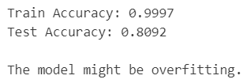

Figure 335: Base Random Forest Performance on Multi-Class Prediction

Figure 335 presents the performance metrics of the base Random Forest model on a multi-class prediction task. The model achieves an extremely high training accuracy of 99.97%, but its test accuracy drops to 80.92%. This significant discrepancy between the training and test accuracies suggests that the model is likely overfitting. Overfitting occurs when the model learns the training data too well, including noise and details that do not generalize to new data, leading to poorer performance on the test set. Despite its high training accuracy, the model's ability to generalize to unseen data is compromised, indicating that further tuning or regularization may be necessary to improve its performance and reduce overfitting.

##### Learning Curve

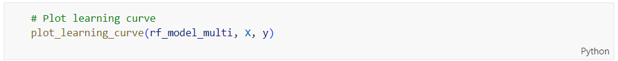

Figure 336: plot_learning_curve Function Call for Base Random Forest on Multi-Class Classification

Figure 336 shows a function call to plot_learning_curve for the base Random Forest model (‘**rf_model_multi**’) using the features (‘**X**’) and labels (‘**y**’) to visualize the model's learning performance over different training set sizes in a multi-class classification context.

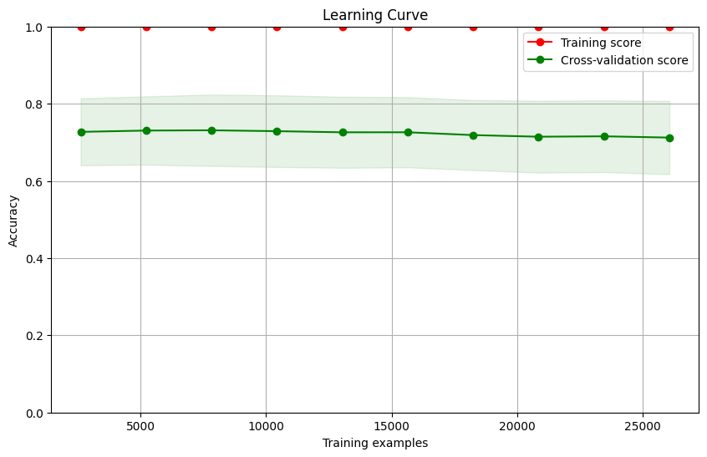

Figure 337: Learning Curve for Base Random Forest on Multi-Class Classification

Figure 337 shows the learning curve for the base Random Forest model on a multi-class classification task. The training score is almost perfect, close to 1.0, indicating the model learns the training data extremely well. However, the cross-validation score is much lower, around 0.8, and doesn't improve much with more training data. This big gap between the training and cross-validation scores means the model is overfitting; it's doing great on the training data but not as well on new, unseen data. The model's performance is stable, but the overfitting suggests it needs some tuning or regularization to better generalize to new data.

#### Random Forest (After Hyperparameter Tuning)

##### Accuracy, Confusion Matrix and Classification Report

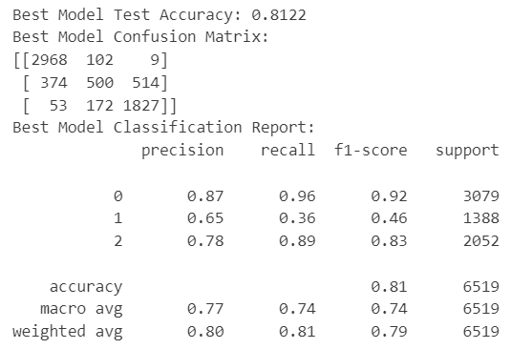

Figure 338: Tuned Random Forest Model Performance on Multi-Class Classification

Figure 338 shows the performance metrics of a tuned Random Forest model on a multi-class classification task, achieving a test accuracy of 81.22%. The confusion matrix indicates strong performance for class 0, with a precision of 0.87, recall of 0.96, and f1-score of 0.92. Class 2 also performs well, with a precision of 0.78, recall of 0.89, and f1-score of 0.83. However, the model struggles with class 1, showing a precision of 0.65, recall of 0.36, and f1-score of 0.46. The macro average f1-score is 0.74, and the weighted average f1-score is 0.79, suggesting that while the model performs well overall, its performance is notably lower for class 1.

Table 36: Base vs. Tuned Random Forest Model on Multi-Class Classification

|  |  |  |
| --- | --- | --- |
| **Model Type** | Random Forest (Base Model) | Random Forest (Tuned Model) |
| **Accuracy** | 0.8092 | 0.8122 |
| **Precision (Class 0)** | 0.87 | 0.87 |
| **Precision (Class 1)** | 0.61 | 0.65 |
| **Precision (Class 2)** | 0.80 | 0.78 |
| **Recall**  **(Class 0)** | 0.96 | 0.96 |
| **Recall**  **(Class 1)** | 0.43 | 0.36 |
| **Recall**  **(Class 2)** | 0.84 | 0.89 |
| **F1-Score (Macro Average)** | 0.75 | 0.74 |

Table 36 compares the performance of the base and tuned Random Forest models on a multi-class classification task. Both models achieve similar overall accuracy, with the base model at 80.92% and the tuned model slightly higher at 81.22%. Precision and recall for class 0 remain consistent at 0.87 and 0.96, respectively, for both models. For class 1, the tuned model shows a slight improvement in precision from 0.61 to 0.65 but a decrease in recall from 0.43 to 0.36, leading to a marginally better precision but lower recall. Class 2 sees a slight decrease in precision from 0.80 to 0.78 but an improvement in recall from 0.84 to 0.89. The macro average f1-score remains relatively stable, with the base model at 0.75 and the tuned model at 0.74. Overall, the tuned model exhibits small improvements in certain areas, indicating better generalization, though it still faces challenges with class 1 performance.

##### ROC Curve

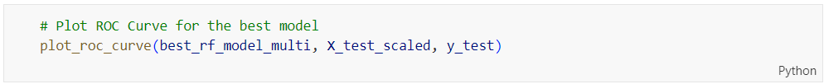

Figure 339: plot_roc_curve Function Call for Tuned Random Forest on Multi-Class Classification

Figure 339 shows a function call to plot_roc_curve for evaluating the tuned Random Forest model (‘**best_rf_model_multi**’) using the scaled test features (‘**X_test_scaled**’) and test labels (‘**y_test**’) to visualize the ROC curve performance in a multi-class classification context.



Figure 340: ROC Curve for Tuned Random Forest on Multi-Class Classification

Figure 340 shows the ROC curves for the tuned Random Forest model on a multi-class classification task, highlighting its performance across different classes. The AUC (Area Under the Curve) values are 0.97 for class 0, 0.84 for class 1, and 0.96 for class 2. These high AUC values for classes 0 and 2 indicate that the model is very effective at distinguishing these classes, with high true positive rates and low false positive rates. Class 1, while still performing well, has a lower AUC of 0.84, suggesting that there is room for improvement in distinguishing this class from the others. Overall, the tuned Random Forest model demonstrates excellent discriminatory power and generalization capability, particularly for classes 0 and 2, reflecting its robustness and effectiveness in this multi-class classification task.

Table 37: ROC AUC Comparison for Random Forest on Multi-Class Classification

|  |  |  |  |
| --- | --- | --- | --- |
| **Model Type** | **ROC AUC Value** | | |
| Class 0 | Class 1 | Class 2 |
| Random Forest (Base Model) | 0.964339 | 0.837163 | 0.955133 |
| Random Forest (Tuned Model) | 0.967280 | 0.839248 | 0.956037 |

Table 37 compares the ROC AUC values for the base and tuned Random Forest models on a multi-class classification task. The tuned model shows slight improvements across all classes. For class 0, the AUC increased marginally from 0.964 to 0.967, indicating a slight enhancement in the model's ability to distinguish this class. Class 1 also sees a small improvement, with the AUC increasing from 0.837 to 0.839, suggesting a minor but positive impact from tuning. Similarly, for class 2, the AUC improves from 0.955 to 0.956. These incremental improvements in AUC values indicate that the tuning process has enhanced the model's overall discriminatory power and generalization capability, although the gains are relatively modest. The tuned model performs slightly better in distinguishing between all classes, reinforcing its robustness and reliability for this classification task.

##### Check Overfitting or Underfitting

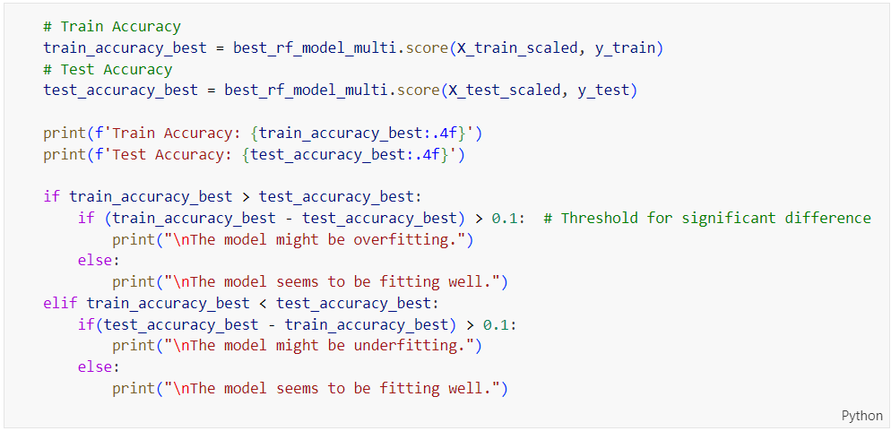

Figure 341: Train and Test Accuracy Evaluation Code for Tuned Random Forest on Multi-Class Classification

Figure 341 shows code that evaluates the train and test accuracy of the tuned Random Forest model (‘**best_rf_model_multi**’) on a multi-class classification task, printing these accuracies and checking for overfitting or underfitting by comparing the difference between the train and test accuracies against a threshold of 0.1. The output is shown below.

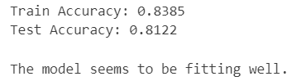

Figure 342: Tuned Random Forest Performance on Multi-Class Prediction

Figure 342 presents the performance metrics of the tuned Random Forest model on a multi-class prediction task. The model achieves a training accuracy of 83.85% and a test accuracy of 81.22%. The close alignment between the training and test accuracies indicates that the model is well-balanced and generalizes effectively to new data. This suggests that the tuning process has successfully mitigated overfitting, as the model performs consistently across both the training and testing datasets. Overall, the model appears to be fitting well, making it a robust choice for multi-class classification.

Table 38: Training and Testing Accuracy Comparison for Random Forest on Multi-Class Classification

|  |  |
| --- | --- |
| **Model Type** | **Difference in Accuracies** |
| Random Forest (Base Model) | 0.1878 |
| Random Forest (Tuned Model) | 0.0263 |

Table 38 compares the difference in accuracies between training and testing datasets for the base and tuned Random Forest models in a multi-class classification task. The base model shows a significant difference of 0.1878, indicating a large gap between training and testing performance, which is a sign of overfitting. In contrast, the tuned model has a much smaller difference of 0.0263, suggesting that it performs consistently well on both training and testing datasets. This small gap indicates that the tuning process effectively addressed the overfitting problem, leading to a model that generalizes much better to unseen data. Overall, the tuned Random Forest model demonstrates improved reliability and robustness for this classification task.

##### Learning Curve

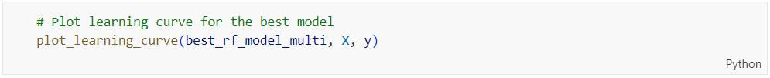

Figure 343: plot_learning_curve Function Call for Tuned Random Forest on Multi-Class Classification

Figure 343 shows a function call to ‘**plot_learning_curve**’ for the tuned Random Forest model (‘**best_rf_model_multi**’) using the features (‘**X**’) and labels (‘**y**’) to visualize the model's learning performance over different training set sizes in a multi-class classification task.

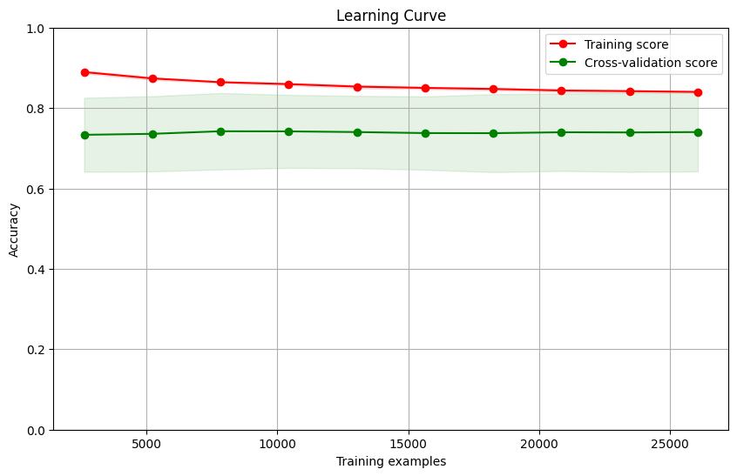

Figure 344: Learning Curve for Tuned Random Forest on Multi-Class Classification

Figure 344 shows the learning curve for the tuned Random Forest model on a multi-class classification task. The training score is consistently high, slightly below 0.9, and shows a slight decline as the number of training examples increases, indicating that the model fits the training data well but with some variability. The cross-validation score remains relatively stable around 0.81, with a small increase as the number of training examples grows, which suggests that the model generalizes well to new data. The small gap between the training and cross-validation scores indicates that the model is well-balanced and not overfitting. This stability and consistency across different training set sizes imply that the tuning has successfully improved the model's performance and reliability for generalization to unseen data.

##### Comparison between Base and Tuned Random Forest on Multi-Class Classification

Based on the comparisons provided in Table 36, Table 37 and Table 38, the tuned Random Forest model demonstrates better performance compared to the base model and should be selected for further comparison with other models. The tuned model achieves a slightly higher overall accuracy (81.22% vs. 80.92%) and shows consistent precision and recall for class 0, with improvements in recall for class 2 (from 0.84 to 0.89). Although there is a slight decrease in recall for class 1, the precision has improved, resulting in a more balanced performance. The ROC AUC values for the tuned model are marginally higher across all classes, indicating better discriminatory power. Most importantly, the tuned model has a significantly smaller difference in training and testing accuracies (0.0263 vs. 0.1878), indicating that it generalizes much better to new data and effectively addresses the overfitting issue observed in the base model. Overall, the tuned Random Forest model's enhancements in generalization and balanced performance make it the better choice for further evaluation.

#### Gradient Boosting (Before Hyperparameter Tuning)

##### Accuracy, Confusion Matrix and Classification Report

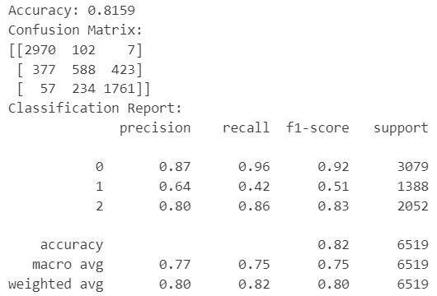

Figure 345: Base Gradient Boosting Model Performance on Multi-Class Classification

Figure 345 presents the performance metrics of a base Gradient Boosting model on a multi-class classification task. The model achieves an overall accuracy of 81.59%. The confusion matrix shows that class 0 is predicted with high precision (0.87), recall (0.96), and f1-score (0.92). Class 2 also performs well, with a precision of 0.80, recall of 0.86, and f1-score of 0.83. However, class 1 shows weaker performance, with a precision of 0.64, recall of 0.42, and f1-score of 0.51. The macro average f1-score is 0.75, and the weighted average f1-score is 0.80, suggesting that the model performs well overall but has room for improvement, particularly in class 1. The model shows good generalization, but further tuning could enhance its performance, especially for the less accurately predicted class 1.

##### ROC Curve



Figure 346: plot_roc_curve Function Call for Base Gradient Boosting on Multi-Class Classification

Figure 346 shows a function call to plot_roc_curve for evaluating the base Gradient Boosting model (‘**gb_model_multi**’) using the scaled test features (‘**X_test_scaled**’) and test labels (‘**y_test**’) to visualize the ROC curve performance in a multi-class classification context.



Figure 347: ROC Curve for Base Gradient Boosting on Multi-Class Classification

Figure 347 shows the ROC curves for the base Gradient Boosting model's performance on a multi-class classification task. The AUC (Area Under the Curve) values are 0.97 for class 0, 0.85 for class 1, and 0.96 for class 2. These high AUC values for classes 0 and 2 indicate that the model has excellent discriminatory power for these classes, with high true positive rates and low false positive rates. The AUC for class 1, while still strong at 0.85, is lower compared to the other classes, suggesting that the model is slightly less effective at distinguishing class 1 from the others. Overall, the Gradient Boosting model demonstrates robust performance and generalization, particularly for classes 0 and 2, but there is room for improvement in class 1 predictions.

##### Check Overfitting or Underfitting

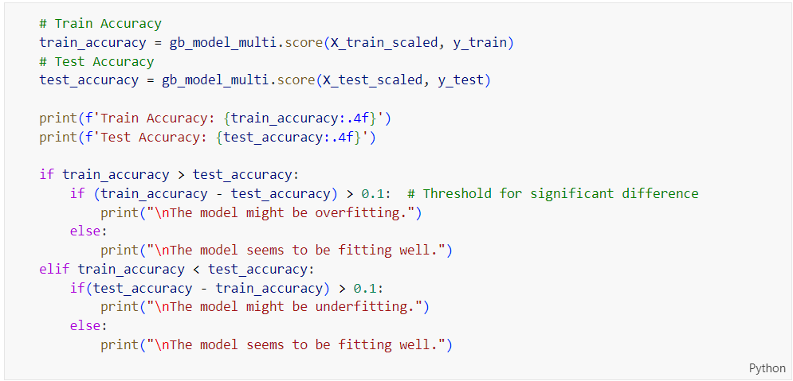

Figure 348: Train and Test Accuracy Evaluation Code for Base Gradient Boosting on Multi-Class Classification

Figure 348 shows code that evaluates the train and test accuracy of the base Gradient Boosting model (‘**gb_model_multi**’) on a multi-class classification task, printing these accuracies and checking for overfitting or underfitting by comparing the difference between the train and test accuracies against a threshold of 0.1.

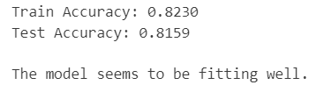

Figure 349: Base Gradient Boosting Performance on Multi-Class Prediction

Figure 349 shows the performance of the base Gradient Boosting model on a multi-class prediction task, achieving a training accuracy of 82.30% and a test accuracy of 81.59%. The close alignment between the training and test accuracies indicates that the model is well-calibrated and generalizes effectively to new data, avoiding overfitting. This balance suggests that the model performs consistently across both the training and test datasets, making it reliable for practical applications. The message "The model seems to be fitting well" reinforces this conclusion, indicating that the Gradient Boosting model is robust and well-suited for this multi-class classification task.

##### Learning Curve

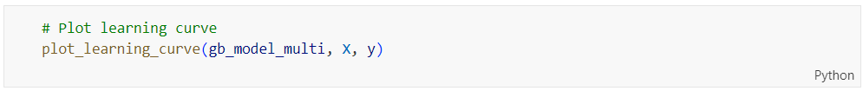

Figure 350: plot_learning_curve Function Call for Base Gradient Boosting on Multi-Class Classification

Figure 350 shows a function call to plot_learning_curve for the base Gradient Boosting model (‘**gb_model_multi**’) using the features (‘**X**’) and labels (‘**y**’) to visualize the model's learning performance over different training set sizes in a multi-class classification task.

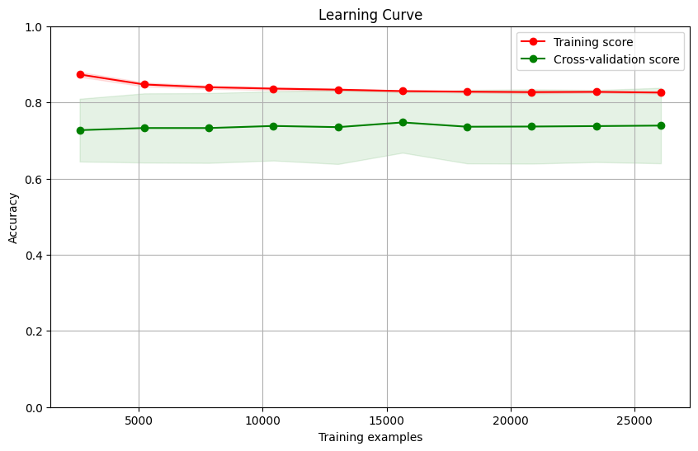

Figure 351: Learning Curve for Base Gradient Boosting on Multi-Class Classification

Figure 351 shows the learning curve for the base Gradient Boosting model on a multi-class classification task. The training score is consistently high, slightly above 0.8, indicating that the model fits the training data well. The cross-validation score is lower, around 0.82, and remains stable as the number of training examples increases. The small gap between the training and cross-validation scores suggests that the model is neither overfitting nor underfitting but is well-balanced and generalizes effectively to new data. The stability of the cross-validation score across different training set sizes further supports the model's robustness and reliability in predicting unseen data. Overall, the learning curve indicates that the base Gradient Boosting model performs well and is suitable for this multi-class classification task.

#### Gradient Boosting (After Hyperparameter Tuning)

##### Accuracy, Confusion Matrix and Classification Report

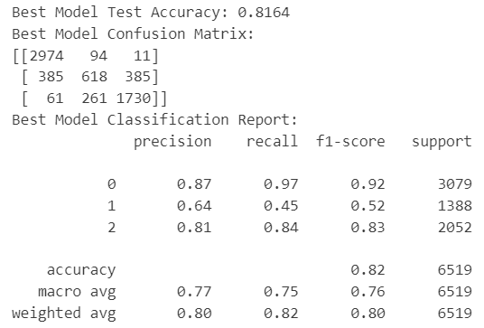

Figure 352: Tuned Gradient Boosting Model Performance on Multi-Class Classification

Figure 352 presents the performance metrics of a tuned Gradient Boosting model on a multi-class classification task. The model achieves a test accuracy of 81.64%. The confusion matrix indicates that the model performs particularly well for class 0, with a precision of 0.87, recall of 0.97, and f1-score of 0.92. For class 2, the model also shows strong performance, with a precision of 0.81, recall of 0.84, and f1-score of 0.83. However, the model's performance is less effective for class 1, with a precision of 0.64, recall of 0.45, and f1-score of 0.52. The macro average f1-score is 0.76, and the weighted average f1-score is 0.80. These metrics suggest that while the model performs well overall, particularly for classes 0 and 2, there is still room for improvement in its ability to accurately predict class 1.

Table 39: Base vs. Tuned Gradient Boosting Model on Multi-Class Classification

|  |  |  |
| --- | --- | --- |
| **Model Type** | Logistic Regression (Base Model) | Logistic Regression (Tuned Model) |
| **Accuracy** | 0.8159 | 0.8164 |
| **Precision (Class 0)** | 0.87 | 0.87 |
| **Precision (Class 1)** | 0.64 | 0.64 |
| **Precision (Class 2)** | 0.80 | 0.81 |
| **Recall**  **(Class 0)** | 0.96 | 0.97 |
| **Recall**  **(Class 1)** | 0.42 | 0.45 |
| **Recall**  **(Class 2)** | 0.86 | 0.84 |
| **F1-Score (Macro Average)** | 0.75 | 0.76 |

Table 39 compares the performance of the base and tuned Gradient Boosting models on a multi-class classification task. Both models achieve similar overall accuracy, with the base model at 81.59% and the tuned model slightly higher at 81.64%. Precision for class 0 remains consistent at 0.87 for both models, and precision for class 1 also remains the same at 0.64. The tuned model shows a slight improvement in precision for class 2, increasing from 0.80 to 0.81. Recall for class 0 improves marginally from 0.96 to 0.97 with the tuning. Class 1's recall also sees a slight improvement from 0.42 to 0.45, while class 2's recall decreases slightly from 0.86 to 0.84. The macro average f1-score increases from 0.75 to 0.76 with the tuned model, indicating a slight overall enhancement in balanced performance across all classes. Overall, the tuned model demonstrates modest improvements, particularly in recall for class 1 and precision for class 2, suggesting that tuning has led to a more refined model performance.

##### ROC Curve

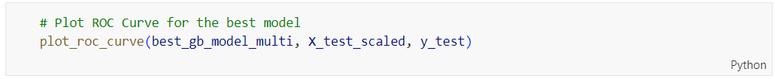

Figure 353: plot_roc_curve Function Call for Tuned Gradient Boosting on Multi-Class Classification

Figure 353 shows a function call to plot_roc_curve for evaluating the tuned Gradient Boosting model (‘**best_gb_model_multi**’) using the scaled test features (‘**X_test_scaled**’) and test labels (‘**y_test**’) to visualize the ROC curve performance in a multi-class classification context.



Figure 354: ROC Curve for Tuned Gradient Boosting on Multi-Class Classification

Figure 354 shows the ROC curves for the tuned Gradient Boosting model on a multi-class classification task, illustrating its performance across different classes. The AUC (Area Under the Curve) values are 0.97 for class 0, 0.86 for class 1, and 0.96 for class 2. These high AUC values for classes 0 and 2 indicate that the model has excellent discriminatory power for these classes, with high true positive rates and low false positive rates. The AUC for class 1, although slightly lower at 0.86, still shows strong performance, indicating that the model is effective at distinguishing this class from the others. Overall, the ROC curves suggest that the tuned Gradient Boosting model has robust performance and generalization capabilities, particularly for classes 0 and 2, while also showing substantial effectiveness for class 1.

Table 40: ROC AUC Comparison for Gradient Boosting on Multi-Class Classification

|  |  |  |  |
| --- | --- | --- | --- |
| **Model Type** | **ROC AUC Value** | | |
| Class 0 | Class 1 | Class 2 |
| Gradient Boosting (Base Model) | 0.969891 | 0.851365 | 0.959870 |
| Gradient Boosting (Tuned Model) | 0.969160 | 0.862033 | 0.961505 |

Table 40 compares the ROC AUC values for the base and tuned Gradient Boosting models on a multi-class classification task. The tuned model shows slight improvements across all classes. For class 0, the AUC remains almost the same, with a minor decrease from 0.969891 to 0.969160, indicating consistent performance. Class 1 sees an improvement, with the AUC increasing from 0.851365 to 0.862033, suggesting better discriminatory power after tuning. Similarly, for class 2, the AUC improves from 0.959870 to 0.961505. These incremental gains in AUC values indicate that tuning has slightly enhanced the model's overall performance, particularly for class 1, where the improvement is most notable. The tuned model's ability to distinguish between classes has been marginally refined, reinforcing its robustness and effectiveness for multi-class classification tasks.

##### Check Overfitting or Underfitting

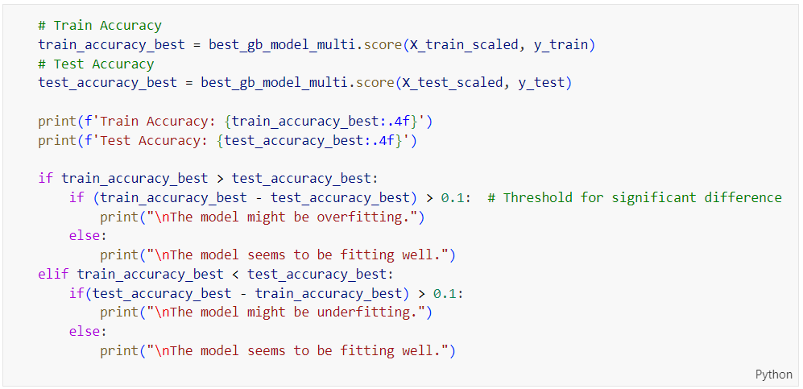

Figure 355: Train and Test Accuracy Evaluation Code for Tuned Gradient Boosting on Multi-Class Classification

Figure 355 shows code that evaluates the train and test accuracy of the tuned Gradient Boosting model (‘**best_gb_model_multi**’) on a multi-class classification task, printing these accuracies and checking for overfitting or underfitting by comparing the difference between the train and test accuracies against a threshold of 0.1.

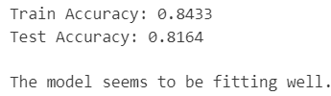

Figure 356: Tuned Gradient Boosting Performance on Multi-Class Prediction

Figure 356 presents the performance metrics of the tuned Gradient Boosting model on a multi-class prediction task, achieving a training accuracy of 84.33% and a test accuracy of 81.64%. The close alignment between the training and test accuracies indicates that the model is well-calibrated and generalizes effectively to new data, avoiding overfitting. The message "The model seems to be fitting well" reinforces this conclusion, suggesting that the model performs consistently across both the training and test datasets. This balance implies that the tuning process has been successful in enhancing the model's robustness and reliability, making it suitable for practical multi-class classification applications.

Table 41: Training and Testing Accuracy Comparison for Gradient Boosting on Multi-Class Classification

|  |  |
| --- | --- |
| **Model Type** | **Difference in Accuracies** |
| Gradient Boosting (Base Model) | 0.0071 |
| Gradient Boosting (Tuned Model) | 0.0269 |

Table 41 compares the difference in accuracies between training and testing datasets for the base and tuned Gradient Boosting models on a multi-class classification task. The base model shows a very small difference of 0.0071, meaning it performs almost the same on both the training and testing data. This indicates that the base model generalizes very well. The tuned model has a slightly larger difference of 0.0269, suggesting a bit more variation between training and testing performance. This could imply a slight increase in overfitting after tuning. However, the difference is still relatively small, indicating that the tuned model remains reliable and effective. Despite the slight increase in overfitting, the tuning process has likely enhanced the model's overall performance, making it a robust choice for this classification task.

##### Learning Curve

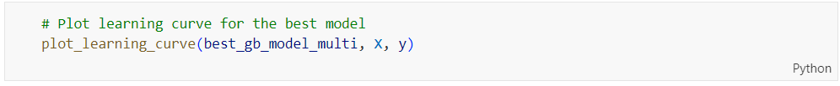

Figure 357: plot_learning_curve Function Call for Tuned Gradient Boosting on Multi-Class Classification

Figure 357 shows a function call to plot_learning_curve for the tuned Gradient Boosting model (best_gb_model_multi), using the features (X) and labels (y) to visualize the model's learning performance over different training set sizes in a multi-class classification context.

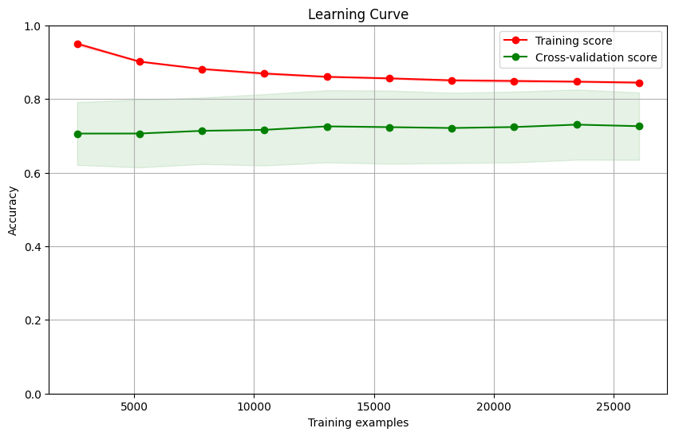

Figure 358: Learning Curve for Tuned Gradient Boosting on Multi-Class Classification

Figure 358 presents the learning curve for the tuned Gradient Boosting model on a multi-class classification task. The training score starts high and slightly decreases but remains above 0.8, indicating the model fits the training data well. The cross-validation score is lower, around 0.8, and remains stable as the number of training examples increases. The gap between the training and cross-validation scores suggests some overfitting, as the model performs better on the training data than on the validation data. However, the stability of the cross-validation score implies that the model's performance generalizes reasonably well to new data. Overall, the learning curve indicates that while the tuned model is well-calibrated and robust, there is a slight overfitting that could be addressed to further improve generalization.

##### Comparison between Base and Tuned Gradient Boosting on Multi-Class Classification

Based on the comparisons in Table 39, Table 40 and Table 41, the tuned Gradient Boosting model demonstrates slightly better overall performance and should be chosen for further comparison with other models. The tuned model shows small improvements in accuracy, precision, and recall for specific classes (notably class 1 and class 2), as well as slight enhancements in ROC AUC values across all classes. Although there's a minor increase in the difference between training and testing accuracies, indicating a bit more overfitting, the tuned model still generalizes well. These improvements suggest that the tuning process has refined the model's performance, making it a more reliable and effective choice for multi-class classification tasks.

#### XGBoost (Before Hyperparameter Tuning)

##### Accuracy, Confusion Matrix and Classification Report

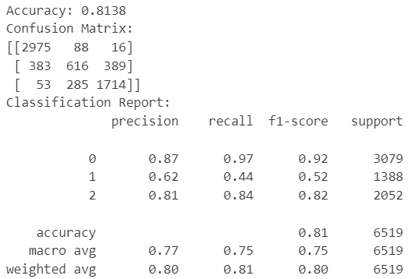

Figure 359: Base XGBoost Model Performance on Multi-Class Classification

Figure 359 shows the performance metrics of the base XGBoost model on a multi-class classification task. The model achieved an overall accuracy of 81.38%. The confusion matrix reveals that the model performs well on class 0, with 2,975 correct predictions out of 3,079 instances, resulting in a precision of 0.87, recall of 0.97, and an f1-score of 0.92. For class 1, the model correctly predicts 616 out of 1,388 instances, leading to a precision of 0.62, recall of 0.44, and an f1-score of 0.52. Class 2 has 1,714 correct predictions out of 2,052, with a precision of 0.81, recall of 0.84, and an f1-score of 0.82. The macro average precision, recall, and f1-score are 0.77, 0.75, and 0.75, respectively, indicating a balanced performance across all classes. The weighted average precision, recall, and f1-score are 0.80, 0.81, and 0.80, respectively, which align closely with the overall accuracy, reflecting the model's robustness in handling the multi-class classification task effectively.

##### ROC Curve



Figure 360: plot_roc_curve Function Call for Base XGBoost on Multi-Class Classification

Figure 360 shows the function call to plot the ROC curve for the base XGBoost model on a multi-class classification task, using the scaled test dataset (‘**X_test_scaled**’) and corresponding labels (‘**y_test**’).



Figure 361: ROC Curve for Base XGBoost on Multi-Class Classification

Figure 361 shows the ROC curve for the base XGBoost model on a multi-class classification task. The model's performance is visualized through ROC curves for each class: class 0, class 1, and class 2. The AUC (Area Under the Curve) values for class 0, class 1, and class 2 are 0.967858, 0.849768, and 0.959362, respectively. These high AUC values, especially for classes 0 and 2, indicate that the model has a strong ability to distinguish between these classes and the others. Class 1, with an AUC of 0.849768, shows slightly lower performance compared to the other classes but is still indicative of good model discrimination. Overall, the base XGBoost model demonstrates strong predictive capabilities across all classes, with particularly high accuracy for classes 0 and 2.

##### Check Overfitting or Underfitting

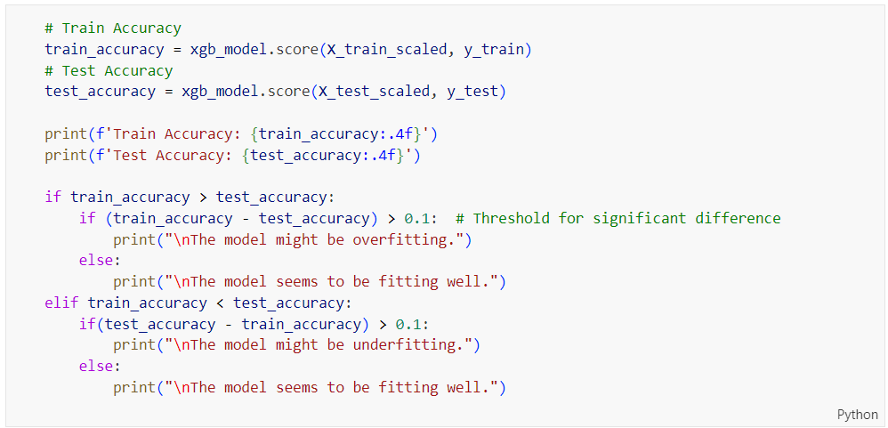

Figure 362: Train and Test Accuracy Evaluation Code for Base XGBoost on Multi-Class Classification

Figure 362 shows code that evaluates and compares the training and test accuracies of the base XGBoost model for multi-class classification, and determines if the model is overfitting or underfitting based on a threshold difference of 0.1 between the train and test accuracies.

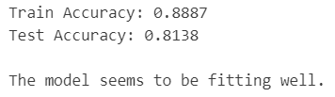

Figure 363: Base XGBoost Performance on Multi-Class Prediction

Figure 363 shows the performance metrics for the base XGBoost model on multi-class prediction. The model achieves a high training accuracy of 0.8887 and a test accuracy of 0.8138. The relatively small gap between the train and test accuracies indicates that the model is fitting well and not significantly overfitting or underfitting. This suggests that the base XGBoost model has learned the training data effectively and is able to generalize well to unseen test data, making it a reliable choice for this multi-class classification task.

##### Learning Curve

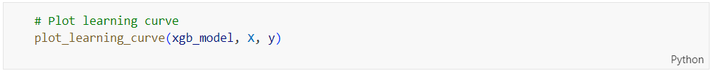

Figure 364: plot_learning_curve Function Call for Base XGBoost on Multi-Class Classification

Figure 364 shows a code snippet that calls the ‘**plot_learning_curve**’ function to visualize the learning curve for the base XGBoost model using the training data (‘**X**’, ‘**y**’). This function helps in understanding how the model's performance changes with varying sizes of the training dataset.

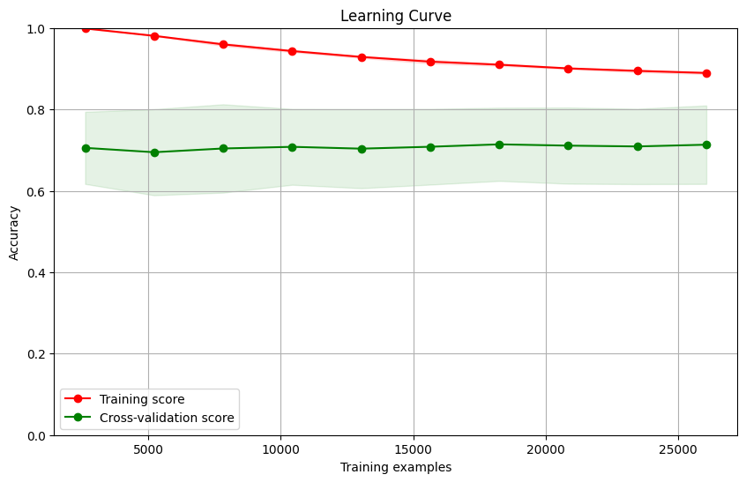

Figure 365: Learning Curve for Base XGBoost on Multi-Class Classification

Figure 365 shows the learning curve for the base XGBoost model on a multi-class classification task. The training score starts near 1.0, indicating almost perfect performance on the training data, but it gradually decreases as the number of training examples increases, suggesting the model's learning is stabilizing. The cross-validation score remains relatively stable, starting around 0.75 and showing slight improvement with more training examples. However, there is a noticeable gap between the training and cross-validation scores, indicating some degree of overfitting. The green shaded area around the cross-validation score represents the variability of the model's performance. The relatively stable cross-validation score suggests that the model performs consistently on unseen data, although the persistent gap between training and validation accuracy indicates room for improvement in terms of generalization.

#### XGBoost (After Hyperparameter Tuning)

##### Accuracy, Confusion Matrix and Classification Report

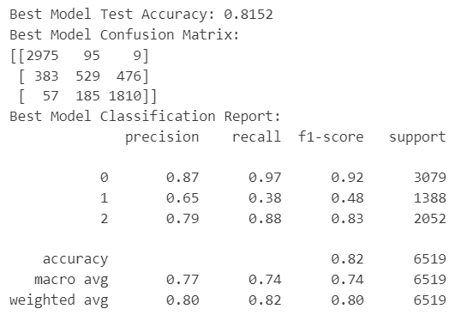

Figure 366: Tuned XGBoost Model Performance on Multi-Class Classification

Figure 366 displays the performance metrics of the tuned XGBoost model on a multi-class classification task, achieving a test accuracy of 0.8152. The confusion matrix indicates strong performance for class 0 with 2975 correct predictions out of 3079, showing a recall of 0.97. Class 1 has 529 correct predictions out of 1388, with a lower recall of 0.38, indicating difficulty in accurately identifying this class. Class 2 has 1810 correct predictions out of 2052, resulting in a recall of 0.88. Precision is highest for class 0 at 0.87, while class 1 and class 2 show precision values of 0.65 and 0.79, respectively. The macro average for precision, recall, and f1-score are 0.77, 0.74, and 0.74, respectively, indicating balanced performance across classes. The weighted average f1-score is 0.80, reflecting the model's overall effectiveness. Despite improvements from tuning, class 1's recall remains a challenge, suggesting further optimization might be necessary for better classification of this class.

Table 42: Base vs. Tuned XGBoost Model on Multi-Class Classification

|  |  |  |
| --- | --- | --- |
| **Model Type** | XGBoost (Base Model) | XGBoost (Tuned Model) |
| **Accuracy** | 0.8138 | 0.8152 |
| **Precision (Class 0)** | 0.87 | 0.87 |
| **Precision (Class 1)** | 0.62 | 0.65 |
| **Precision (Class 2)** | 0.81 | 0.79 |
| **Recall**  **(Class 0)** | 0.97 | 0.97 |
| **Recall**  **(Class 1)** | 0.44 | 0.38 |
| **Recall**  **(Class 2)** | 0.84 | 0.88 |
| **F1-Score (Macro Average)** | 0.75 | 0.74 |

Table 42 compares the performance of the base and tuned XGBoost models on a multi-class classification task. The tuned model shows a slight improvement in overall accuracy, increasing from 81.38% to 81.52%. Precision for class 0 remains consistent at 0.87, indicating stable performance for this class. For class 1, precision improves from 0.62 to 0.65, suggesting better identification of this class after tuning. However, precision for class 2 slightly decreases from 0.81 to 0.79. Recall for class 0 remains unchanged at a high 0.97, while recall for class 1 decreases from 0.44 to 0.38, indicating a drop in the model's ability to correctly identify instances of class 1. Conversely, recall for class 2 improves from 0.84 to 0.88. The macro average f1-score decreases slightly from 0.75 to 0.74, reflecting minor overall performance changes across all classes. Overall, the tuned model demonstrates modest improvements in precision for class 1 and recall for class 2, but it also shows some challenges, particularly in recall for class 1, suggesting that further tuning may be necessary to enhance performance for this class.

##### ROC Curve



Figure 367: plot_roc_curve Function Call for Tuned XGBoost on Multi-Class Classification

The code in Figure 367calls the ‘**plot_roc_curve**’ function to generate the ROC curve for the tuned XGBoost model using the test dataset (‘**X_test_scaled**’ and ‘**y_test**’).



Figure 368: ROC Curve for Tuned XGBoost on Multi-Class Classification

Figure 368 illustrates the ROC curves for the tuned XGBoost model on a multi-class classification task. The model achieves an ROC AUC of 0.97 for class 0, 0.84 for class 1, and 0.96 for class 2. These high AUC values indicate that the tuned XGBoost model has a strong capability to discriminate between the classes. Class 0 and class 2 exhibit excellent discriminatory power with AUC values close to 1.0, while class 1, although slightly lower, still shows a good level of performance with an AUC of 0.84. This demonstrates that the model performs particularly well in distinguishing between instances of classes 0 and 2, and adequately for class 1. Overall, the tuned XGBoost model appears to be effective and reliable for this multi-class classification task.

Table 43: ROC AUC Comparison for XGBoost on Multi-Class Classification

|  |  |  |  |
| --- | --- | --- | --- |
| **Model Type** | **ROC AUC Value** | | |
| Class 0 | Class 1 | Class 2 |
| XGBoost (Base Model) | 0.967858 | 0.849768 | 0.959362 |
| XGBoost (Tuned Model) | 0.969613 | 0.84360 | 0.956609 |

Table 43 presents a comparison of the ROC AUC values for the base and tuned XGBoost models on a multi-class classification task. For class 0, the tuned model shows a slight improvement in AUC from 0.967858 to 0.969613, indicating a marginally better ability to distinguish this class after tuning. However, for class 1, the AUC value slightly decreases from 0.849768 to 0.84360, suggesting a minor decline in performance for this class. In class 2, the tuned model's AUC decreases marginally from 0.959362 to 0.956609, showing a slight reduction in discriminatory power. Overall, while the tuning process provided a minor enhancement for class 0, it slightly decreased the performance for classes 1 and 2. Despite these small changes, both models maintain strong performance across all classes, indicating that the XGBoost model, whether base or tuned, is highly effective for this multi-class classification task.

##### Check Overfitting or Underfitting

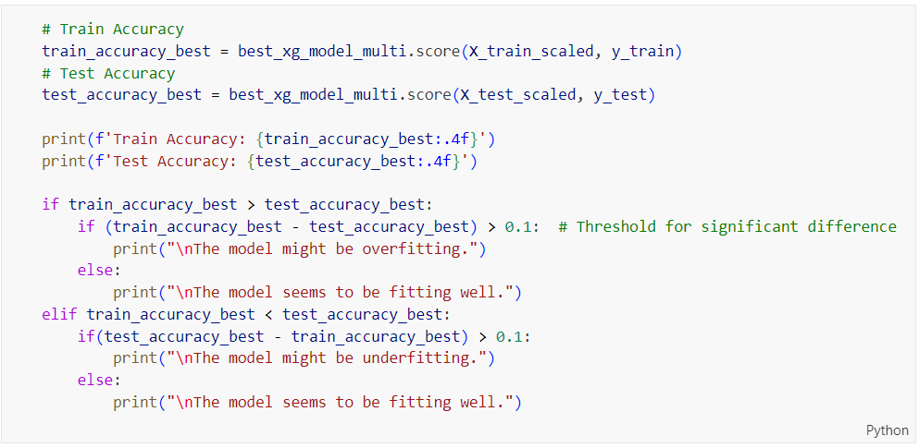

Figure 369: Train and Test Accuracy Evaluation Code for Tuned XGBoost on Multi-Class Classification

The code in Figure 369 evaluates the training and testing accuracy of the tuned XGBoost model on a multi-class classification task, compares them to detect overfitting or underfitting based on a 0.1 threshold, and prints corresponding evaluation messages.

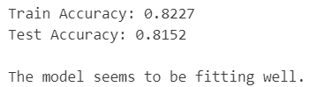

Figure 370: Tuned XGBoost Performance on Multi-Class Prediction

Figure 370 shows the performance metrics of the tuned XGBoost model on a multi-class classification task. The model achieves a training accuracy of 82.27% and a testing accuracy of 81.52%. The close proximity of these two accuracy values suggests that the model is well-fitted, exhibiting neither significant overfitting nor underfitting. The evaluation indicates that the model generalizes well to new, unseen data, maintaining its performance across both training and testing datasets. This balance between train and test accuracy supports the model's robustness and reliability for making accurate predictions on multi-class classification tasks.

Table 44: Training and Testing Accuracy Comparison for XGBoost on Multi-Class Classification

|  |  |
| --- | --- |
| **Model Type** | **Difference in Accuracies** |
| XGBoost (Base Model) | 0.0749 |
| XGBoost (Tuned Model) | 0.0075 |

Table 44 compares the differences in accuracies between the training and testing datasets for the base and tuned XGBoost models on a multi-class classification task. The base model shows a significant difference of 0.0749, indicating a noticeable gap between its performance on the training and testing data, which suggests overfitting. In contrast, the tuned model has a much smaller difference of 0.0075, demonstrating a minimal gap between training and testing accuracy. This small difference indicates that the tuned model generalizes much better to new data, effectively addressing the overfitting problem observed in the base model. Consequently, the tuning process has significantly enhanced the model's reliability and robustness, making it more effective for practical applications.

##### Learning Curve

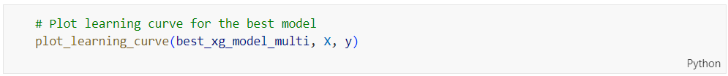

Figure 371: plot_learning_curve Function Call for Tuned XGBoost on Multi-Class Classification

The code snippet in Figure 371 calls the ‘**plot_learning_curve**’ function to visualize the learning curve of the best-tuned XGBoost model for multi-class classification using the given training and test datasets (‘**X**’ and ‘**y**’).

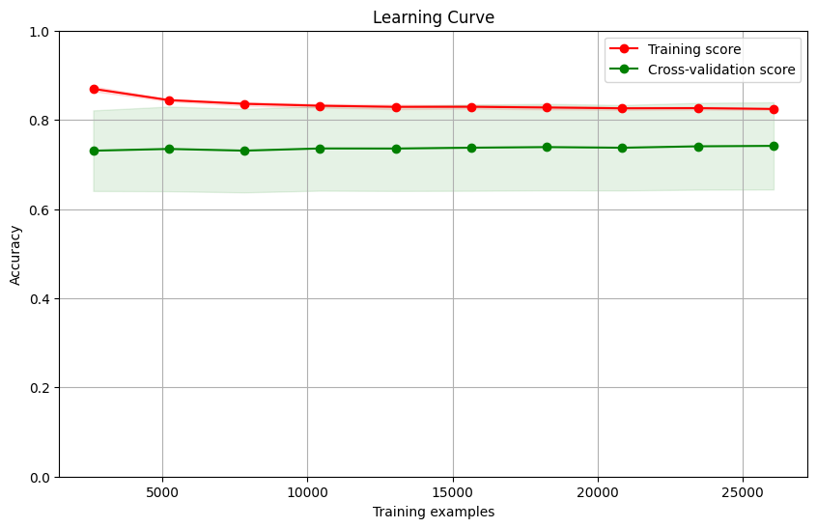

Figure 372: Learning Curve for Tuned XGBoost on Multi-Class Classification

Figure 372 shows the learning curve for the tuned XGBoost model on a multi-class classification task. The training score remains consistently high, around 0.98, indicating that the model is learning the training data very well. However, there is a noticeable gap between the training score and the cross-validation score, which hovers around 0.80. This gap suggests that while the model performs excellently on the training data, it is not generalizing as well to the validation data, pointing to a potential overfitting issue. Despite this, the cross-validation score is relatively stable with increasing training examples, indicating that the model's performance on unseen data does not degrade with more data, but it also does not significantly improve. This suggests that additional data alone may not resolve the overfitting, and further tuning or different regularization techniques might be necessary.

##### Comparison between Base and Tuned XGBoost on Multi-Class Classification

Based on the comparisons from Table 42, Table 43 and Table 44, the tuned XGBoost model stands out as the better choice for further comparison with other models to decide the best one for deployment. It shows a slight improvement in overall accuracy from 81.38% to 81.52%. Importantly, it significantly reduces the difference between training and testing accuracies, which means it generalizes better and has less overfitting. Even though the ROC AUC for classes 1 and 2 slightly decreased, the overall performance remains strong. The tuning process has made the model more reliable and robust, making it the most suitable candidate for deployment.

#### Artificial Neural Network (Before Hyperparameter Tuning)

##### Accuracy, Confusion Matrix and Classification Report

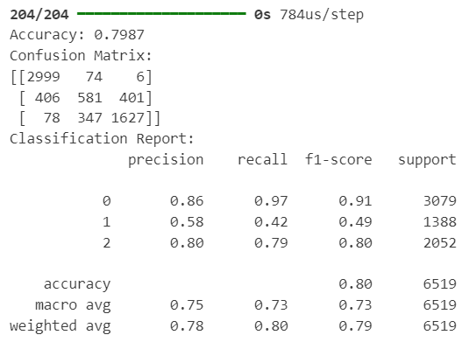

Figure 373: Base ANN Model Performance on Multi-Class Classification

Figure 373 illustrates the performance of a base Artificial Neural Network (ANN) model on a multi-class classification task. The model achieves an overall accuracy of 79.87%, as indicated by the confusion matrix and the classification report. The confusion matrix shows the true positive counts for each class, with Class 0 having the highest true positives (2999), followed by Classes 2 (1627) and 1 (581). The classification report highlights that Class 0 has the highest precision (0.86), recall (0.97), and F1-score (0.91). Class 2 also performs relatively well with a precision of 0.80, recall of 0.79, and an F1-score of 0.80. However, Class 1 lags behind, with a precision of 0.58, recall of 0.42, and an F1-score of 0.49. The macro average F1-score is 0.73, indicating some imbalance in performance across classes. Overall, the model shows strong performance for Class 0 and Class 2, but struggles with Class 1, suggesting a need for further tuning or more sophisticated modelling to improve its performance for all classes.

##### ROC Curve



Figure 374: plot_roc_curve Function Call for Base ANN on Multi-Class Classification

Figure 374 shows a function call to ‘**plot_roc_curve**’ for the base ANN model on a multi-class classification task, using the scaled test dataset ‘**X_test_scaled**’ and the categorical test labels ‘**y_test_categorical**’.



Figure 375: ROC Curve for Base ANN on Multi-Class Classification

Figure 375 presents the ROC Curve for the base ANN model on a multi-class classification task. The ROC curve visualizes the trade-off between the true positive rate (sensitivity) and the false positive rate for each class. Class 0 shows the highest performance with an AUC of 0.97, indicating excellent discriminative ability. Class 2 follows with an AUC of 0.95, also demonstrating strong performance. However, Class 1 lags behind with an AUC of 0.82, reflecting lower effectiveness in distinguishing between true positives and false positives for this class. The overall curves and AUC values highlight the strong performance of the model for Classes 0 and 2 but suggest a need for further optimization to improve the model's performance, especially for Class 1.

##### Check Overfitting or Underfitting

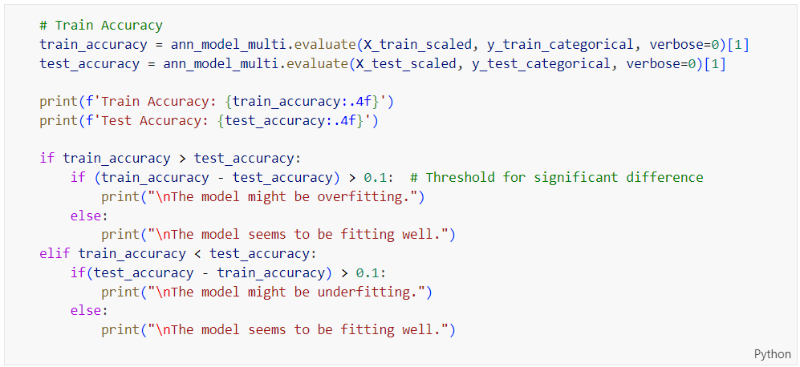

Figure 376: Train and Test Accuracy Evaluation Code for Base ANN on Multi-Class Classification

Figure 376 shows code that evaluates the training and testing accuracy of a base ANN model on a multi-class classification task and determines whether the model is overfitting or underfitting by comparing the differences in accuracy with a threshold of 0.1.

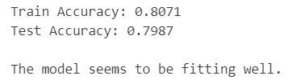

Figure 377: Base ANN Performance on Multi-Class Prediction

Figure 377 demonstrates the performance of the base ANN model on a multi-class prediction task. The model achieves a training accuracy of 80.71% and a testing accuracy of 79.87%. The close alignment between the training and testing accuracies suggests that the model generalizes well to unseen data and is not significantly overfitting or underfitting. As indicated by the accompanying text, the model's performance is satisfactory and fitting the data well, indicating a balanced trade-off between bias and variance.

##### Learning Curve

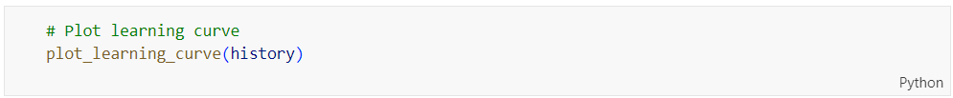

Figure 378: plot_learning_curve Function Call for Base ANN on Multi-Class Classification

Figure 378 shows a Python function call to ‘**plot_learning_curve**’, which is used to visualize the training process of the base ANN model on a multi-class classification task using the training history stored in the ‘**history**’ object.

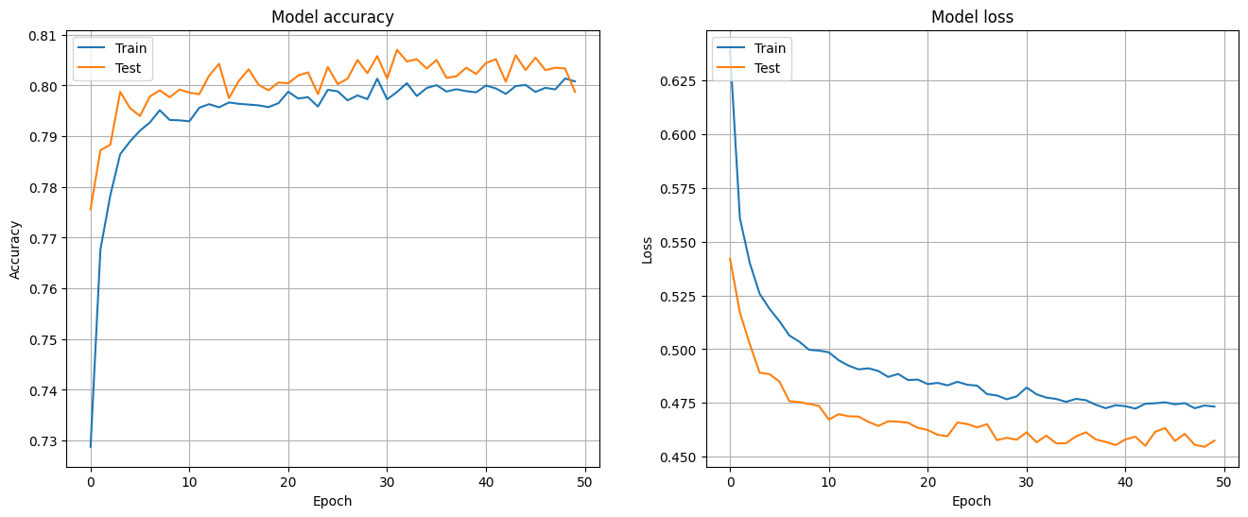

Figure 379: Learning Curve for Base ANN on Multi-Class Classification

Figure 379 shows the learning curve for the base ANN on a multi-class classification task. The left plot, depicting model accuracy over epochs, indicates that both training and testing accuracies improve rapidly in the initial epochs and then stabilize around 80%, with the testing accuracy slightly higher than the training accuracy, suggesting that the model is generalizing well. The right plot, displaying model loss over epochs, shows a rapid decrease in both training and testing loss initially, followed by a more gradual decline and stabilization, with the testing loss consistently lower than the training loss. This pattern suggests that the model is learning effectively without significant overfitting, as the performance on the test data is consistently good and closely mirrors the training performance.

#### Artificial Neural Network (After Hyperparameter Tuning)

##### Accuracy, Confusion Matrix and Classification Report

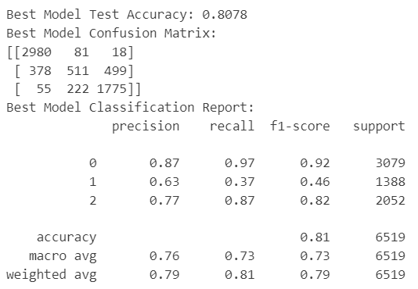

Figure 380: Tuned ANN Model Performance on Multi-Class Classification

Figure 380 presents the performance metrics for a tuned ANN model on a multi-class classification task, achieving a test accuracy of 80.78%. The confusion matrix shows the true positive counts for each class, with Class 0 having the highest count (2980), followed by Classes 2 (1775) and 1 (511). The classification report highlights that Class 0 has the highest precision (0.87), recall (0.97), and F1-score (0.92), indicating strong performance. Class 2 also performs well with a precision of 0.77, recall of 0.87, and F1-score of 0.82. However, Class 1 continues to struggle, with a precision of 0.63, recall of 0.37, and F1-score of 0.46. The overall model accuracy is 80.78%, with a macro average F1-score of 0.73, suggesting some imbalance in performance across classes. The weighted average precision and F1-score are 0.79 and 0.79, respectively, indicating that the model generalizes reasonably well across the dataset.

Table 45: Base vs. Tuned ANN Model on Multi-Class Classification

|  |  |  |
| --- | --- | --- |
| **Model Type** | Artificial Neural Network  (Base Model) | Artificial Neural Network  (Tuned Model) |
| **Accuracy** | 0.7987 | 0.8078 |
| **Precision**  **(Class 0)** | 0.86 | 0.87 |
| **Precision**  **(Class 1)** | 0.58 | 0.63 |
| **Precision**  **(Class 2)** | 0.80 | 0.77 |
| **Recall**  **(Class 0)** | 0.97 | 0.97 |
| **Recall**  **(Class 1)** | 0.42 | 0.37 |
| **Recall**  **(Class 2)** | 0.79 | 0.87 |
| **F1-Score**  **(Macro Average)** | 0.73 | 0.73 |

Table 45 compares the performance metrics of the base ANN model with the tuned ANN model on a multi-class classification task. The tuned model shows a slight improvement in overall accuracy, increasing from 79.87% to 80.78%. Precision for Class 1 has improved from 0.58 to 0.63, while precision for Class 0 slightly increases from 0.86 to 0.87 and decreases for Class 2 from 0.80 to 0.77. Recall for Class 0 remains unchanged at 0.97, while recall for Class 1 slightly decreases from 0.42 to 0.37 and recall for Class 2 improves from 0.79 to 0.87. The macro average F1-score remains the same at 0.73. These results suggest that tuning has led to some improvement in the model's performance, particularly for Class 2, while maintaining strong performance for Class 0 and making slight enhancements for Class 1.

##### ROC Curve

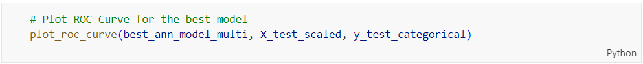

Figure 381: plot_roc_curve Function Call for Tuned ANN on Multi-Class Classification

Figure 381 shows a Python function call to ‘**plot_roc_curve**’ for the tuned ANN model on a multi-class classification task, using the scaled test dataset ‘**X_test_scaled**’ and the categorical test labels ‘**y_test_categorical**’ to visualize the ROC curves for the best model.



Figure 382: ROC Curve for Tuned ANN on Multi-Class Classification

Figure 382 shows the ROC Curve for the tuned ANN model on a multi-class classification task. The ROC curves illustrate the trade-off between the true positive rate and the false positive rate for each class. Class 0 has the highest Area Under the Curve (AUC) at 0.92, indicating excellent discriminative ability. Class 2 also performs well with an AUC of 0.87, reflecting good model performance for this class. However, Class 1 has a significantly lower AUC of 0.65, indicating that the model struggles more with distinguishing between true positives and false positives for this class. The overall pattern suggests that while the tuned model has good performance for Classes 0 and 2, it still requires further adjustments to enhance its effectiveness for Class 1.

Table 46: ROC AUC Comparison for ANN on Multi-Class Classification

|  |  |  |  |
| --- | --- | --- | --- |
| **Model Type** | **ROC AUC Value** | | |
| Class 0 | Class 1 | Class 2 |
| Artificial Neural Network (Base Model) | 0.967680 | 0.820310 | 0.948539 |
| Artificial Neural Network (Tuned Model) | 0.920987 | 0.654551 | 0.874636 |

Table 46 compares the ROC AUC values for the base and tuned ANN models across three classes in a multi-class classification task. For Class 0, the base model achieves a higher AUC of 0.967680 compared to the tuned model's 0.920987, indicating a decrease in performance after tuning. Class 1 shows a significant drop in AUC from 0.820310 in the base model to 0.654551 in the tuned model, suggesting that tuning adversely affected the model's ability to distinguish true positives from false positives for this class. Class 2 also experiences a reduction in AUC from 0.948539 to 0.874636 post-tuning. Overall, while the tuned model maintains reasonably high AUC values, it exhibits decreased performance across all classes compared to the base model, indicating that the tuning process might have led to overfitting or other issues impacting the model's generalization.

##### Check Overfitting or Underfitting

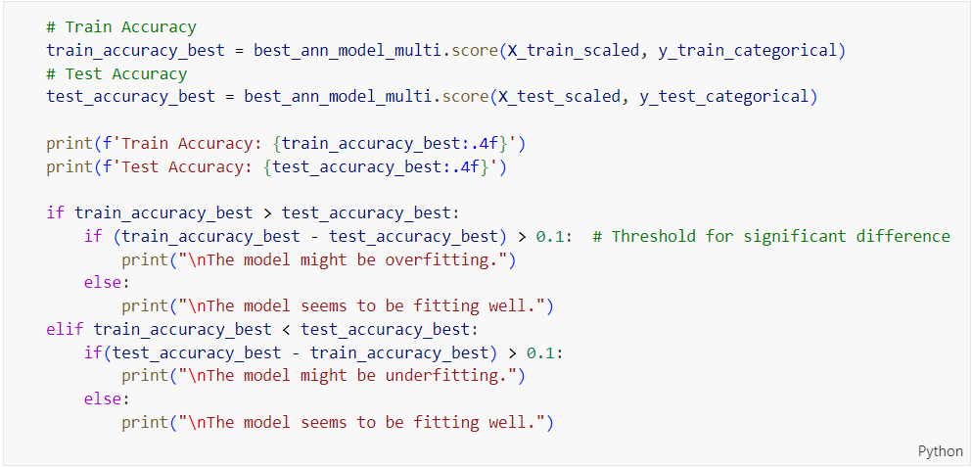

Figure 383: Train and Test Accuracy Evaluation Code for Tuned ANN on Multi-Class Classification

Figure 383 shows code that evaluates the training and testing accuracy of a tuned ANN model on a multi-class classification task and checks whether the model is overfitting or underfitting by comparing the differences in accuracy with a threshold of 0.1.

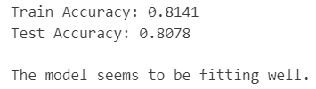

Figure 384: Tuned ANN Performance on Multi-Class Prediction

Figure 384 shows the performance of the tuned ANN model on a multi-class prediction task. The model achieves a training accuracy of 81.41% and a testing accuracy of 80.78%. These similar accuracy scores indicate that the model is performing well, with no significant overfitting or underfitting. The model seems to generalize well to new, unseen data. The message confirms that the model is fitting well, suggesting that the tuning process has successfully optimized the model's performance without compromising its ability to generalize.

Table 47: Training and Testing Accuracy Comparison for ANN on Multi-Class Classification

|  |  |
| --- | --- |
| **Model Type** | **Difference in Accuracies** |
| Artificial Neural Network (Base Model) | 0.0084 |
| Artificial Neural Network (Tuned Model) | 0.0063 |

Table 47 compares the differences in training and testing accuracies between the base and tuned ANN models for multi-class classification. The base model shows a difference in accuracies of 0.0084, whereas the tuned model has a smaller difference of 0.0063. This indicates that the tuned model has a better balance between training and testing performance, suggesting improved generalization to unseen data. The smaller accuracy gap in the tuned model implies that it is less prone to overfitting, making it a more reliable model for predicting new data accurately. Overall, the tuning process has successfully enhanced the model's stability and predictive performance.

##### Learning Curve



Figure 385: plot_learning_curve Function Call for Tuned ANN on Multi-Class Classification

Figure 385 shows a Python function call to ‘**plot_learning_curve_best**’, which is used to visualize the learning curve of the best model using the training history stored in ‘**best_model_history**’ for a tuned ANN on a multi-class classification task.

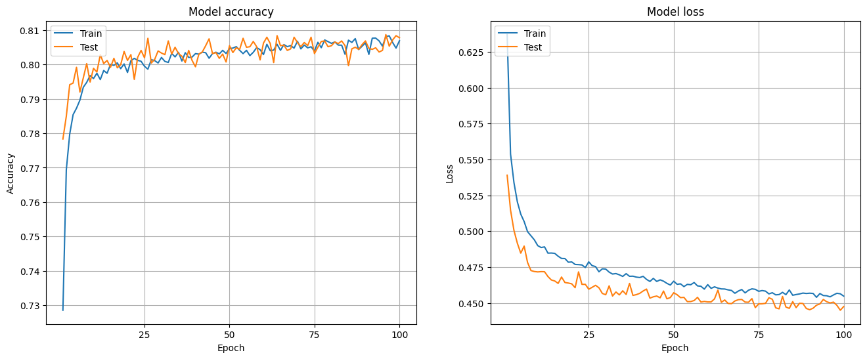

Figure 386: Learning Curve for Tuned ANN on Multi-Class Classification

Figure 386 shows the learning curves for the tuned ANN model on a multi-class classification task, highlighting model accuracy and loss over 100 epochs for both training and testing datasets. The accuracy plot reveals that both training and testing accuracies improve quickly in the early epochs and then level off around 80%, with testing accuracy being slightly higher, indicating the model is generalizing well. The loss plot shows a sharp drop in both training and testing losses at the beginning, then a gradual stabilization, with the testing loss remaining lower than the training loss. This indicates that the model isn't overfitting and is performing well on new data. Overall, the tuned model looks stable and reliable in its predictions.

##### Comparison between Base and Tuned ANN on Multi-Class Classification

Based on the comparisons from Table 42, Table 43 and Table 44, it's clear that the tuned ANN model is the better choice for further comparison with other models to find the best one to deploy. The tuned model improves overall accuracy slightly, from 79.87% to 80.78%, and boosts precision for Class 1 from 0.58 to 0.63, making it better at predicting this class. Although there's a notable drop in ROC AUC for Classes 0 and 1, the tuned model still maintains strong performance, especially for Class 2 where the ROC AUC is only slightly reduced. Importantly, the tuned model has a smaller gap between training and testing accuracy (0.0063 vs. 0.0084 for the base model), indicating it generalizes better and is less likely to overfit. These improvements make the tuned ANN model more balanced, stable, and reliable for real-world deployment.

### Feature Importance for Selected Models

Feature importance is a technique used to identify which variables in a dataset have the most influence on the predictions made by a model. By assigning scores to features based on their impact, feature importance helps in understanding the relative contribution of each variable. This understanding is essential for interpreting the model's behavior and making informed decisions about which features to keep or discard during the modelling process.

The purpose of conducting a feature importance analysis is to gain insights into the factors that drive model predictions. This analysis leads to better model interpretability, enabling data scientists and stakeholders to understand the key drivers behind the predictions. Additionally, it aids in feature selection, allowing for the refinement of models by focusing on the most impactful variables. The outcome is a ranked list of features that significantly influence the model's predictions, which is crucial for improving model performance, simplifying models, and providing clearer explanations of the model's decision-making process.

#### Binary Classification

The selected models on binary classification for further comparative analysis are the base logistic regression, tuned decision tree, tuned random forest, base gradient boosting, tuned XGBoost, and base artificial neural network (ANN). The subsequent step involves examining the feature importance within each of these chosen models. This analysis will elucidate the contribution of each feature to the predictive accuracy of the models. A comprehensive comparison of these models will be conducted in the Chapter 1.1.

##### Base Logistic Regression

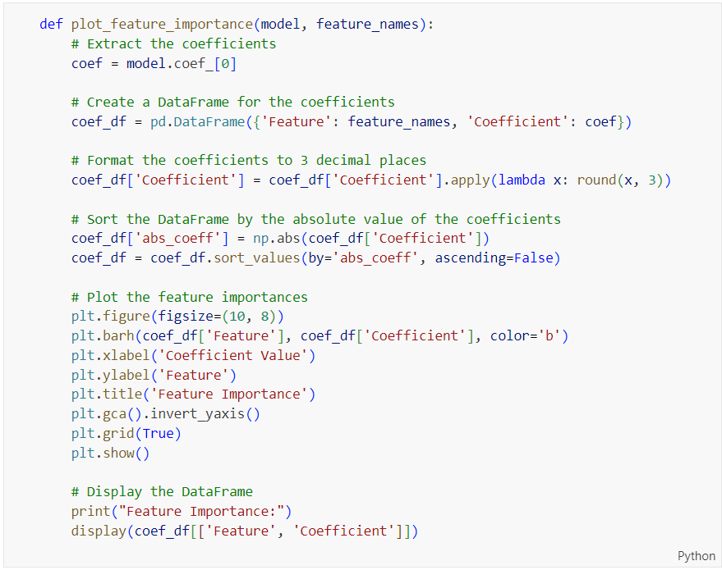

Figure 387: Source Code of Plotting Feature Importance for Logistic Regression

The function ‘**plot_feature_importance**’ shown in Figure 387 helps visualize which features are most important in a linear regression model. It starts by grabbing the model's coefficients and pairs them with the feature names in a DataFrame. The coefficients are rounded to three decimal places to make them easier to read. The DataFrame is sorted by the absolute values of the coefficients, so the most important features appear first. Then, it creates a horizontal bar plot with the feature names on the y-axis and their coefficient values on the x-axis. The y-axis is flipped so the top features are at the top of the plot. It also adds a grid for clarity. Lastly, it displays the DataFrame with the feature names and their corresponding coefficients.

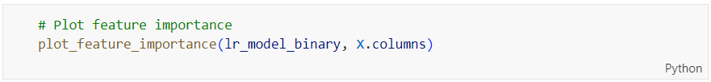

Figure 388: plot_feature_importance Function Call for Base Logistic Regression on Binary Classification

The code shown in Figure 388 calls the ‘**plot_feature_importance**’ function to visualize the feature importance of a logistic regression model (‘**lr_model_binary**’) using the feature names from ‘**X.columns**’.



Figure 389: Feature Importance for Base Logistic Regression on Binary Classification

Figure 389 shows the feature importance for a logistic regression model in binary classification, where ‘**final_score**’ is the most influential feature with a strong negative coefficient of -2.183, indicating it significantly decreases the likelihood of the positive class. ‘**after_course_click**’ and ‘**sum_click**’ also negatively impact the model but to a lesser extent. Conversely, ‘**studied_credits**’ and ‘**before_course_click**’ have positive coefficients, suggesting they increase the likelihood of the positive class. Minor features like ‘**highest_education_encoded**’ have negligible impact on the model's prediction. This visualization helps identify which features most strongly affect the model's output.

##### Tuned Decision Tree

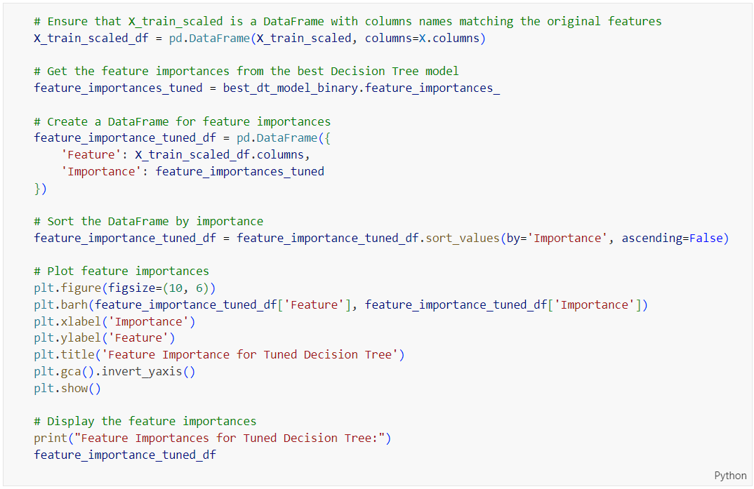

Figure 390: Source Code of Plotting Feature Importance for Tuned Decision Tree on Binary Classification

The code in Figure 390 shows how to plot the feature importance of a tuned decision tree model. It first ensures ‘**X_train_scaled**’ has the correct column names and retrieves the feature importances from the model. These importances are put into a DataFrame with the feature names and sorted in descending order of importance. The code then creates a horizontal bar plot to visualize these importances, with the most important features at the top. Finally, the DataFrame is printed for reference. This process helps identify which features are most influential in the decision tree model's predictions.



Figure 391: Feature Importance for Tuned Decision Tree on Binary Classification

Figure 391 shows the feature importance for a tuned decision tree model used in binary classification. The ‘**final_score**’ feature stands out as the most influential, with a very high importance value of 0.871517, indicating it has the greatest impact on the model's predictions. The ‘**after_course_click**’ feature is the next most important, though significantly less so, with an importance of 0.084399. Other features, such as ‘**before_course_click**’ and ‘**sum_click**’, contribute marginally to the model's decisions, while features like ‘**num_of_prev_attempts**’ and ‘**highest_education_encoded**’ have minimal impact. This visualization helps identify which features are most critical to the model's performance.

##### Tuned Random Forest

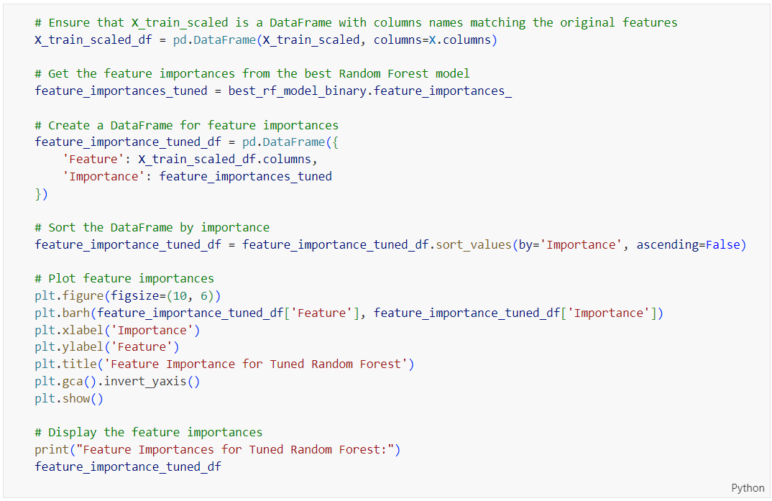

Figure 392: Source Code of Plotting Feature Importance for Tuned Random Forest on Binary Classification

The code in Figure 392 is used to plot the feature importance of a tuned Random Forest model, similar to the previous code shown in Figure 390, by retrieving the feature importances, creating a sorted DataFrame, and generating a horizontal bar plot to visualize the importance of each feature. The output is shown in Figure 393.



Figure 393: Feature Importance for Tuned Random Forest on Binary Classification

Figure 393 shows the feature importance for a tuned Random Forest model in binary classification. The ‘**final_score**’ feature is the most influential, with a high importance value of 0.567912, indicating it has the greatest impact on the model's predictions. ‘**after_course_click**’ and ‘**sum_click**’ are also significant, with importance values of 0.175885 and 0.162023, respectively. Other features like ‘**studied_credits**’ and ‘**before_course_click**’ contribute to a lesser extent, while features such as ‘**num_of_prev_attempts**’ and **imd_band_encoded**’ have minimal impact. This visualization highlights which features are most critical in determining the model's output.

##### Base Gradient Boosting

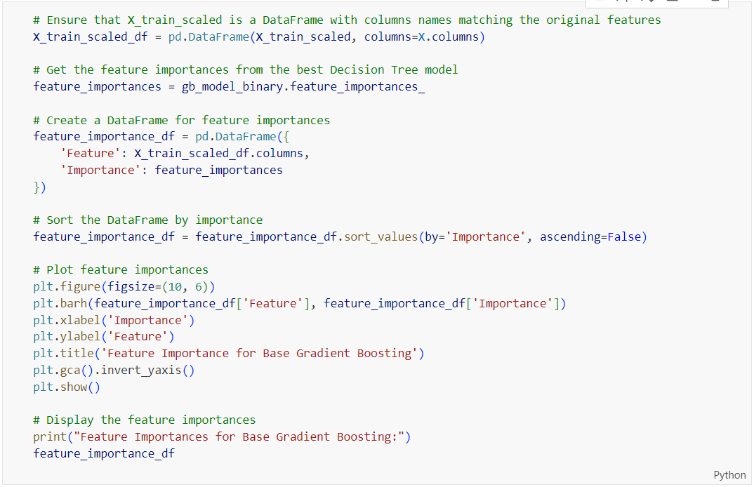

Figure 394: Source Code of Plotting Feature Importance for Base Gradient Boosting on Binary Classification

The code in Figure 394 is used to plot the feature importance of a tuned Random Forest model, similar to the previous code shown in Figure 390, by retrieving the feature importances, creating a sorted DataFrame, and generating a horizontal bar plot to visualize the importance of each feature. The output is shown in Figure 395.



Figure 395: Feature Importance for Base Gradient Boosting on Binary Classification

Figure 395 illustrates the feature importance for a base Gradient Boosting model in binary classification. The ‘**final_score**’ feature is overwhelmingly the most influential, with an importance value of 0.912267, indicating it has the greatest impact on the model's predictions. ‘**after_course_click**’ follows with a significantly lower importance of 0.076540. Other features like ‘**studied_credits**’ and ‘**before_course_click**’ have minimal influence, with very low importance values. This visualization highlights that the ‘**final_score**’ is the primary driver in the model's decision-making process, while other features contribute very little.

##### Tuned XGBoost

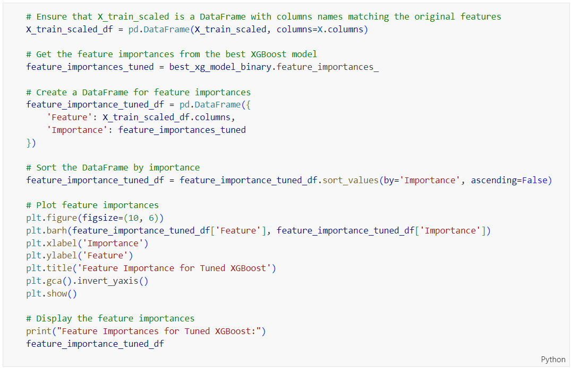

Figure 396: Source Code of Plotting Feature Importance for Base Gradient Boosting on Binary Classification

The code in Figure 396 is used to plot the feature importance of a tuned Random Forest model, similar to the previous code shown in Figure 390, by retrieving the feature importances, creating a sorted DataFrame, and generating a horizontal bar plot to visualize the importance of each feature. The output is shown in Figure 397.



Figure 397: Feature Importance for Tuned XGBoost on Binary Classification

Figure 397 shows the feature importance for a tuned XGBoost model used in binary classification. The ‘**final_score**’ is the most critical feature, with an importance value of 0.823632, indicating it has the largest impact on the model's predictions. The ‘**after_course_click**’ feature is the next most significant, but with a much lower importance value of 0.088571. Other features like ‘**studied_credits**’, ‘**sum_click**’, and ‘**before_course_click**’ have minimal influence, with even smaller importance values. This visualization indicates that the model heavily relies on ‘**final_score**’ for making predictions, while other features play a relatively minor role.

##### Base Artificial Neural Network (ANN)

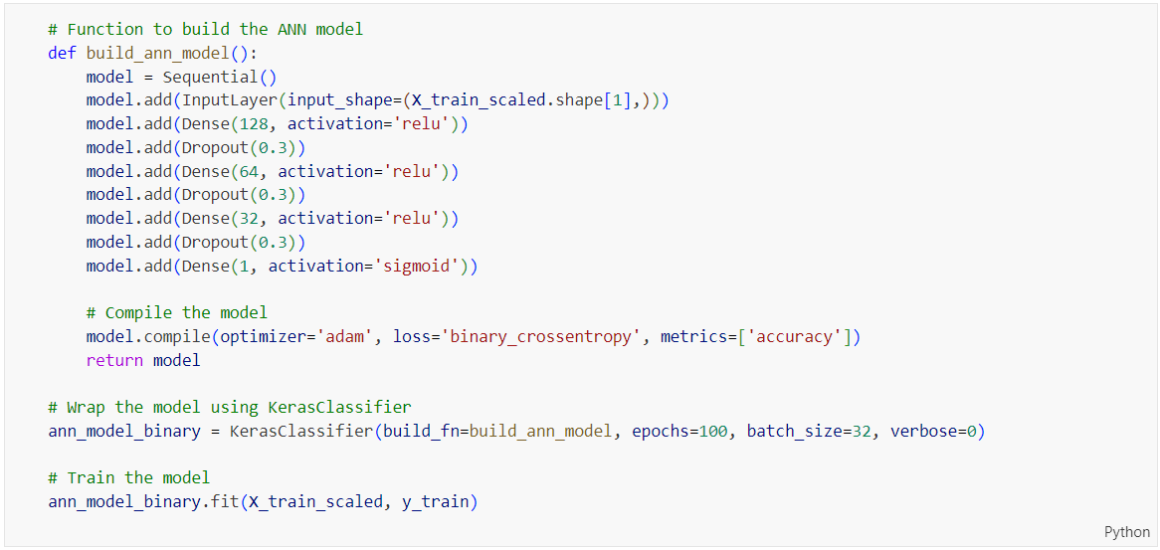

Figure 398: Source Code of putting ann_model_binary as Function ‘build_ann_model’

The code in Figure 398 defines a function ‘**build_ann_model**’ that creates, compiles, and returns an Artificial Neural Network (ANN) model, which is then wrapped using ‘**KerasClassifier**’ and trained on ‘**X_train_scaled**’ and ‘**y_train**’ for binary classification.

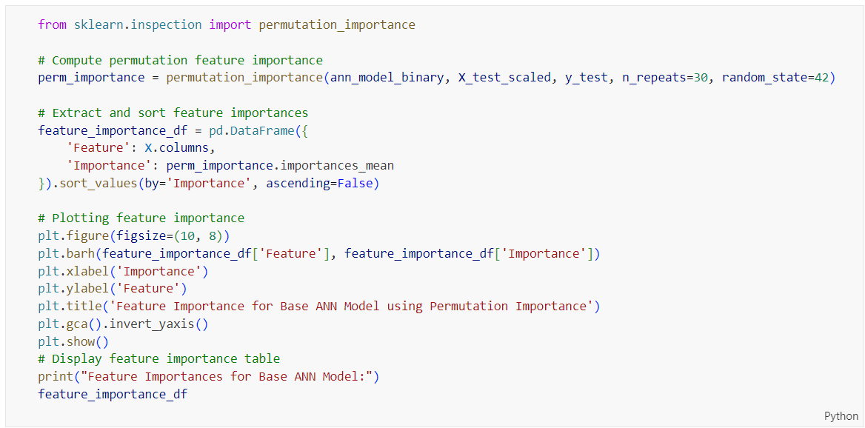

Figure 399: Source Code of Plotting Feature Importance for Base ANN using Permutation Importance on Binary Classification

The code in Figure 399 demonstrates how to compute and plot the permutation feature importance for a base ANN model using permutation_importance from sklearn.inspection. The process starts by calculating the permutation importance of the model (ann_model_binary) with the test data (X_test_scaled, y_test) over 30 repeats for robustness. The resulting importances are then extracted and placed into a DataFrame, sorted by the mean importance values. The feature importances are visualized using a horizontal bar plot, where the most important features are listed at the top. Additionally, the DataFrame of feature importances is printed for reference. The output is shown in Figure 400.

Keras models need to be wrapped using ‘**KerasClassifier**’ before computing permutation importance because ‘**permutation_importance**’ expects a scikit-learn compatible estimator, which includes methods such as ‘**fit**’ and ‘**predict**’. The KerasClassifier provides this compatibility, allowing the ANN model to be used seamlessly with scikit-learn utilities, such as ‘**permutation_importance**’, enabling consistent evaluation and feature importance analysis.



Figure 400: Feature Importance for Base ANN using Permutation Importance on Binary Classification

Figure 400 illustrates the feature importance for the base ANN model using permutation importance. The ‘**final_score**’ feature is the most influential, with an importance value of 0.373478, significantly higher than other features. The ‘**after_course_click**’ and ‘**sum_click**’ features follow, with importance values of 0.064892 and 0.046249, respectively, indicating moderate impact. Other features such as ‘**studied_credits**’, ‘**before_course_click**’, ‘**highest_education_encoded**’, ‘**num_of_prev_attempts**’, and ‘**imd_band_encoded**’ have much lower importance values, suggesting minimal impact on the model's predictions. This analysis highlights that ‘**final_score**’ is the primary driver in the model's decision-making process, while other features contribute less significantly.

#### Multi-Class Classification

The selected models on multi-class classification for further comparative analysis are the tuned logistic regression, tuned decision tree, tuned random forest, tuned gradient boosting, tuned XGBoost, and tuned artificial neural network (ANN). The subsequent step involves examining the feature importance within each of these chosen models. This analysis will elucidate the contribution of each feature to the predictive accuracy of the models. A comprehensive comparison of these models will be conducted in the Chapter 1.1.

##### Tuned Logistic Regression

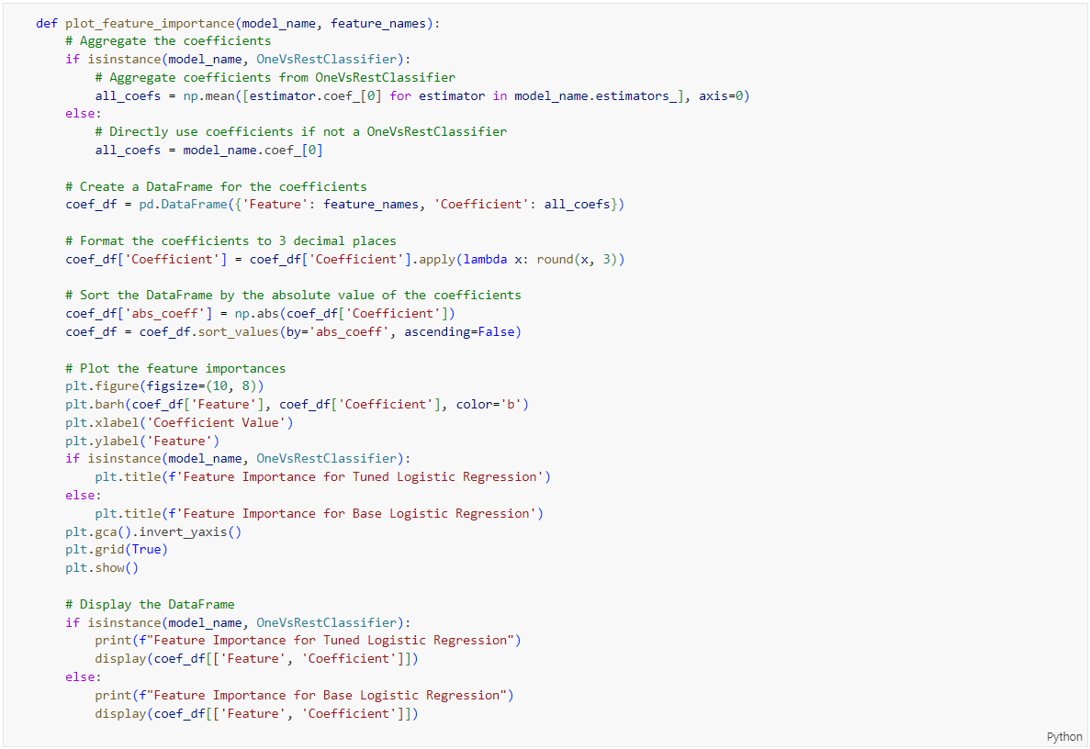

Figure 401: Source Code of Plotting Feature Importance for Tuned Logistic Regression on Multi-Class Classification

The code in Figure 401 defines a function ‘**plot_feature_importance**’ to visualize the feature importance for a tuned logistic regression model, particularly handling multi-class classification scenarios with the ‘**OneVsRestClassifier**’. It starts by aggregating the coefficients: if the model is a ‘**OneVsRestClassifier**’, it averages the coefficients from all its estimators; otherwise, it directly uses the model's coefficients. A DataFrame is created to pair the feature names with their respective coefficients, which are rounded to three decimal places for readability. The DataFrame is then sorted by the absolute values of the coefficients in descending order to highlight the most influential features. The function generates a horizontal bar plot of feature importances, labelling the axes and inverting the y-axis so the most important features appear at the top. Additionally, the function includes conditional logic to tailor the plot's title and printed output based on whether the model is a ‘**OneVsRestClassifier**’ or a regular logistic regression model. Finally, it displays the DataFrame with the sorted feature importances. This process helps in understanding which features significantly impact the model's predictions.



Figure 402: plot_feature_importance Function Call for Tuned Logistic Regression on Multi-Class Classification

The code in Figure 402 calls the ‘**plot_feature_importance**’ function to visualize the feature importance for the tuned logistic regression model (‘**best_lr_model_multi**’) on a multi-class classification task using the feature names from ‘**X.columns**’. The output is shown in Figure 403.



Figure 403: Feature Importance for Tuned Logistic Regression on Multi-Class Classification

Figure 403 shows the feature importance for a tuned logistic regression model in a multi-class classification task. The most important feature is final_score, with a strong negative coefficient of -0.269, meaning it significantly reduces the likelihood of a certain class when its value increases. The sum_click feature also has a notable negative impact with a coefficient of -0.129. On the other hand, after_course_click and before_course_click have positive coefficients (0.060 and 0.037, respectively), indicating they increase the likelihood of a particular class. Other features like studied_credits, imd_band_encoded, and highest_education_encoded have smaller coefficients, showing they have minimal influence on the model's predictions. In summary, final_score and sum_click are the most influential features in this logistic regression model.

##### Tuned Decision Tree

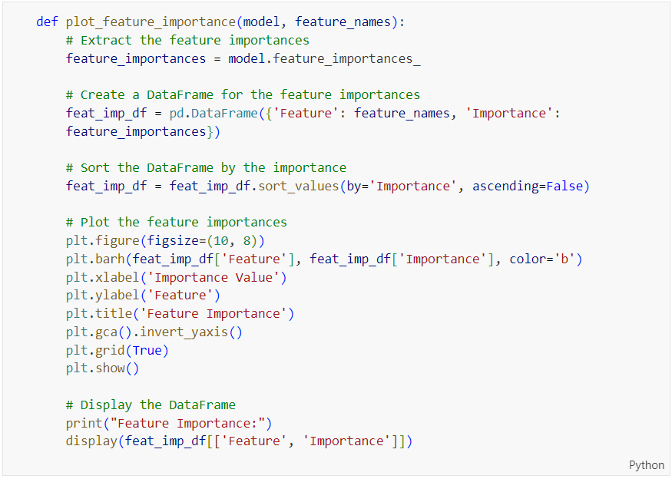

Figure 404: Source Code of Plotting Feature Importance for Tuned Decision Tree, Tuned Random Forest, Tuned Gradient Boosting and Tuned XGBoost on Multi-Class Classification

The code in Figure 404 defines a function ‘**plot_feature_importance**’ which visualizes the feature importance for a given model. It first extracts the feature importances from the model using ‘**model.feature_importances_**’ and creates a DataFrame ‘**feat_imp_df**’ with the feature names and their corresponding importance values. The DataFrame is then sorted in descending order of importance. A bar plot is generated using ‘**matplotlib**’ to display the sorted feature importances, with features on the y-axis and their importance values on the x-axis. The plot includes labels for the x-axis ("Importance Value") and y-axis ("Feature"), a title ("Feature Importance"), and an inverted y-axis to display the most important features at the top. Finally, the DataFrame containing the feature importances is displayed. This function can be used to visualize the feature importances of tuned models such as Decision Tree, Random Forest, Gradient Boosting, and XGBoost on a multi-class classification task.

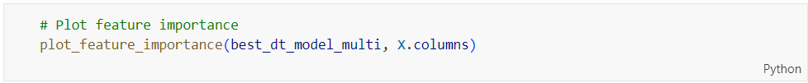

Figure 405: plot_feature_importance Function Call for Tuned Decision Tree on Multi-Class Classification

The code in Figure 405 calls the ‘**plot_feature_importance**’ function to visualize the feature importances of the tuned Decision Tree model (‘**best_dt_model_multi**’) using the feature names from ‘**X.columns**’ for a multi-class classification task. The output is shown in Figure 406.



Figure 406: Feature Importance for Tuned Decision Tree on Multi-Class Classification

Figure 406 shows the feature importance for a tuned Decision Tree model in a multi-class classification task. The ‘**final_score**’ stands out as the most influential feature by far, with an importance value of 0.828733. This means the model relies heavily on this feature for making predictions. The next important feature is ‘**after_course_click**’, but it has a much lower importance value of 0.090521. Other features like ‘**before_course_click**’ (0.034005) and ‘**sum_click**’ (0.021837) also contribute, but not as significantly. Features such as ‘**studied_credits**’, ‘**imd_band_encoded**’, and ‘**highest_education_encoded**’ have minimal impact on the model's decisions. This analysis highlights that final_score is the key driver in the model’s performance, while the other features play relatively minor roles.

##### Tuned Random Forest



Figure 407: plot_feature_importance Function Call for Tuned Random Forest on Multi-Class Classification

The code in Figure 407 calls the ‘**plot_feature_importance**’ function, which is explained in Figure 404, to visualize the feature importance for the tuned Random Forest model on a multi-class classification task, using the features from ‘**X.columns**’. The output is shown in Figure 408.



Figure 408: Feature Importance for Tuned Random Forest on Multi-Class Classification

The feature importance plot for the tuned Random Forest model on multi-class classification, Figure 408 shows that ‘**final_score**’ is the most significant feature, with an importance value of 0.567818. This means that ‘**final_score**’ has the largest impact on the model's predictions. Following this, ‘**after_course_click**’ and ‘**sum_click**’ also play substantial roles, with importance values of 0.160031 and 0.143943, respectively. Other features such as ‘**before_course_click**’, ‘**studied_credits**’, ‘**imd_band_encoded**’, and highest_education_encoded contribute less but are still relevant. These results suggest that while final_score is the key predictor, other features like after_course_click and sum_click also significantly influence the model's performance.

##### Tuned Gradient Boosting

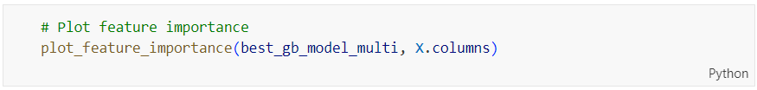

Figure 409: plot_feature_importance Function Call for Tuned Gradient Boosting on Multi-Class Classification

The code in Figure 409 calls the ‘**plot_feature_importance**’ function, which is explained in Figure 404, to visualize the feature importance for the tuned Gradient Boosting model on a multi-class classification task, using the features from ‘**X.columns**’. The output is shown in Figure 408.



Figure 410: Feature Importance for Tuned Gradient Boosting on Multi-Class Classification

The results in Figure 410 show which features the tuned Gradient Boosting model considers most important for multi-class classification. The '**final_score**' stands out as the most critical feature by far, with an importance value of 0.87. This means it has the most significant impact on the model's predictions. The next important feature is ‘**after_course_click**’, but its importance value is much lower at 0.08. Other features, like ‘**before_course_click**’, ‘**sum_click**’, ‘**studied_credits**’, ‘**imd_band_encoded**’, and ‘**highest_education_encoded**’ have even less influence, with values ranging from 0.017 to 0.0025. Essentially, ‘**final_score**’ is the main driver of the model's predictions, while the other features play a much smaller role.

##### Tuned XGBoost

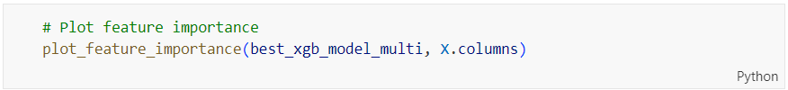

Figure 411: plot_feature_importance Function Call for Tuned XGBoost on Multi-Class Classification

The code in Figure 411 calls the ‘**plot_feature_importance**’ function, which is explained in Figure 404, to visualize the feature importance for the tuned Gradient Boosting model on a multi-class classification task, using the features from ‘**X.columns**’. The output is shown in Figure 412.



Figure 412: Feature Importance for Tuned XGBoost on Multi-Class Classification

The results in Figure 412 reveal the most important features for the tuned XGBoost model on a multi-class classification task. The ‘**final_score**’ stands out as the most influential feature, with a high importance value of 0.658, meaning it plays a crucial role in the model's predictions. ‘**after_course_click**’ is the next significant feature with an importance value of 0.165. Other features like ‘**sum_click**’, ‘**before_course_click**’, ‘**studied_credits**’, ‘**highest_education_encoded**’ and ‘**imd_band_encoded**’ have lower importance values, ranging from 0.05 to 0.01. This indicates that while ‘**final_score**’ and **‘after_course_click**’ are key drivers in the model's accuracy, the remaining features contribute less to the predictions.

##### Tuned Artificial Neural Network (ANN)

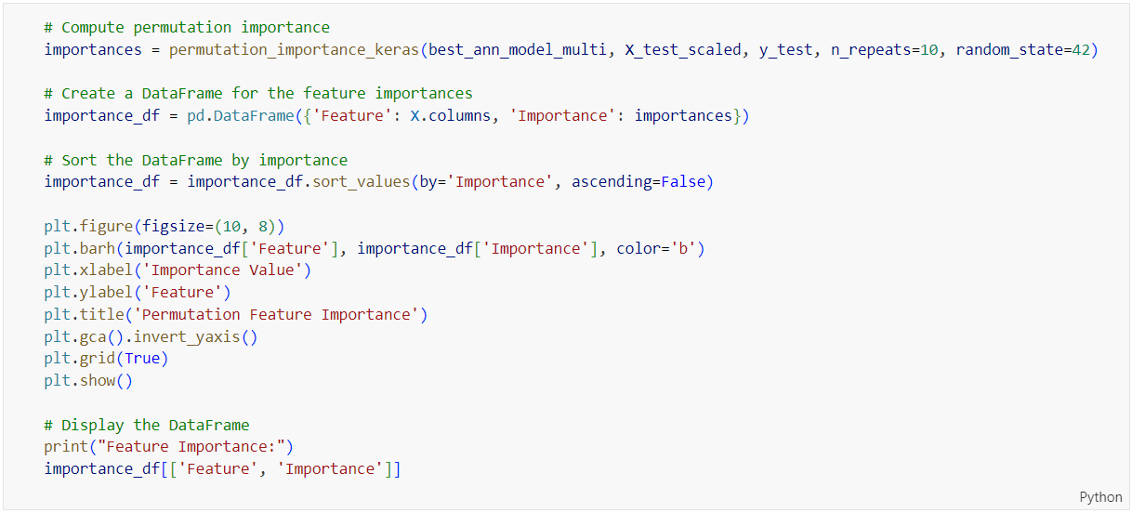

Figure 413: Source Code of Plotting Feature Importance for Tuned ANN on Multi-Class Classification

The code in Figure 413 computes and plots the permutation feature importance for a tuned Artificial Neural Network (ANN) on a multi-class classification task. It begins by calculating the permutation importance using the ‘**permutation_importance_keras**’ function, which assesses the impact of each feature by randomly shuffling its values and measuring the decrease in model accuracy. The resulting importances are then used to create a DataFrame, which is sorted in descending order of importance. The code proceeds to plot these sorted feature importances using a bar chart, with the most important features appearing at the top. Finally, the DataFrame is displayed, showing the feature names and their respective importance values. The output is shown in Figure 414.



Figure 414: Feature Importance for Tuned ANN on Multi-Class Classification

The results in Figure 414 show the importance of different features in the tuned ANN model for multi-class classification. The ‘**final_score**’ is by far the most significant feature, with an importance value of 0.383510, meaning it has the biggest impact on the model's predictions. Following that, ‘**after_course_click**’ and ‘**sum_click**’ have importance values of 0.045038 and 0.034852, respectively, but their influence is much smaller compared to ‘**final_score**’. Other features like ‘**studied_credits**’, ‘**before_course_click**’, ‘**imd_band_encoded**’, and ‘**highest_education_encoded**’ have even lower importance values, indicating they play a minor role in the model's decisions. In summary, ‘**final_score**’ is the key driver of the model's predictions, while the other features have relatively little influence.

## 

## Model Comparison

### A white grid with many different colored squares Description automatically generated with medium confidenceComparison Across Models

Figure 415: Performance Metrics for Various Binary and Multi-Class Models

Based on **Error! Not a valid bookmark self-reference.**, various models have been evaluated to determine the best one for deployment. The key metrics considered include Accuracy, F1 Score, and ROC AUC, which provide a comprehensive view of the model's performance.

For binary classification, several models were assessed. The Base Logistic Regression model showed good performance with an accuracy of 86.87%, F1 Scores of 0.8587 for Class 0 and 0.8774 for Class 1, and a ROC AUC of 0.9257. The Tuned Decision Tree model improved on this with an accuracy of 90.92%, F1 Scores of 0.9084 for Class 0 and 0.9099 for Class 1, and a ROC AUC of 0.9540. The Tuned Random Forest model performed even better, achieving an accuracy of 91.81%, F1 Scores of 0.9170 for Class 0 and 0.9192 for Class 1, and a ROC AUC of 0.9668. The Base Gradient Boosting model demonstrated similar performance with an accuracy of 91.70%, F1 Scores of 0.9157 for Class 0 and 0.9183 for Class 1, and a ROC AUC of 0.9695. The Tuned XGBoost model closely matched these results, with an accuracy of 91.81%, F1 Scores of 0.9171 for Class 0 and 0.9190 for Class 1, and a ROC AUC of 0.9698. The Tuned ANN model also showed high performance, with an accuracy of 91.52%, F1 Scores of 0.9146 for Class 0 and 0.9157 for Class 1, and a ROC AUC of 0.9660. Among these, the **Tuned XGBoost** model stands out with the highest ROC AUC of 0.9698, coupled with high accuracy and balanced F1 scores, making it the strongest candidate for deployment.

For multi-class classification, several models were evaluated. The Tuned Logistic Regression model showed reasonable performance with an accuracy of 72.10%, F1 Scores of 0.8628 for Class 0, 0.4625 for Class 1, and 0.7196 for Class 2, and a ROC AUC of 0.8923. The Tuned Decision Tree model improved significantly, achieving an accuracy of 80.50%, F1 Scores of 0.9032 for Class 0, 0.4937 for Class 1, and 0.8175 for Class 2, and a ROC AUC of 0.9487. The Tuned Random Forest model performed slightly better with an accuracy of 81.22%, F1 Scores of 0.9169 for Class 0, 0.4625 for Class 1, and 0.8301 for Class 2, and a ROC AUC of 0.9560. The Tuned Gradient Boosting model achieved the highest overall performance, with an accuracy of 81.64%, F1 Scores of 0.9152 for Class 0, 0.5235 for Class 1, and 0.8281 for Class 2, and a ROC AUC of 0.9615. The Tuned XGBoost model also performed well, with an accuracy of 81.52%, F1 Scores of 0.9162 for Class 0, 0.5188 for Class 1, and 0.8326 for Class 2, and a ROC AUC of 0.9566. Lastly, the **Tuned ANN** model showed strong performance, with an accuracy of 80.78%, F1 Scores of 0.9141 for Class 0, 0.5041 for Class 1, and 0.8172 for Class 2, and a ROC AUC of 0.9504.

After evaluating the models for both binary and multi-class classification, the **Tuned XGBoost** model emerges as the best choice for deployment. It demonstrates outstanding performance in binary classification with an accuracy of 91.81%, F1 Scores of 0.9171 for Class 0 and 0.9190 for Class 1, and a ROC AUC of 0.9698. Additionally, it shows competitive performance in multi-class classification with an accuracy of 81.52%, F1 Scores of 0.9162 for Class 0, 0.5188 for Class 1, and 0.8326 for Class 2, and a ROC AUC of 0.9566. The Tuned XGBoost model’s high accuracy and balanced F1 Scores make it the most suitable choice for deployment across different classification tasks.

## Model Deployment

### Code Implementation

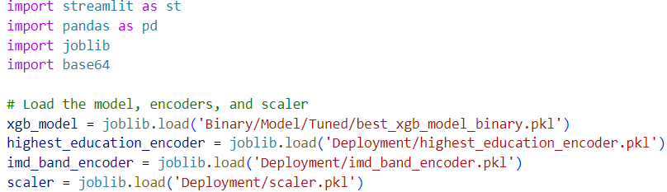

Figure 416: Imports and Model Loading

The code shown in Figure 416 imports essential libraries: ‘**streamlit**’ for building the web app interface, pandas for data manipulation, ‘**joblib**’ for loading the pre-trained model and encoders, and base64 for encoding the download link. The pre-trained XGBoost model, along with encoders for the highest education and IMD band and a scaler for feature normalization, are then loaded from the specified file paths. These components are crucial for processing input data and making predictions.

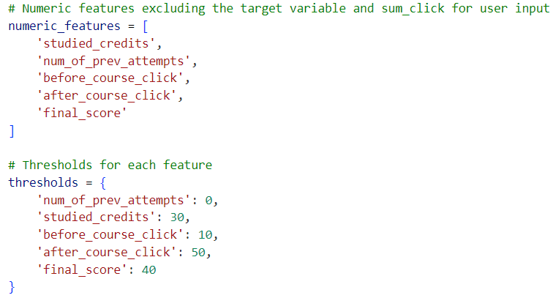

Figure 417: Define Numeric Features and Thresholds

The code then defines the numeric features that will be used for making predictions. These features exclude the target variable and include studied credits, number of previous attempts, clicks before and after the course, and the final score. Thresholds for each feature are also set to provide customized advice based on the student's data. These thresholds help in identifying high-risk factors and generating appropriate advice for students.

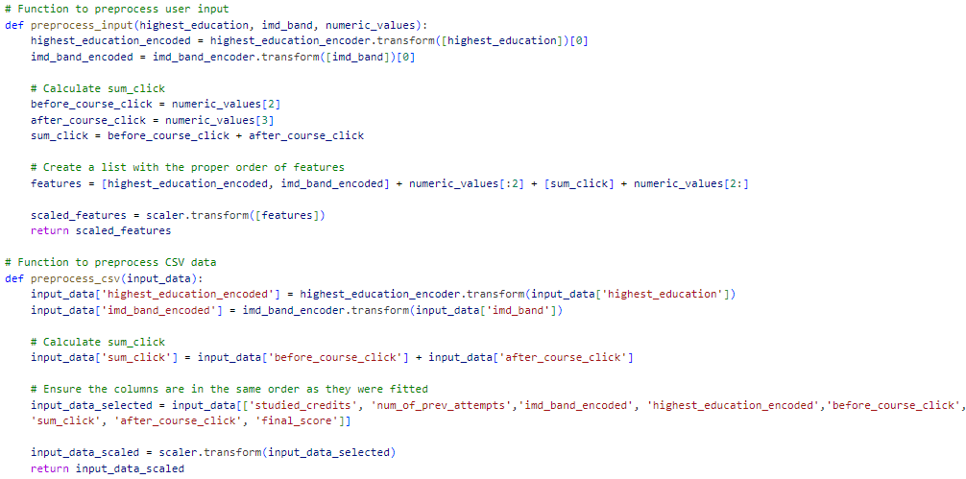

Figure 418: Preprocessing Function

Two preprocessing functions are defined to handle user input and CSV data. The ‘**preprocess_input**’ function encodes categorical features, calculates the sum of clicks before and after the course, orders the features correctly, and scales them. Similarly, the ‘**preprocess_csv**’ function applies the same transformations to data from a CSV file. These preprocessing steps ensure that the input data is in the correct format and scale for the model to make accurate predictions.

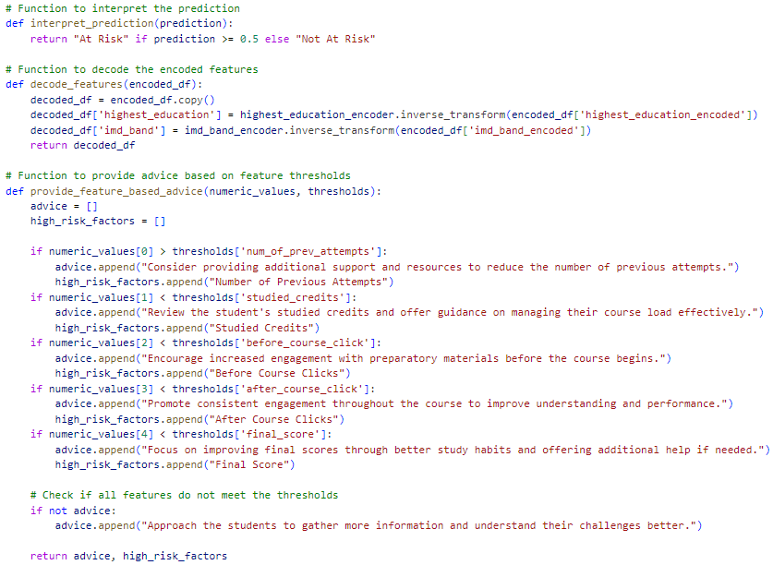

Figure 419: Prediction and Advice Function

The ‘**interpret_prediction**’ function interprets the prediction result as "At Risk" or "Not At Risk" based on a threshold. The ‘**decode_features**’ function decodes the encoded categorical features back to their original values for easier interpretation. The ‘**provide_feature_based_advice**’ function generates personalized advice based on the feature thresholds, helping to address the student's specific challenges and improve their performance. If no specific advice is needed, a general suggestion to gather more information about the student's challenges is provided.

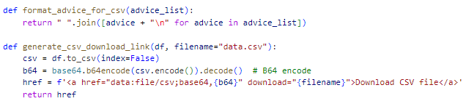

Figure 420:Utility Functions for CSV Handling

The ‘**format_advice_for_csv**’ function formats the advice list for inclusion in a CSV file, ensuring that each piece of advice is on a new line. The ‘**generate_csv_download_link**’ function creates a downloadable link for a CSV file by encoding the file in base64. This allows users to download the processed data, including predictions and advice, directly from the web application.

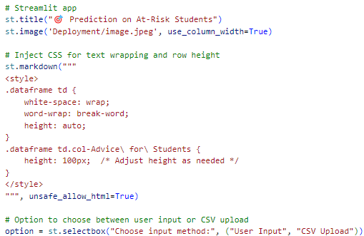

Figure 421:Streamlit App Interface

The Streamlit app interface begins with setting up the title and an image at the top. Custom CSS is injected to improve the display of the data table, ensuring text wrapping and appropriate row height for advice columns. The user is given an option to choose between manual input and CSV upload for entering student data. This choice determines the subsequent steps for data input and processing.

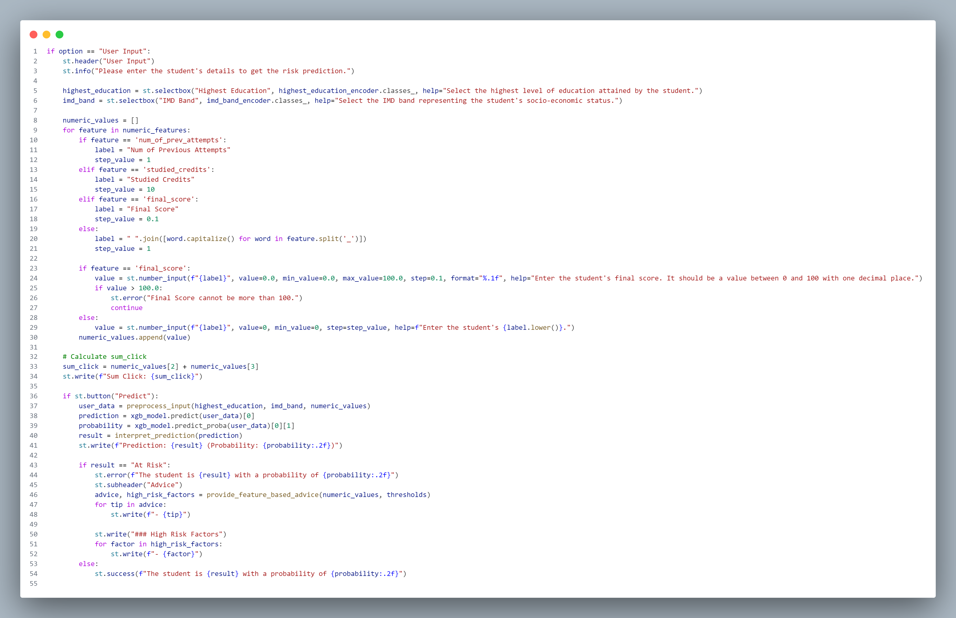

Figure 422:User Input Handling

If the user selects "User Input," the app displays fields for manually entering the student's details, including highest education and IMD band using dropdown menus. Numeric input fields are provided for features like the number of previous attempts, studied credits, clicks before and after the course, and the final score. The sum_click value is calculated and displayed. Upon pressing the "Predict" button, the data is preprocessed, a prediction is made, and the result is displayed. If the student is identified as at risk, specific advice and high-risk factors are shown.



Figure 423: CSV Upload Handling

If the user selects "CSV Upload," instructions and requirements for the CSV file format are provided. The user can upload a CSV file, which is then preprocessed and used to make predictions. The app displays the predictions, probabilities, and specific advice for each student if they are at risk. The encoded features are decoded for better readability, and sidebar filters are provided for refining the displayed data. The filtered dataset is displayed, and a download link is generated for users to save the processed data.

### User Input

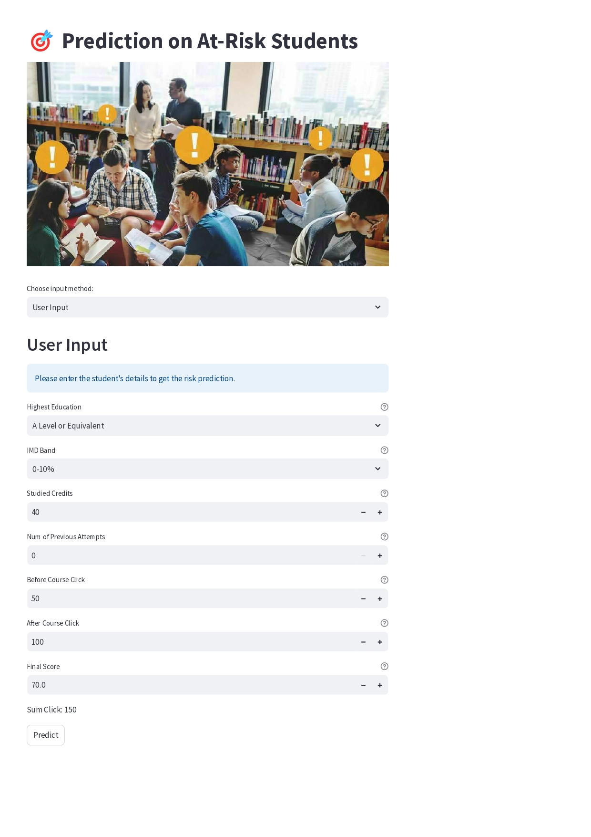

Figure 424: User Interface of At-Risk Students Prediction Website using User Input

The user interface of Prediction on At-Risk Students shown in Figure 415 has a straightforward and user-friendly design. The main section of the page allows users to input data through a form. There's a dropdown menu for choosing the input method, which defaults to "User Input." The form asks for various details like the student's highest education level, IMD band, studied credits, number of previous attempts, course clicks before and after, final score, and total clicks. Once all the information is entered, users can click the "Predict" button to get a risk prediction. The design makes it easy to follow and enter the required information.

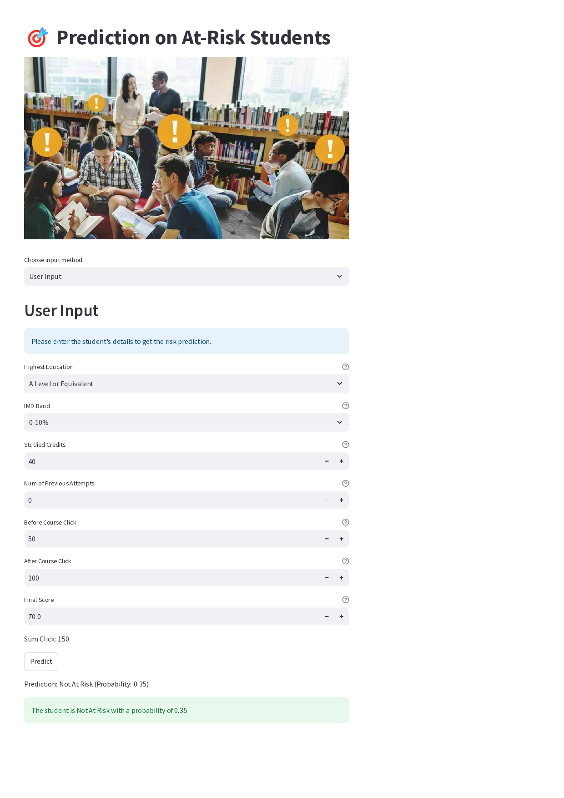

Figure 425: Example 1

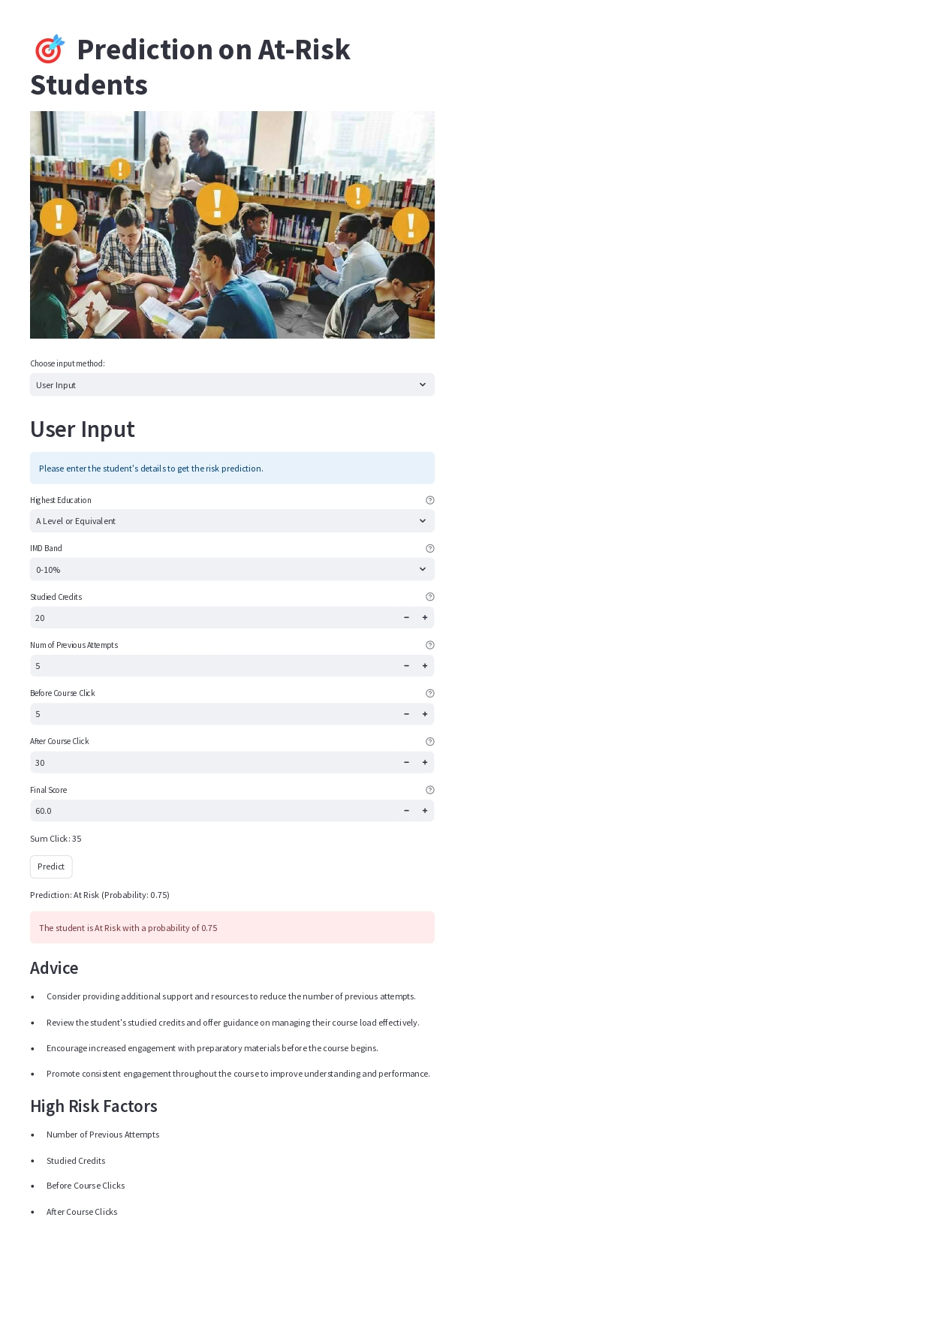

Figure 426: Example 2

After the users have provided all of the required information, they are able to begin the process of prediction by pressing the “Predict” button. The app then makes use of the XGBoost classifier that has been pre-trained in order to interpret the input data and presents the projected result, which indicates whether or not the student is expected to be at risk. Figure 425 has detected the student is not at risk of failing in the course or dropping out from the school. The system displays a green box that inform the user the student is not at risk. If the student is detected as at risk, the system pops up a red box that inform the user the student is likel to fail in that module or drop out from the school, as shown in Figure 426. Additionally, the system provides advice on supporting at-risk students related to the input of the user High-risk factors are also highlighted to know which factors is affecting the at-risk probablity. This additional information helps users understand the reasons behind the prediction and offers actionable steps to mitigate the risk.

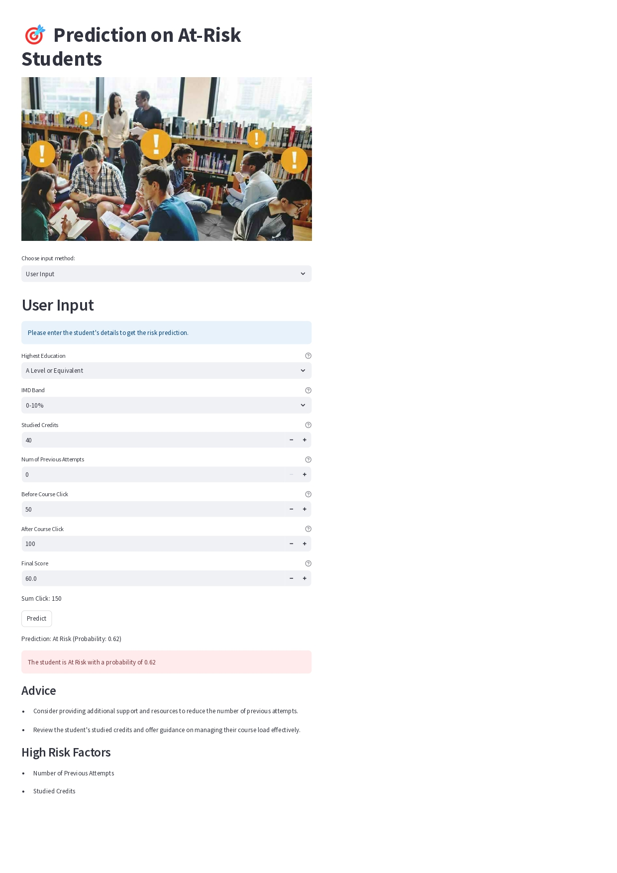

Figure 427: Example 3

Figure 427 show another example where only few factors contributing to the risk probabilities.

### CSV File Upload



Figure 428: User Interface of At-Risk Students Prediction Website using CSV Upload

Users can select the input method, currently set to "CSV Upload," and are provided with detailed instructions on the required CSV columns: highest education, IMD band, number of previous attempts, studied credits, before and after course clicks, and final score. The file upload area allows users to drag and drop or browse for their CSV files, with a clear indication of the file size limit and accepted format.



Figure 429: Example of CSV Upload as Input

Figure 429 shows more details of the web application for predicting at-risk students. On the left, there are filters for refining the data, including options for highest education, IMD band, and the number of previous attempts. Once a CSV file, like the shown "dummy_data.csv," is uploaded, the filtered data appears in a table below. This table includes columns such as id_student, gender, Highest Education, IMD Band, Number of Previous Attempts, and Studied Credits. The table displays five rows of student data. At the bottom, there’s a link to download the filtered data as a CSV file, making it easy for users to save their refined dataset.

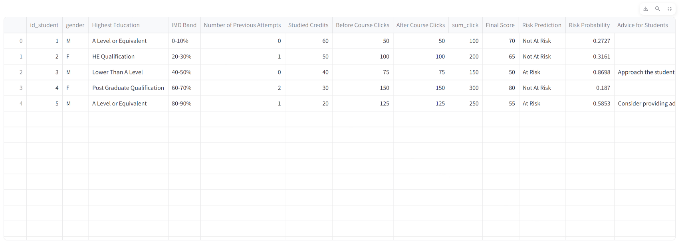

Figure 430: Filtered Data for CSV File Uploaded



Figure 431: Filtered Data for CSV File Uploaded

Figure 430 and Figure 431 show the detailed filtered data section of the web application for predicting at-risk students. For each student, the table provides a risk prediction and risk probability. If the student is identified as at risk, specific advice is given. For instance, one student with a risk probability of 0.8698 receives advice to "Approach the student to gather more information and understand their challenges better." Another student with a risk probability of 0.5853 is advised to "Consider providing additional support and resources to reduce the number of previous attempts" and their high-risk factors are highlighted as the number of previous attempts and studied credits. This section allows users to view comprehensive details and actionable insights for each student's risk status.

## Summary

Chapter 5 provides a thorough assessment of the prediction models used to identify kids who are at risk. Multiple machine learning algorithms, such as Logistic Regression, Random Forests, Decision Trees, Gradient Boosting, XGBoost, and Artificial Neural Networks, are evaluated using important performance measures including precision, recall, accuracy, F1-score, and ROC AUC. The chapter meticulously documents the performance of each model before and after hyperparameter tuning, providing a clear understanding of their predictive capabilities. Visual aids like confusion matrices and ROC curves are employed to illustrate the results, ensuring an intuitive grasp of the data.

The chapter also explores multi-class classification models, analysing their effectiveness in predicting multiple risk levels. Additionally, the importance of different features is discussed, highlighting which factors most significantly contribute to predicting at-risk students. The chapter concludes with a comparative analysis of the models, identifying their strengths and weaknesses and offering insights into their practical applicability. Based on the evaluation, the tuned XGBoost model is selected for deployment due to its superior performance and robustness. This thorough evaluation lays the groundwork for implementing these models in educational settings, ultimately aiming to enhance student support systems and improve educational outcomes.

# chapter 6: CRITICAL EVALUATION



## Critical Evaluation

The project's critical assessment is on examining the efficacy of the methodology and models used to forecast pupils at risk using machine learning techniques. The main objective was to assess the effectiveness of the chosen algorithms in identifying pupils who may be prone to academic failure. This assessment entails assessing the merits and drawbacks of each model, examining the accuracy, recall, precision, and F1 scores. Through a careful analysis of these parameters, we may get valuable information on the strength and dependability of the predictive models.

Additionally, the evaluation explores the practical implications of the model deployment. This includes the ease of integration into existing educational systems and the potential impact on student outcomes. The user-friendliness of the model, the interpretability of the results, and the actionable insights provided to educators are key factors considered in this assessment. The goal is to ensure that the model not only performs well in a controlled environment but also offers tangible benefits when applied in real-world educational settings.

## Limitation

Despite the promising results, the project faced several limitations that need to be acknowledged. One significant limitation was the quality and comprehensiveness of the dataset used. The dataset might not have captured all relevant variables affecting student performance, potentially limiting the model's accuracy and generalizability. Additionally, the dataset's size and diversity could impact the model's ability to generalize across different educational contexts.

Another limitation is the computational complexity associated with training and tuning certain machine learning models, particularly neural networks. These models require significant computational resources and time, which may not be feasible for all educational institutions. Moreover, the interpretability of complex models like neural networks can be challenging, making it difficult for educators to understand and trust the predictions and recommendations generated by the model.

## Recommendation

To address the limitations identified, several recommendations are proposed. Firstly, enhancing the dataset by including more comprehensive and diverse variables can improve the model's accuracy and generalizability. Collaborating with educational experts to identify and incorporate additional relevant features can provide a more holistic view of factors influencing student performance.

Secondly, simplifying the model architecture or using ensemble methods can help balance performance and interpretability. Ensuring that the models are not only accurate but also interpretable is crucial for gaining educators' trust and facilitating the practical application of the model's predictions. Providing detailed documentation and training for educators on how to use and interpret the model can further enhance its usability and effectiveness.

Lastly, future work could explore the integration of real-time data streams into the predictive model, allowing for continuous monitoring and timely interventions. This dynamic approach can help educators address emerging risks promptly and support students more effectively. Continuous evaluation and refinement of the model based on feedback and new data will also be essential for maintaining its relevance and accuracy in changing educational environments.

# References

Ahmed, D. M., Abdulazeez, A. M., Zeebaree, D. Q., & Ahmed, F. Y. (2021). Predicting University's Students Performance Based on Machine Learning Techniques. *2021 IEEE International Conference on Automatic Control and Intelligent Systems (I2CACIS 2021).* doi:10.1109/i2cacis52118.2021.9495862

Albreiki, B., Zaki, N., & Alashwal, H. (2021). A Systematic Literature Review of Student’ Performance Prediction Using Machine Learning Techniques. *Education Sciences, 11*(9), 552. doi:10.3390/educsci11090552

Alshareef, F., Alhakami, H., Alsubait, T., & Baz, A. (2020). Educational Data Mining Applications and Techniques. *(IJACSA) International Journal of Advanced Computer Science and Applications, 11*(4), 729-734. doi:10.14569/ijacsa.2020.0110494

Ashtari, H. (2024). *XGBoost vs. Random Forest vs. Gradient Boosting: Differences | Spiceworks*. Retrieved from Spiceworks Inc: https://www.spiceworks.com/tech/artificial-intelligence/articles/xgboost-vs-random-forest-vs-gradient-boosting/

Balabied, S. A., & Eid, H. F. (2023). Utilizing random forest algorithm for early detection of academic underperformance in open learning environments. *PeerJ. Computer science*. doi:10.7717/peerj-cs.1708

Benkő, Z., Bábel, T., & Somogyvári, Z. (2022). Model-free Detection of Unique Events in Time Series. *Scientific Reports, 12*(1). doi:10.1038/s41598-021-03526-y

Bravo, D. P., Alves, M. A., Ensina, L. A., & Oliveira, L. E. (2023). Evaluating Strategies to Predict Student Dropout of a Bachelor's Degree in Computer Science. *Symposium on Knowledge Discovery, Mining and Learning (KDMiLe 2023)*. doi:10.5753/kdmile.2023.232763

Cheng, B., Liu, Y., & Jia, Y. (2024). Evaluation of students' performance during the academic period using the XG-Boost Classifier-Enhanced AEO hybrid model. *Expert Systems with Applications, 238*, 122136. doi:10.1016/j.eswa.2023.122136

Ellis, C. (2022). *When to use logistic regression - Crunching the Data*. Retrieved from Crunching the Data: https://crunchingthedata.com/when-to-use-logistic-regression/

Feldman-Maggor, Y., Barhoom, S., Blonder, R., & Tuvi-Arad, I. (2020). Behind the scenes of educational data mining. *Education and Information Technologies, 26*(2), 1455-1470. doi:10.1007/s10639-020-10309-x

Feng, G., Fan, M., & Chen, Y. (2022). Analysis and Prediction of Students’ Academic Performance Based on Educational Data Mining. *IEEE Access, 10*, 19558-19571. doi:10.1109/access.2022.3151652

Flanagan, B., Majumdar, R., & Ogata, H. (2022). Early-warning prediction of student performance and engagement in open book assessment by reading behavior analysis. *International Journal of Educational Technology in Higher Education, 19*. doi:10.1186/s41239-022-00348-4

GeeksforGeeks. (2023). *ML XGBoost (eXtreme Gradient Boosting)*. Retrieved from GeeksforGeeks: https://www.geeksforgeeks.org/ml-xgboost-extreme-gradient-boosting

Ghorakavi, V. (3 January, 2024). *What is a neural network?* Retrieved from GeeksforGeeks: https://www.geeksforgeeks.org/neural-networks-a-beginners-guide/

Hasan, R., Palaniappan, S., Mahmood, S., Abbas, A., Sarker, K. U., & Sattar, M. U. (2020). Predicting Student Performance in Higher Educational Institutions Using Video Learning Analytics and Data Mining Techniques. *Applied sciences, 10*(11), 3894. doi:10.3390/app10113894

He, Y., Chen, R., Li, X., Hao, C., Liu, S., Zhang, G., & Jiang, B. (2020). Online At-Risk Student Identification using RNN-GRU Joint Neural Networks., *11.* doi:10.3390/info11100474

Hoijtink, M., & Hardeveld, A. P.-v. (2022). Machine Learning and the Platformization of the Military: A Study of Google's Machine Learning Platform TensorFlow. *International Political Sociology, 16*(2). doi:10.1093/ips/olab036

Hotz, N. (28 April, 2024). *What is CRISP DM?* Retrieved from Data Science Process Alliance: https://www.datascience-pm.com/crisp-dm-2/

Hung, H.-C., Liu, I.-F., Liang, C.-T., & Su, Y.-S. (2020). Applying Educational Data Mining to Explore Students’ Learning Patterns in the Flipped Learning Approach for Coding Education. *Symmetry, 12*(2), 213. doi:10.3390/sym12020213

Hussain, S., & Khan, M. Q. (2023). Student-Performulator: Predicting Students’ Academic Performance at Secondary and Intermediate Level Using Machine Learning. *Annals of Data Science, 10*, 637-355. doi:10.1007/s40745-021-00341-0

IBM Documentation. (17 August, 2021). *CRISP-DM Help Overview.* Retrieved from IBM Documentation: https://www.ibm.com/docs/en/spss-modeler/saas?topic=dm-crisp-help-overview

Ifenthaler, D., & Yau, J.-K. (2020). Utilising learning analytics to support study success in higher education: a systematic review. *Educational Technology Research and Development, 68*, 1961-1990. doi:10.1007/s11423-020-09788-z

Jawad, K., Shah, M., & Tahir, M. (2022). Students’ Academic Performance and Engagement Prediction in a Virtual Learning Environment Using Random Forest with Data Balancing. *Sustainability, 14*(22). doi:10.3390/su142214795

Kumar, M., Walia, N., Bansal, S., Kumar, G., & Cengiz, K. (2023). Predicting College Students’ Placements Based on Academic Performance Using Machine Learning Approaches. *International Journal of Modern Education and Computer Science, 15*(6), 1-13. doi:10.5815/ijmecs.2023.06.01

Lemay, D. J., Baek, C., & Doleck, T. (2021). Comparison of learning analytics and educational data mining: A topic modeling approach. *Computers and Education. Artificial intelligence*, 100016. doi:10.1016/j.caeai.2021.100016

Liu, Y., Fan, S., Xu, S., Sajjanhar, A., Yeom, Y., & Wei, Y. (2022). Predicting Student Performance Using Clickstream Data and Machine Learning. *Education sciences, 13*(1). doi:10.3390/educsci13010017

Lutfiani, N., & Meria, L. (2022). Utilization of Big Data in Educational Technology Research. *International Transactions on Education Technology (ITEE)*, 73-83. doi:10.34306/itee.v1i1.198

Maheshwari, E., Roy, C., Pandey, M., & Rautray, S. S. (2020). Prediction of Factors Associated with the Dropout Rates of Primary to High School Students in India Using Data Mining Tools. *Advances in Intelligent Systems and Computing*, 242-251. doi:10.1007/978-981-32-9186-7_26

Mduma, N., Kalegele, K., & Machuve, D. (2019). A Survey of Machine Learning Approaches and Techniques for Student Dropout Prediction. *Data Science Journal, 18*, 1-10. doi:10.5334/dsj-2019-014

Mengash, H. (2020). Using Data Mining Techniques to Predict Student Performance to Support Decision Making in University Admission Systems. *IEEE Access*, 55462-55470. doi:10.1109/access.2020.2981905

Mubarak, A. A., Cao, H., & Zhang, W. (2020). Prediction of students’ early dropout based on their interaction logs in online learning environment. *Interactive Learning Environments, 30*(8). doi:10.1080/10494820.2020.1727529

Nabil, A., Seyam, M., & Abou-Elfetouh, A. (2021). Prediction of Students’ Academic Performance Based on Courses’ Grades Using Deep Neural Networks. *IEEE Access, 9*, 140731-140746. doi:10.1109/access.2021.3119596

Nachouki, M., & Naaj, M. (2022). Predicting student performance to improve academic advising using the Random Forest algorithm. *International Journal of Distance Education Technologies (IJDET), 20*(1), 1-17. doi:10.4018/IJDET.296702

Nafea, A. A., Mishlish, M., Shaban, A. M., AL-Ani, M., Alheeti, K., & Mohammed, H. J. (2023). Enhancing Student's Performance Classification Using Ensemble Modeling. *Iraqi journal for computer science and mathematics, 4*(4). doi:10.52866/ijcsm.2023.04.04.016

Niyogisubizo, J., Liao, L., Nziyumva, E., Murwanashyaka, E., & Nshimyumukiza, P. C. (2022). Predicting student's dropout in university classes using two-layer ensemble machine learning approach: A novel stacked generalization. *Computers and Education: Artificial Intelligence, 3*. doi:10.1016/j.caeai.2022.100066

OECD. (2021). *OECD Digital Education Outlook 2021: Pushing the Frontiers with Artificial Intelligence, Blockchain and Robots.* OECD Publishing, Paris. doi:10.1787/589b283f-en

Paramita, A. S., & Tjahjono, L. M. (2021). Implementing Machine Learning Techniques for Predicting Student Performance in an E-Learning Environment. *International Journal of Informatics and Information System, 4*(2), 149-156. doi:10.47738/ijiis.v4i2.112

Rajendran, S., Chamundeswari, S., & Sinha, A. A. (2022). Predicting the academic performance of middle- and high-school students using machine learning algorithms. *Social Sciences & Humanities Open, 6*(1), 100357. doi:10.1016/j.ssaho.2022.100357

Ramchandani, M., Khandare, H., Singh, P., Rajak, P., Suryawanshi, N., Jangde, A. S., . . . Sahu, M. (2022). Survey: Tensorflow in Machine Learning. *Journal of Physics: Conference Series, 2273*(1), 012008. doi:10.1088/1742-6596/2273/1/012008

Rodríguez-Hernández, C. F., Musso, M., Kyndt, E., & Cascallar, E. (2021). Artificial neural networks in academic performance prediction: Systematic implementation and predictor evaluation. *Computers and Education. Artificial Intelligence, 2*, 100018. doi:10.1016/j.caeai.2021.100018

Romero, C., & Ventura, S. (2020). Educational Data mining and Learning Analytics: An updated survey. *WIREs Data Mining and Knowledge Discovery, 10*(3). doi:10.1002/widm.1355

ŞAHİN, M., & YURDUGÜL, H. (2023). Educational Data Mining and Learning Analytics: Past, Present and Future. *Bartın University Journal of Faculty of Education, 9*(1), 121-131. doi:10.14686/buefad.606077

Saini, A. (10 January, 2024). *Gradient Boosting Algorithm: A Complete Guide for Beginners*. Retrieved from Analytics Vidhya: https://www.analyticsvidhya.com/blog/2021/09/gradient-boosting-algorithm-a-complete-guide-for-beginners/

Sandhya, E., Arava, R. R., Krishna, E. P., & Baseer, K. (2022). Investigating Student Learning Process and Predicting Student Performance Using Machine Learning Approaches. *International Journal of Early Childhood Special Education (INT-JECS), 14*(7), 622-628. doi:10.9756/INTJECSE/V14I7.60

Sedrakyan, G., Malmberg, J., Verbert, K., Järvelä, S., & Kirschner, P. A. (2020). Linking learning behavior analytics and learning science concepts: Designing a learning analytics dashboard for feedback to support learning regulation. *Computers in Human Behavior, 107*, 105512. doi:10.1016/j.chb.2018.05.004

Shah, A. (28 September, 2023). *Enhancing Educational Planning: Predicting Student Placement Using CRISP-DM and Data Science*. Retrieved from Medium: https://medium.com/@aagamshah0812/enhancing-educational-planning-predicting-student-placement-using-crisp-dm-and-data-science-8db6a112b250

Verma, B. K., Srivastava, N., & Singh, H. K. (2021). Prediction of Students’ Performance in e-Learning Environment using Data Mining/ Machine Learning Techniques. *Journal of University of Shanghai for Science and Technology, 23*(5), 586-593. doi:10.51201/jusst/21/05179

Waheed, H., Hassan, S.-U., Aljohani, N. R., Hardman, J., Alelyani, S., & Nawaz, R. (2020). Predicting academic performance of students from VLE Big Data using Deep Learning Models. *Computers in Human Behavior, 104*. doi:10.1016/j.chb.2019.106189

Wehrstein, L. (19 December, 2020). *CRISP-DM ready for Machine Learning Projects*. Retrieved from Medium: https://towardsdatascience.com/crisp-dm-ready-for-machine-learning-projects-2aad9172056a

Yağcı, M. (2022). Educational data mining: prediction of students' academic performance using machine learning algorithms. *Smart Learning Environments, 9*(11). doi:10.1186/s40561-022-00192-z

Zeineddine, H., Braendle, U., & Farah, A. (2021). Enhancing prediction of student success: Automated machine learning approach. *Computers & Electrical Engineering, 89*, 106903. doi:10.1016/j.compeleceng.2020.106903

# appendices

## Appendix A: PPF – Title Registration Proposal









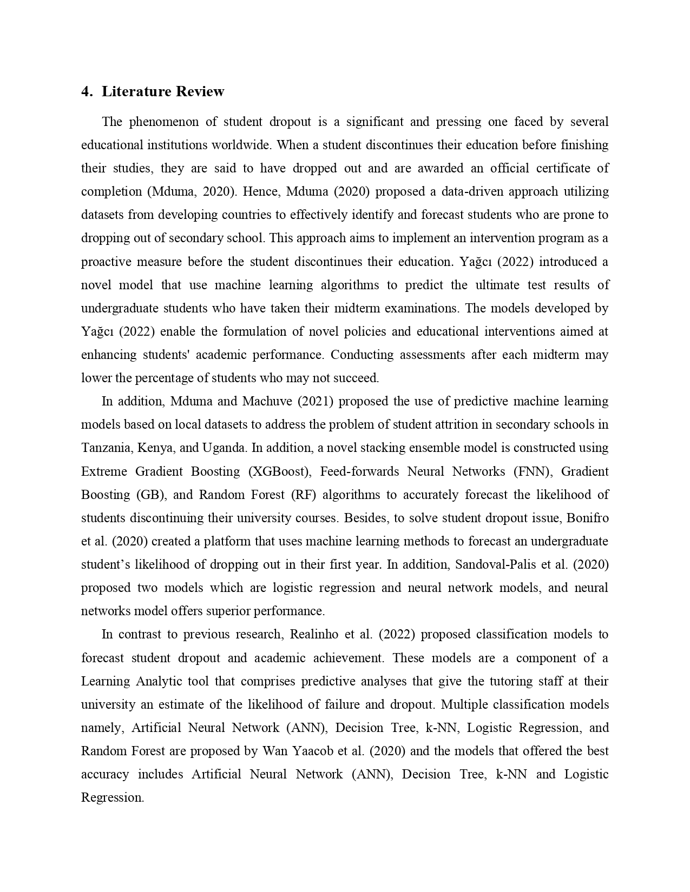





## Appendix B: Ethics Forms (Fast Track)









## Appendix C: Log Sheets







## Appendix D: Poster

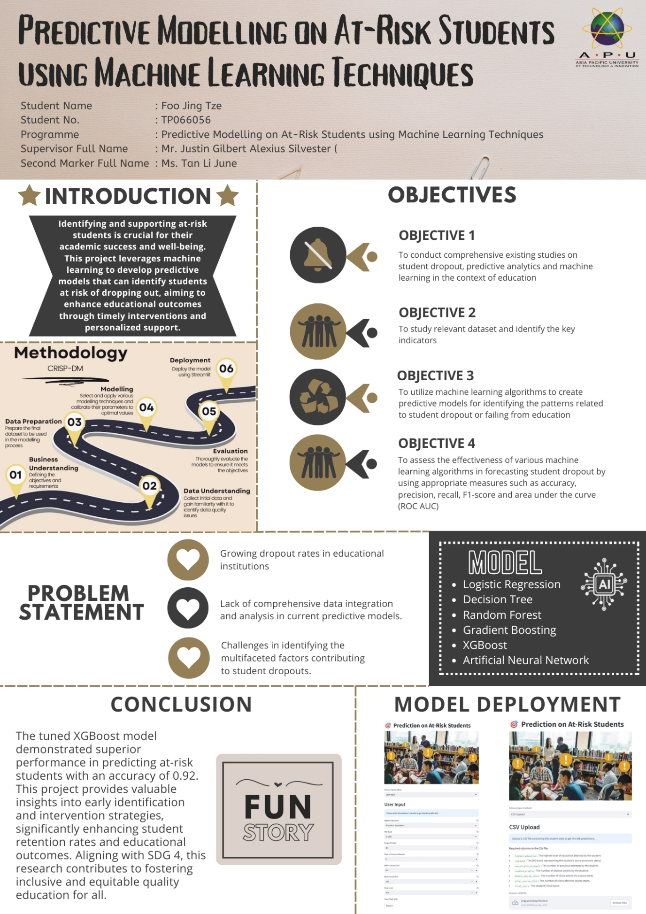

## Appendix E: Gantt Chart

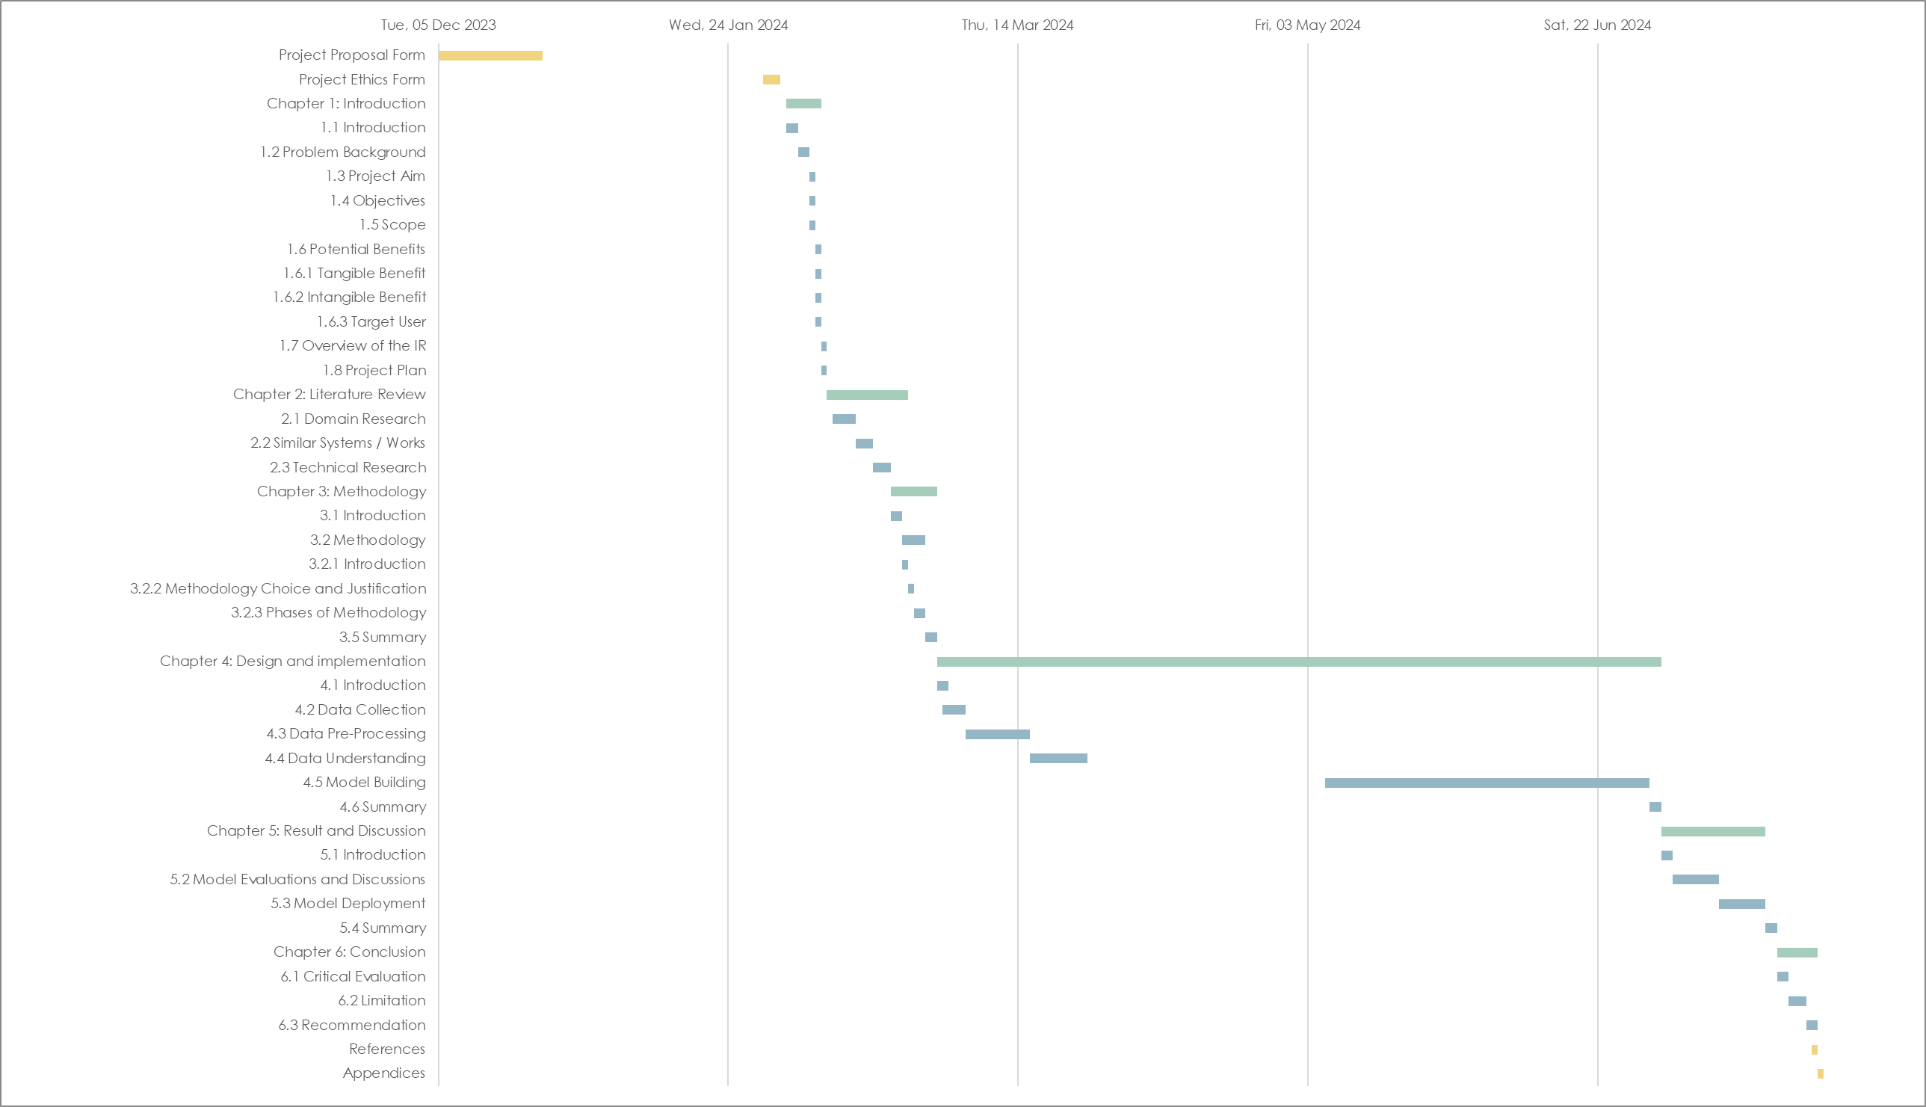

Figure 432: Gantt Chart

## Appendix F: Sample Code Implementation